**Data Science**

**By Devi Sri Charan**

Claim Prediction Model 2

Exploratory Data Analysis on Historical Claims Data 3

Preparing Dataset 3

EDA 3

Information of the data 3

Statistics of the data 3

Missing Values 4

Visual Distribution of Numerical Variables 4

Visual Distribution of Categorical Variables 5

Time Series Analysis of Date Columns 6

Predictive Model to estimate Claim Amounts 8

# Claim Prediction Model

## Exploratory Data Analysis on Historical Claims Data

### Preparing Dataset

First, I have merged the Inpatient, Outpatient, Beneficiary and Provider Data

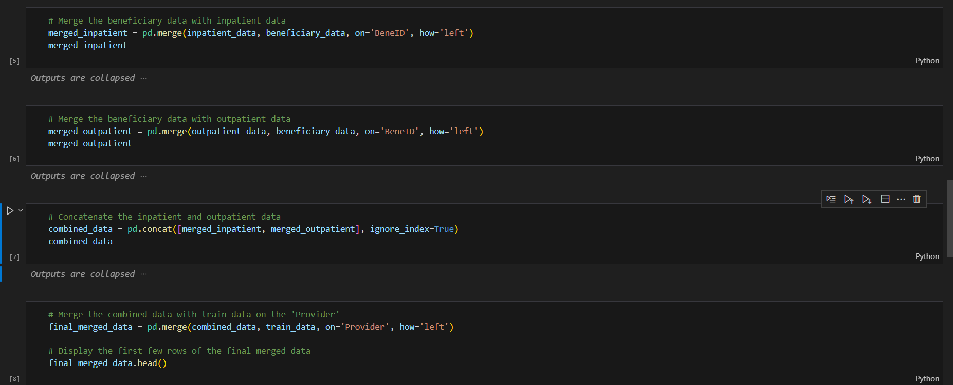

### EDA

#### Information of the data

The dataset has 54 columns

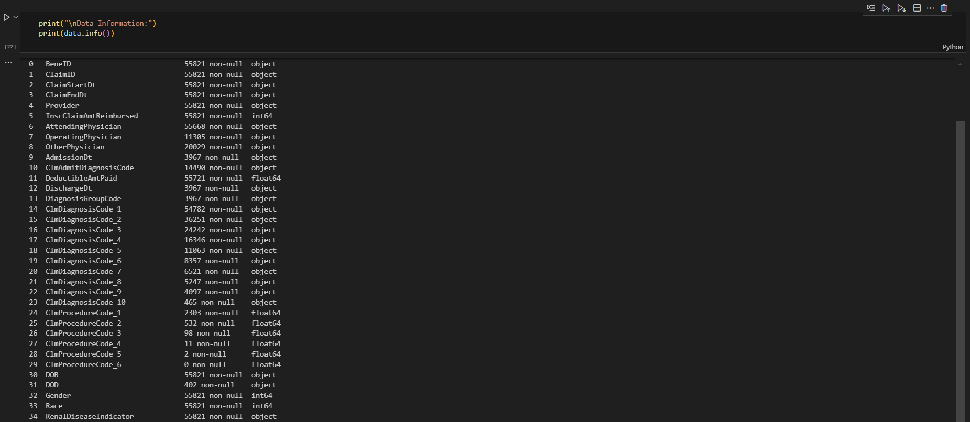

#### Statistics of the data

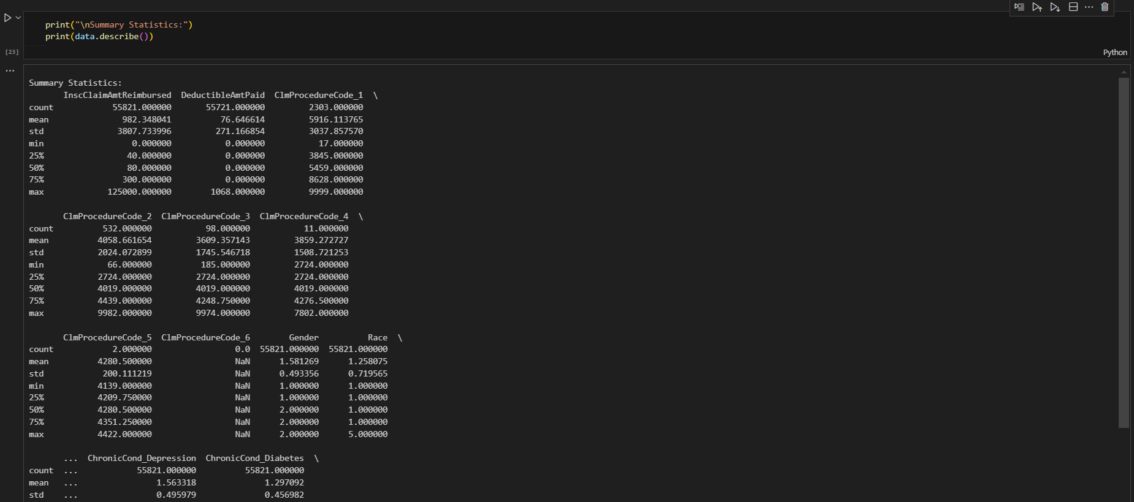

#### Missing Values

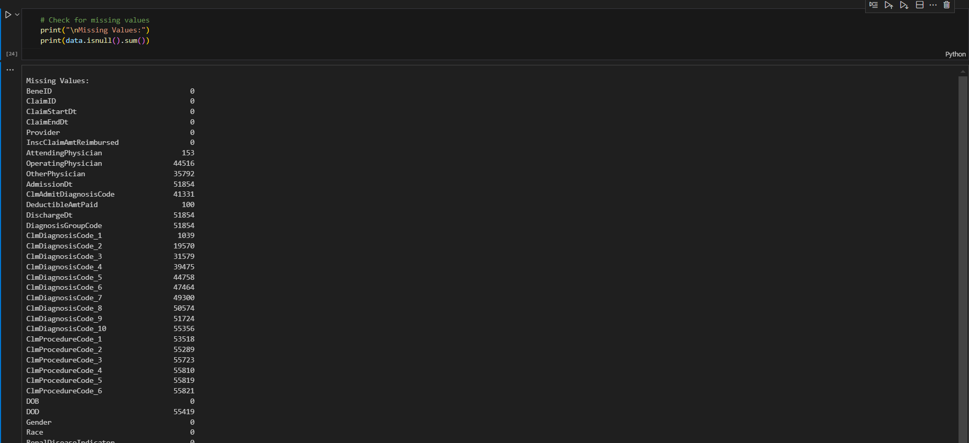

#### Visual Distribution of Numerical Variables



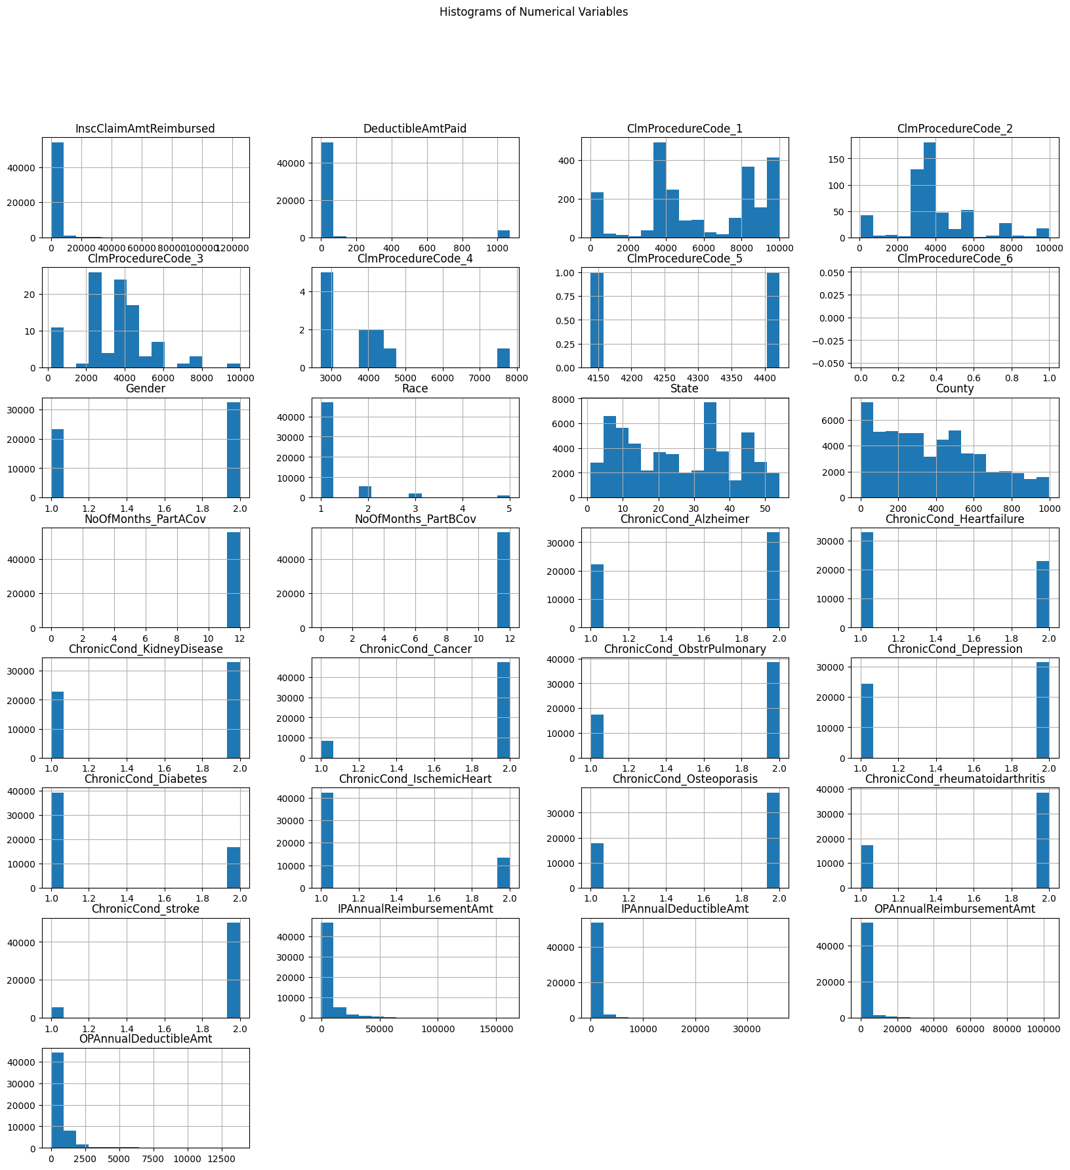

#### Visual Distribution of Categorical Variables

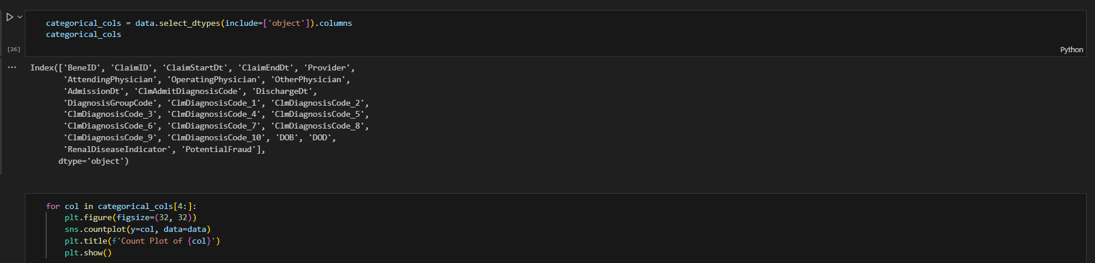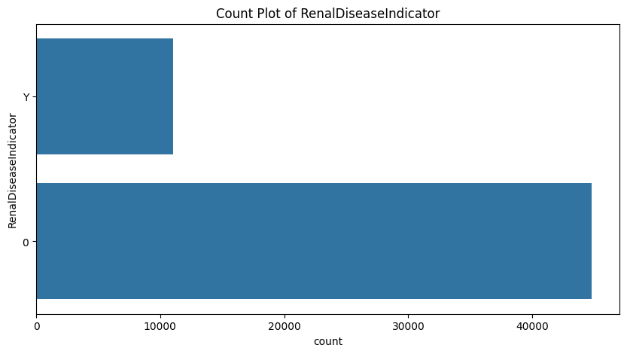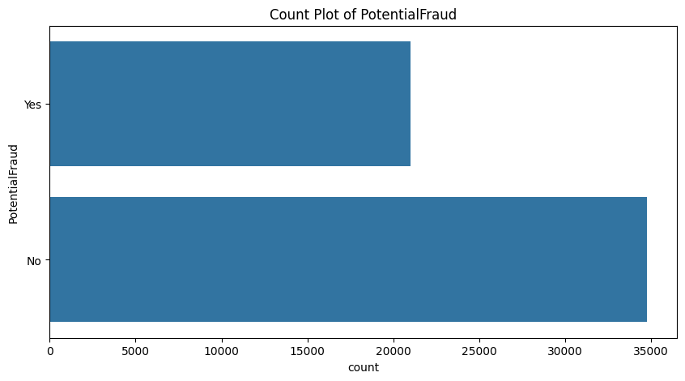

#### Time Series Analysis of Date Columns

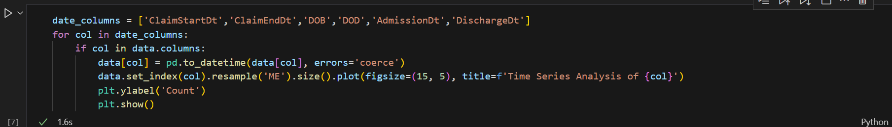

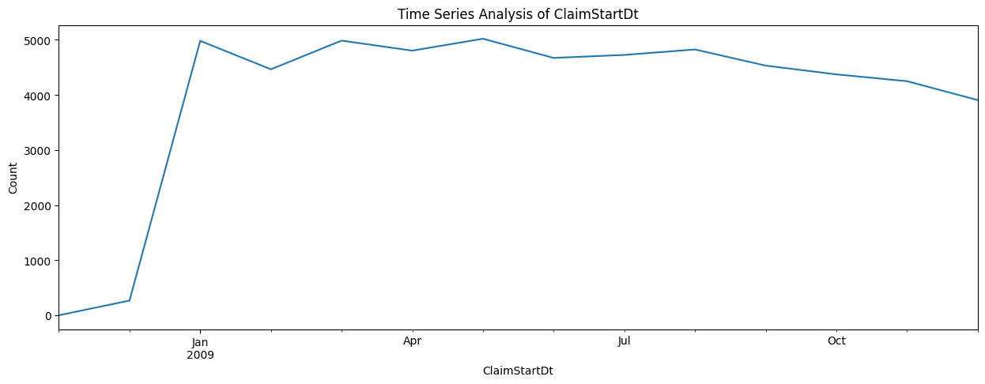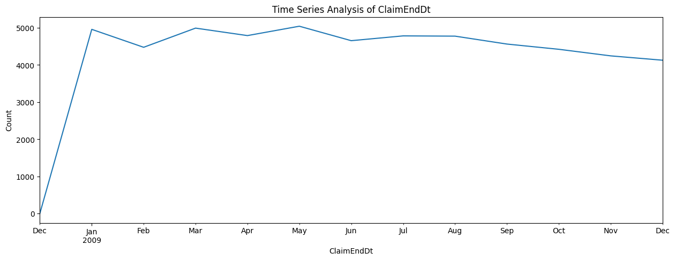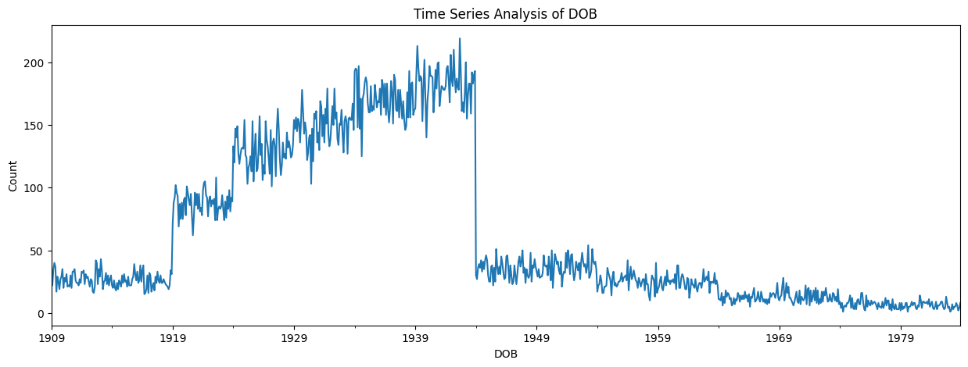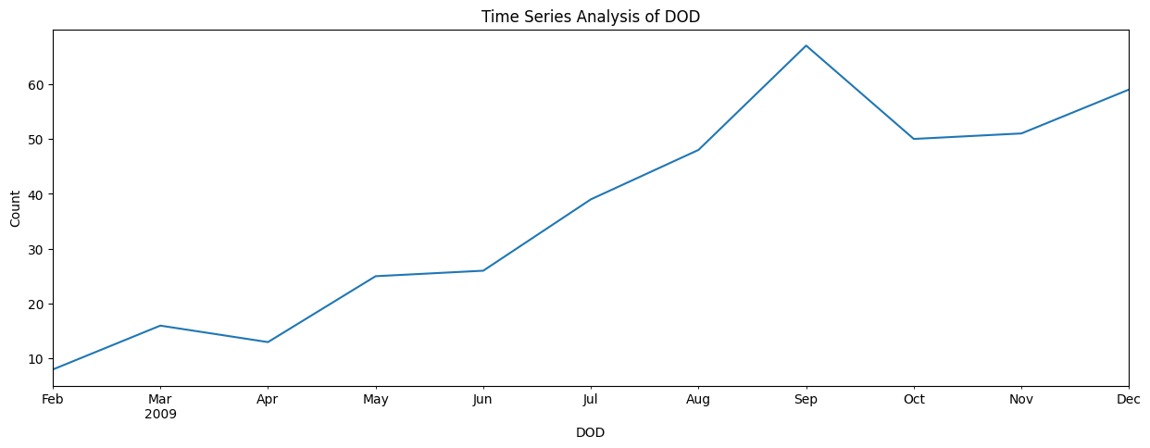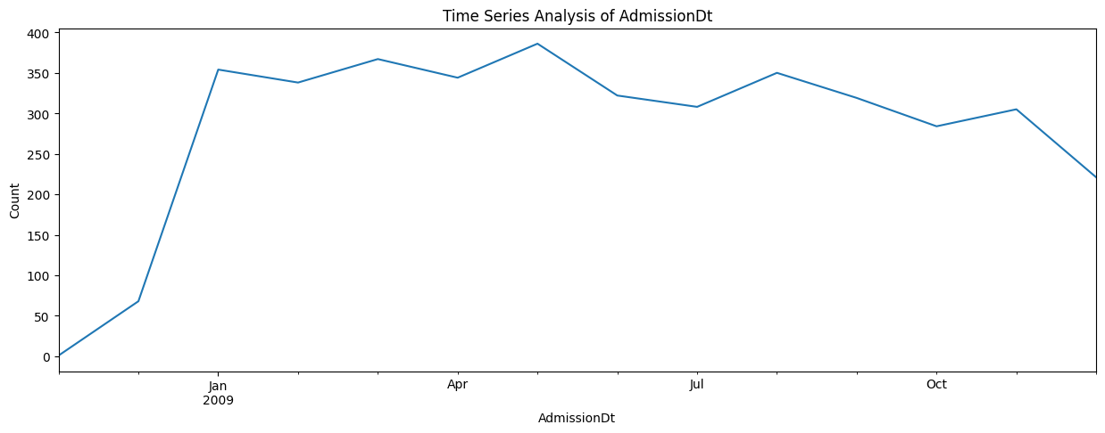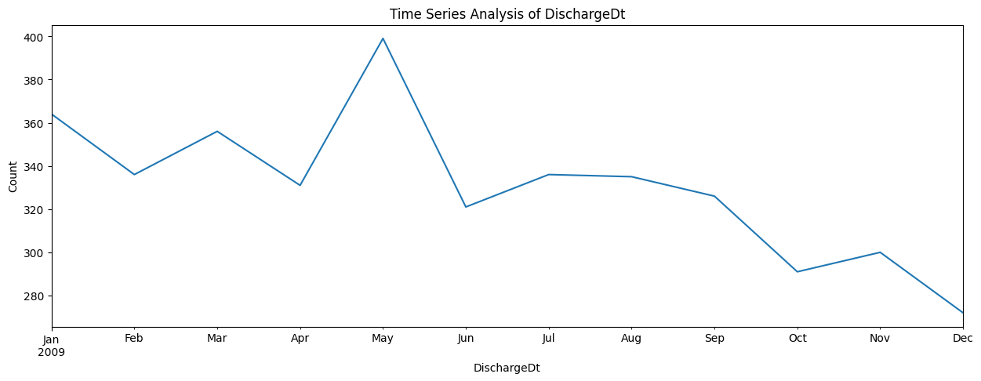

## Predictive Model to estimate Claim Amounts

To build a predictive model for estimating the claim amounts (InscClaimAmtReimbursed), we need to identify relevant features from the dataset.

1. **Unnecessary columns**: Some columns, such as BeneID, ClaimID, ClaimStartDt, ClaimEndDt, Provider, and physician IDs (AttendingPhysician, OperatingPhysician, OtherPhysician), are likely unnecessary for predicting claim amounts.
2. **Potentially relevant features**:
   * Demographic information: Gender, Race
   * Health condition indicators: ChronicCond_... columns
   * Annual reimbursement and deductible amounts: IPAnnualReimbursementAmt, IPAnnualDeductibleAmt, OPAnnualReimbursementAmt, OPAnnualDeductibleAmt
   * Indicator of potential fraud: PotentialFraud

Next, we will:

1. Select the relevant features.
2. Preprocess the data (handle missing values, encode categorical variables, etc.).
3. Split the data into training and testing sets.
4. Build a predictive model using different machine learning algorithms.
5. Evaluate the model's performance.

