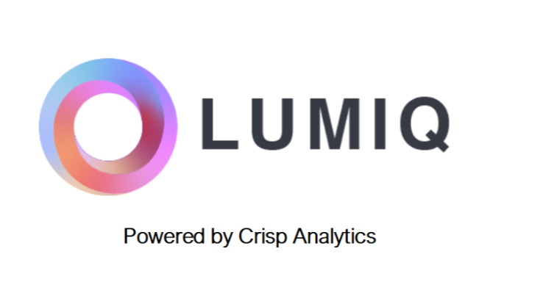**Data Science**

**By Devi Sri Charan**

Continuous Learning Pipeline 2

Establish an automated data ingestion mechanism for the model 3

Data Fetching Script 3

Scheduled Task 3

Implement a continuous learning pipeline for model retraining 3

Model Retraining Script 4

CI/CD Pipeline 4

# Continuous Learning Pipeline

## Establish an automated data ingestion mechanism for the model

I have set up a system that can periodically fetch new data and feed it to the model. This can be achieved using scheduled tasks (using cron jobs)

Data Fetching Script

A script to fetch and preprocess new data.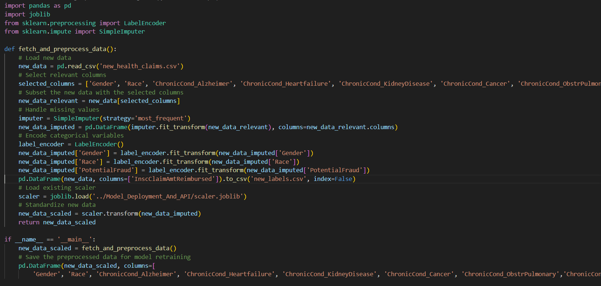

### Scheduled Task

Use a cron job or a similar scheduler to run fetch_data.py periodically.

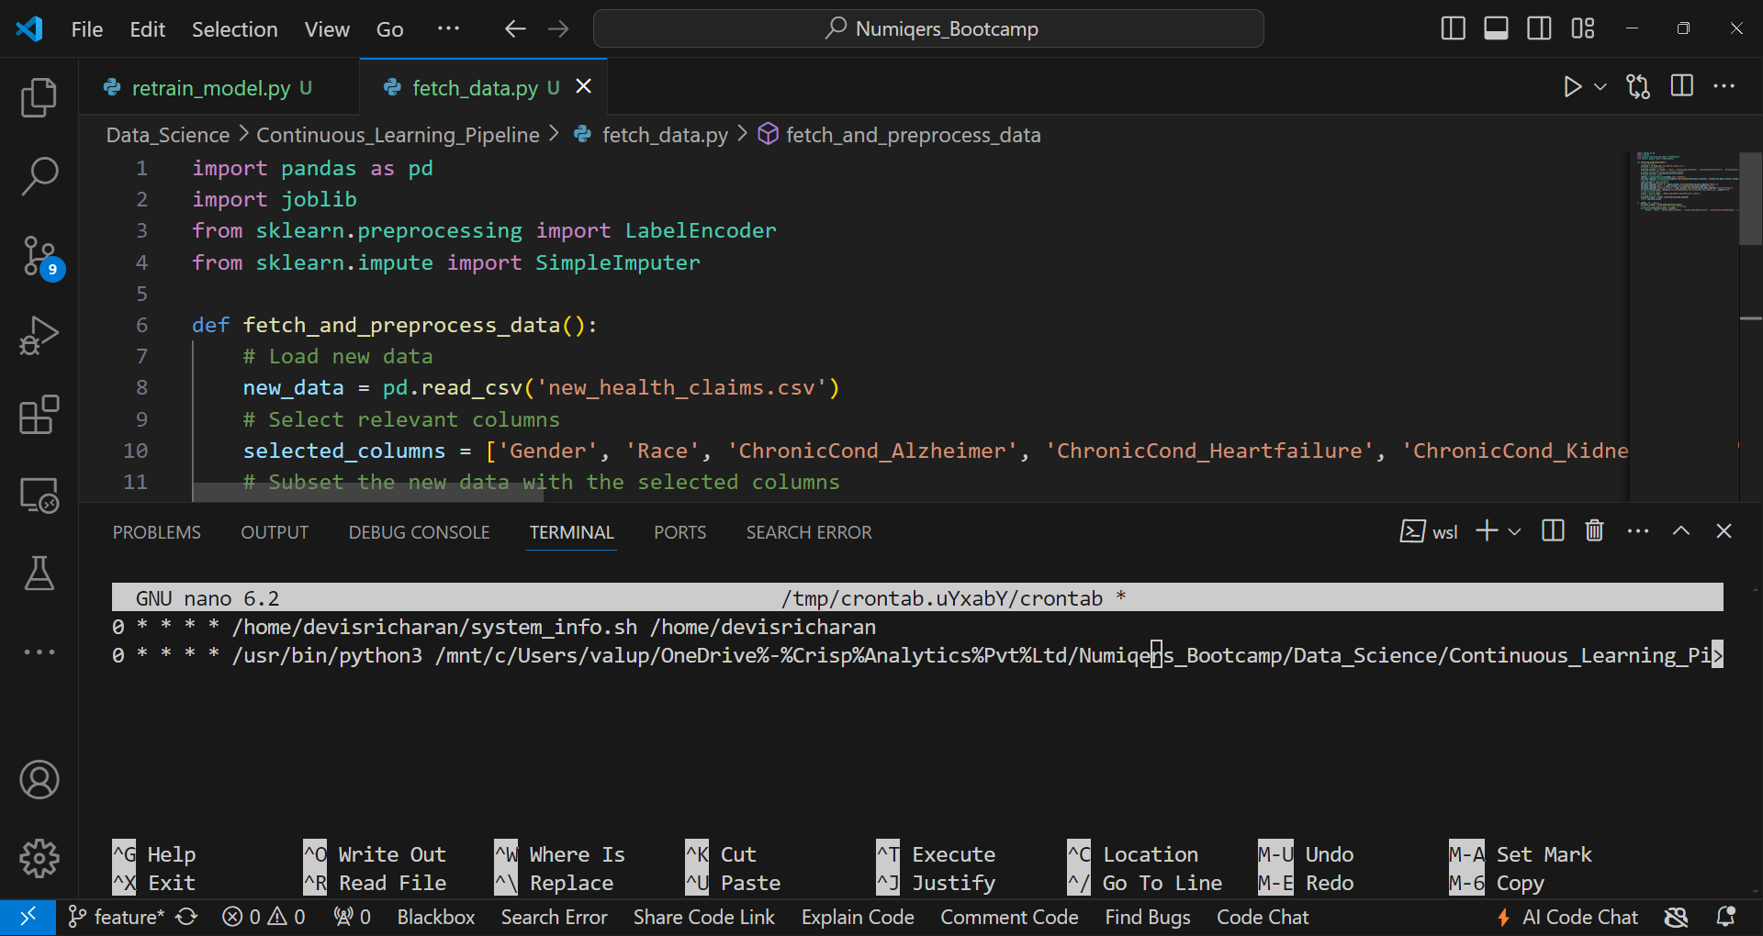

## Implement a continuous learning pipeline for model retraining

### Model Retraining Script

A script to retrain the model with new data.

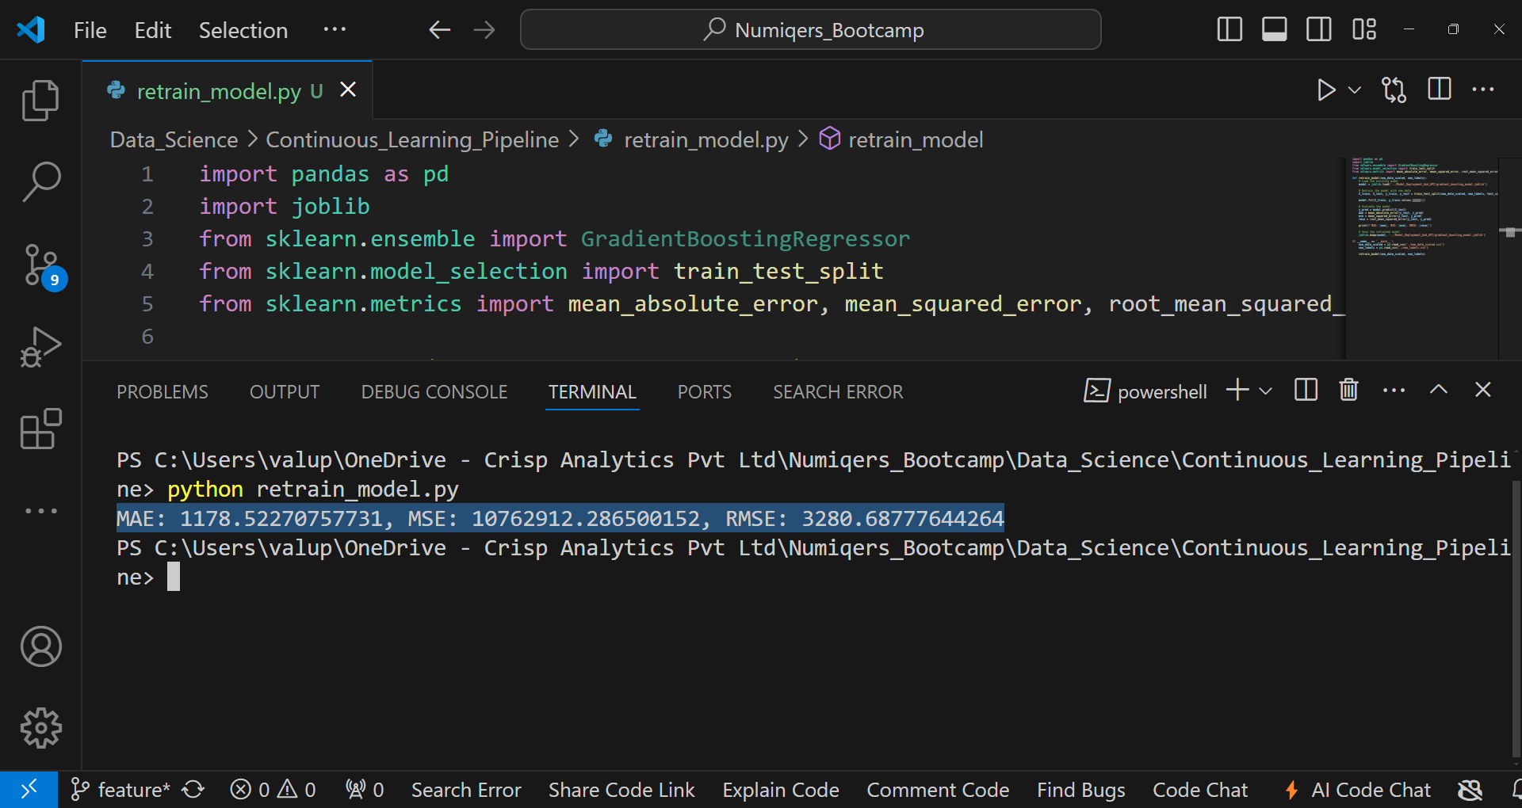

### CI/CD Pipeline

Set up a CI/CD pipeline (using GitHub Actions) to trigger the retrain_model.py script after the data ingestion script runs.

