**Data Science**

**By Devi Sri Charan**

Model Deployment and API 2

Serialize the trained claim prediction model 3

Deploy the model as a service with an API for integration 3

Set up the Flask API 3

Use the API 4

# Model Deployment and API

## Serialize the trained claim prediction model

We'll use joblib to serialize the model. Additionally, save the scaler used for data standardization during model training to standardize the input data during predicting using the same scaler used during training.

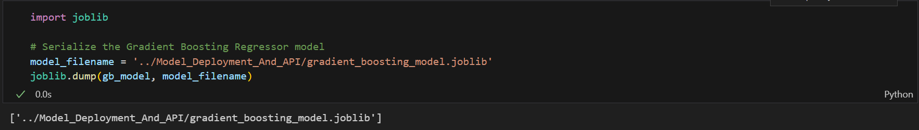

## Deploy the model as a service with an API for integration

### Set up the Flask API

* Save the Flask API code in a file, e.g., app.py.
* Run the Flask application by executing python app.py from your terminal.

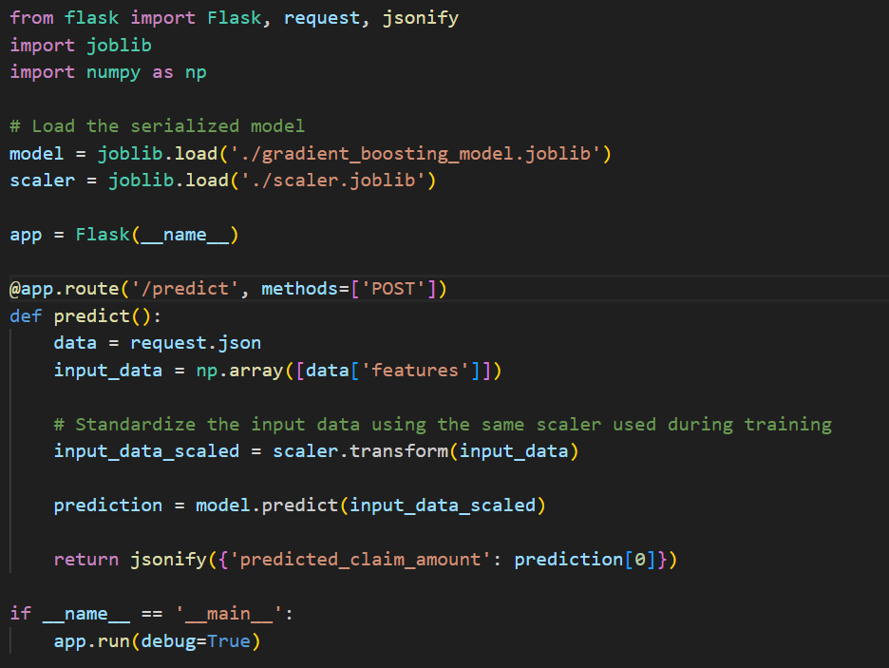

### Use the API

* Send a POST request to <http://127.0.0.1:5000/predict> with a JSON payload containing the input features.
* Example JSON payload: {"features": [value1, value2, ..., valueN]} where value1, value2, ..., valueN are the feature values expected by the model.

