**Programming and Application**

**By Devi Sri Charan**

Create a User Interface / Frontend 2

Developed the frontend using React 3

Created forms for data entry and update operations that interface with the backend API 4

Deployed the frontend in vercel 5

# Create a User Interface / Frontend

## Developed the frontend using React

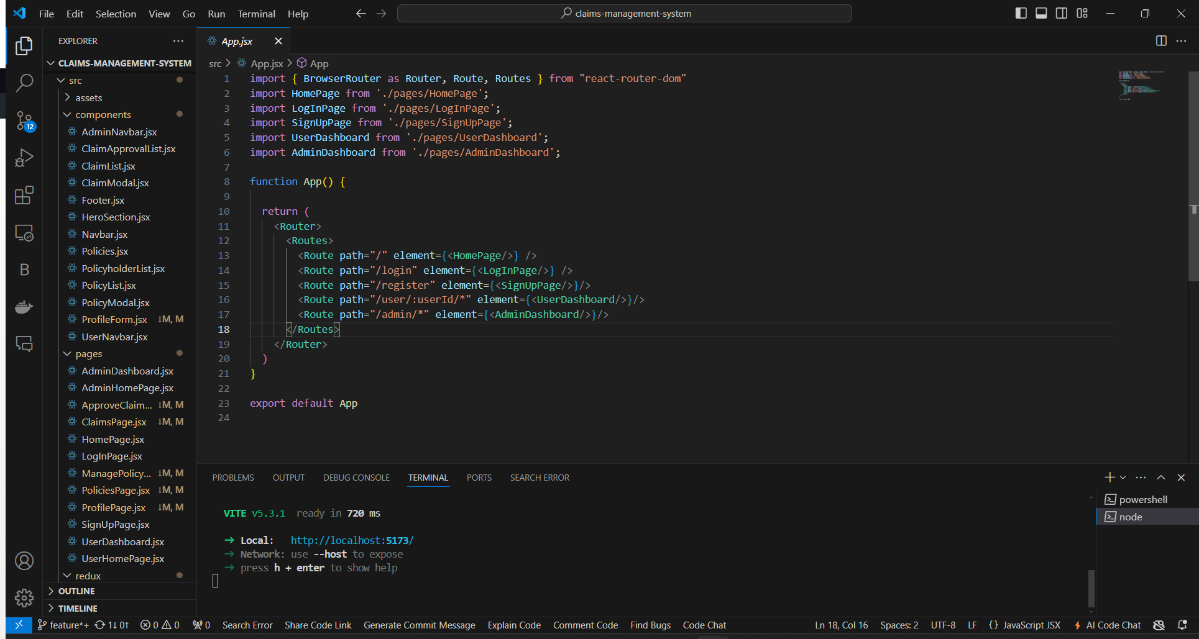

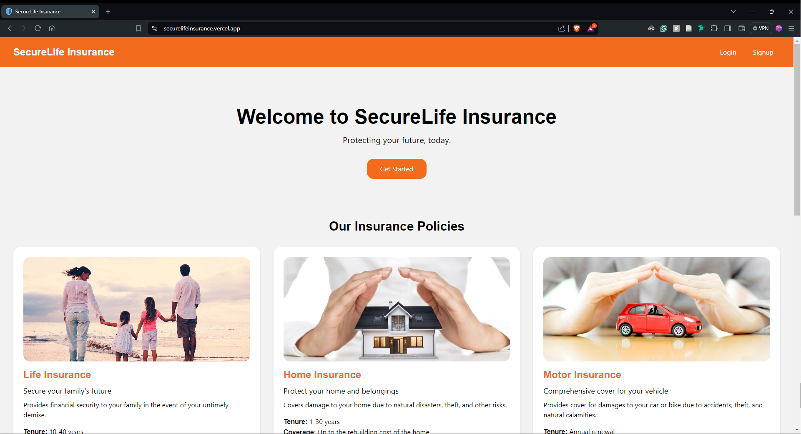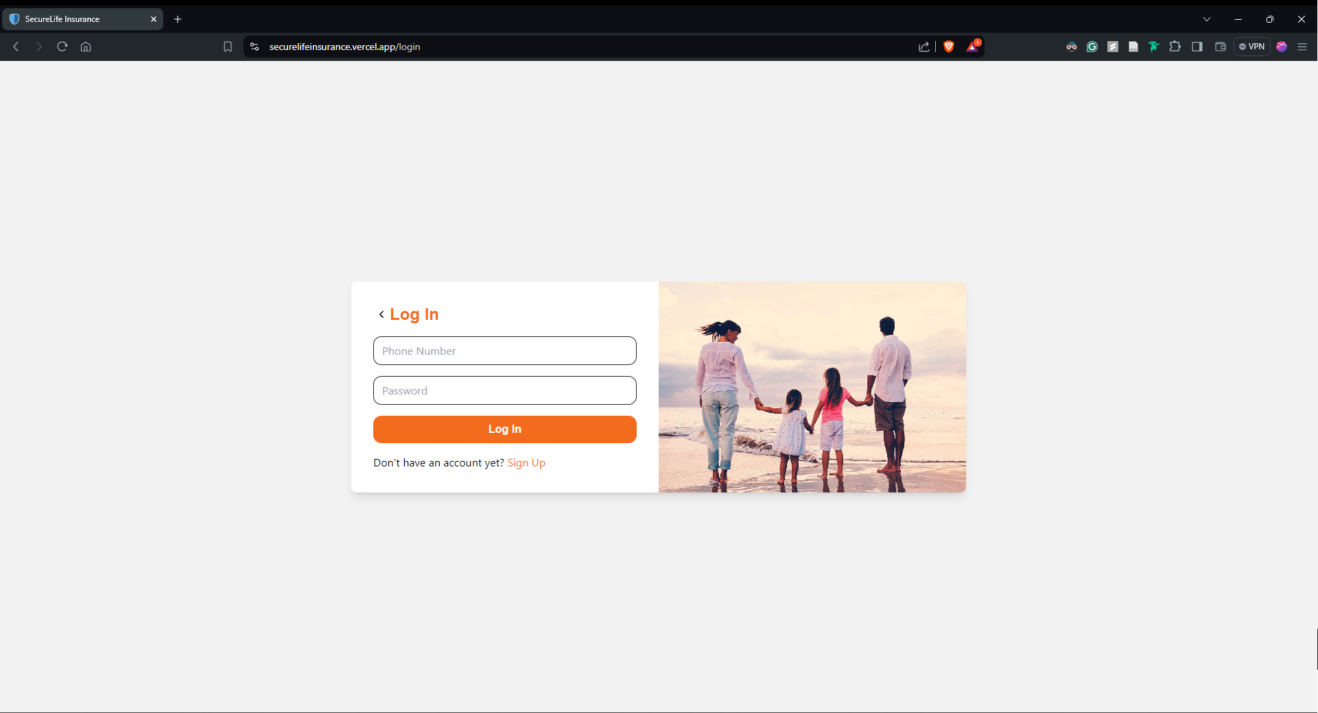

## Created forms for data entry and update operations that interface with the backend API

<https://bootcamp-y8br.onrender.com>

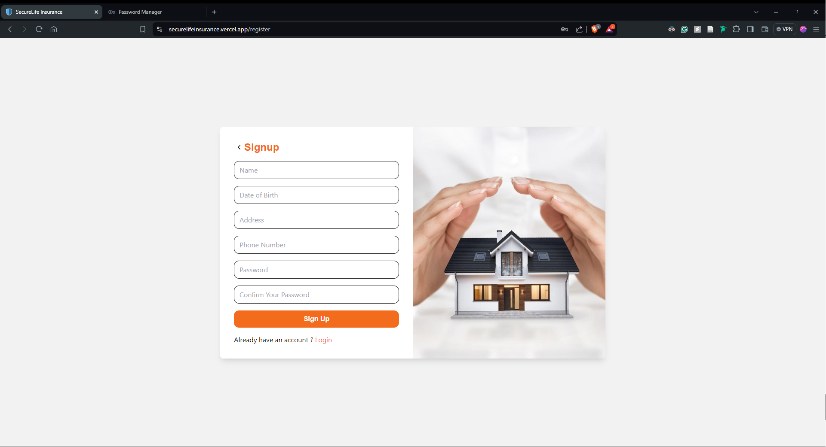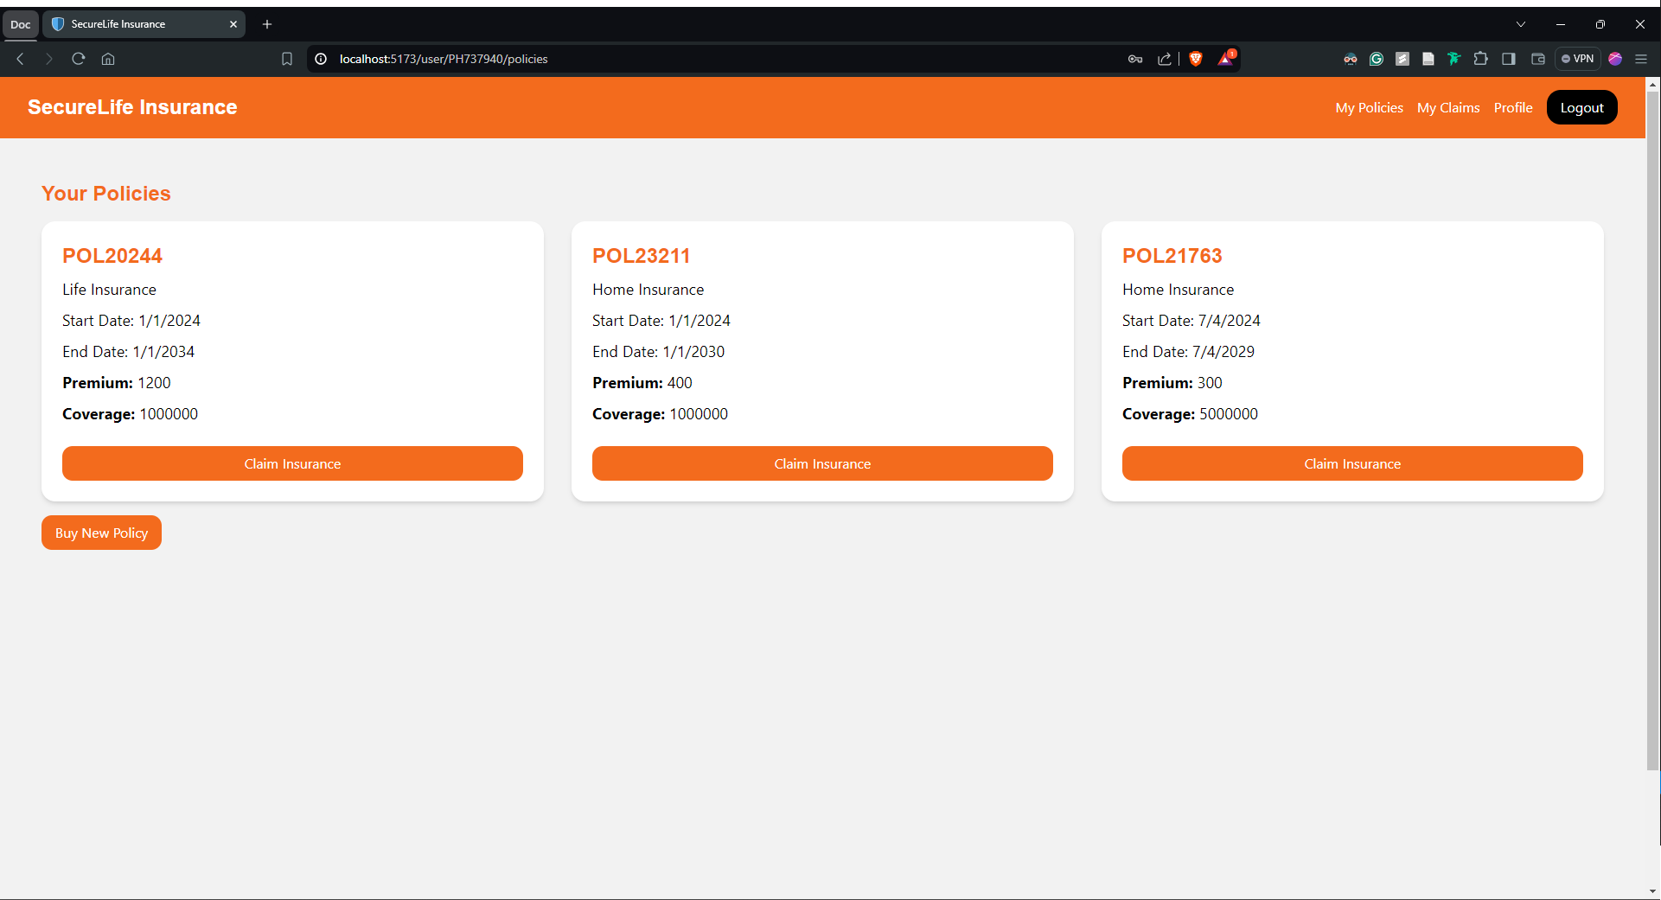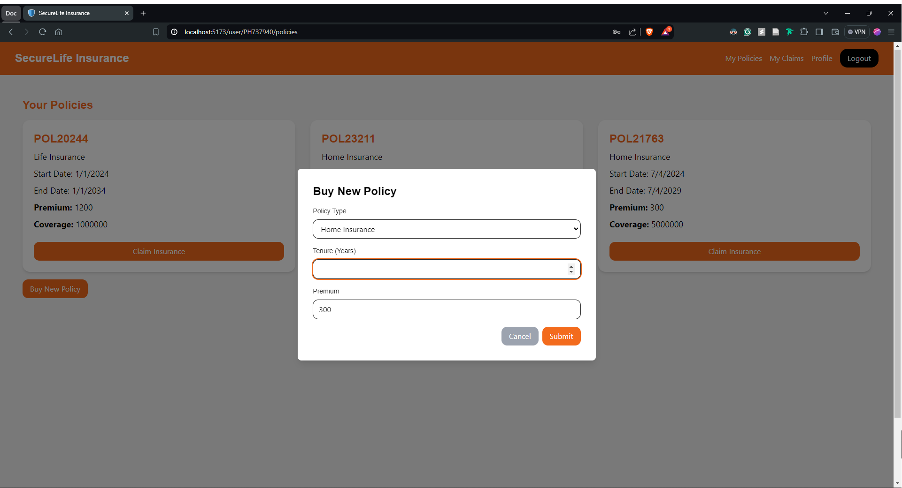

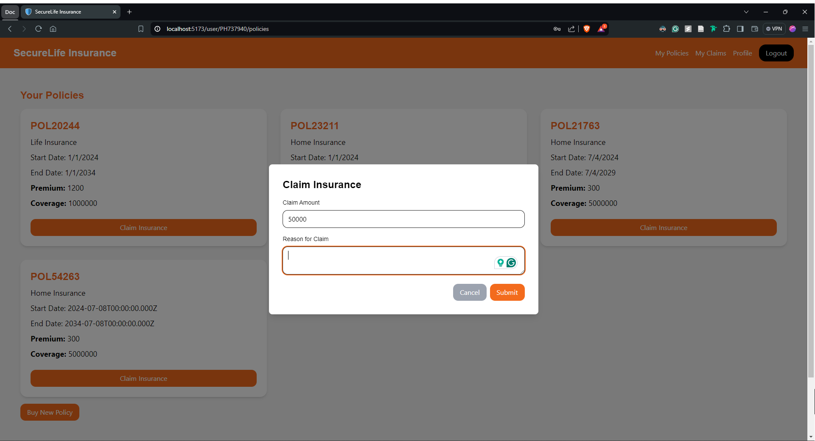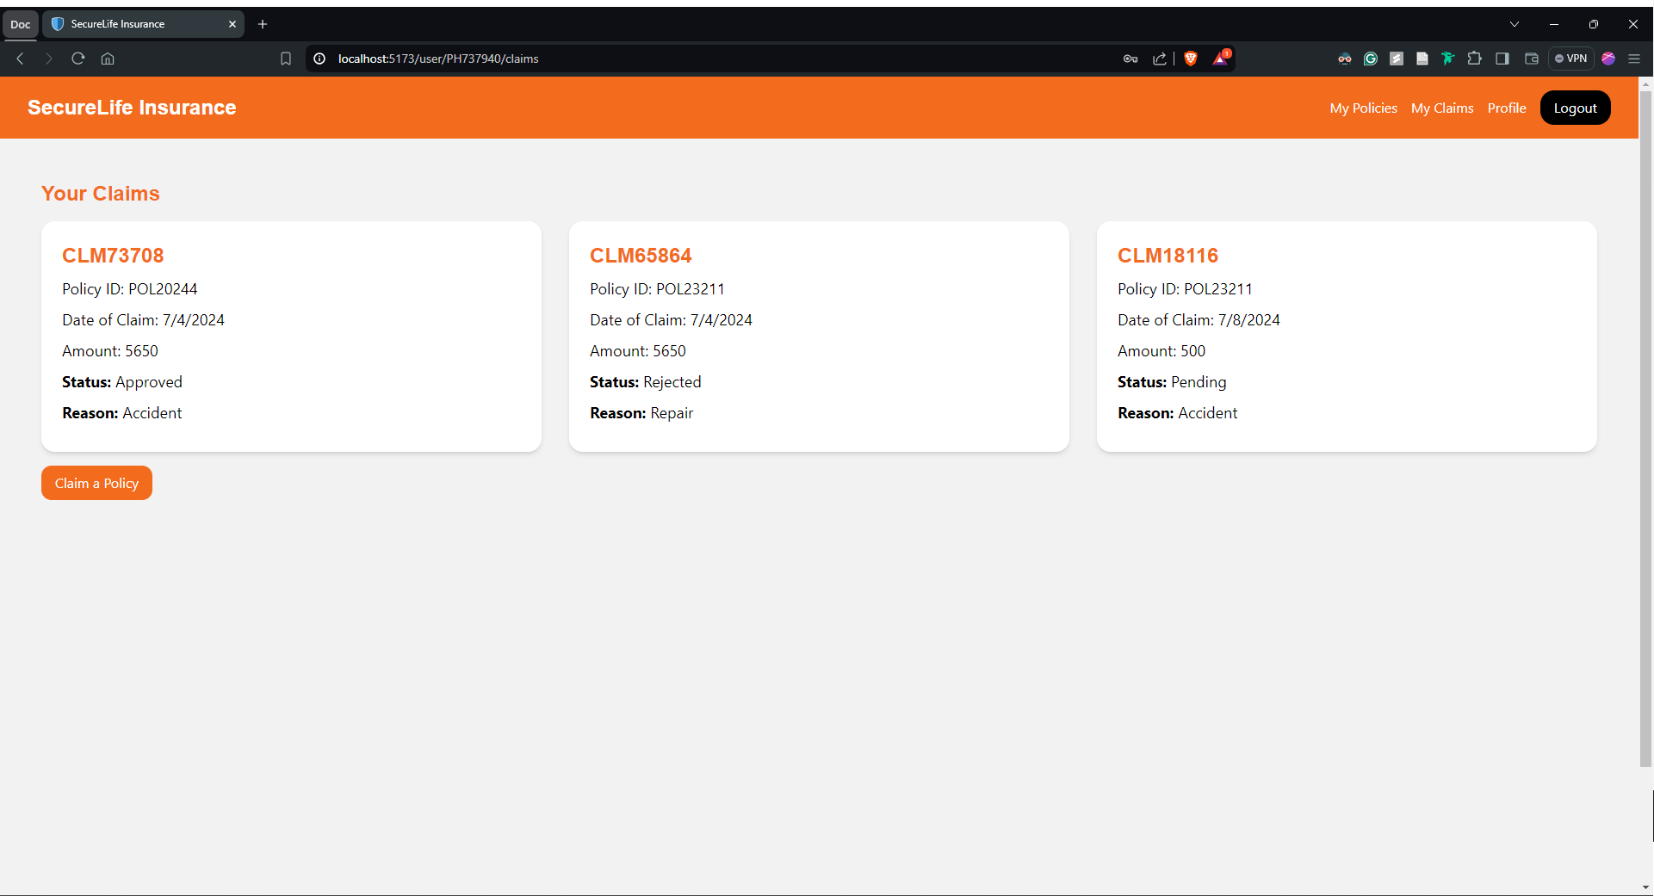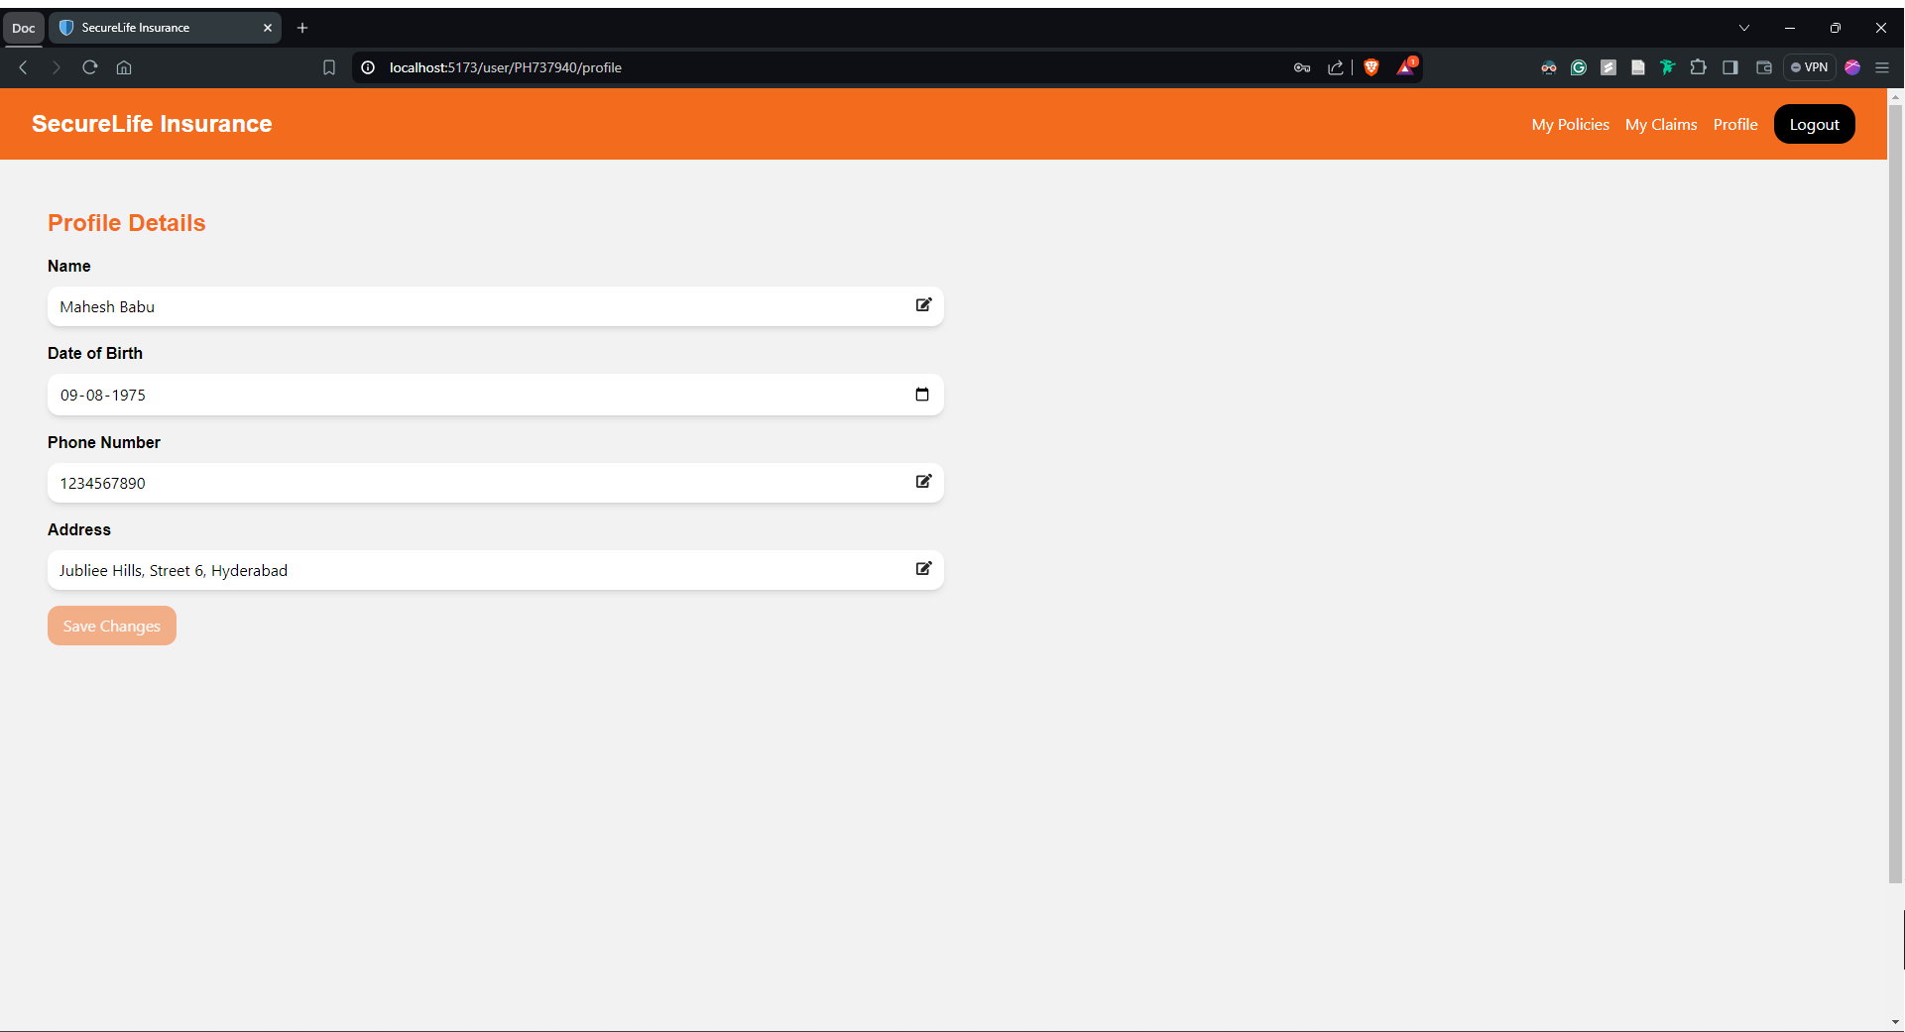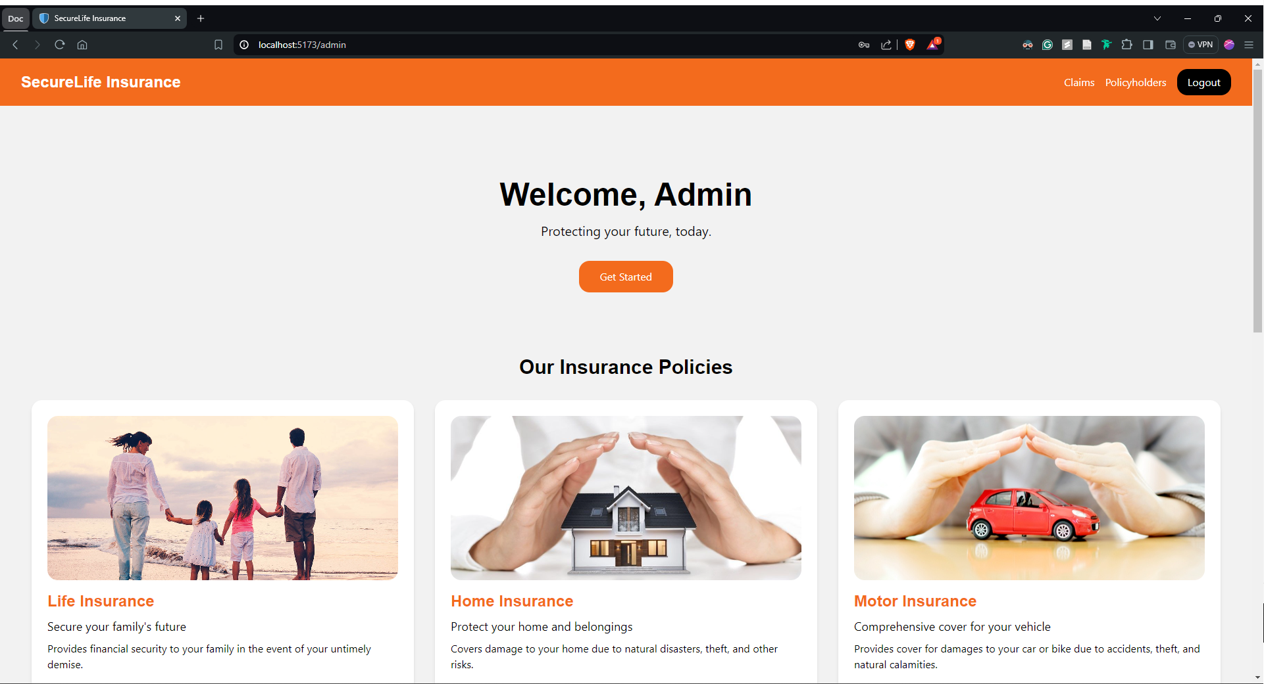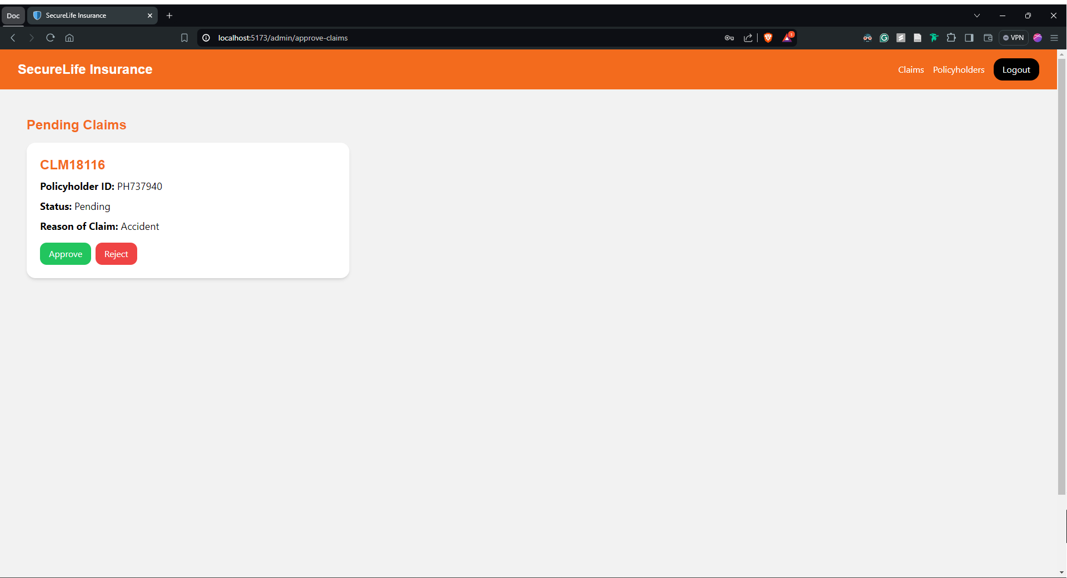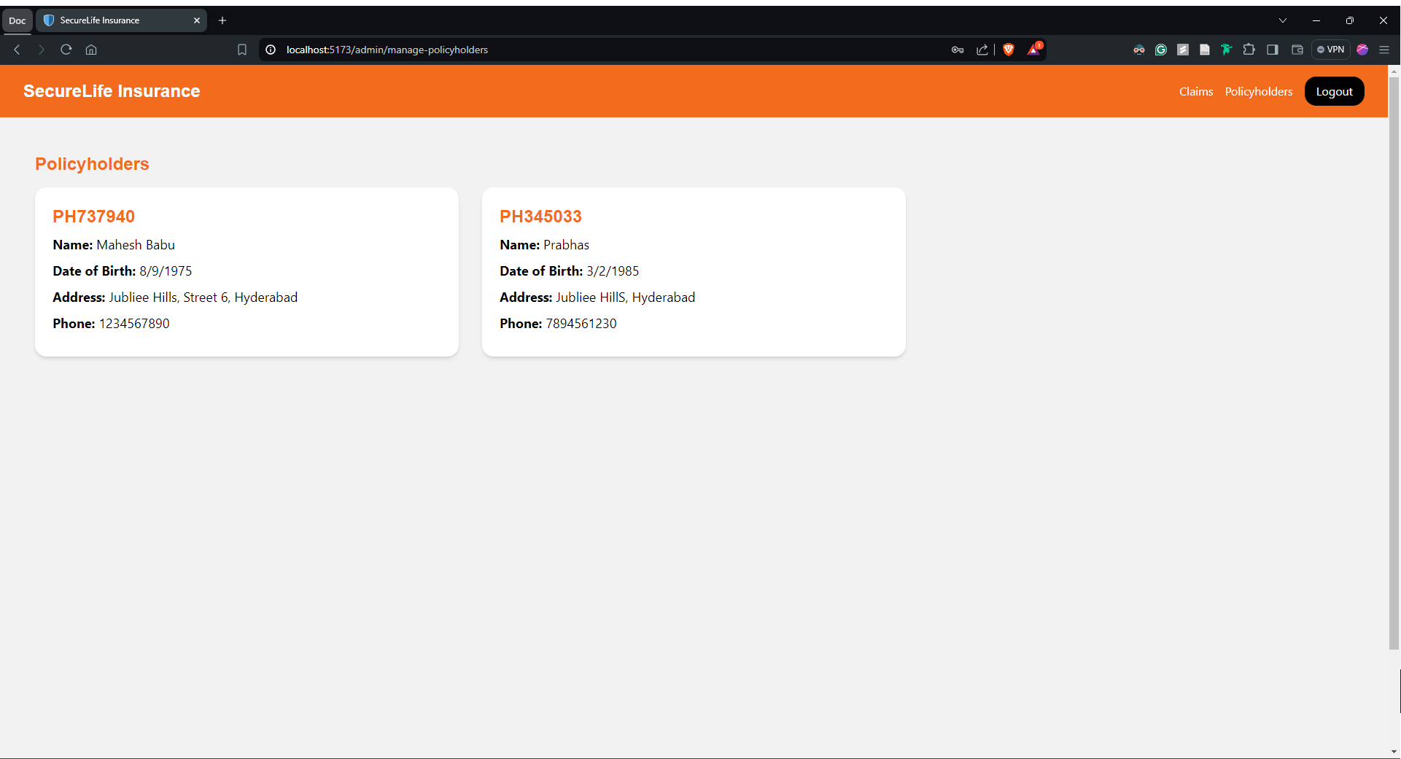

## Deployed the frontend in vercel

<https://securelifeinsurance.vercel.app/>