**Programming and Application**

**By Devi Sri Charan**

Implement Automation Testing on the Application 1

Concept of automation testing and its necessity in software development 2

Choose an automation testing tool and write basic test cases for the application 2

Step 1: Install Cypress 2

Step 2: Set Up Cypress 2

Step 3: Write Basic Test Cases 3

Test Navigation to Home, Login, and Signup Pages 3

Test Login Form Submission 3

Test Signup Form Submission 4

Test User Dashboard Navigation 4

Test Admin Dashboard Navigation 4

# Implement Automation Testing on the Application

## Concept of automation testing and its necessity in software development

Automation testing is a software testing technique that utilizes specialized tools and scripts to execute tests on software applications automatically. This approach replaces repetitive manual testing tasks with automated processes, enhancing efficiency, accuracy, and coverage. Automation testing is especially valuable in regression testing, where previously validated functionalities need to be re-verified after code changes. It ensures that the software remains stable, and functions as expected throughout the development cycle. Automation testing tools can simulate user interactions, perform complex test scenarios, and generate detailed reports, enabling faster identification and resolution of defects.

The necessity of automation testing in software development lies in its ability to significantly reduce the time and effort required for testing, thus accelerating the development process. It helps maintain high-quality standards by consistently executing predefined test cases and catching bugs early in the development cycle. Automation testing is essential for continuous integration and continuous deployment (CI/CD) pipelines, ensuring that new code integrations do not introduce new issues. Additionally, it supports scalability by allowing extensive testing across different platforms, browsers, and devices, which is critical in today's diverse technological landscape.

## Choose an automation testing tool and write basic test cases for the application

I have chosen Cypress as the automation testing tool, a popular end-to-end testing framework that is well-suited for testing modern web applications.

### **Step 1: Install Cypress**

First, we need to install Cypress:

npm install cypress --save-dev

### **Step 2: Set Up Cypress**

Initialize Cypress in the project:

npx cypress open

This will create a cypress directory with default files and open the Cypress test runner.

### **Step 3: Write Basic Test Cases**

These test cases will cover basic navigation and form submissions.

#### Test Navigation to Home, Login, and Signup Pages

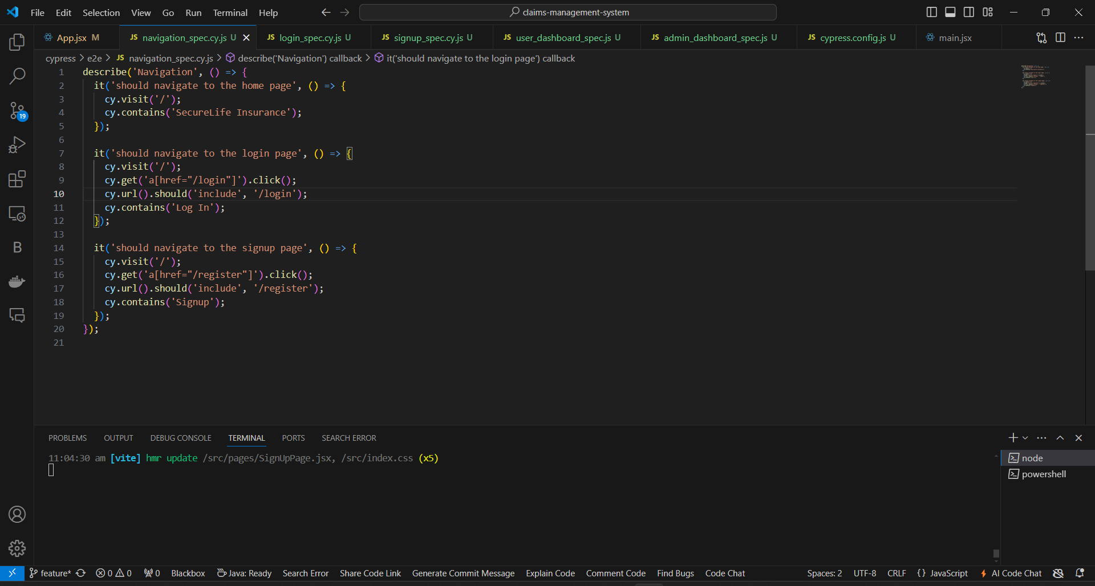

#### Test Login Form Submission

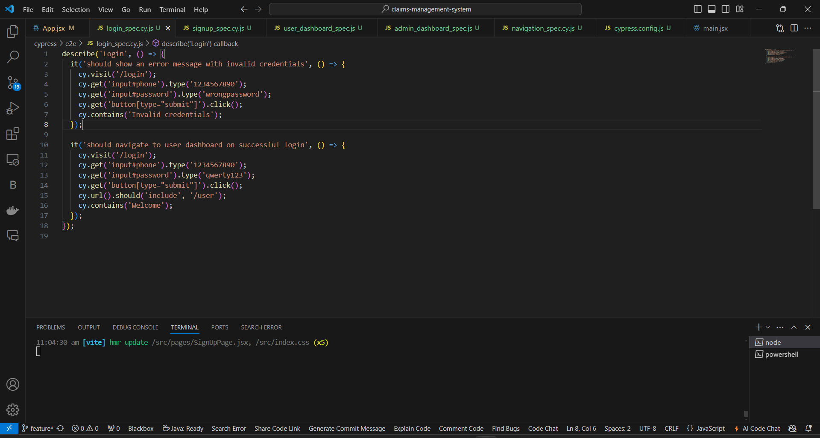

#### Test Signup Form Submission

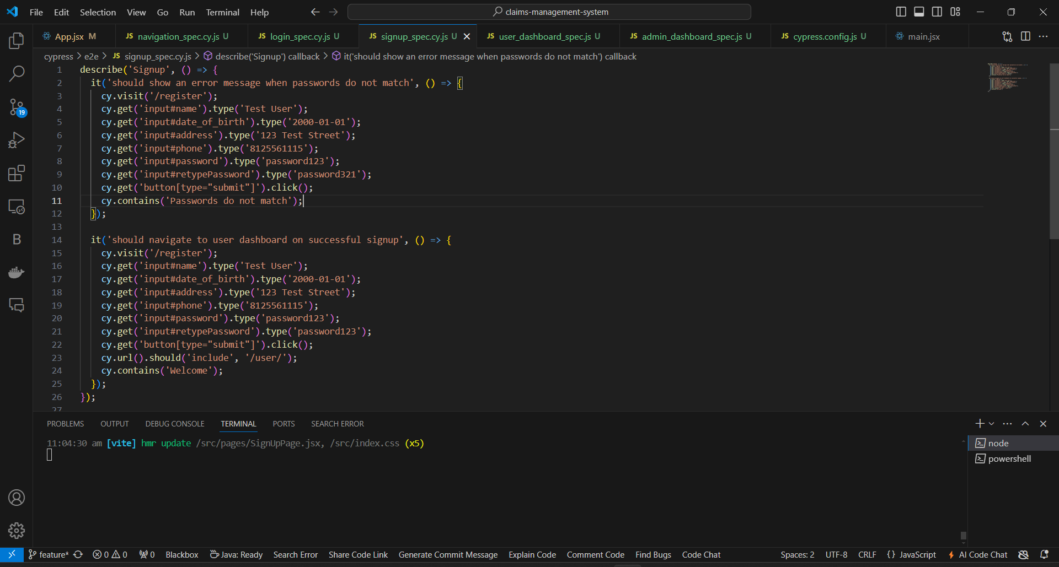

#### Test User Dashboard Navigation

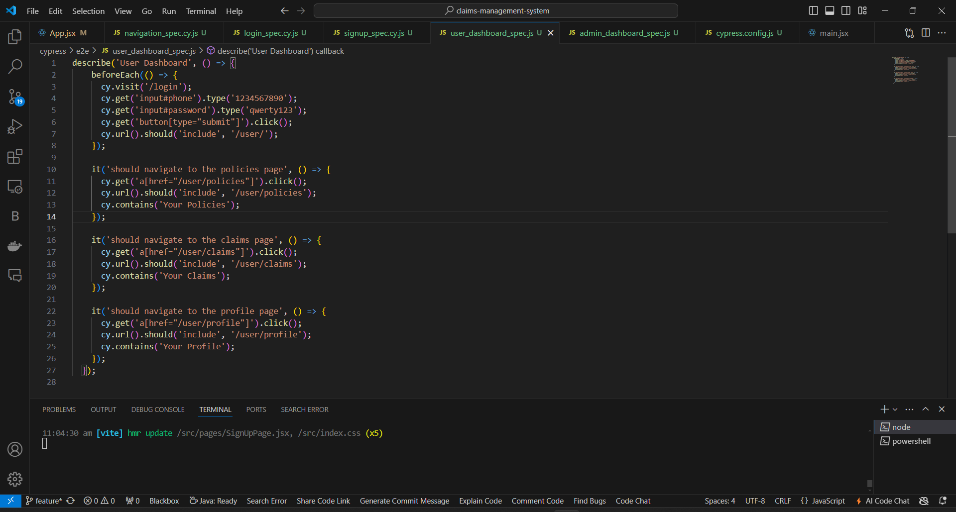

#### Test Admin Dashboard Navigation

