

# Microservices

1



## Microservices - V2

#### **V2** - Latest Releases of

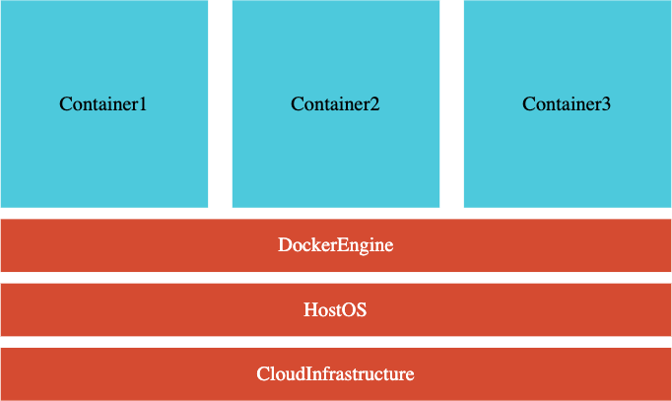Spring Boot

Spring Cloud Docker and Kubernetes

**Skip to Next Section :)**

#### **V1** - Old Versions

Spring Boot v2.3 and LOWER

**Continue on to next lecture :(**

## Microservices - V2

You have **skipped V1**

Go to next lecture!

You have **completed V1**

Option 1: **Start from Zero Again**:

Go to the next lecture!

Option 2: **Get a Quick Start**:

Jump to **"Step 21 - QuickStart by Importing Microservices"**

Same microservices as V1: **Currency Exchange** and

**Currency Conversion**

Very little changes in **Eureka Naming Server**

**Step 21** helps you set these up and get started quickly!

## Microservices - V2 - What's New

Microservices Evolve Quickly

**Important Updates**:

Latest Versions of Spring Boot & Spring Cloud

**Spring Cloud LoadBalancer** instead of Ribbon

**Spring Cloud Gateway** instead of Zuul

**Resilience4j** instead of Hystrix

**Docker**: Containerize Microservices

Run microservices using Docker and Docker Compose

**Kubernetes**: Orchestrate all your Microservices with Kubernetes



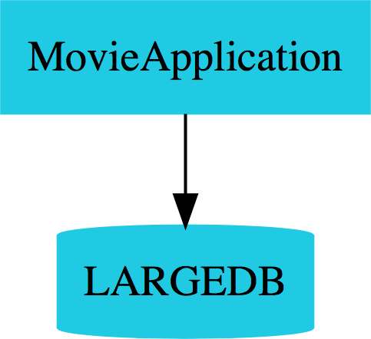

**Monolith**

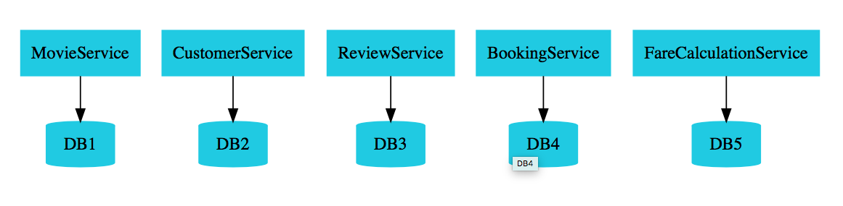

**Microservices**

## What is a Microservice?



*Small autonomous services that work together*

***Sam Newman***

**What is a Microservice?**



*Approach to developing a application as a suite of small services, each running in its own process and communicating with lightweight mechanisms oken an HTTP resource API.*

*These services are built around business capabilities and*

*independently deployable by fully automated deployment machinery. There is a bare minimum of centralized management of these services, which may be written in diﬀerent programming languages and use*

*diﬀerent data storage technologies.*

***James Lewis and Martin Fowler***

## Microservices for me

#### REST

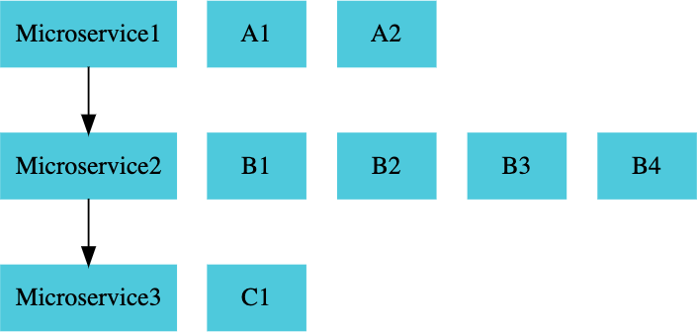Small Well Chosen Deployable Units

Cloud Enabled

## Microservices - Challenges



#### Bounded Context Configuration Management

Dynamic Scale Up and Scale Down Visibility

#### Pack of Cards

Zero Downtime Deployments

## Microservice - Solutions



**Spring Cloud** Umbrella Projects

Centralized Configuration Management (Spring Cloud Config Server)

Location Transparency - Naming Server (Eureka)

Load Distribution (Ribbon, Spring Cloud Load Balancer) Visibility and Monitoring (Zipkin)

API Gateway (Zuul, Spring Cloud Gateway) Fault Tolerance (Hystrix, Resilience4j)

#### **Docker**: Language Neutral, Cloud Neutral deployable units

**Kubernetes**: Orchestrate Thousands of Microservices

## Microservices - 3 Key Advantages



#### New Technology & Process Adoption Dynamic Scaling

Faster Release Cycles

## Ports Standardization

|  |  |
| --- | --- |
| **Application** | **Port** |
| **Limits Microservice** | 8080, 8081, ... |
| **Spring Cloud Config Server** | 8888 |
| **Currency Exchange Microservice** | 8000, 8001, 8002, .. |
| **Currency Conversion Microservice** | 8100, 8101, 8102, ... |
| **Netflix Eureka Naming Server** | 8761 |
| **API Gateway** | 8765 |
| **Zipkin Distributed Tracing Server** | 9411 |

**Need for Centralized Configuration**

#### Lot of configuration:

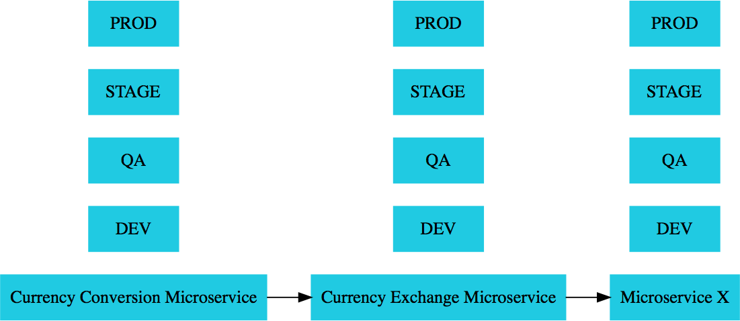External Services

Database Queue

Typical Application Configuration

#### Configuration variations:

1000s of Microservices

Multiple Environments

Multiple instances in each Environment

#### How do you manage all this configuration?

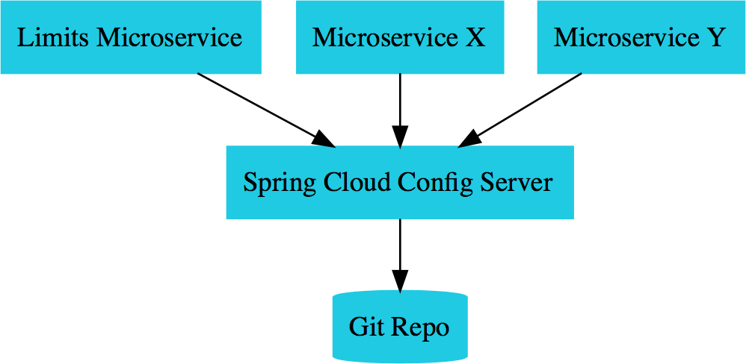 

**Config Server**

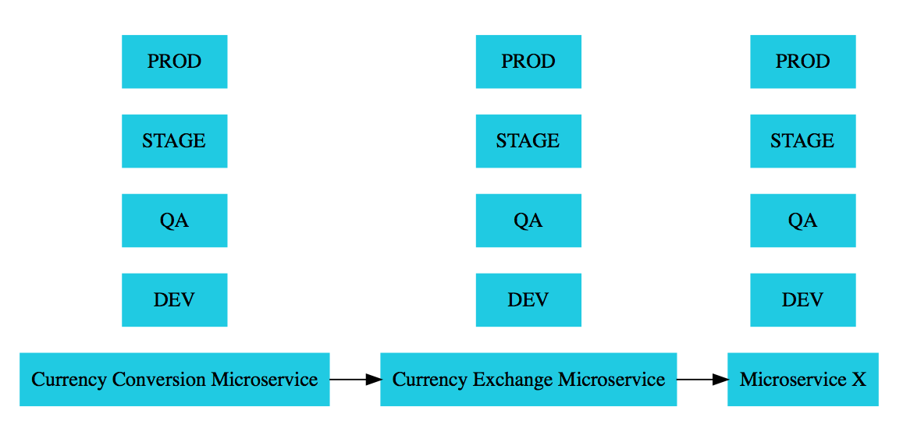

**Environments**

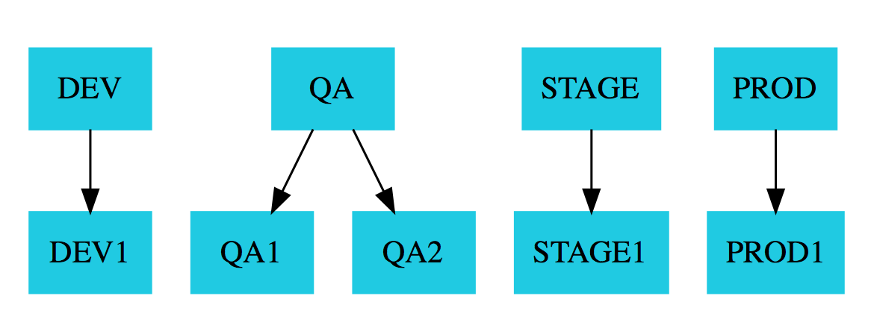

**Environments**

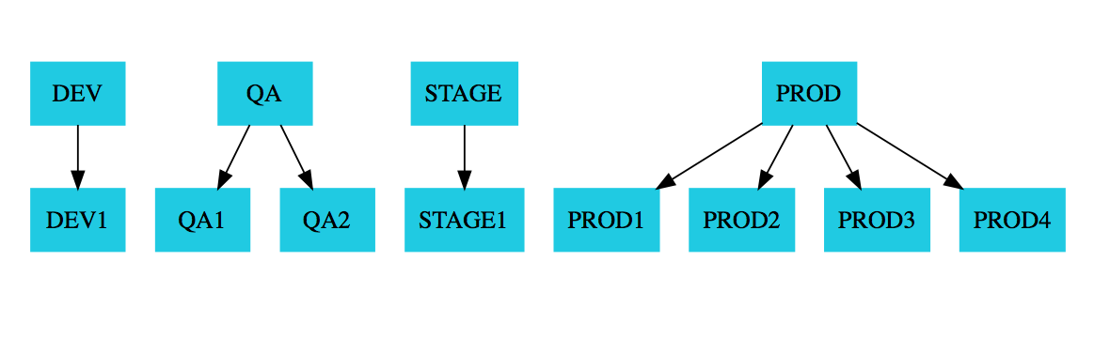

**Environments**

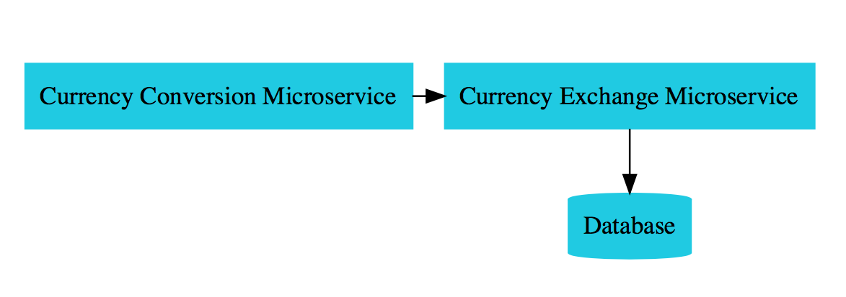

**Microservices Overview**

## Currency

**Exchange**

## Microservice



*What is the exchange rate of one currency in another?*

http://localhost:8000/currency-exchange/from/USD/to/INR

{ "id":10001,

"from":"USD",

"to":"INR",

"conversionMultiple":65.00, "environment":"8000 instance-id"

}

**Currency Conversion Microservice**

*Convert 10 USD into INR*

http://localhost:8100/currency-conversion/from/USD/to/INR/quantity/10

{

"id": 10001,

"from": "USD",

"to": "INR",

"conversionMultiple": 65.00,

"quantity": 10,

"totalCalculatedAmount": 650.00,

"environment": "8000 instance-id"

}

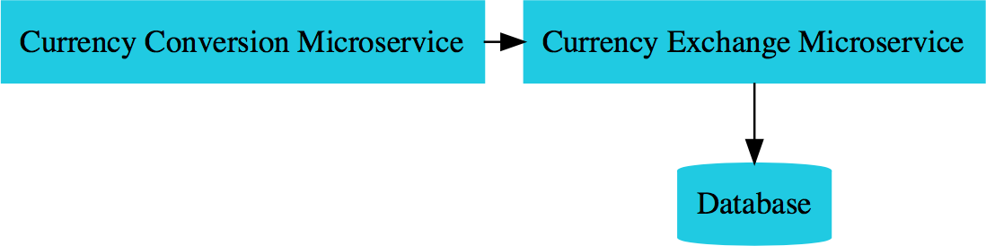

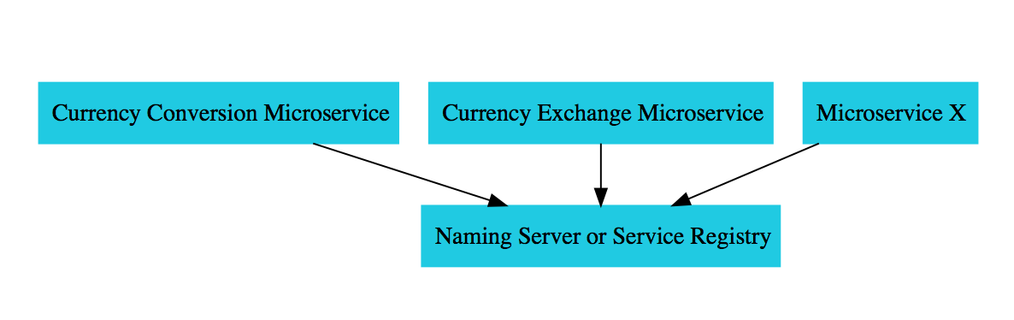

**Naming Server**

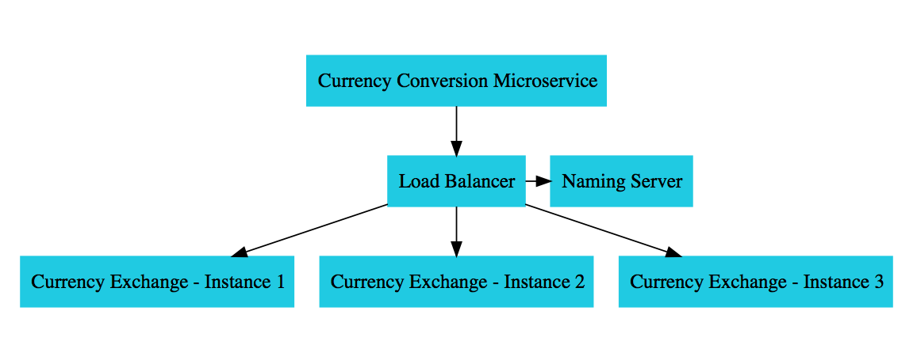

**Load Balancing**

## Spring Cloud Gateway

#### Simple, yet effective way to route to APIs Provide cross cutting concerns:

Security

Monitoring/metrics

#### Built on top of Spring WebFlux (Reactive Approach)

Features:

Match routes on any request attribute

Define Predicates and Filters

Integrates with Spring Cloud Discovery Client (Load Balancing)

Path Rewriting

#### From



[***https://docs.spring.io***](https://docs.spring.io/)

## Circuit Breaker



#### What if one of the services is down or is slow?

Impacts entire chain!

#### Questions:

Can we return a fallback response if a service is down?

Can we implement a Circuit Breaker pattern to reduce load? Can we retry requests in case of temporary failures?

Can we implement rate limiting?

Solution: Circuit Breaker Framework - Resilience4j

## Distributed Tracing



#### Complex call chain

How do you debug problems?

How do you trace requests across microservices? Enter Distributed Tracing

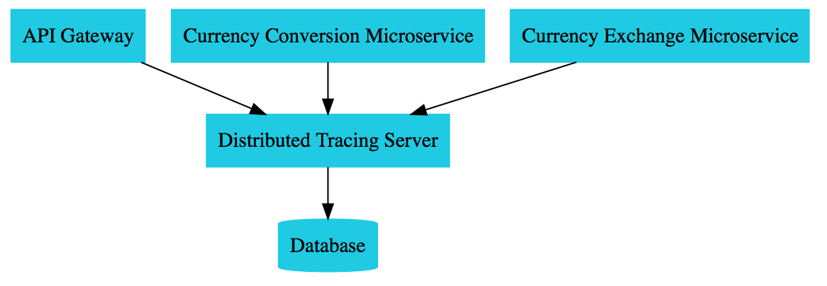

**Distributed Tracing**

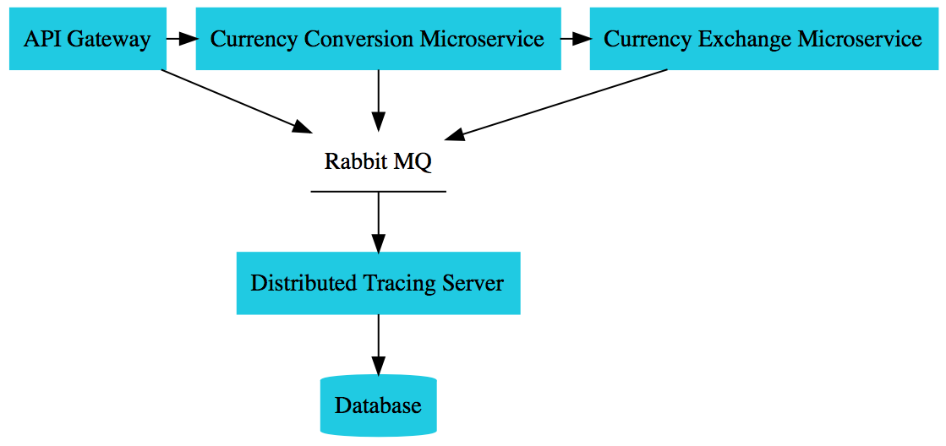

**Distributed Tracing - Asynchronous**

## Microservices

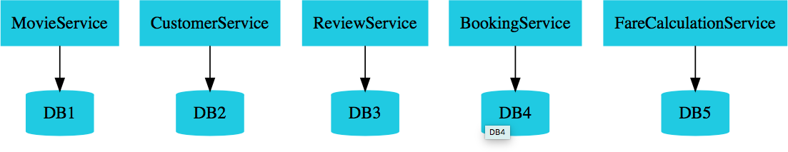

#### Enterprises are heading towards microservices architectures

Build small focused microservices

**Flexibility to innovate** and build applications in different programming languages (Go, Java, Python, JavaScript, etc)

BUT **deployments become complex**!

How can we have **one way of deploying** Go, Java, Python or JavaScript .. microservices?

Enter **containers**!

## Docker

Create **Docker images** for each microservice

Docker image **contains everything a microservice needs** to run:

Application Runtime (JDK or Python or NodeJS)

Application code Dependencies

#### You can run these docker containers

**the same way** on any infrastructure

Your local machine

Corporate data center Cloud

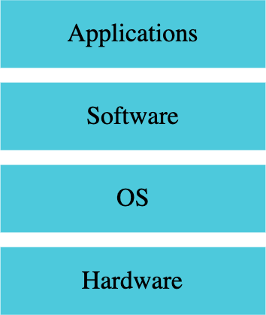 

*Traditional Deployment*

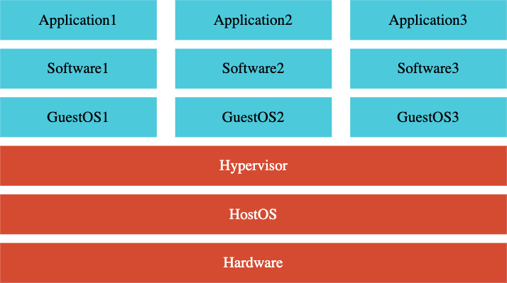 

*Deployments using Virtual Machines*

 

*Deployments using Docker*

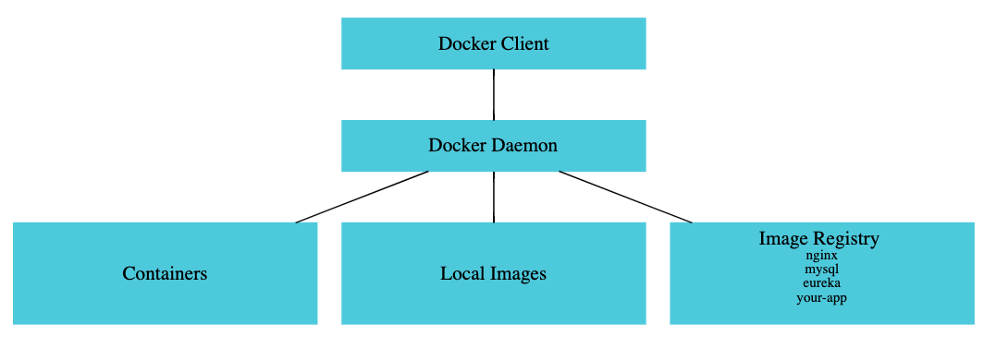

*Docker Architecture*

## Container Orchestration

#### **Requirement** : I want 10 instances of Microservice A container, 15 instances of Microservice B container and ....

Typical Features:

**Auto Scaling** - Scale containers based on demand

**Service Discovery** - Help microservices find one another

**Load Balancer** - Distribute load among multiple instances of a microservice

**Self Healing** - Do health checks and replace failing instances

**Zero Downtime Deployments** - Release new versions without downtime

## Container Orchestration Options

### AWS Specific

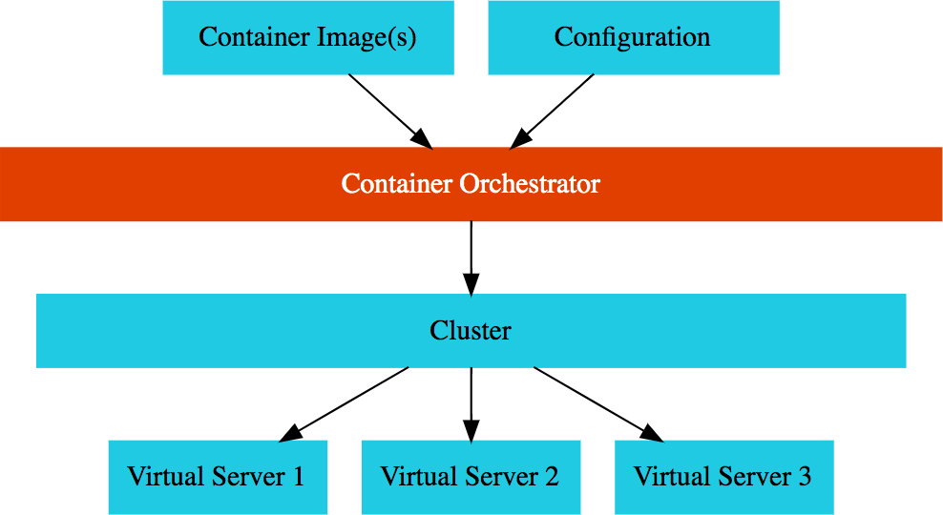AWS Elastic Container Service (ECS)

AWS Fargate : Serverless version of AWS ECS

**Cloud Neutral** - Kubernetes

AWS - Elastic Kubernetes Service (EKS)

Azure - Azure Kubernetes Service (AKS) GCP - Google Kubernetes Engine (GKE) EKS/AKS does not have a free tier!

We use GCP and GKE!

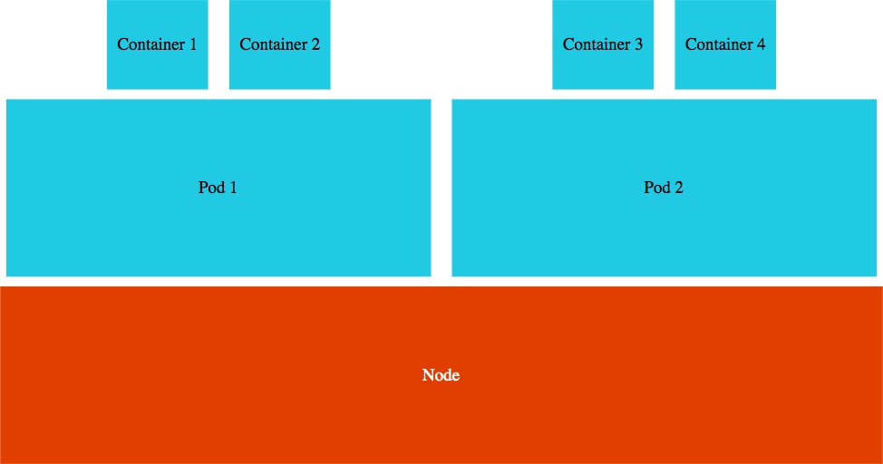



*Kubernetes Architecture*

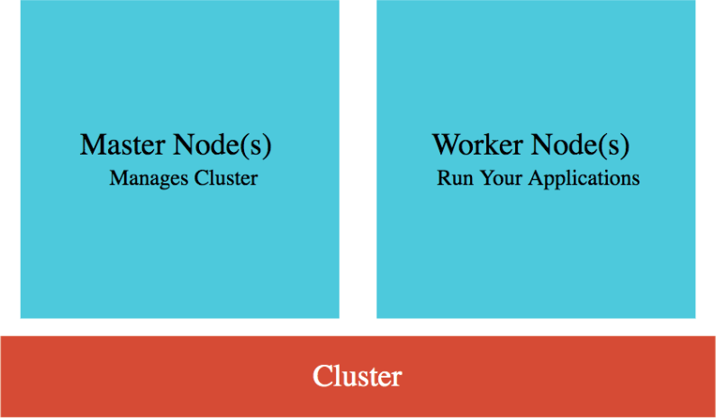 

*Kubernetes Architecture*

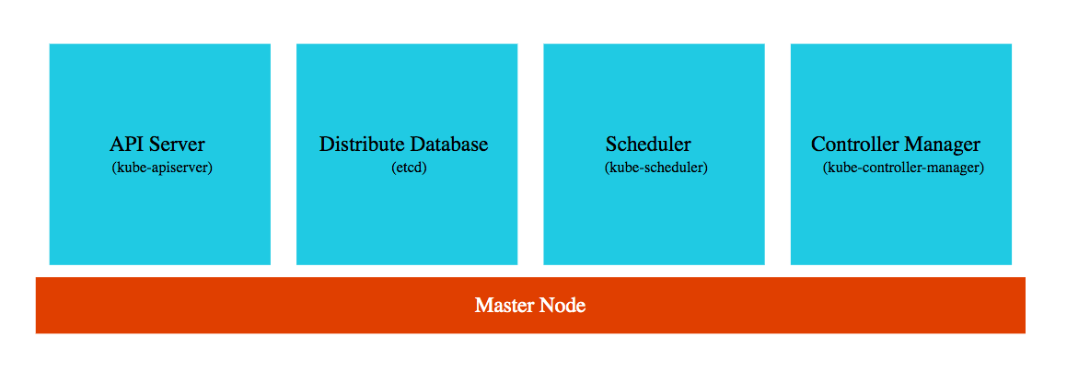

*Kubernetes Architecture*

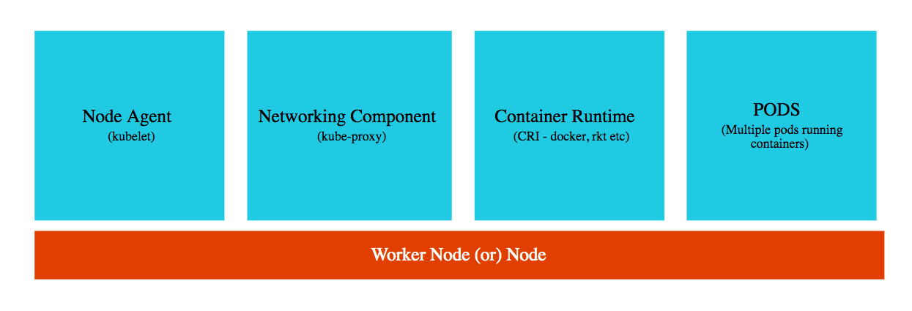

*Kubernetes Architecture*

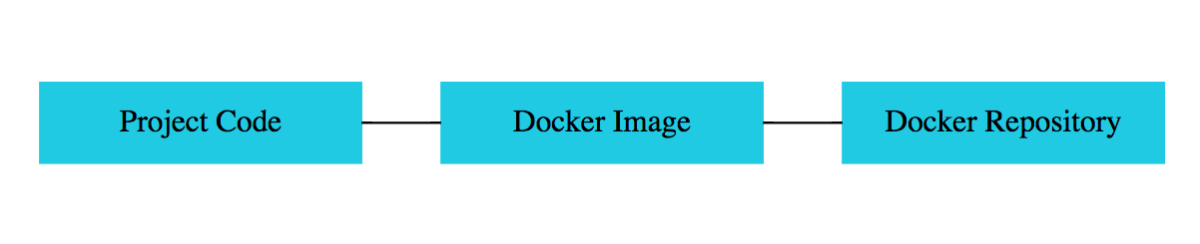

*Kubernete Deployments*

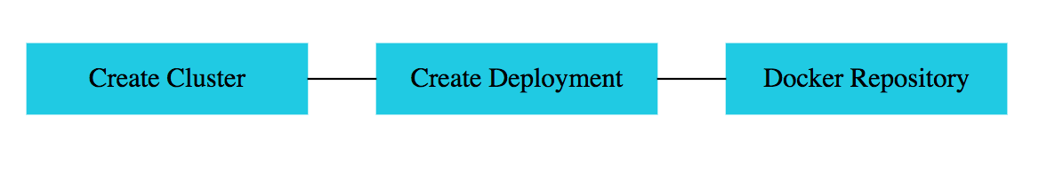

*Kubernete Deployments*

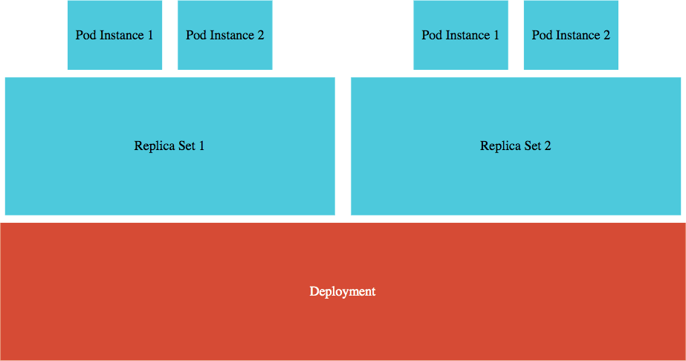 

*Kubernete Deployments*

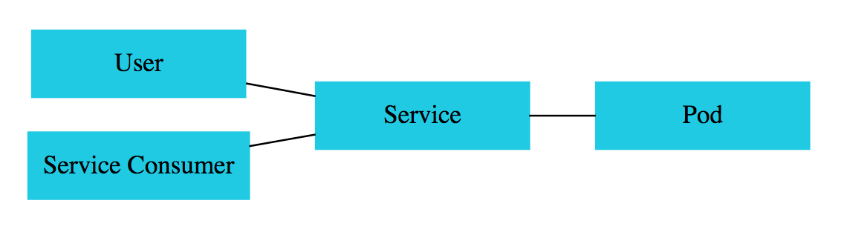

*Kubernete Service*

## Kubernetes -

**Liveness and**

## Readiness Probes





#### Kubernetes uses probes to check the health of a microservice:

If readiness probe is not successful, no traffic is sent

If liveness probe is not successful, pod is restarted

#### Spring Boot Actuator (>=2.3) provides inbuilt readiness and liveness probes:

/health/readiness

/health/liveness



# What Next?

## Docker & Kubernetes in Depth

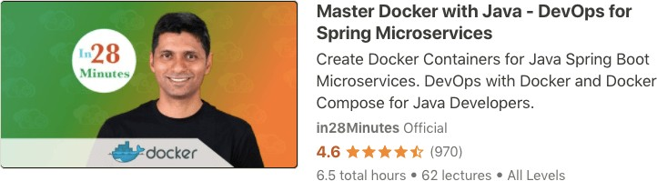

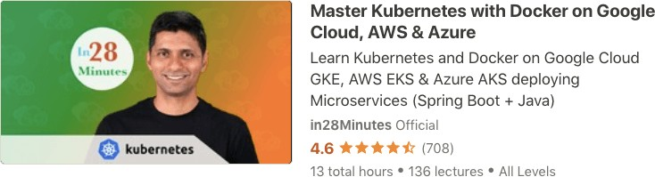

**Full Stack**



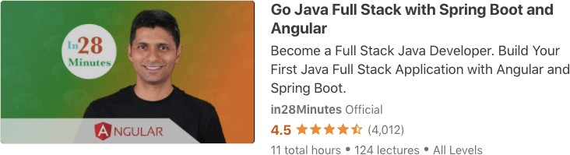

## AWS Certifications



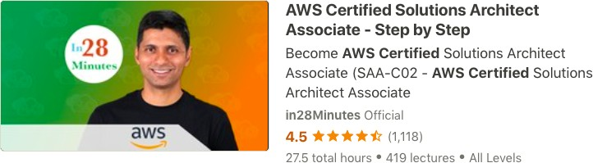

**Serverless**

