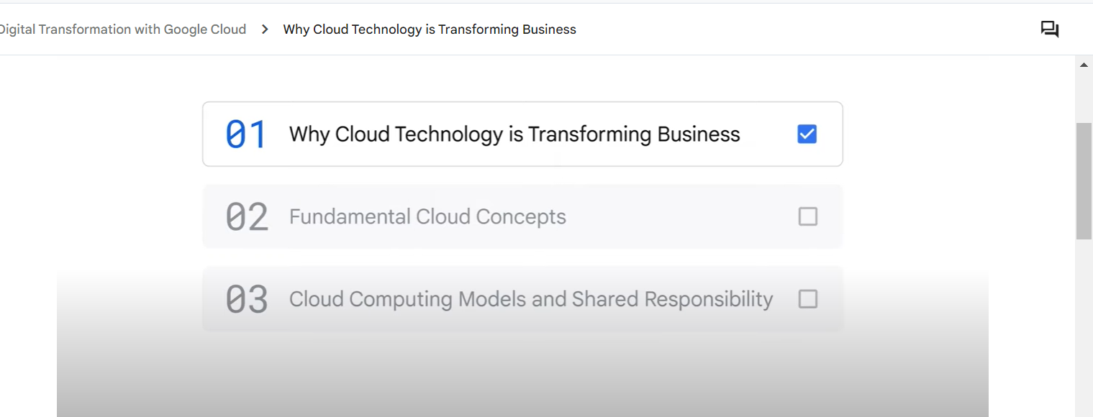

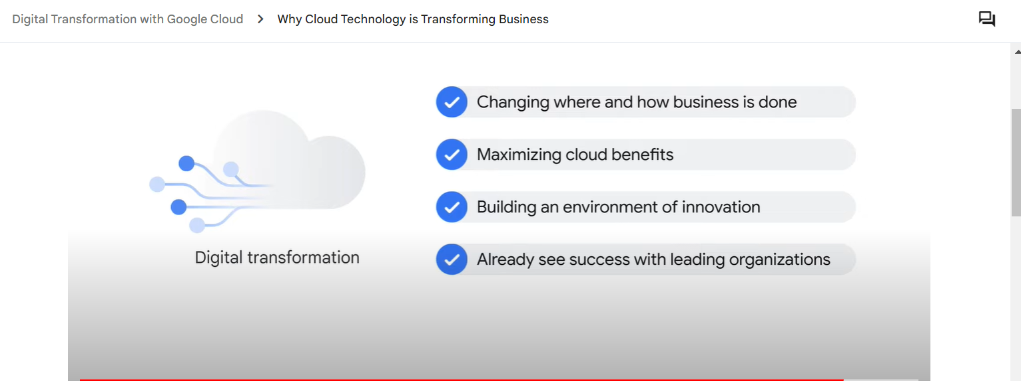

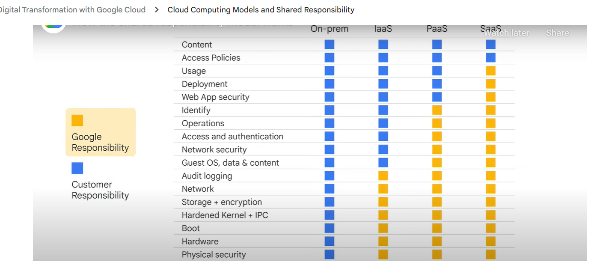

Cloud sql

Cloud spark

Data warehouse.big query –fully managed data warehouse ,serverless

Database –transcational data

Data warehouse –converts

Un structured data- cloud storage

Data lakes—

Dataflow – is server less, cost effective, fast