**SET-1**

1. **Explain DevOps tool stack implementation to support a process or workflow. [10M]**

DevOps uses a **collection of tools** called a **DevOps tool stack** to support every step of software development and delivery. These tools help in planning, coding, building, testing, deploying, and monitoring software automatically and efficiently.

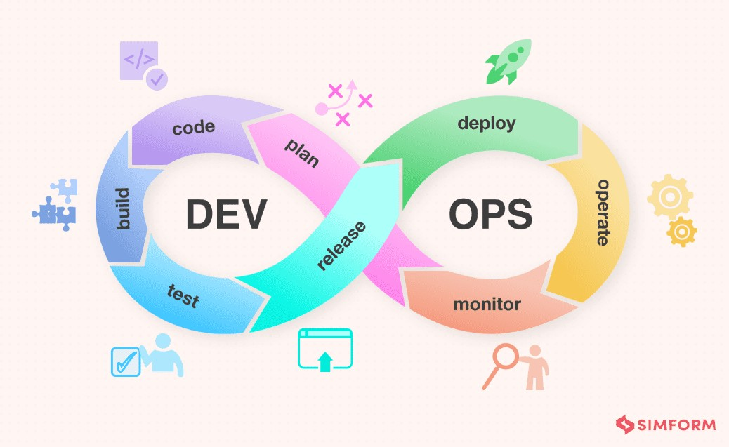

**Stages and Common Tools in DevOps Tool Stack:**

* 1. **Plan**:
     + - Tools: **Jira**, **Trello**, **Confluence**.
       - Used for tracking work, tasks, bugs, and planning sprints.
  2. **Code**:
     + - Tools: **Git**, **GitHub**, **GitLab**, **Bitbucket**.
       - Used to store source code, manage versions, and collaborate with other developers.
  3. **Build**:
     + - Tools: **Maven**, **Gradle**, **Ant**.
       - Used to compile source code, package files, and prepare code for deployment.
  4. **Test**:

o Tools: **Selenium**, **JUnit**, **Postman**, **Cypress**. o Used for testing code, APIs, and user interfaces automatically.

* 1. **Release:**
  + **Tools:** Jenkins, Spinnaker, Bamboo, Azure DevOps, Octopus Deploy
  + Automating the release process, managing versions, approvals, and promoting builds to production environments. These tools help schedule releases, handle complex deployments, and roll back if needed.

**6. Deploy**:

* + - * Tools: **Docker**, **Kubernetes**, **Ansible**, **Terraform**.
      * Docker packages the app into containers, Kubernetes manages and scales containers, and Ansible/Terraform automate infrastructure setup.
    1. **Monitor**:

Tools: **Nagios**, **Prometheus**, **Grafana**, **ELK Stack**.

Help monitor servers, applications, performance, logs, and alerts.

* + 1. **Operate:**
  + **Tools:** Kubernetes, Docker, Puppet, Chef, Ansible, Terraform
  + Running and managing applications and infrastructure in production. These tools help with configuration management, auto-scaling, load balancing, and ensuring the system runs reliably and efficiently.

DevOps tool stack ensures **fast delivery**, **quality software**, **automated tasks**, and **better teamwork** across the entire software lifecycle.

1. **What is Continuous Integration? Explain the few benefits the software industry gets by incorporating Continuous Integration. [10M]**

**Continuous Integration (CI)** means that developers frequently merge (combine) their code changes into a central repository, and then automatically build and test the project.

**How CI Works:**

* + A developer writes code and pushes it to GitHub or GitLab.
  + Jenkins (or any CI tool) detects the change.
  + It runs automatic builds and tests.
  + If something breaks, it notifies the developer immediately.

**Benefits of Continuous Integration:**

* 1. **Catches Bugs Early**:

o If something goes wrong, you know right away. o Easier and cheaper to fix bugs early.

* 1. **Faster Development**:
     + - CI saves time by automating testing and builds.
       - Developers don’t have to wait for testing manually.
  2. **Better Code Quality**:
     + - Automated testing ensures that every change is tested.
       - Reduces the chances of errors in the code.
  3. **Less Merge Conflicts**:
     + - Small, regular changes are easier to merge than large ones.
       - Avoids major problems when combining everyone's code.
  4. **Quick Feedback**:
     + - Developers get instant alerts if something fails.
       - Helps teams move faster.
  5. **Strong Foundation for CD**:
     + - CI prepares the system for Continuous Delivery and Deployment.
       - Makes future automation easier.

CI is an important part of DevOps because it improves **speed**, **safety**, and **collaboration**.

**3) What is the need for using the DevOps maturity model? Describe key factors of DevOps maturity model. [10M]**

The **DevOps Maturity Model** is a roadmap that helps companies measure how well they are doing in their DevOps journey. It helps teams grow step-by-step and become faster, more efficient, and more reliable.

**Why DevOps Maturity Model is Needed:**

1. **To know your current level**: It shows whether you are just starting with DevOps or already advanced.
2. **To plan improvements**: Helps decide what to improve next—tools, culture, automation, etc.
3. **To track progress**: Measures how far your team has come.
4. **To reduce risks**: Identifies weak areas like slow deployments or manual testing.
5. **To deliver faster**: Helps teams become more agile and efficient.

**Key Factors (Areas) in DevOps Maturity Model:**

1. **Culture & Collaboration**:
   * Dev and Ops teams work together.

Trust, shared responsibility, and communication.

1. **Automation**:
   * Build, test, and deploy processes are automated.
   * Less manual work, more speed and reliability.
2. **CI/CD Implementation**:
   * Regular code integration and automatic delivery.
   * Faster and safer releases.
3. **Monitoring and Feedback**:
   * Real-time tracking of systems and apps.
   * Teams act quickly on performance issues.
4. **Security (DevSecOps)**:
   * Security is integrated early.
   * Tools check code for issues automatically.
5. **Measurement and Metrics**:
   * Tracks key metrics like deployment time, failure rate, MTTR (Mean Time To Recover).

**SET-2**

1. **Explain the component 'people aspect' of DevOps methodology. [10M]**

DevOps is not just about tools—it’s about **people** working together. The **people aspect** is about creating a culture where development, testing, operations, and other teams collaborate and communicate effectively.

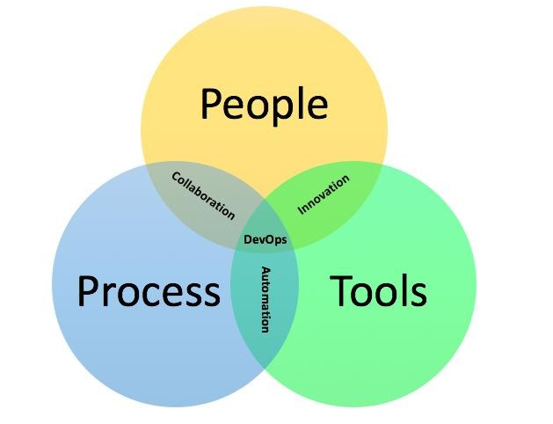

**Important Points About the People Aspect:**

* 1. **Team Collaboration**:
     + Developers, testers, and operations work closely.
     + Shared responsibility for success and failure.
  2. **Breaking Silos**:
     + No more separate Dev and Ops teams. o Everyone works towards a common goal.
  3. **Skills and Learning**:
     + Team members learn multiple skills.
     + Developers understand deployment, and ops understand coding.
  4. **Ownership**:
     + Teams take full responsibility for the product—building, testing, deploying, and maintaining it.
  5. **Culture of Trust**:
     + Mistakes are seen as learning opportunities.

Everyone feels safe to experiment and innovate.

* 1. **Leadership Support**: o Leaders support the DevOps culture by investing in tools and training.
  2. **Communication Tools**:
     + Slack, MS Teams, and project management tools help everyone stay updated.

The people aspect is the **heart of DevOps**. Without team collaboration, DevOps tools and practices will not be successful.

1. **Differentiate Between: [10M]**
2. **Continuous Integration (CI) vs Continuous Delivery (CD)**

**Continuous Integration (CI) Continuous Delivery (CD)**

Developers merge code often Code is ready to deploy anytime

Tests run automatically Deployment to staging is automated

Main goal: Find bugs early Main goal: Deliver software faster Focuses on builds & tests Focuses on deployment readiness

Tools: Jenkins, Travis CI Tools: Spinnaker, Octopus

1. **Continuous Integration vs Continuous Deployment**

**Continuous Integration Continuous Deployment**

Code is built and tested Code is automatically deployed to production

Needs manual deployment No manual steps—fully automated

Good for development Good for fast-paced companies

Risk is lower Needs strong automated testing

1. **Continuous Delivery vs Continuous Deployment**

**Continuous Delivery Continuous Deployment**

Needs approval before deploying No approval needed—auto deploy

Safer with human checks Faster with full automation

Used when companies want control Used by companies like Amazon, Netflix

**3) Explain the different stages of the DevOps maturity model. [10M]**

The DevOps maturity model has different **stages or levels** that show how mature an organization is in using DevOps practices.

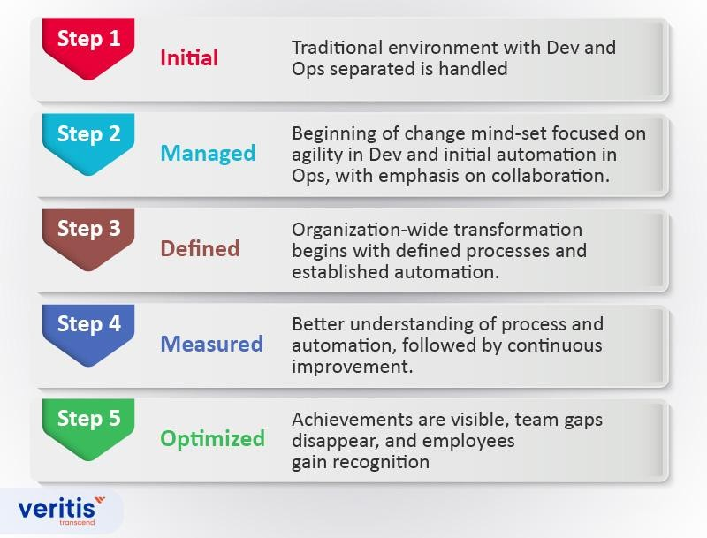

**Stages of DevOps Maturity:**

1. **Initial**:
   * Teams work separately. o No automation. Everything is manual. o Deployment is slow and error-prone.
2. **Managed**:
   * Some automation is introduced. o Basic use of tools like Git and Jenkins.
   * Still not fully integrated.
3. **Defined**:
   * Teams start collaborating more. o CI/CD pipelines are working.

Testing and builds are automated.

1. **Measured**:
   * Teams use data to improve.
   * Metrics like deployment time and failure rate are tracked.
   * Monitoring tools in place.
2. **Optimized**:
   * Full automation of CI/CD and infrastructure. o Security, testing, and deployment are all integrated.
   * DevOps is part of the culture.

**SET-3**

1. **Explain the component process aspect of DevOps methodology. [10M]**

In DevOps, the **process aspect** is all about how things are done—the **steps**, **workflows**, and **practices** followed by the team to build, test, deliver, and manage software.

**Key Elements of DevOps Process:**

* 1. **Agile Development**:
     + Work is broken into small tasks and completed in short time cycles (sprints).
     + Frequent releases help gather feedback and improve.
  2. **Version Control**:
     + Tools like Git are used to manage code changes.
     + Developers can work on code together and avoid conflicts.
  3. **Continuous Integration (CI)**:
     + Code is automatically tested and merged into the main branch.
     + Helps catch errors early.
  4. **Continuous Delivery/Deployment (CD)**:
     + Code is automatically deployed to staging or production.
     + Reduces manual work and speeds up delivery.
  5. **Infrastructure as Code (IaC)**:
     + Servers and systems are created using code (e.g., Terraform, Ansible). o Easy to automate and reproduce environments.
  6. **Automated Testing**:
     + Tests run automatically on every code change.
     + Ensures that bugs are caught early.
  7. **Monitoring and Logging**:
     + Tools like Prometheus, Grafana, and ELK stack track system performance.
     + Helps identify and fix issues quickly.

The process aspect is about creating a **repeatable, reliable workflow** to deliver software faster, better, and safer.

1. **Explain metrics used to track CI and CD practices. [10M]**

Metrics help DevOps teams measure performance and find areas for improvement in their CI/CD pipelines.

**Common DevOps Metrics:**

* 1. **Lead Time for Changes**:
     + Time from writing code to deploying it.
     + Shorter time means faster delivery.
  2. **Deployment Frequency**:
     + How often new code is released.
     + More frequent = more agile.
  3. **Change Failure Rate**:
     + How often a deployment causes an issue.
     + Lower failure rate = better quality.
  4. **Mean Time to Recovery (MTTR)**:
     + Time to fix a failure in production. o Lower MTTR = quicker recovery.
  5. **Build Success Rate**:
     + Percentage of builds that pass.
     + Helps detect broken code early.
  6. **Test Coverage**:
     + Percentage of code tested by automated tests.
     + More coverage = more confidence.
  7. **Cycle Time**:

Time from starting work to completing a task.

* + - Helps improve speed of development.

These metrics help in making decisions, finding bottlenecks, and improving software delivery.

1. **Explain the steps involved in DevOps maturity assessment. [10M]**

A **DevOps maturity assessment** helps organizations understand how far they’ve come in their DevOps journey and what they need to improve.

**Steps in a DevOps Maturity Assessment:**

1. **Define Goals**:
   * Decide what the company wants: faster delivery, better quality, etc.
2. **Choose Assessment Areas**: o Areas include culture, automation, CI/CD, testing, monitoring, and security.
3. **Evaluate Current State**:
   * See what tools and practices are currently used.
   * Interview teams, review workflows, and check tools.
4. **Assign Maturity Levels**:
   * Use a scale like:
     + Level 1: Initial (chaotic)
     + Level 2: Managed
     + Level 3: Defined
     + Level 4: Measured ▪ Level 5: Optimized
5. **Identify Gaps**:
   * Find areas where practices are missing or weak.
6. **Create Improvement Plan**:
   * Suggest tools, training, or process changes.
   * Set timelines and responsible teams.
7. **Re-assess Periodically**:
   * Regular checks help track progress. o Allows for continuous improvement.

Maturity assessment is like a **health checkup** for DevOps. It shows where you stand and what steps to take next.

**SET-4**

1. **Explain the various factors that influence DevOps adoption. [10M]**

Adopting DevOps can be challenging, and several factors play a role in whether it succeeds or fails.

**Key Factors That Influence DevOps Adoption:**

* 1. **Organizational Culture**:
     + Companies must promote teamwork, trust, and shared goals.
     + A blame-free culture supports DevOps growth.
  2. **Leadership Support**:
     + Without leadership support, DevOps adoption is slow.
     + Leaders should fund tools, training, and team restructuring.
  3. **Skills and Training**:
     + Teams need to learn new tools (Docker, Jenkins, Kubernetes) and practices.
     + Upskilling is necessary for success.
  4. **Tooling and Automation**:
     + Proper tools for CI/CD, testing, and monitoring are needed.
     + Automation improves speed and reduces errors.
  5. **Process Standardization**:
     + Repeating the same process every time improves consistency.
     + Helps teams collaborate better.
  6. **Team Structure**:
     + Cross-functional teams (Dev, QA, Ops together) work best.
     + Silos should be broken down.
  7. **Legacy Systems**:
     + Old systems may be hard to automate. o Need careful planning to integrate them.
  8. **Security Practices**:
     + Security should be part of the pipeline (DevSecOps).

Helps avoid last-minute surprises.

* 1. **Monitoring and Feedback Loops**:
     + Systems need to be monitored in real-time.
     + Fast feedback helps teams fix problems quickly.

Successful DevOps adoption depends on people, tools, process, and mindset.

1. **What is Continuous Deployment? Explain the benefits of CD. [10M]**

**Continuous Deployment (CD)** means **automatically deploying** every code change that passes tests directly into **production**—without manual approval.

**How It Works:**

* + Code is written → Tests run → If all pass, it's deployed to users automatically.
  + Tools like Jenkins, Spinnaker, and GitLab help automate this.

**Benefits of Continuous Deployment:**

* 1. **Faster Releases**:
     + Features go live quickly.
     + Shortens the time between idea and delivery.
  2. **Improved Productivity**:
     + Developers don’t waste time on manual deployments.
     + Focus on coding and innovation.
  3. **Fewer Errors**:
     + Automated tests catch bugs early.
     + Smaller changes are easier to test and debug.
  4. **Better Customer Experience**:
     + Customers get updates more frequently.
     + Bugs are fixed faster.
  5. **Quick Feedback Loop**:
     + Teams learn fast from user feedback.
     + Helps improve products quickly.
  6. **Higher Quality Code**:
     + Continuous testing and validation improve code quality.
  7. **Strong Automation Culture**:
     + Encourages better automation practices and tools.

CD is powerful, but it requires **strong testing** and **confidence** in your code pipeline.

**3) Write a short note on business benefits of DevOps maturity. [10M]**

When a company reaches a higher level of **DevOps maturity**, it sees several **business advantages**.

**Business Benefits of DevOps Maturity:**

1. **Faster Time to Market**: o Software is released faster, giving a competitive edge. 2. **Better Product Quality**: o Fewer bugs, better performance, and more reliability.

1. **Higher Customer Satisfaction**: o Frequent updates and quick fixes keep customers happy.
2. **Lower Operational Costs**: o Automation reduces manual work and errors.
3. **Increased Innovation**: o Teams can try new ideas quickly without fear of failure.
4. **Better Team Collaboration**:
   * Teams work together with shared goals and improved morale.
5. **More Transparency and Monitoring**:
   * Issues are caught early with real-time monitoring and logging.
6. **Stronger Security**:
   * DevSecOps ensures security is part of the development process.
7. **Scalability and Flexibility**:
   * DevOps tools help scale applications easily when business grows.

In short, a mature DevOps setup means **faster growth, better service, and happier teams**.