Activity 1
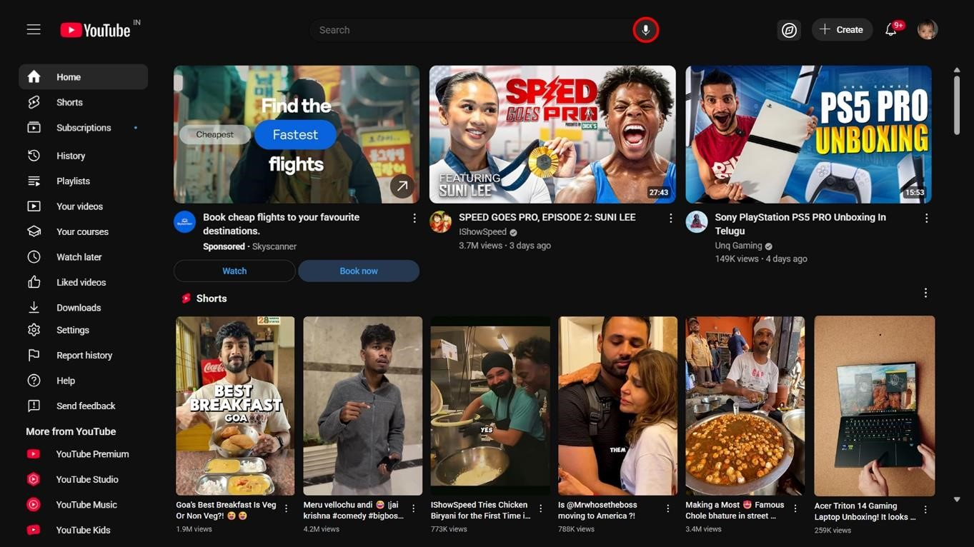

Activity 2

1.Berkshire Hathaway Website
Problems :
Design looks very outdated.
It’s not visually appealing.
Poor readability(low contrast and small font size) Fixes :
Improve design by adding a few elements and colours
Changing font size and style
Instead of text everywhere add some visually attractive images

2. Hacker News
Problems :
Extremely text heavy
No proper gap between two sections
Font style looks outdated Fixes :
Decrease the amount of text in a single screen.
Change font style.
Add proper separation between sections.

3.Bellads.info
Problems :
Too many images in a single frame
No brief description of image(No Alt text)
The options like(Tell a friend , Make a donation etc…) aren’t even findable.
Due to this messiness the images aren’t readable.
Buttons look outdated.
Fixes :
Arrage things in order.
Move all the options(Tell a friend , Make a donation etc…)to one side.
Collage the images properly with added alt text.
Add clear navigations and remove distractions.
Remove unnecessary information.

4.Pacific Northwest X-ray inc.
Problems :
The gradient on the back is not attractive .
Text is unreadable.
Old fashioned typography and layout.
Buttons look very outdated.
Things are not aligned properly.
Fixes :
Change the background gradient to a plain and solid colour Change the
font style .
Arrange them in a way that looks good.
Improve colour scheme.
Replace text links with images or buttons
Change the search bar

5.Toronto Cupcake
Problems:
Image displayed is Dull.
Font displayed below the image doesn’t look like announcements or welcome text . It looks like a copyright notice related text Menu options are very hard to notice.
Overall layout is not organised.
Order option is hard to notice.
Fixes:
Replace the image with a high resolution and attractive one.
Add the welcome text above the image in a different font style that looks minimal.
Change the place of Date.
Move the (home ,About, etc) options at the bottom to menu or increase their size.
Highlight sections like “Order Now” , “Shop Cupcakes” , “see menu” .

Activity 3
For someone who is colorblind I’ll design the app screen with monochrome elements as it is easy for them to distinguish options based on brightness and shade.
For someone who can’t hear I’ll try to avoid relying on audio output for conveying information or add captions if it is mandatory to output audio. will use haptic feedback for any alerts or notifications.
For someone who has shaky hands I’ll try to add larger buttons and to avoid difficulty in typing ,can use voice to text feature . Try to provide navigation keys at the bottom or somewhere which have plenty gap between them. If the hands are too shaky I’ll try to track the movement of eyeball and use it as a pointer.

Activity 4
Opening the app -> choosing food delivery ->akipping all the ads in between-> choosing restaurant/food I want to eat -> add to cart ->choose topings or sides ->Skipping swiggy one at 1 rupees add ->checking address ->choosing delivery type ->payment -> waiting
I feel frustrated by seeing the advertisements in between . I would suggest to add an option,
When we select food delivery , there should be an option for choosing among restaurants etc who can deliver faster and the dishes they delivery faster , so I can decide among them fast and order quickly.
The only place where I feel happy is the app automatically knows my location(if location services are turned on)and doesn’t ask where to deliver

Bonus task
Biggest annoyance is to find things manually in quanta or aws.If there is a search option that would be great.(ex :- if I search for M1 handout it should take me to the place where it is or directly give me the required file)

I have modified quanta a bit and added search option.

