OLIST E-COMMERCE
SALES ANALYTICS
SQL & Power BI Data Analytics Project
Project Documentation
Dataset | Brazilian E-Commerce Public Dataset by Olist
Database | PostgreSQL
Visualization | Power BI
Supporting Tools | SQL, DAX, DBDiagram.io, Git & GitHub

Prepared as a fresher-level portfolio project

1. Introduction
The Olist E-Commerce Sales Analytics project is a data analytics project based on the Brazilian E-Commerce Public Dataset provided by Olist. The project focuses on understanding sales, orders, customers, products, sellers, payments, and reviews.
The work starts with organizing the data in a PostgreSQL database. SQL is then used for data validation and business analysis. Finally, Power BI is used to create an interactive dashboard that presents the main results in a simple way.

2. Project Objective
- Understand the structure of the Olist e-commerce dataset.
- Store and organize the data in a relational PostgreSQL database.
- Perform basic data quality checks.
- Use SQL to answer business-related questions.
- Analyze revenue, orders, customers, products, and sellers.
- Identify top products and top sellers by revenue.
- Study revenue changes over time.
- Create an interactive Power BI dashboard.
- Present the results in a clear and easy-to-understand format.

3. Dataset Description
The project uses the Brazilian E-Commerce Public Dataset by Olist. The dataset contains information about orders placed through the Olist marketplace and includes different tables for different parts of the e-commerce process.

Main Tables
- customers – customer details and location information.
- orders – order status and important order dates.
- order_items – products and sellers linked to each order.
- products – product details and physical attributes.
- sellers – seller details and location information.
- order_payments – payment method, installments, and payment value.
- order_reviews – customer review information.
- product_category_translation – product category names and English translations.
- geolocation – latitude, longitude, city, and state information.

4. Database Design
PostgreSQL was used to create and manage the project database. The data was kept in separate related tables so that information could be joined when required for analysis.
Some important relationships in the database are:
- Customers are connected to Orders through customer_id.
- Orders are connected to Order Items through order_id.
- Order Items are connected to Products through product_id.
- Order Items are connected to Sellers through seller_id.
- Orders are connected to Payments through order_id.
- Orders are connected to Reviews through order_id.

5. Entity Relationship Diagram
The ERD shows the main tables in the database, their important columns, and the relationships between the tables. It was created to make the database structure easier to understand before analysis.
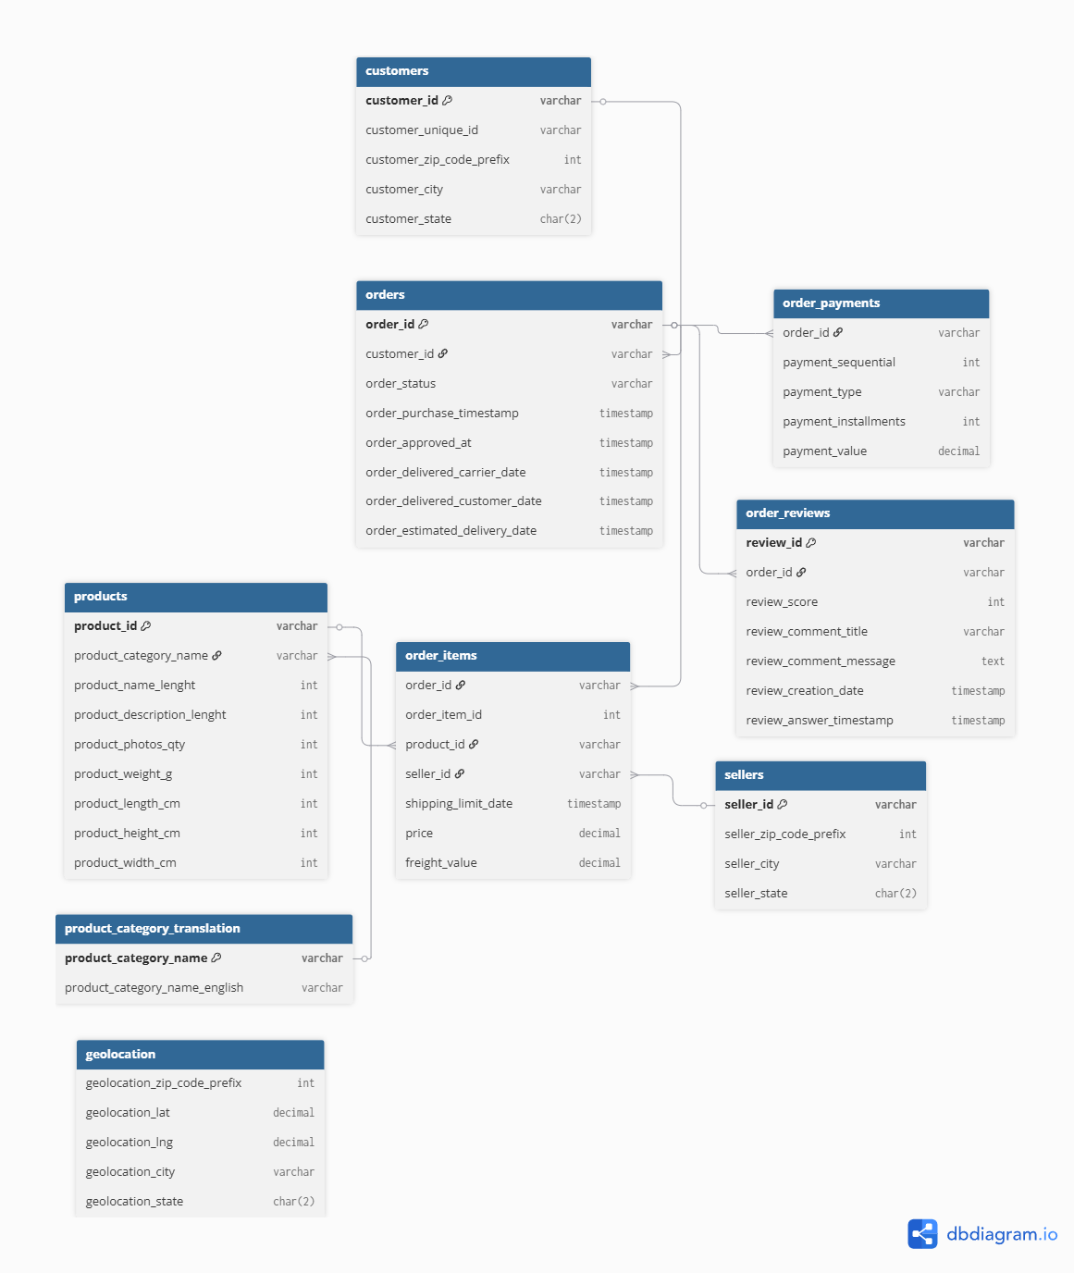
Figure 1: Olist E-Commerce Database Entity Relationship Diagram

6. SQL Data Analysis
SQL was used to validate the data and perform business analysis. The queries were written to understand the data and prepare useful results for the Power BI dashboard.

6.1 Data Quality Checks
- Checked NULL values in important columns.
- Checked the number of records in tables.
- Reviewed missing order dates and order status information.
- Checked table relationships using primary and foreign key columns.
- Reviewed the data before using it for business analysis.

6.2 Business Analysis
- Total revenue and order count.
- Customer, product, and seller counts.
- Revenue by product category.
- Top 10 products by revenue.
- Top 10 sellers by revenue.
- Monthly revenue trend.
- Geographic distribution of marketplace activity.

7. Power BI Executive Dashboard
Power BI was used to present the results of the SQL analysis in an interactive dashboard. The dashboard contains KPI cards, charts, a geographic visual, and an Order Year slicer.

Figure 2: Olist E-Commerce Sales Analytics – Executive Dashboard

8. Key Performance Indicators
The dashboard provides a quick summary of the main business metrics. The values below are based on the current dashboard view with the Order Year filter set to All.
KPI | Value | Meaning
Total Revenue | 20.31M | Total revenue represented in the data
Total Orders | 99K | Total number of orders
Total Customers | 95K | Number of customers represented
Total Products | 33K | Number of products represented
Total Sellers | 3K | Number of sellers represented
Average Order Value | 205.83 | Average value per order

9. Dashboard Visualizations

9.1 Monthly Revenue Trend
The Monthly Revenue Trend shows how revenue changed over time. It helps in understanding the overall sales pattern and identifying periods of higher or lower revenue.
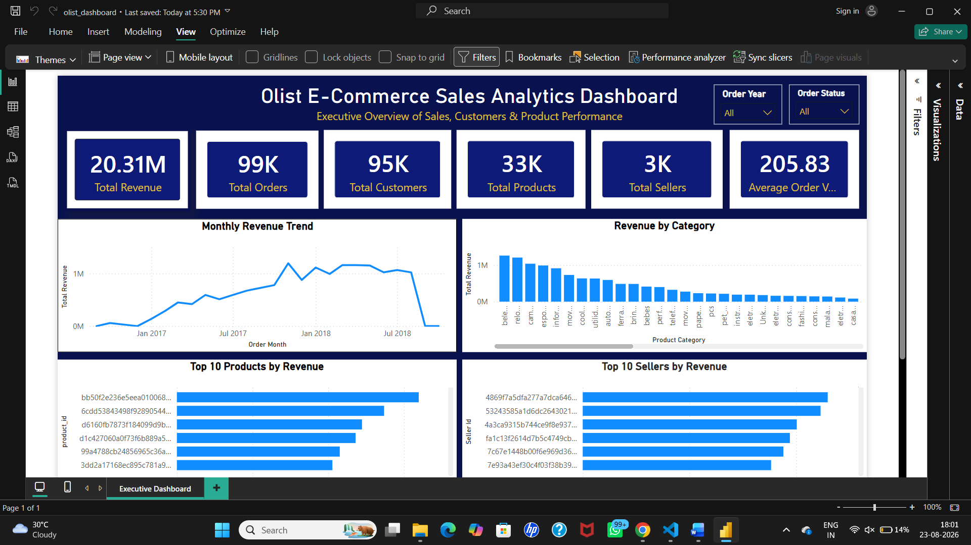

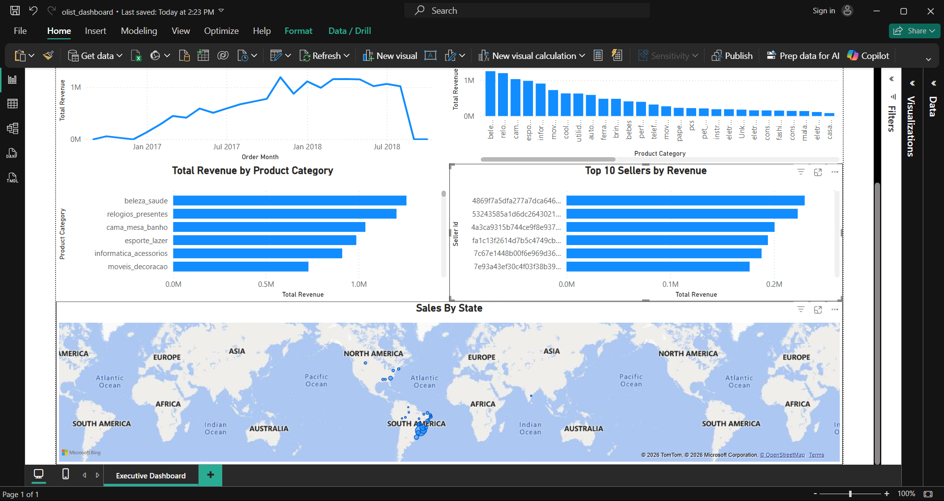

9.2 Revenue by Category
The Revenue by Category chart compares revenue across product categories. It helps identify categories that contribute more to total revenue.

9.3 Top 10 Products by Revenue
This chart lists the top products based on revenue. It helps identify products that make a higher contribution to sales.

9.4 Top 10 Sellers by Revenue
This chart shows the sellers with the highest revenue. It provides a simple view of seller performance within the marketplace.

9.5 Geographic Analysis
The dashboard includes a map to show the geographic distribution of marketplace activity. It can be used to understand where customers or orders are concentrated.

10. Dashboard Filter
An Order Year slicer was added to the dashboard. Users can select a specific year or choose All to view the overall data. The selected value filters the dashboard visuals.

11. Key Findings
- The current dashboard shows total revenue of approximately 20.31M.
- The dataset contains approximately 99K orders and 95K customers.
- There are approximately 33K products and 3K sellers represented in the data.
- The average order value shown on the dashboard is 205.83.
- Revenue is distributed differently across product categories.
- Some products generate much higher revenue than others.
- The top sellers contribute a significant amount of marketplace revenue.
- The monthly revenue chart shows changes in revenue over the selected time period.

12. Technologies Used
Technology | Purpose
PostgreSQL | Database creation, storage, and data management
SQL | Data validation and business analysis
Power BI | Dashboard creation and visualization
DAX | Calculated measures and KPI calculations
DBDiagram.io | ERD creation
Git & GitHub | Version control and project sharing

13. Project Workflow
1. Dataset Collection
2. Database Design
3. ERD Creation
4. PostgreSQL Database Creation
5. Data Import
6. Data Quality Checks
7. SQL Analysis
8. Business Analysis
9. Power BI Connection
10. Dashboard Creation
11. Final Documentation

14. Conclusion
The Olist E-Commerce Sales Analytics project provided practical experience in working with a real-world e-commerce dataset. The project covered database design, SQL data analysis, and Power BI visualization.
The final dashboard brings the main results together using KPIs, charts, a map, and an interactive Order Year filter. This project shows how raw business data can be organized, analyzed, and presented in a simple format for decision-making.

15. Learning Outcomes
- Improved understanding of relational database design.
- Practical experience with PostgreSQL and SQL.
- Experience with data quality checks and business analysis.
- Understanding of relationships between multiple tables.
- Experience creating KPIs and calculated measures in Power BI.
- Experience designing an interactive business dashboard.
- Improved understanding of how to present data clearly.

16. Documentation Screenshot Reference
The main screenshots used in this documentation are the ERD and the final Power BI dashboard. Additional cropped screenshots can be added under the relevant visualization sections if a more detailed presentation is required.

