# **Module 1 Activity 2: Project Setup**

**Submitted By: Devi Subadra Venkatesan**

**IFT 458 & IFT 554: Middleware Programming & Database Security**

**Dinesh Sthapit**

**Due Date: 01/21/2024**

**Screenshot 1: Visual Studio Folder**

**Screenshot 2: Node js Terminal**

**Screenshot 3 : node -v command**

**Screenshot 4: npm -v command**

**Screenshot 5: Folder Venkatesan_myproject created**

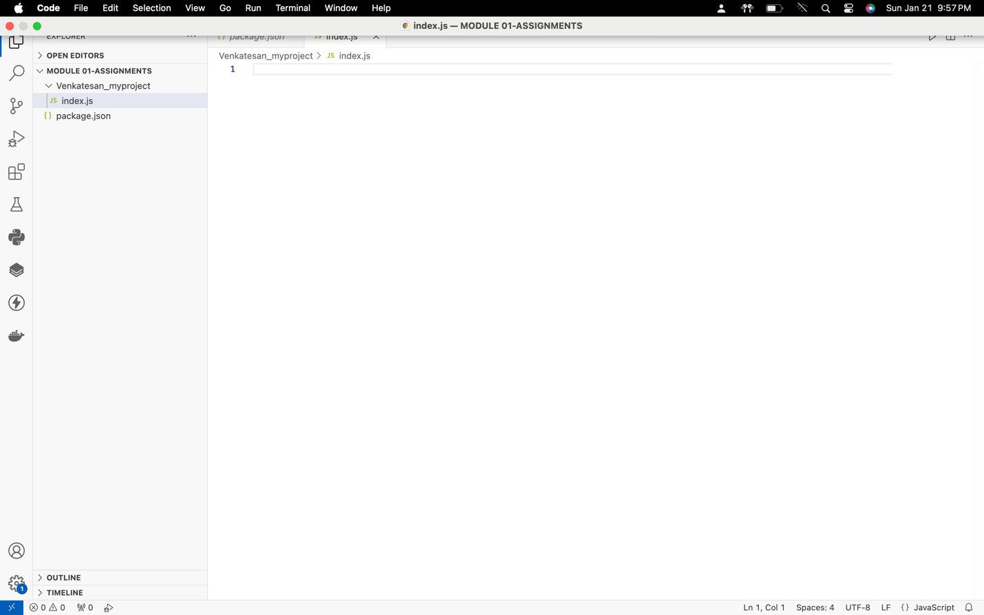

**Screenshot 6:** npm init -y commandfor package creation

**Screenshot 7:** index.js file creation



**Screenshot 8:** index.js file from Open Editor

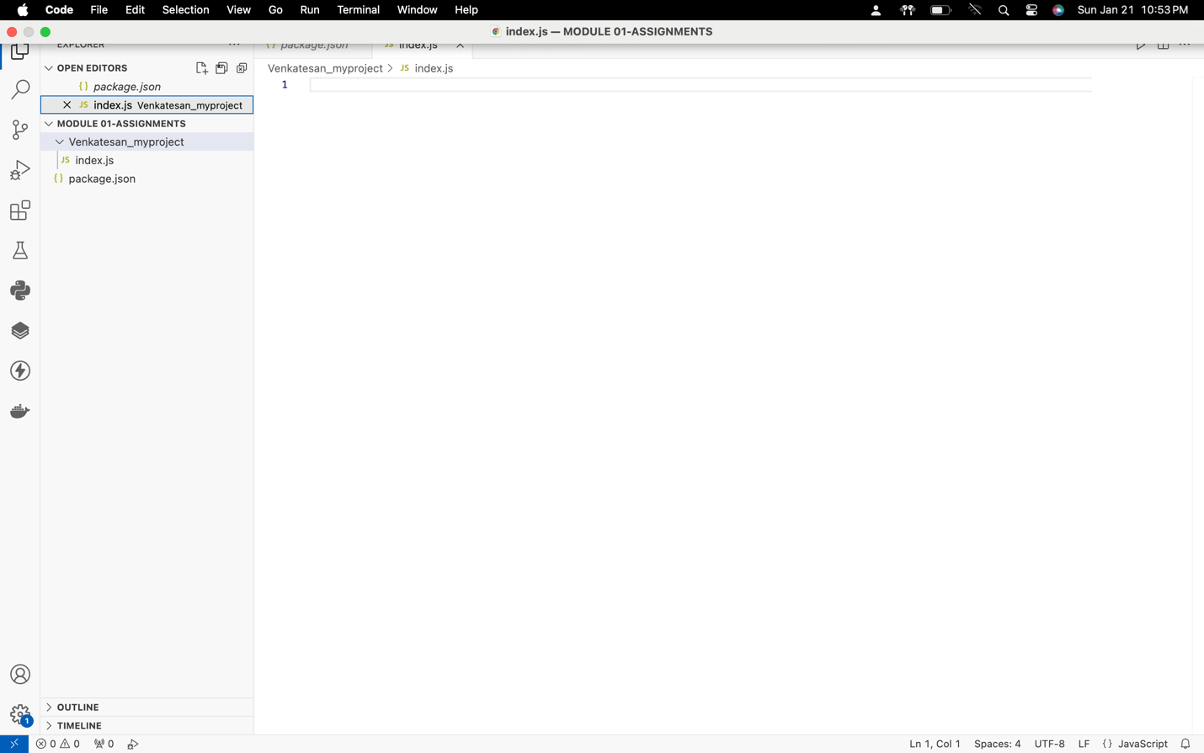

**Screenshot 9:** npm install express command

**Screenshot 10:** Code Display

**Screenshot 11: Auto Save enabled**

**Screenshot 12:** Code Execution

