**Module 2 Activity 1: Basic Static Web Project Using Node.JS and EJS**

**Submitted By: Devi Subadra Venkatesan**

**IFT 458 & IFT 554: Middleware Programming & Database Security**

**Dinesh Sthapit**

**Due Date: 02/04/2024**

**Screenshot 1: Command npm install ejs**

**Screenshot 2: app.js in Visual Studio code**

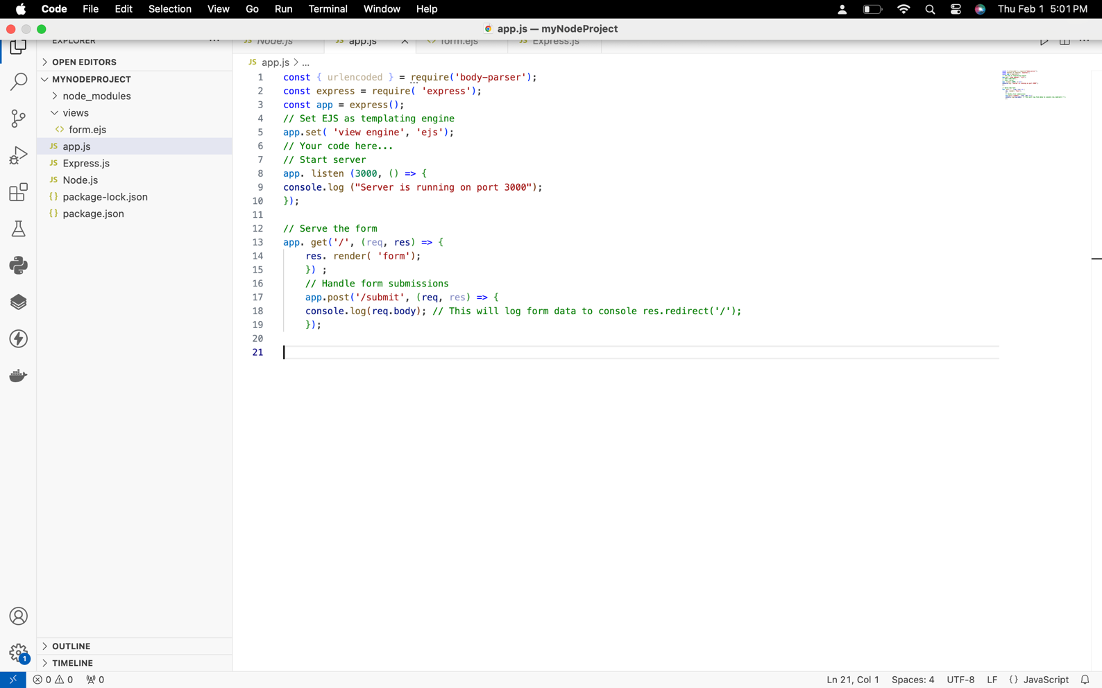

**Screenshot 3:app.js in Editor View**

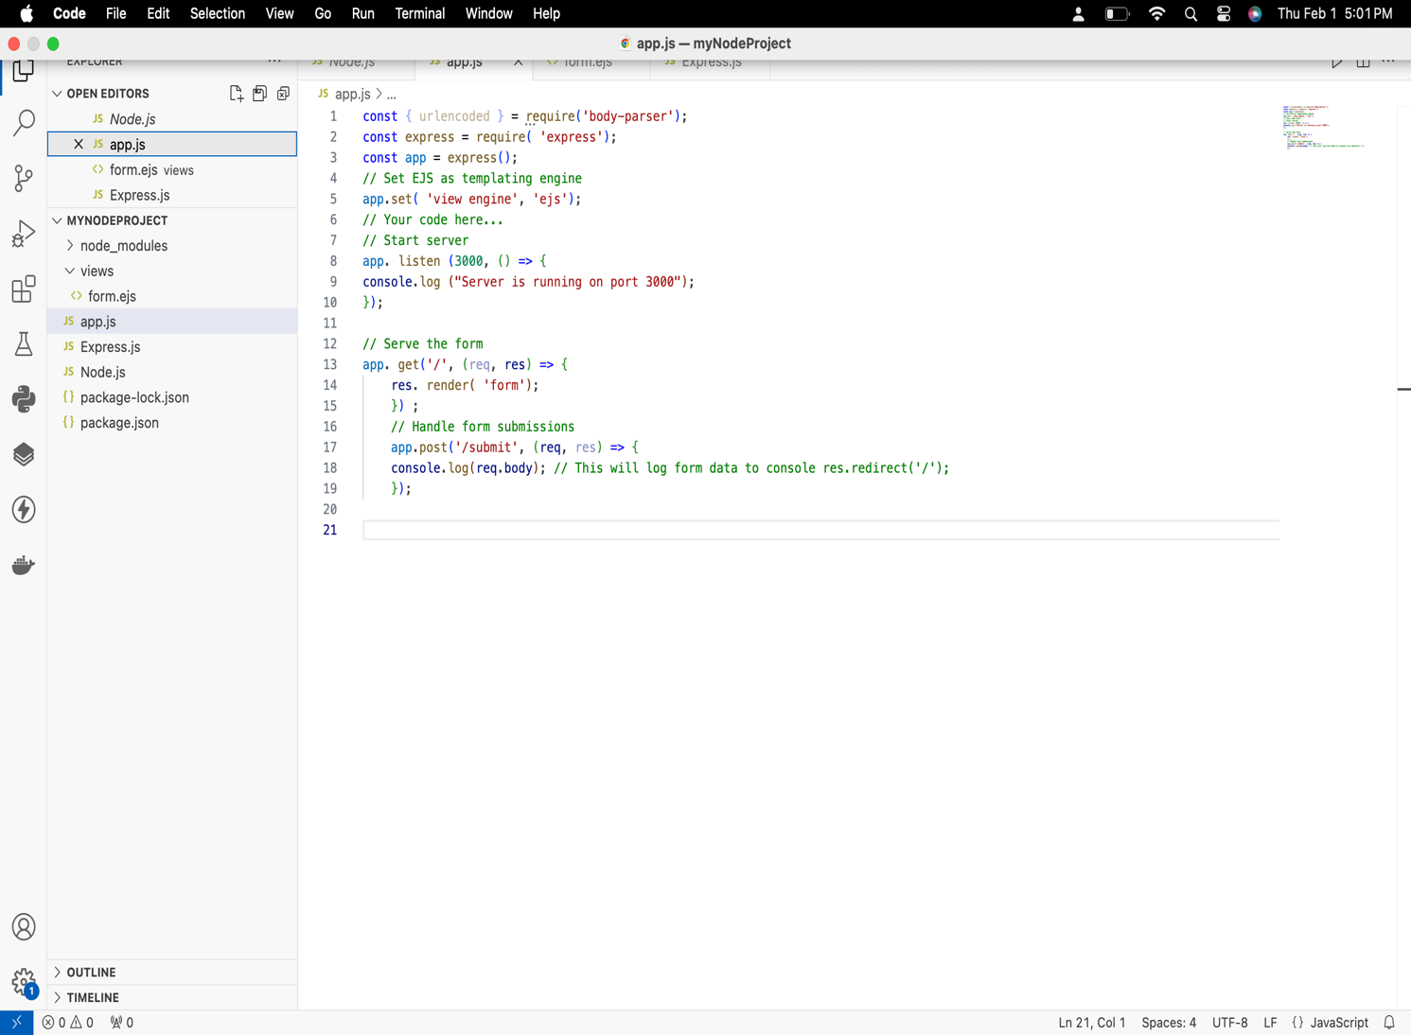

**Screenshot 4: creation of views folder**

**Screenshot 5: HTML code of form.ejs**

**Screenshot 6: adding route to app.js**

**Screenshot 7: Resultant page for a Student Information form and Terminal page**

