**Module 3 Lab 1: Implementing MongoDB Operations in Node.js**

Devi Subadra Venkatesan

Dinesh Sthapit

18th February, 2024

**Module 3 Lab 1: Implementing MongoDB Operations in Node.js**

config.env file showing the added environment variables.



**Create Express Backend and Interact with Mongo**

loanmodel.js

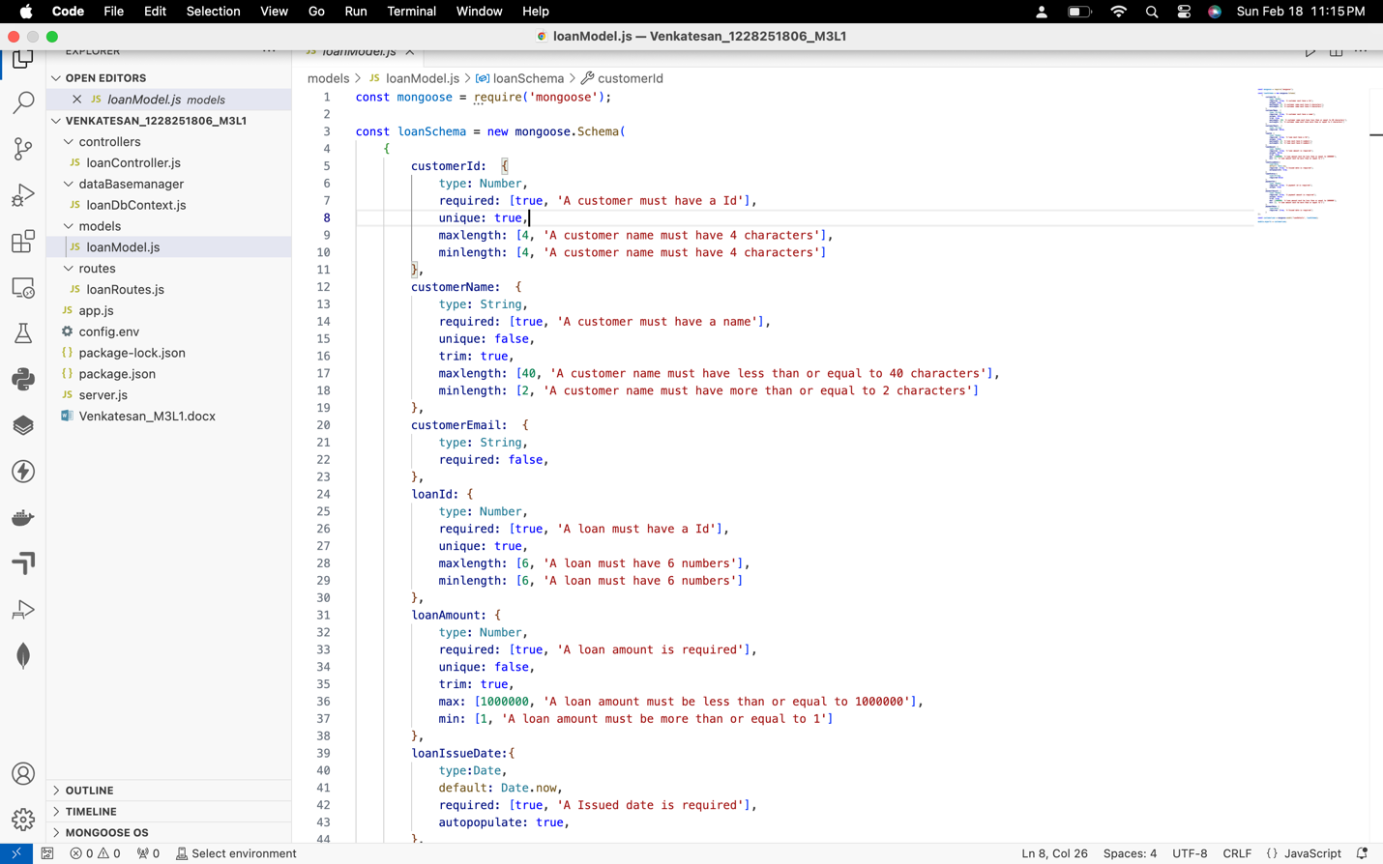

loanRoutes.js

Server.js File:

loanDbContext.js file within the dataBaseManager folder showing the modified code.

Updated loanController.js showing the controller logic.

app.js file showing the new routes and their configuration.

