# **Module 3 Lab 2: Integrating MongoDB with Express.js**

Devi Subadra Venkatesan

IFT 554: Middleware Programming & Database Security

Dinesh Sthapit

February 18th, 2024

# **Module 3 Lab 2: Integrating MongoDB with Express.js**

Screenshots of the Express.js server code and the browser displaying "Hello World!"

**Screenshots of routing code in Express.js in Virtual Studio**

MongoDB Connection and GET function Code.

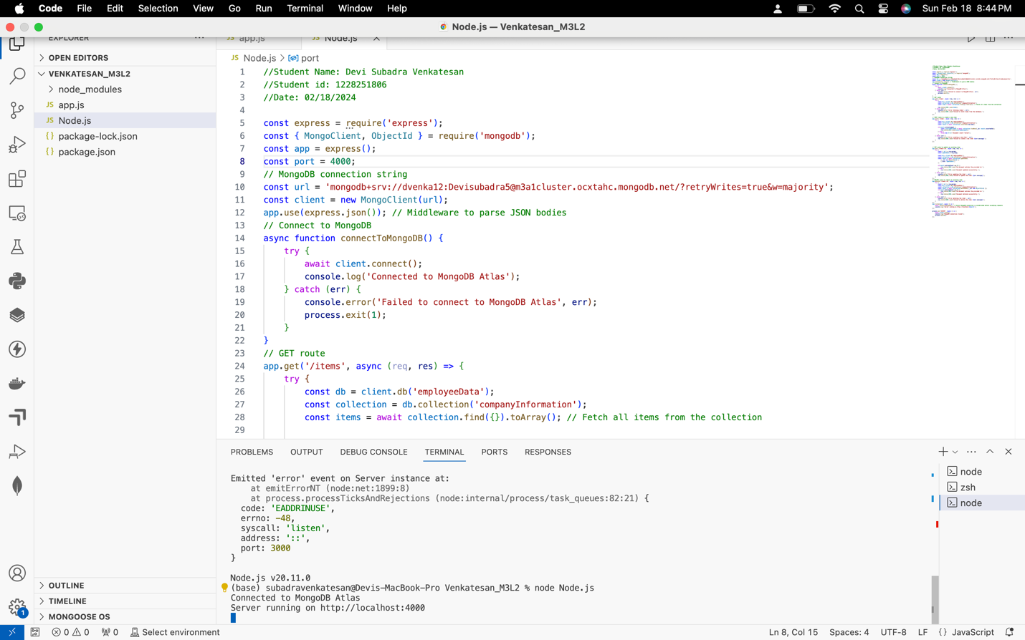



Post Function:

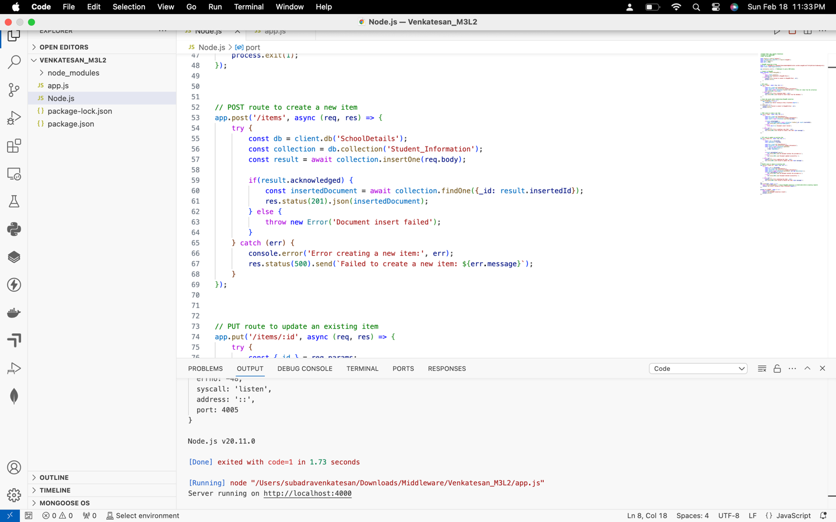

Put Function:

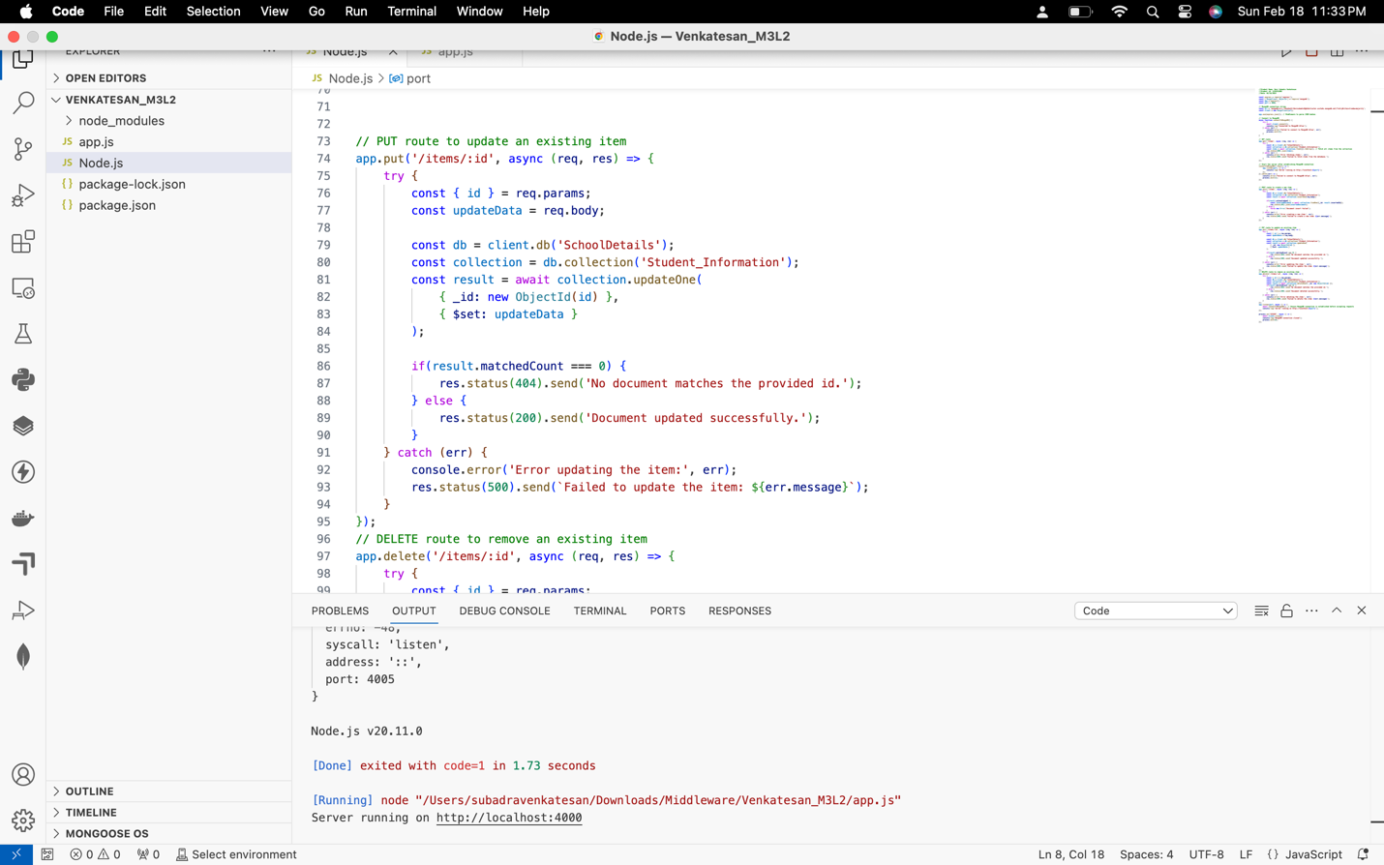

Delete Function: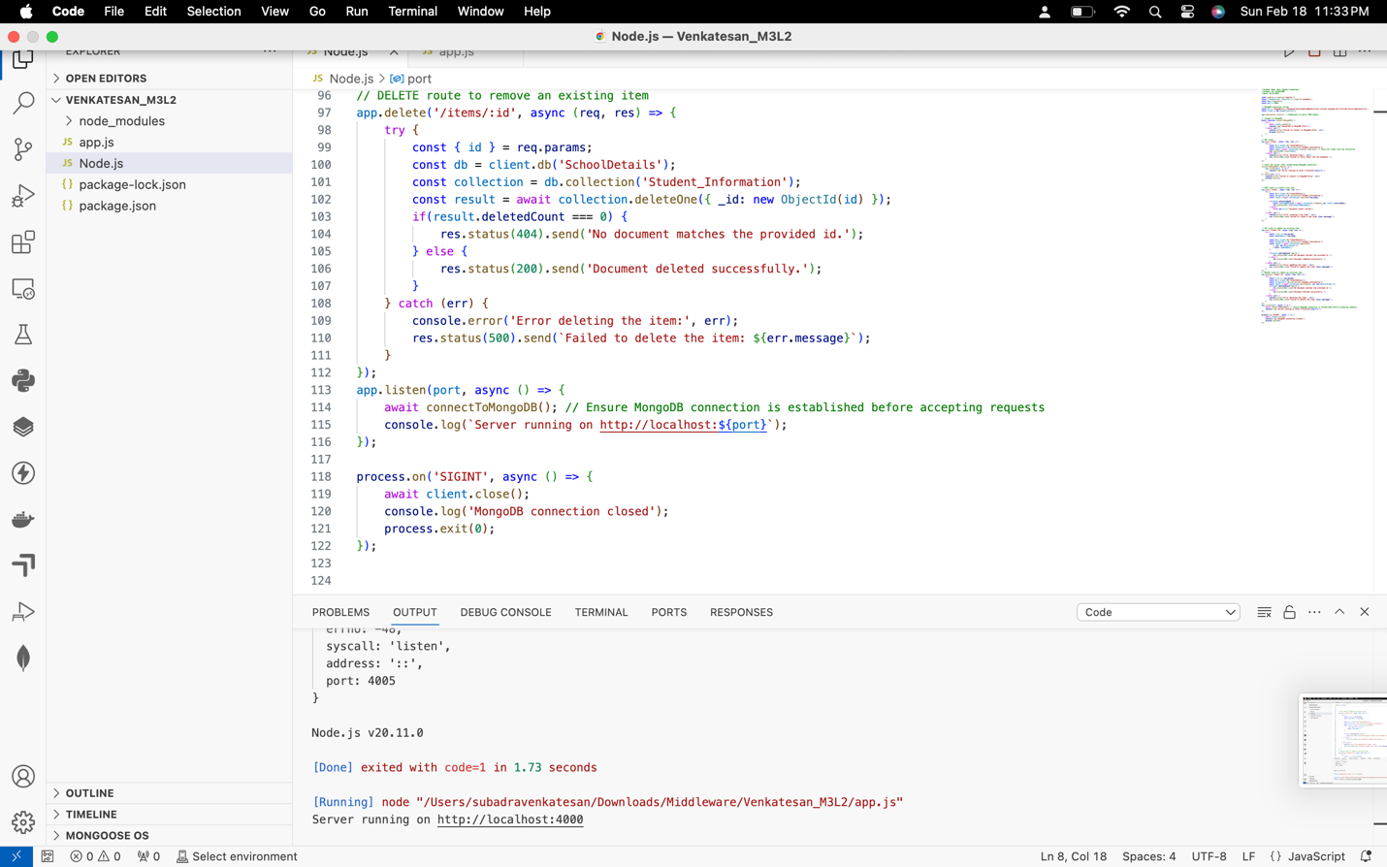

**Screenshots of Postman & MongoDB showing successful API requests and responses**

GET function.

POST function.

PUT function.

DELETE function.



