**Module 4 Activity 1: Protecting Resources**

**Submitted By: Devi Subadra Venkatesan**

**IFT 458 & IFT 554: Middleware Programming & Database Security**

**Dinesh Sthapit**

**Due Date: 03/03/2024**

**Project Initialization**

**Screenshot 1: Successful dependencies Installation**

**Debug Terminal Mode**

**Screenshot 2:**

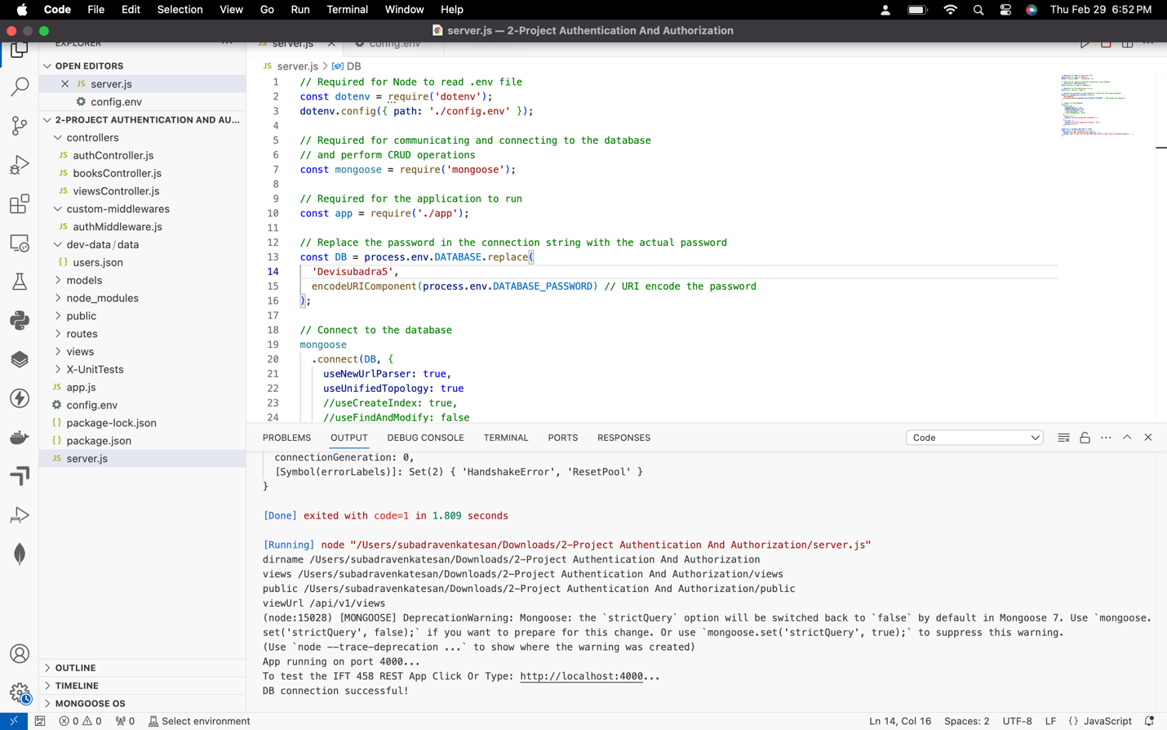

**Set Breakpoints**

**Screenshot 3:**

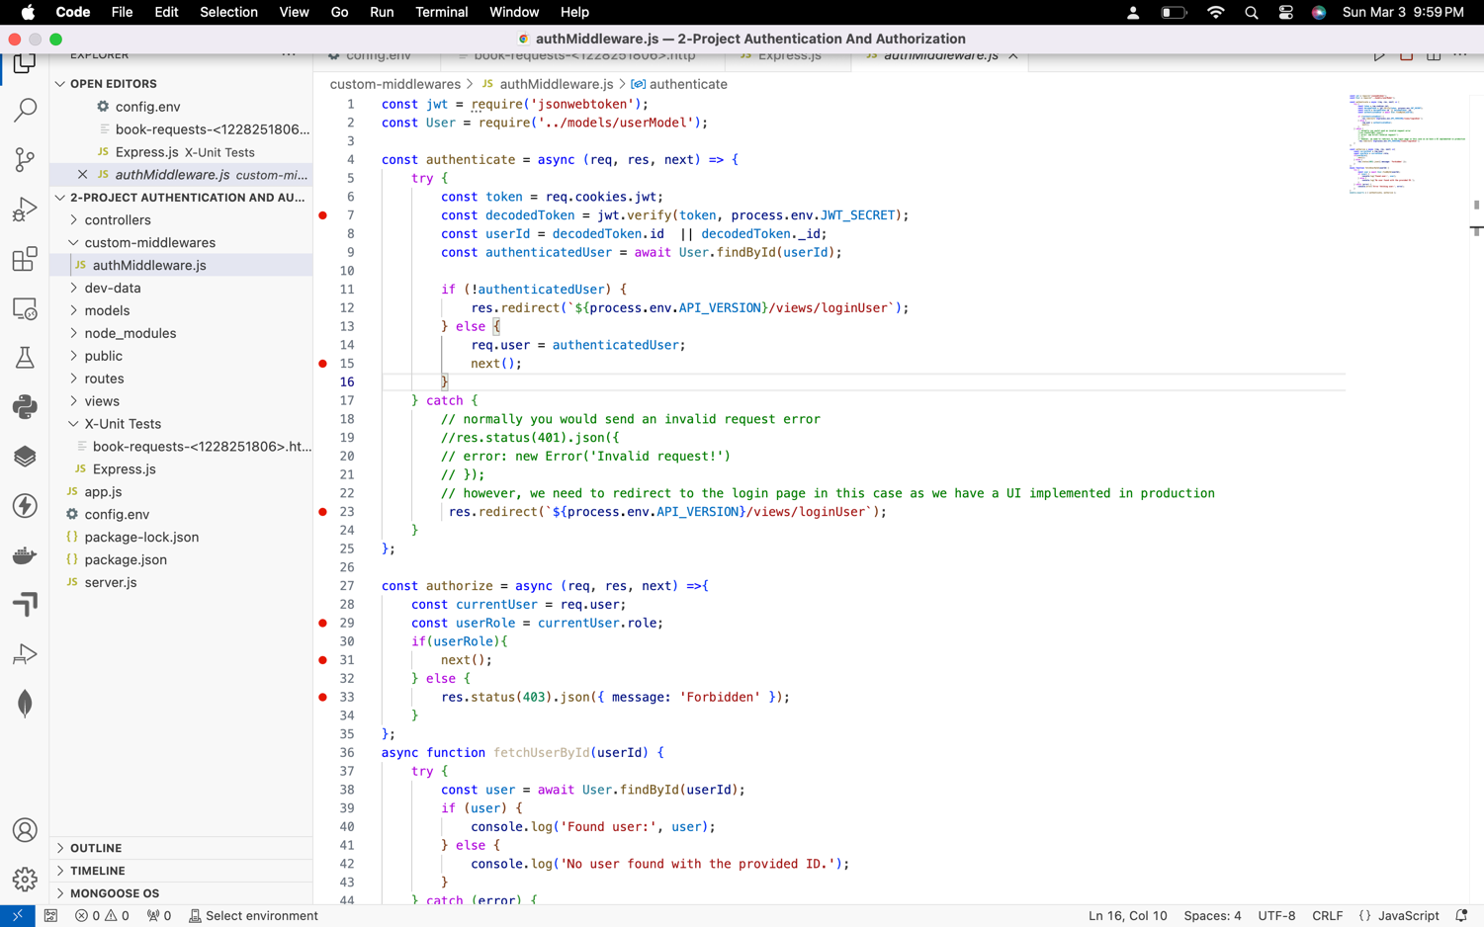

**Screenshot 4: ” Debugger Attached” message**

**Screenshot 5: Homepage of the application**

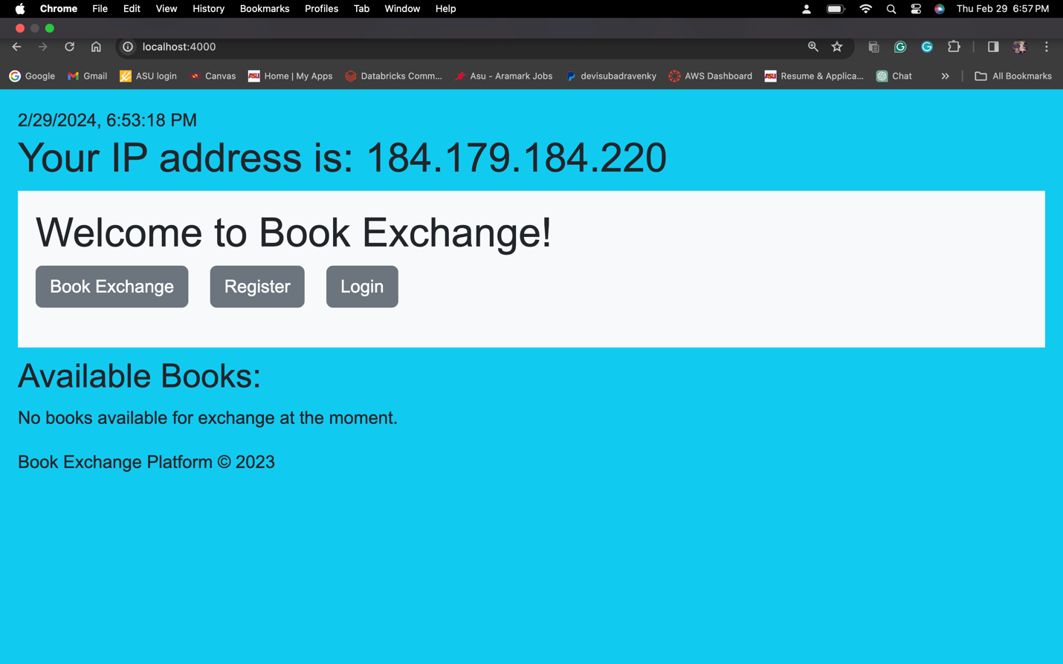

**Screenshot 6: " New Book Exchange" page and “ login screen” .**

**Login Page-**

**Sign-up-**

**Screenshot 7: "Add New Book Exchange" page, indicating access to protected resources.**

**Screenshot 8: Terminal page for restarting**

**Screenshot 9: Direct access to the "Add New Book Exchange" UI**

**Screenshot 10 : JWT token data**

