**Module 4 Lab 1: Protecting Resources**

**Submitted By: Devi Subadra Venkatesan**

**IFT 458 & IFT 554: Middleware Programming & Database Security**

**Dinesh Sthapit**

**Due Date: 03/03/2024**

**Screenshot 1: The application has stopped and restarted**

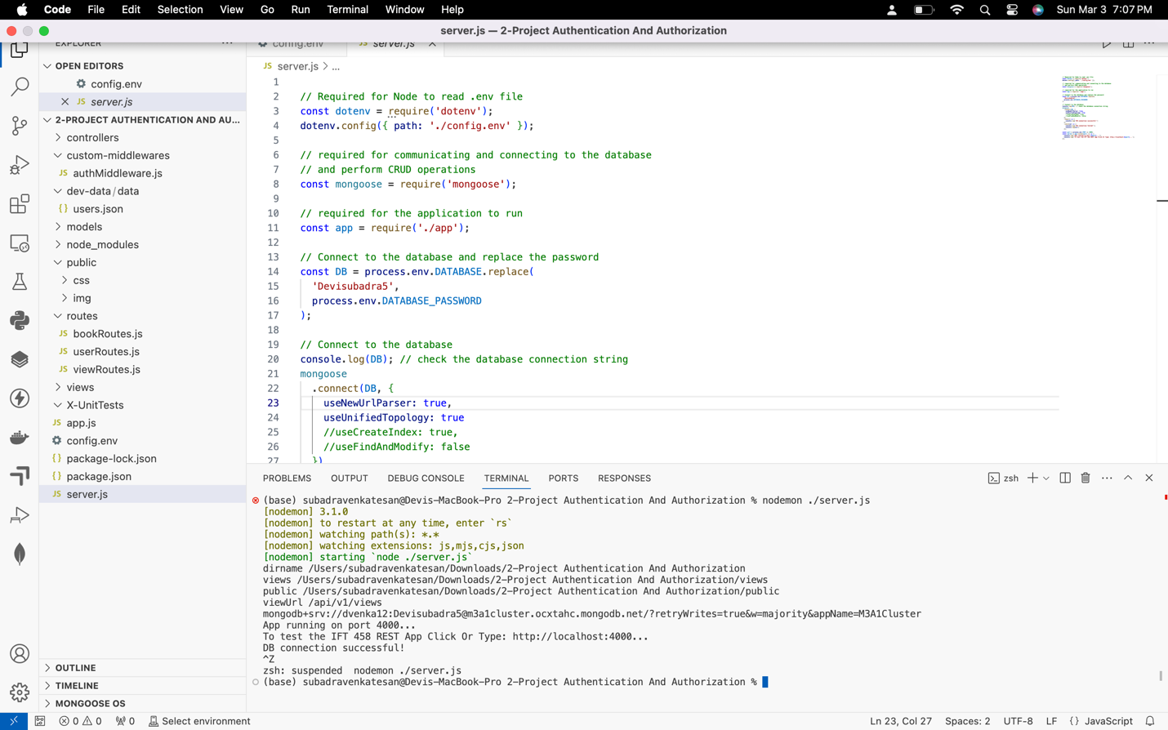

**Screenshot 2: Dependencies Installation**

**Screenshot 3: EJS file code and rendered UI**

**Screenshots of GET and POST client responses-**

**POST Rest client-**

**GET Rest Client-**

**GET by ID Client Responses-**

