**Variables**

(<https://realpython.com/quizzes/python-variables/>)

**Operators and Expressions**

(<https://realpython.com/quizzes/python-operators-expressions/>)

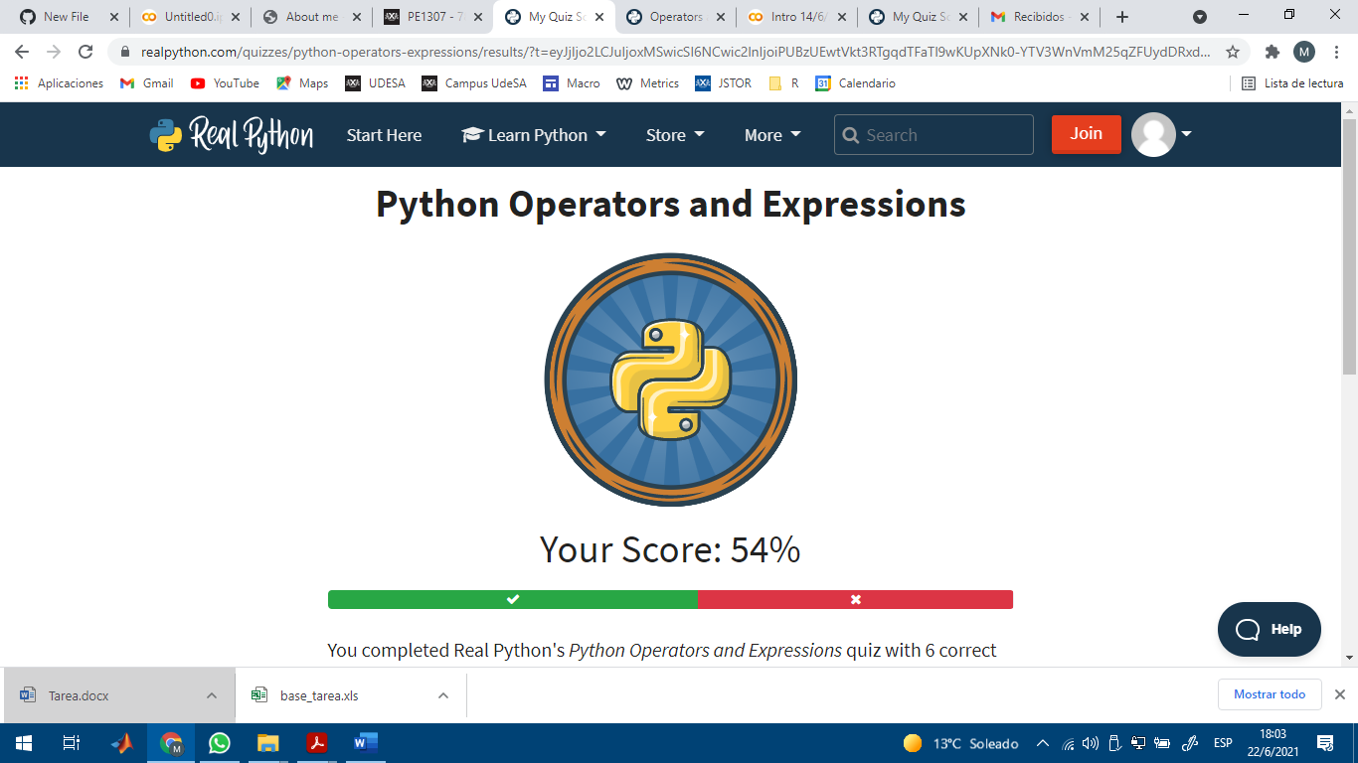

**Conditional statements**

(<https://realpython.com/quizzes/python-conditional-statements/>)

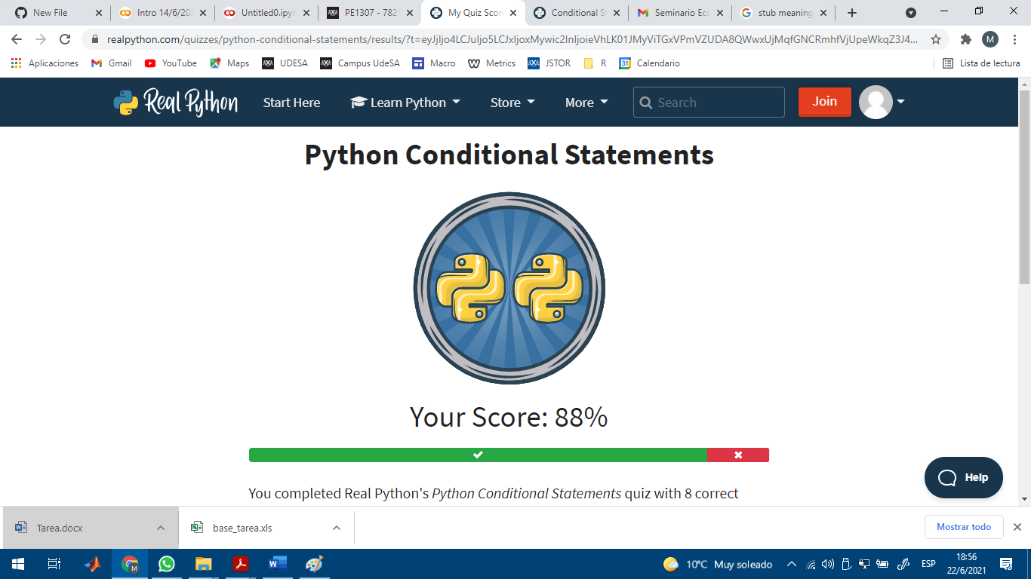

**Strings and character data**

(<https://realpython.com/quizzes/python-strings/>)

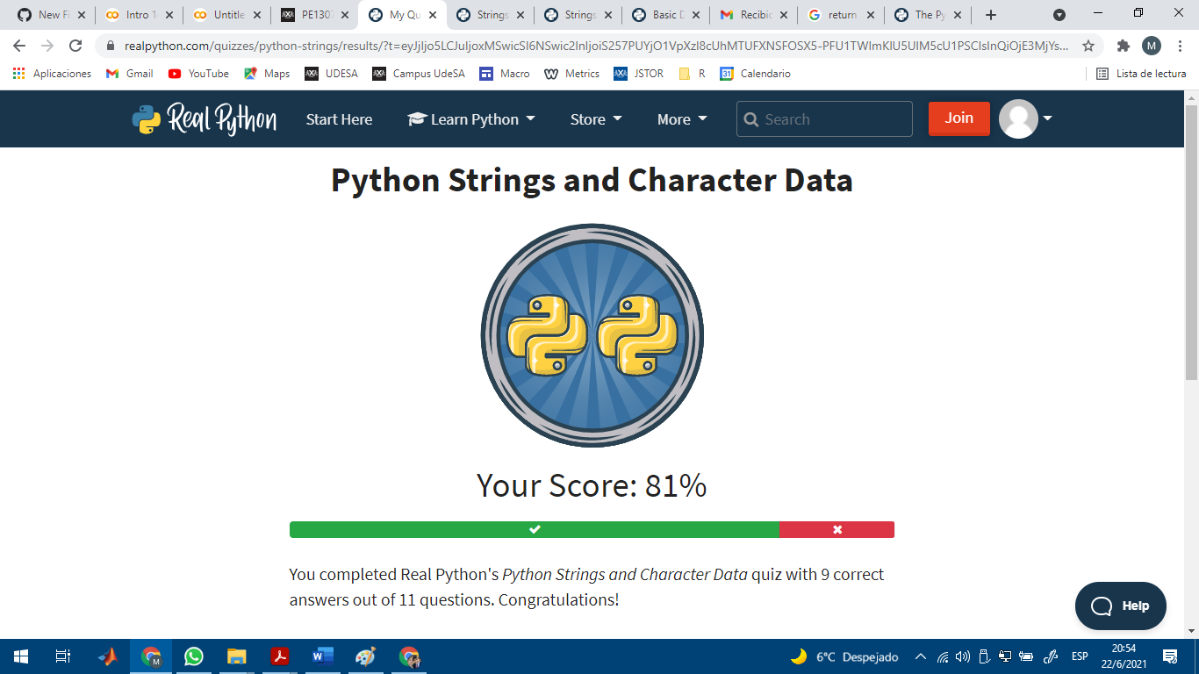

**Lists and Tuples**

(<https://realpython.com/quizzes/python-strings/>)

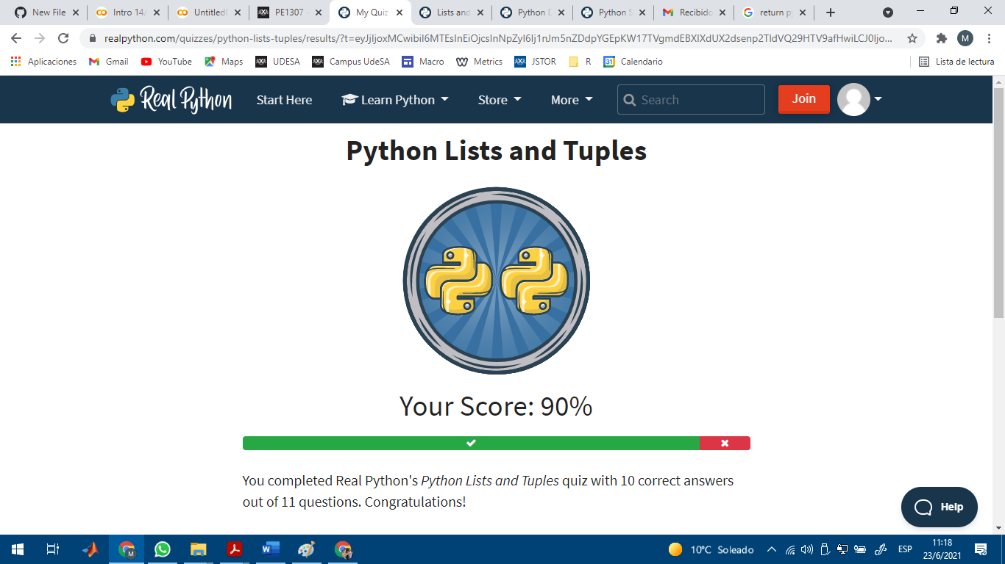

**Dictionaries**

(<https://realpython.com/quizzes/python-dicts/>)

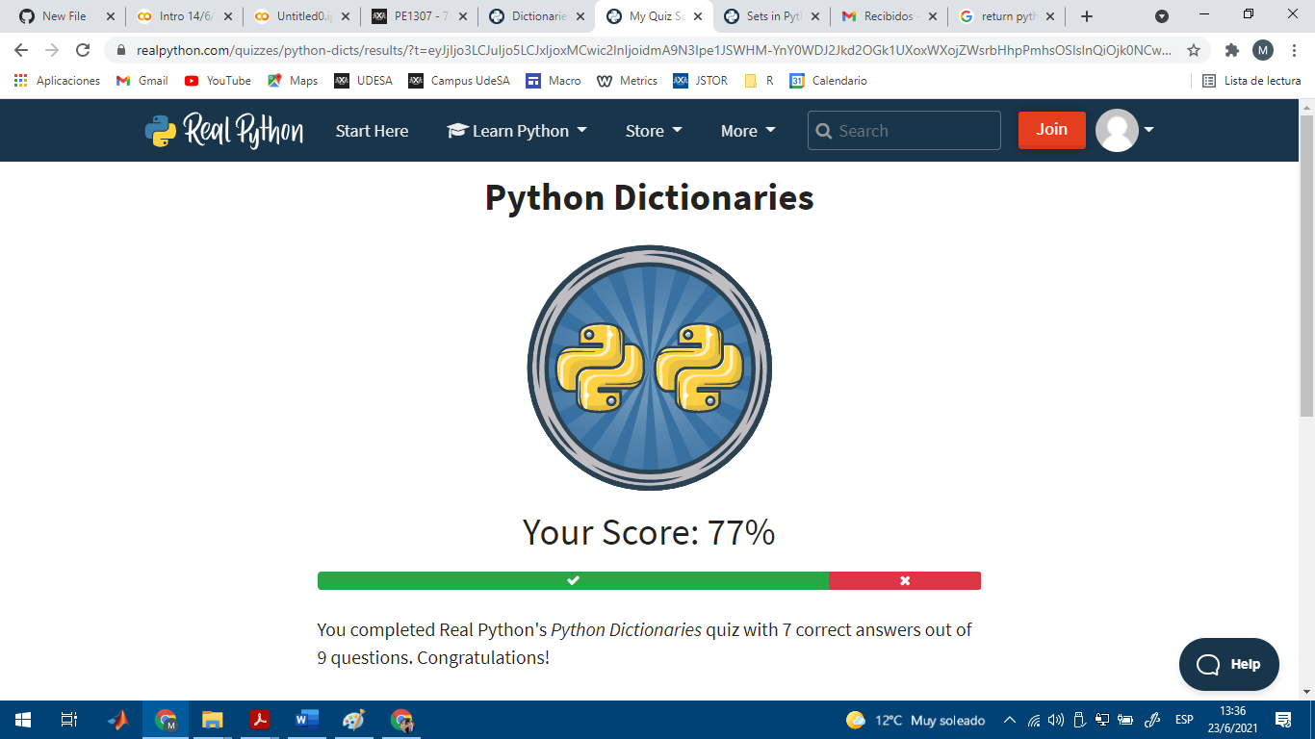

**Sets**

(<https://realpython.com/quizzes/python-sets/>)

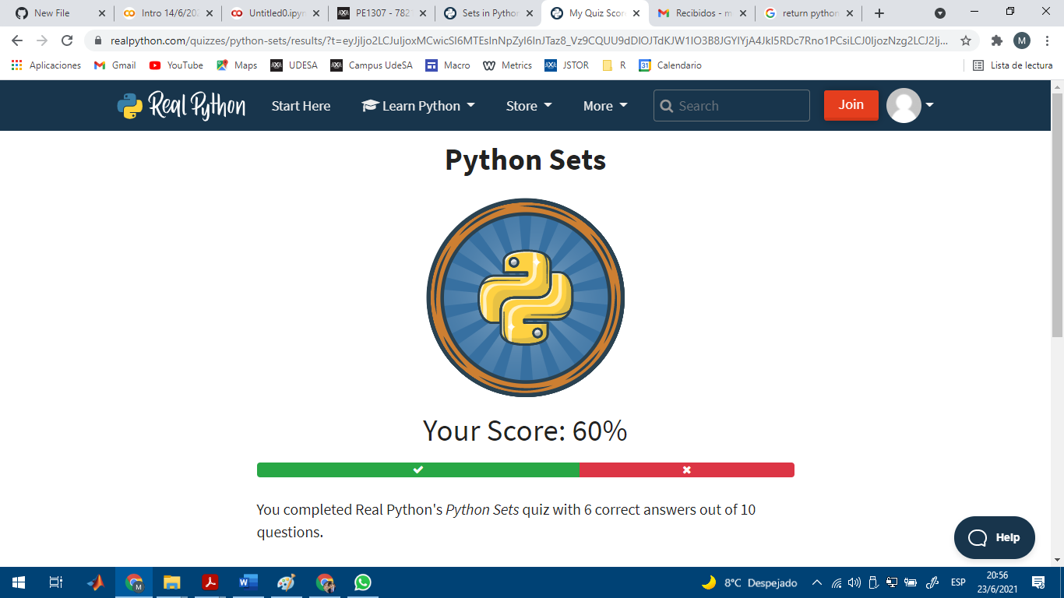

**Functions**

(<https://pynative.com/python-functions-quiz/>)

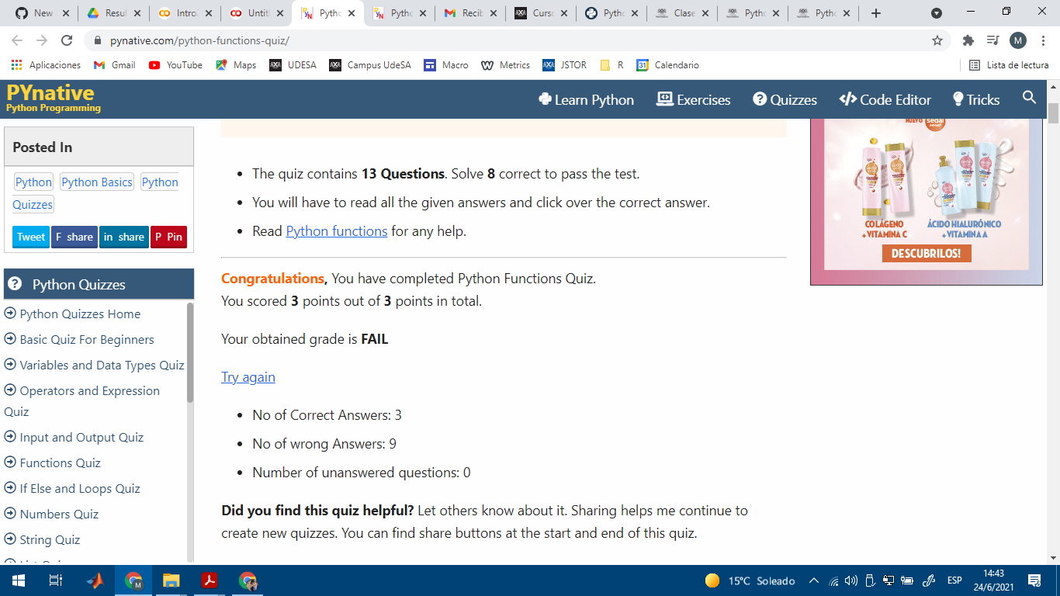

El resultado me dio FAIL, pero hice los ejercicios en Colab y me daban un resultado distinto al que dice como correcto: <https://colab.research.google.com/drive/1N_e8nYMRYxi-3DNKT82Vneuzw7UnIjOV>

**Program Structure**

(<https://realpython.com/quizzes/python-program-structure/viewer/>)

