User Manual

ℹ

**EECS 2311 W22 - Group 9**

**v0.2**

**Members:**

**-** Vivek Wadhwani (*vivek121@my.yorku.ca*)

* Kris Singh (*ksingh7@my.yorku.ca*)
* Kingsley Okon (*King808@my.yorku.ca*)
* Lan Zhang (*zhalala8@my.yorku.ca*)

**Project:** [github.com/devivekw/TAB2XML](https://github.com/devivekw/TAB2XML)

[**Documentation Link**](https://www.notion.so/EECS-2311-W22-Group-9-f2baeba60f334988a815d6a46fc53c2c)

**Table Of Contents**

1. Introduction
   1. Intended Use
   2. Features & Overview 2 System Requirements
2. Setup & Installation
   1. Setup with Eclipse + Gradle 4 Usage
   2. **View the music sheet**
   3. **Play the music**

# Introduction

is Java/Gradle based tool that enables users to convert musical tablature from text to [MusicXML](https://www.musicxml.com/) (*an open source standard for exchanging digital sheet music*) and

TAB2XML

enables them to play their converted file as well as visualize their file. This document outlines how a step-by-step guide to install and use the system for common use cases.

## Intended Use

The intended audience and use for this application/document is mainly guided towards testers for this system, as well our customers. This should cover most of the relevant use cases for the most up to date version of our system, further changes will be reflected in this document.

## Features & Overview

This app is built to be able to run offline and the user can interact with a graphical user interface that is simple and ease to use. The application will also allow the user to import a file of their choosing and export into a MusicXML file as well as the ability to play, pause, forward and rewind their converted audio file.

(**Note:** *As the product is under development and not been implemented completely, instruments of conversion are limited but will expand soon*)

# System Requirements

The following requirements mentioned below are the minimum needs your system needs to satisfy before you can install or run the app:

Java: v17+ (*JRE*)

Gradle: v7.3.3 or v7.1.1

Operating System: Windows, Mac, Ubuntu (*any OS that supports the above requirements*)

# Setup & Installation

TAB2XML is built as a Gradle project, and should work with any IDE/platform of your choice, but we will only go over installation in Eclipse.

## Setup with Eclipse + Gradle

* + 1. 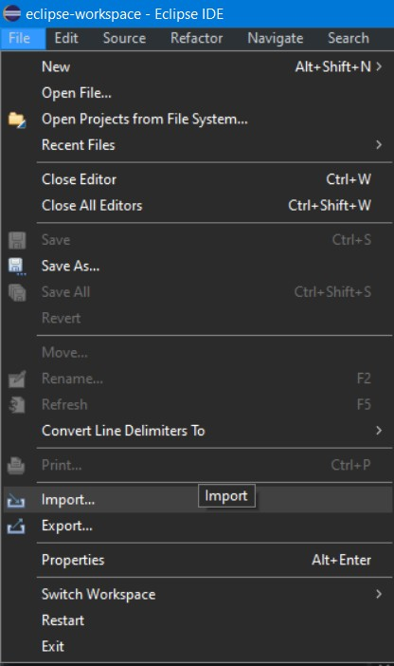We need to begin by importing the project from GitHub , can be done by selecting

File > Import

* + 1. The next step would be selecting menu provided

Git > Projects from Git (with smart import)

from the

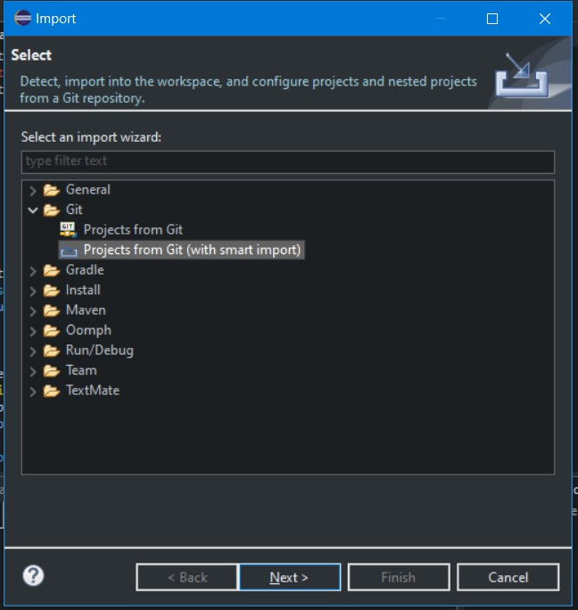

* + 1. And then select from the options available

Clone URI

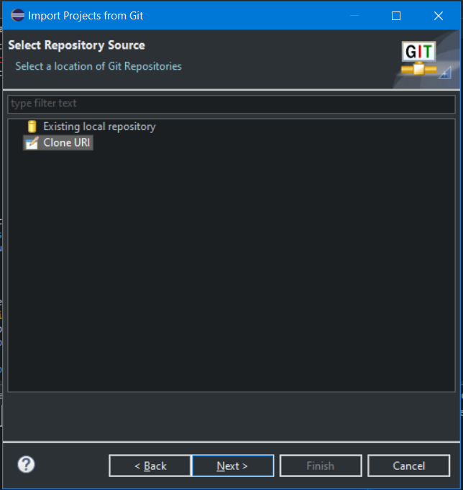

* + 1. This brings up a detailed menu with the information about the origin of the repository you’re trying to import in this case it would be -

[github.com/devivekw/TAB2XML](https://github.com/devivekw/TAB2XML). Paste the link in the section and fill in the

URI

other sections if you wish to do so. (*Not required if you are just trying to setup*)

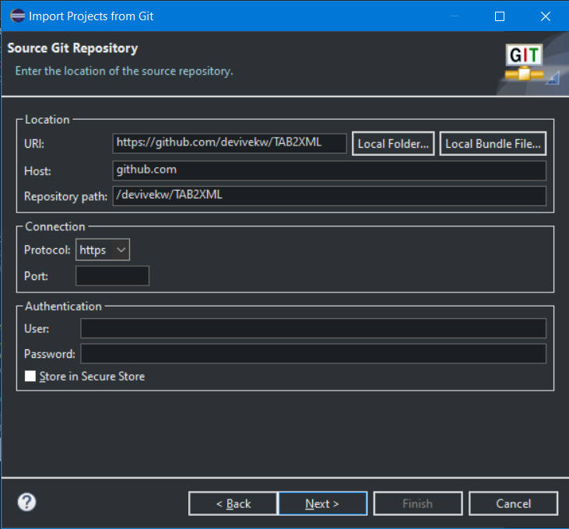

* + 1. Once the project is successfully imported we would need perform the following three steps:
       1. Go to

Windows > Preference > Java > Installed JREs

JRE is set to

v17

and make sure the default

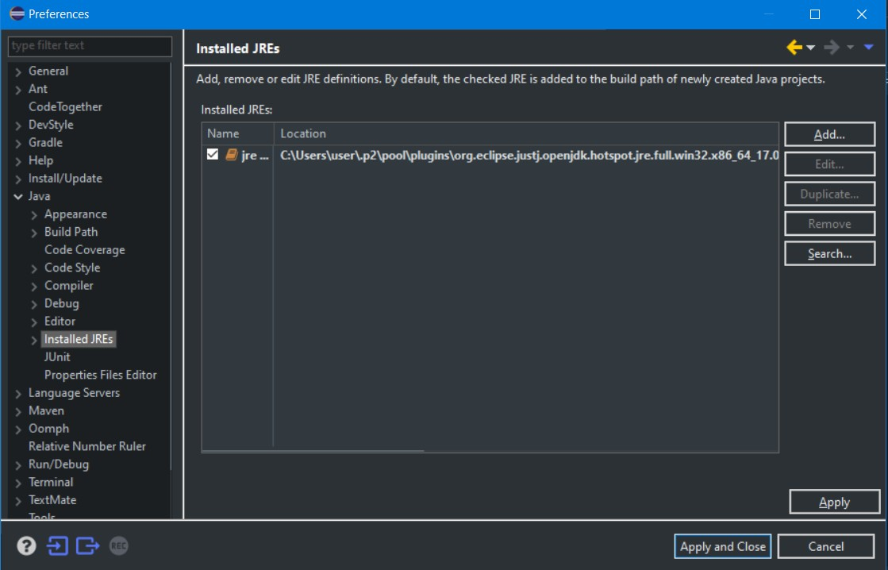

* + - 1. Go to

Windows > Preference > Gradle

7.1.1

and select

to be 7.3.3 or

Gradle Version

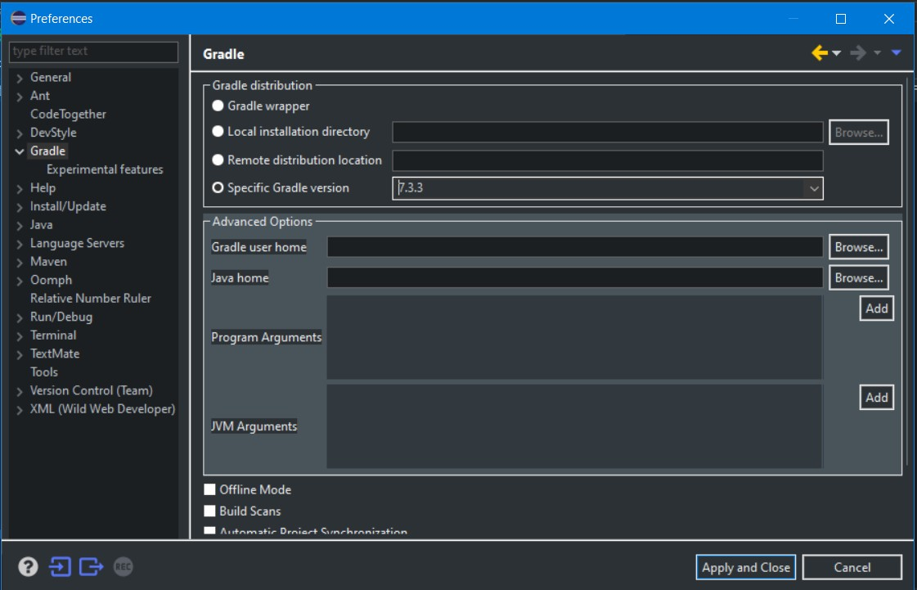

* + - 1. Right-click on the project folder and the Gradle Tasks are working

Gradle > Refresh Gradle Project

make sure

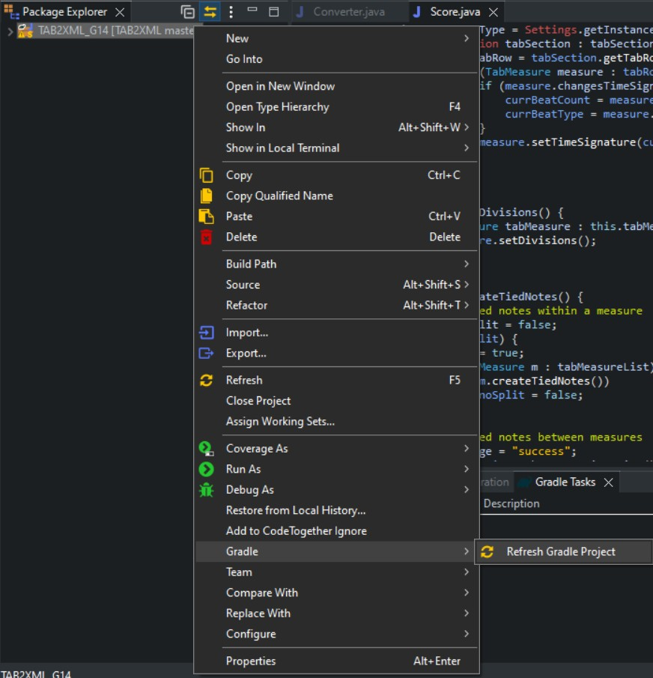

* + 1. In the Gradle Task window now you will be able to see various options and go

ahead and select to build the project.

TAB2XML > build > build

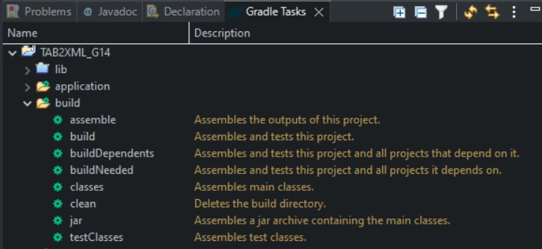

Following all the above steps, you should be able to successfully build the project. Then follow the steps below to run and use the application.

# Usage

The following section entails in detail how to use the application for the two main task.

## View the music sheet

* + 1. After correctly setting up the project, simply start the application using the Gradle run command in

Gradle Tasks > TAB2XML_G14 > application > run

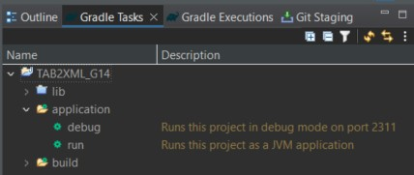

Double click on the run button to launch the application.

* + 1. Upon launching the application, you will be greeted by the home screen where you can choose to either paste in the tablature into the white space or upload a .txt file

from and then select the desired file. You can also paste the .txt file

File > Open...

content to the API interface text field to add the file

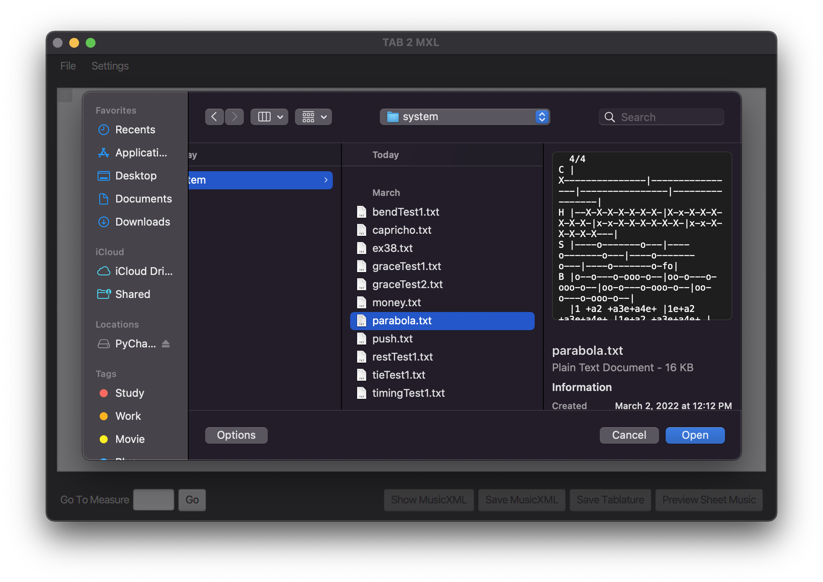

1. Now the text is loaded. To view the music score, Click the Preview Sheet Music button.

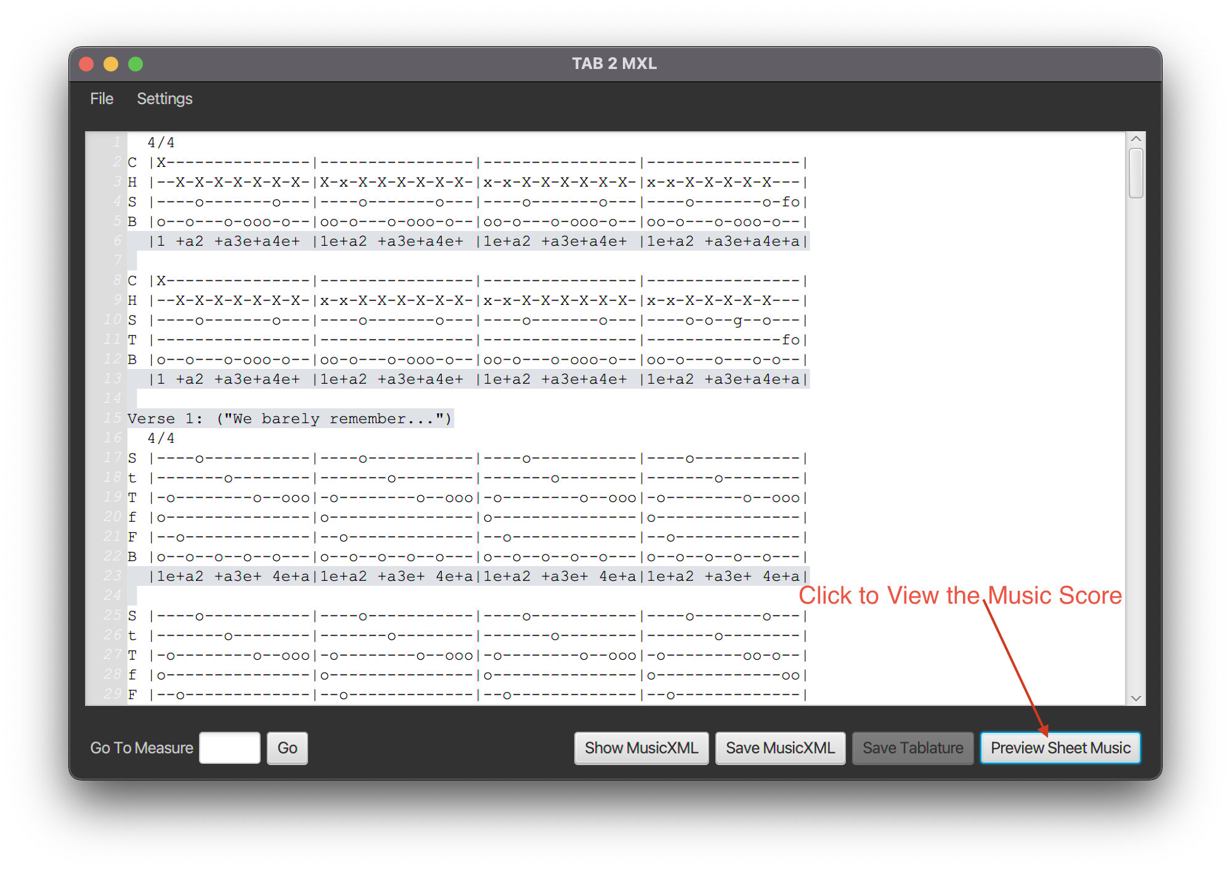

text filed is loaded with musicFile.txt content

1. Since the imported music text is for the Drumset instrument. The clef is shown as percussion. We identified the position of notes based on their notes octave and display-step. For instance, we covered notes from C4 up to G5 combining display- step and octave. We have included note elements such as Duration, Type, noteHead, Chord, Grace and Slur into our implementation. As well as we implemented measures and their numbers. when the file is large, user can use scroll to view the full script.

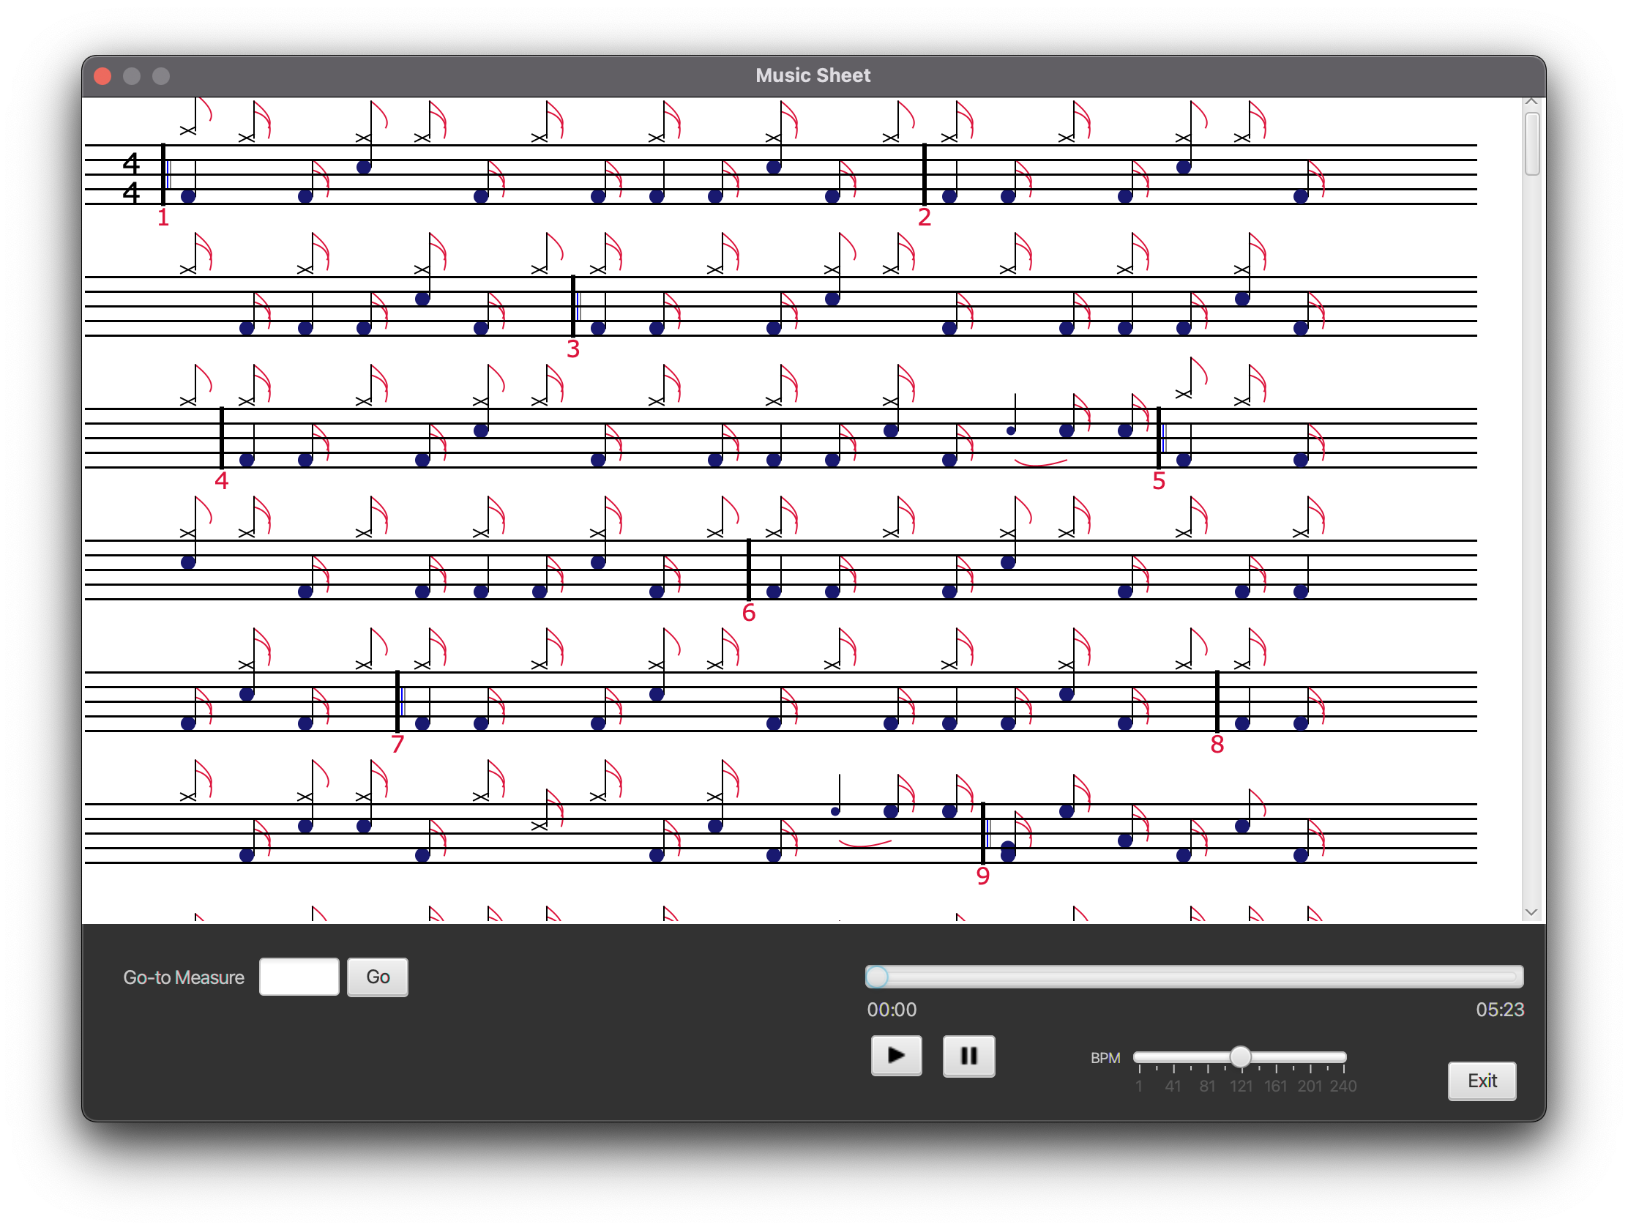

music sheet generated from parabola.txt

1. Similarly, supports guitar sheet music and common guitar note elements

TAB2XML

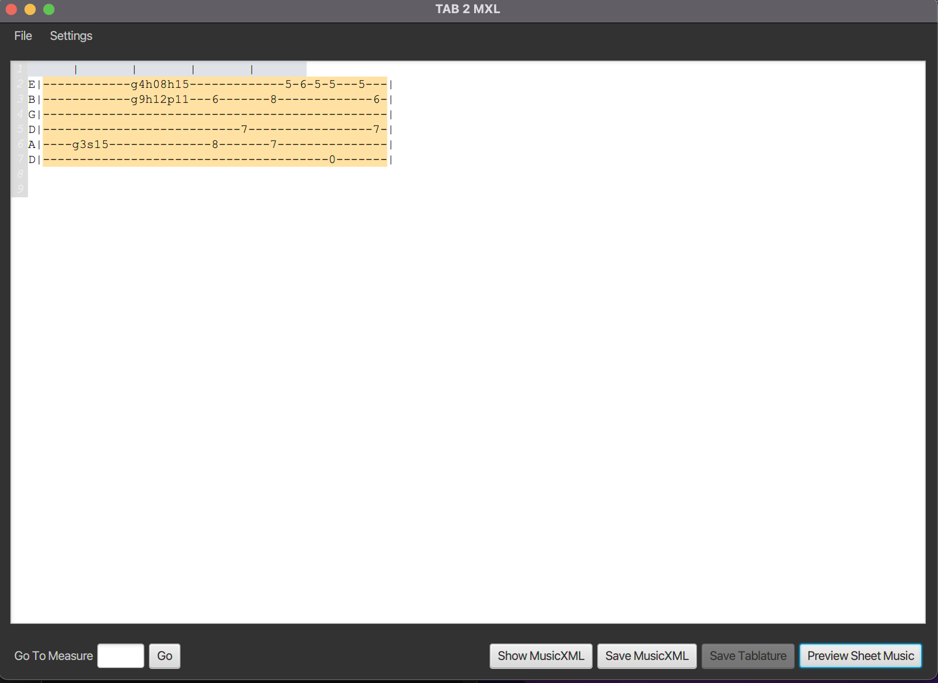

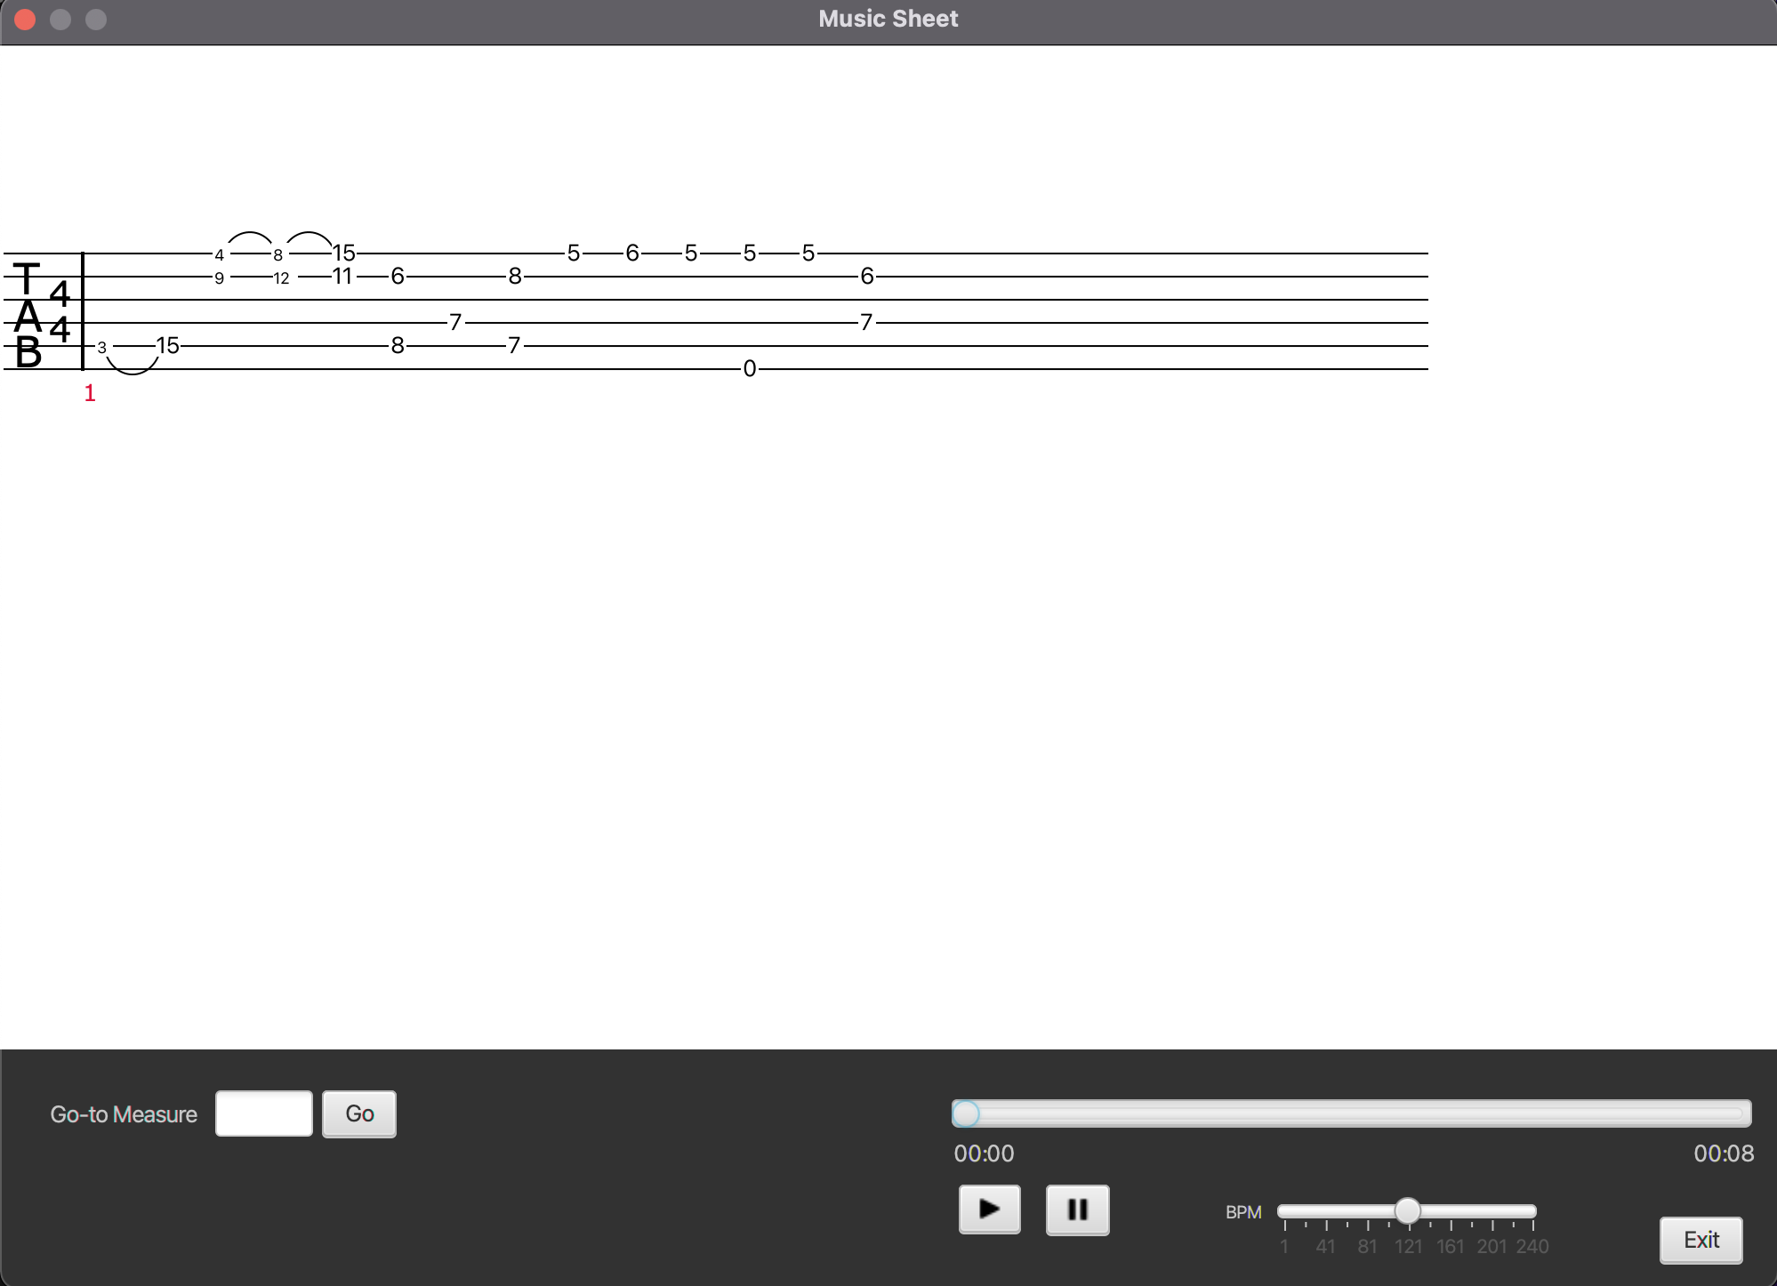

Sample screenshot of the guitar preview sheet Music window.

## Play the music

* + 1. Once you are in the preview sheet music window there is a panel to the bottom right with a music player that enables users to play the music in the given tablature.

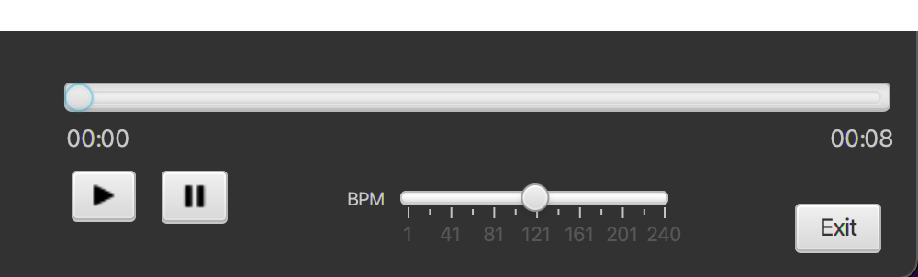

Music Player

* + 1. Once you click the button, the slider and time are updated and start to

play

pause

exit

progress until you either

the music, change the tempo , or

the window.

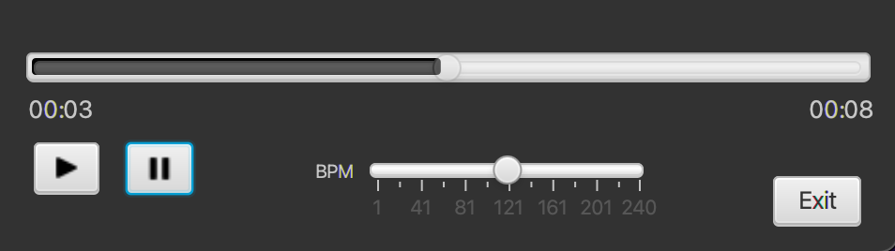

Pause music playback

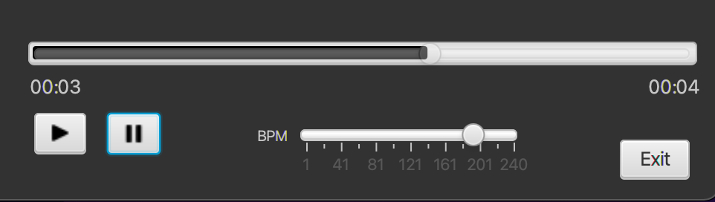

Adjust the tempo

* + 1. If you are using a lengthier tablature, you can use the function to find

Go To Measure

a specific measure by entering what measure you are looking for and pressing the button.



Go

1. Simply press the play button to being the playback and press pause when you are satisfied.
2. Additionally, the Music Player has a per minute of the playback if you wish.

BPM

slider where you can customize the beats

7. Once you are finished with the program, you can press the button in the sheet

Exit

music window and exit out of the program by clicking on the x button in the top right of the screen.