Stock Market Portfolio Web App

[Explain as a web developer]

* A stock market portfolio is like a collection of different investments that you own - think of it as your personal investment basket.
* The Stock Market Portfolio project is a web application that helps to efficiently manage and track stock market investments and portfolios.
* 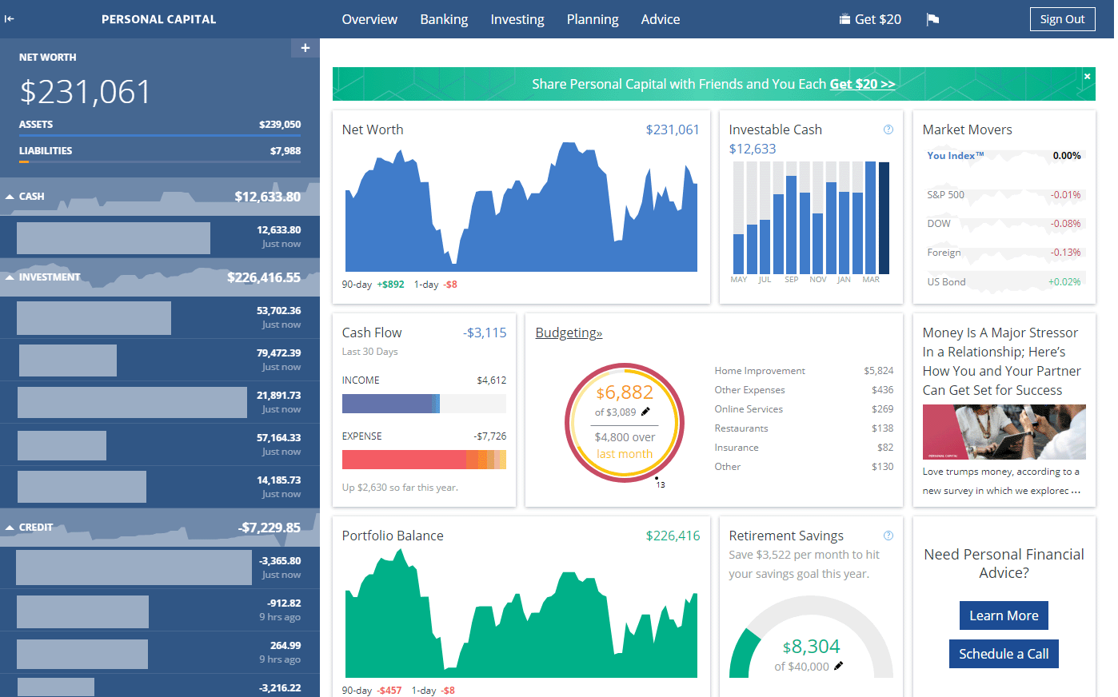  
  A stock market web app is a platform that allows users to manage their investments, track stock performance, and analyze market data.   
    
  Core Features of a Stock Market Portfolio Web App
* **Real-Time Market Data**
* The app should provide users with up-to-the-minute stock prices, trading volumes, and other market indicators. This information is crucial for making informed trading decisions and monitoring market trends
* [1](https://www.spaceotechnologies.com/blog/stock-trading-app-development/" \t "_blank)
* [4](https://openwebsolutions.in/blog/10-features-stock-market-app/" \t "_blank)
* .
* **Portfolio Tracking**
* Users need the ability to track their investments, including gains and losses over time. The app should display current values of holdings, overall portfolio performance, and asset allocation
* [3](https://syndelltech.com/the-essential-features-for-a-successful-stock-market-app-development/" \t "_blank)
* [4](https://openwebsolutions.in/blog/10-features-stock-market-app/" \t "_blank)
* .
* **Customizable Watchlists**
* A watchlist feature allows users to add stocks they are interested in monitoring closely. This helps users stay updated on specific stocks without having to search for them repeatedly
* [2](https://www.rupeeseed.com/key-features-of-a-good-stock-market-app/" \t "_blank)
* [4](https://openwebsolutions.in/blog/10-features-stock-market-app/" \t "_blank)
* .
* **Advanced Charting Tools**
* Incorporating advanced charting tools enables users to conduct technical analysis of stocks. Features might include various chart types, technical indicators (like moving averages), and drawing tools for trend analysis
* [3](https://syndelltech.com/the-essential-features-for-a-successful-stock-market-app-development/" \t "_blank)
* [4](https://openwebsolutions.in/blog/10-features-stock-market-app/" \t "_blank)
* .
* **Alerts and Notifications**
* Users should receive customizable alerts for significant events such as price changes, earnings announcements, or news updates related to their tracked stocks. This keeps them informed without constant monitoring
* [1](https://www.spaceotechnologies.com/blog/stock-trading-app-development/" \t "_blank)
* [3](https://syndelltech.com/the-essential-features-for-a-successful-stock-market-app-development/" \t "_blank)
* .
* **Integration with Financial Accounts**
* The app can allow users to link their brokerage accounts or bank accounts for a comprehensive view of their financial portfolio. This integration simplifies management and provides better insights into overall financial health
* [1](https://www.spaceotechnologies.com/blog/stock-trading-app-development/" \t "_blank)
* [2](https://www.rupeeseed.com/key-features-of-a-good-stock-market-app/" \t "_blank)
* .
* **Educational Resources**
* Providing articles, videos, and courses can help users improve their investing knowledge. This feature is particularly beneficial for beginners but can also serve experienced investors looking to refine their strategies
* [1](https://www.spaceotechnologies.com/blog/stock-trading-app-development/" \t "_blank)
* [7](https://www.gotradingo.com/blog/15-features-to-look-for-in-a-reliable-stock-market-trading-app" \t "_blank)
* .
* **User-Friendly Interface**
* A clean and intuitive user interface (UI) enhances the user experience (UX). Navigation should be straightforward, allowing users to access market data, portfolios, and trading options easily
* [2](https://www.rupeeseed.com/key-features-of-a-good-stock-market-app/" \t "_blank)
* [7](https://www.gotradingo.com/blog/15-features-to-look-for-in-a-reliable-stock-market-trading-app" \t "_blank)
* .
* **Security Features**
* Implementing robust security measures such as two-factor authentication (2FA) is essential to protect user accounts from unauthorized access
* [7](https://www.gotradingo.com/blog/15-features-to-look-for-in-a-reliable-stock-market-trading-app" \t "_blank)
* .
* **Performance Analysis Tools**
* The app should offer tools that allow users to analyze the performance of their portfolios over time using various metrics and visualizations

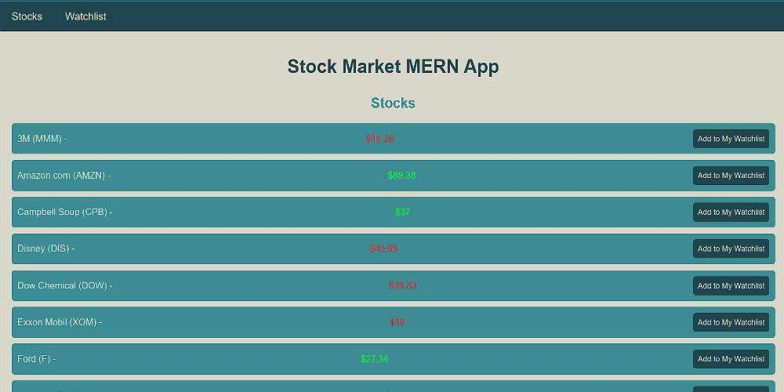

Flow Diagram [  
as a three tier architecture]

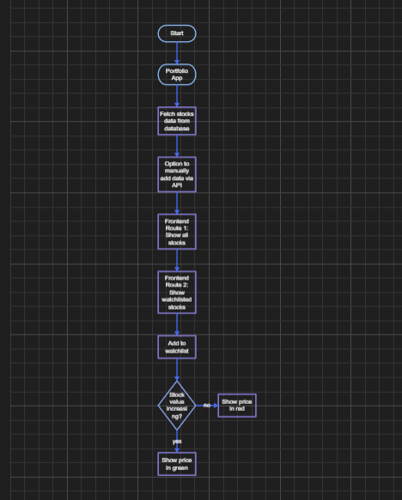

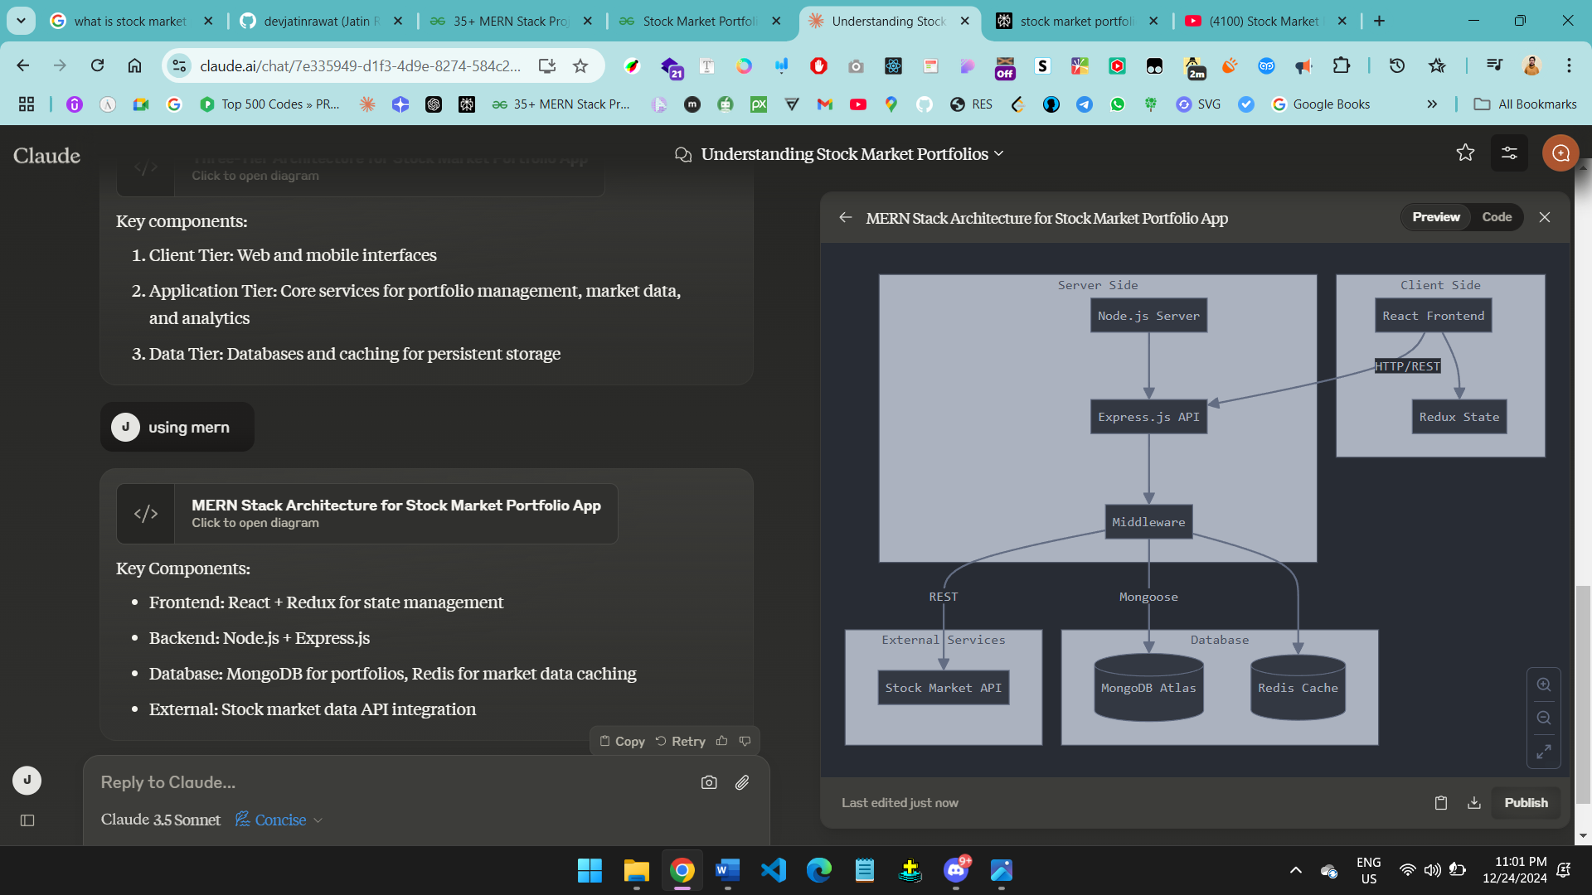

Package.json

Npm init -y

1. Acts as a manifest file containing project metadata including name, version, dependencies, and scripts

2. Lists all required npm packages (dependencies) and development dependencies needed to run the project

3. Defines scripts for common tasks like "start", "test", "build" that can be run using npm commands

4. Controls which versions of packages are installed using version constraints (e.g., "express": "^4.17.1")

5. Essential for npm/Node.js to understand how to handle the project and its dependencies during installation and execution  
  
**Step 1:**Create a folder for the projectbackend and initialized the Express Application.

mkdir stock-market-portfolio  
cd stock-market-portfolio  
npm init -y

**Step 2:** Install Express and other required packages:

npm install express mongoose body-parser cors

package-lock.json =>   
• Automatically generated file that locks exact versions and dependencies of all installed packages

• Ensures consistent installations across different environments by recording precise package versions and their entire dependency tree

• Contains integrity hashes to verify each package hasn't been modified

• Helps prevent issues caused by package updates by maintaining exact versions rather than version ranges

• Should be committed to version control to ensure all developers use identical dependencies

Npm : software package manager.

<https://www.slideshare.net/slideshow/express-js-56848061/56848061#5>  
  
<https://www.slideshare.net/slideshow/nodejs-presentation-91061690/91061690>  
  
<https://www.slideshare.net/slideshow/express-js-56848061/56848061>

route handler app.get   
<https://masteringjs.io/tutorials/express/app-get>  
  
The app.listen() method in Express.js is used to start the server and listen for incoming connections on a specified port. Here are the key points about app.listen() based on the provided search results:

1. **Server Initialization**: app.listen(port, callback) binds the Express application to a specific port, allowing it to accept incoming HTTP requests. The port parameter specifies which port the server will listen to, while the optional callback function is executed once the server starts successfully

[1](https://www.geeksforgeeks.org/express-js-app-listen-function/" \t "_blank)

[2](https://www.geeksforgeeks.org/express-js-app-listen-vs-server-listen/" \t "_blank)

.

1. **Default Behavior**: If the port is not specified, Express will typically use a default port (often 3000) or assign an arbitrary unused port by the operating system, which can be useful for automated tasks like testing

[5](https://www.tutorialspoint.com/express-js-app-listen-method" \t "_blank)

.

1. **Host Specification**: You can also specify an optional host parameter to define the IP address on which the server should listen. If not provided, it listens on all available network interfaces (0.0.0.0) by default

[2](https://www.geeksforgeeks.org/express-js-app-listen-vs-server-listen/" \t "_blank)

[5](https://www.tutorialspoint.com/express-js-app-listen-method" \t "_blank)

.

1. **Connection Queue**: The method can accept an optional backlog parameter that defines the maximum length of the queue for pending connections, helping manage how many connections can be waiting to be processed

[2](https://www.geeksforgeeks.org/express-js-app-listen-vs-server-listen/" \t "_blank)

[5](https://www.tutorialspoint.com/express-js-app-listen-method" \t "_blank)

.

1. **Logging and Callbacks**: The callback function can be used to log messages or perform actions after the server has started listening, such as confirming that the server is running and on which port it is accessible

[1](https://www.geeksforgeeks.org/express-js-app-listen-function/" \t "_blank)

[3](https://stackoverflow.com/questions/70384927/what-does-the-listen-method-in-express-look-like" \t "_blank)

.Why Importing ?

Importing modules in Node.js is essential for several reasons:

1. **Code Reusability**: By importing modules, you can reuse code across different parts of your application or even in different projects, which reduces redundancy and promotes DRY (Don't Repeat Yourself) principles. For example, importing the express module allows you to use its functionalities to create web servers without having to rewrite the underlying HTTP handling code.
2. **Modularity**: Importing allows you to break your application into smaller, manageable pieces or modules. Each module can encapsulate specific functionality, making it easier to maintain and debug. This modularity helps developers organize their code logically and improves collaboration among team members.
3. **Dependency Management**: When you import modules, you can easily manage dependencies between different parts of your application. For instance, if a module relies on another module (like mongoose for database interactions), importing makes it clear what dependencies are needed for that module to function correctly.
4. **Enhanced Maintainability**: With imported modules, you can update or modify a single module without affecting the entire application. This separation of concerns leads to better maintainability and allows developers to focus on specific functionalities without worrying about the entire codebase.
5. **Access to External Libraries**: Importing enables you to leverage a vast ecosystem of third-party libraries available through npm (Node Package Manager). For example, by importing cors, you can easily implement Cross-Origin Resource Sharing in your application without writing custom code.

In summary, importing modules in Node.js is crucial for creating organized, maintainable, and scalable applications by promoting code reuse, modularity, and efficient dependency management.  
  
Other Way to write require :

1. **Using ES6 Import Syntax**

Instead of using require, you can use the import statement to bring in modules. For example:

javascript

*// Instead of using require*

**const** express = require("express");

*// Use import syntax*

**import** express **from** "express";

2. **Exporting Modules**

When creating your own modules, you can export functions, objects, or variables using the export keyword:

javascript

*// myModule.js*

**export** **const** myFunction = () => {

console.log("Hello from myFunction!");

};

*// Or export default*

**const** myDefaultFunction = () => {

console.log("This is the default export!");

};

**export** **default** myDefaultFunction;

// Import required modules

const express = require("express"); // Express framework for building web applications

const mongoose = require("mongoose"); // Mongoose for MongoDB object modeling

const cors = require("cors"); // Middleware to enable Cross-Origin Resource Sharing

const bodyParser = require("body-parser"); // Middleware to parse incoming request bodies

// Create an instance of the Express application

const app = express();

// Define the port on which the server will listen, defaulting to 5000 if not specified in environment variables

const PORT = process.env.PORT || 5000;  
  
**Importance of .env as a security aspect**

The .env file is often used in Node.js and other programming environments to store configuration settings and environment variables that the application needs to run. One of the key benefits of using .env files is for security purposes.

1. **Sensitive Data Isolation**: Storing sensitive data like API keys, database passwords, and other secrets in a .env file separate from your code means you're not exposing this sensitive information in the application's source code. This is crucial for reducing the risk of accidental exposure of secrets.
2. **Environment-specific Configuration**: .env files can be tailored for different environments (development, staging, production, etc.), which allows you to easily separate environment-specific security configurations.
3. **Version Control**: By keeping sensitive information in a .env file, you can safely commit your other code files to version control systems like Git without including the secrets. Typically, the .env file is listed in the .gitignore file to prevent it from being committed to the repository.
4. **Access Control**: You can set strict OS-level permissions on the .env file to restrict who can read it, adding another layer of security.
5. **Ease of Update**: If any of the third-party services whose credentials are being used in the application has been compromised, using .env files makes it easier to update those without touching the codebase.
6. **Code Reusability and Sharing**: If secrets are stored separately, code can be more easily shared between developers or even made public without disclosing sensitive information.

So, the .env file is an important aspect of application security, but it's not a one-stop solution. It should be part of a broader strategy for securely managing configuration data we will discuss more into upcoming articles.

if process.env.PORT is set, the Express app will listen on that port. Otherwise, it will default to listening on port 3000

// Use middleware for handling CORS and parsing JSON request bodies

app.use(cors());

app.use(bodyParser.json());

// Connect to MongoDB using Mongoose

mongoose.connect("Your MongoDB URI link", {

useNewUrlParser: true, // Use the new URL parser to avoid deprecation warnings

useUnifiedTopology: true, // Use the new Server Discover and Monitoring engine

});

// Define a Mongoose schema for the stock data

const stockSchema = new mongoose.Schema({

company: String, // Name of the company

description: String, // Description of the stock

initial\_price: Number, // Initial price of the stock

price\_2002: Number, // Price of the stock in 2002

price\_2007: Number, // Price of the stock in 2007

symbol: String, // Stock symbol (ticker)

});

// Create a Mongoose model based on the defined schema

const Stock = mongoose.model("Stock", stockSchema);

// Define a route to handle GET requests for retrieving all stocks

app.get("/api/stocks", async (req, res) => {

try {

const stocks = await Stock.find(); // Fetch all stocks from the database

res.json(stocks); // Send the retrieved stocks as a JSON response

} catch (error) {

console.error(error); // Log any errors that occur during the process

res.status(500).json({ error: "Internal Server Error" }); // Send an error response if something goes wrong

}

});

// Define a route to handle POST requests for adding a stock to the watchlist

app.post("/api/watchlist", async (req, res) => {

try {

// Destructure stock data from the request body

const {

company,

description,

initial\_price,

price\_2002,

price\_2007,

symbol,

} = req.body;

// Create a new stock instance using the provided data

const stock = new Stock({

company,

description,

initial\_price,

price\_2002,

price\_2007,

symbol,

});

await stock.save(); // Save the new stock to the database

res.json({ message: "Stock added to watchlist successfully" }); // Send a success message as a JSON response

} catch (error) {

console.error(error); // Log any errors that occur during the process

res.status(500).json({ error: "Internal Server Error" }); // Send an error response if something goes wrong

}

});

// Start the server and listen for incoming requests on the specified port

app.listen(PORT, () => {

console.log(`Server is running on port ${PORT}`); // Log a message indicating that the server is running successfully

});

https://www.youtube.com/watch?v=yMVpolHRMPk  
CORS : cross origin resource sharing  
web service hit kartey hai , why response is not coming

* A.com -> B.com
* When you send request to B.com header also goes
* Header also goes with it , it contains protocol , domain , status + http body goes into it.
* Then you receive the response
* Resources anything if same origin is there it will work
* For Cross origin how it works
* For ex B.com/users it wants to access
* access control allow origin , Method is important .
* access control allow origin \* , A.com , access control allow origin request method : get post   
  in case of pre-flight domain
* also use can use postman. Becoz there is no preflight condition.

<https://www.scaler.com/topics/expressjs-tutorial/express-cors/>

<https://www.youtube.com/watch?v=woXBXJgGQvQ>

<https://www.youtube.com/watch?v=ZQXKp-ha89c>

middleware : <https://dev.to/m__mdy__m/middleware-in-expressjs-4b4>