Eclipse : https://www.baeldung.com/eclipse-shortcuts

Spring Framework

- Spring is a java based framework which is use to achieve the faster development.
- Spring is provides easy way to integrate other framework such as Hibernate, structs etc.
- Spring is also known as Framework of framework.
- Spring provides multiple modules which can be use independently as per the project requirement.
  - Spring Core/IOC
  - Spring JDBC
  - Spring ORM
  - Spring MVC
  - Spring JMS
  - Spring Batch
  - Spring Cloud
  - Spring Rest
  - Spring Security
- To learn and implement the module of the spring you can follow the septs
  - Identify the Add the jar files.
  - Add configuration of the module.
  - API provided by spring to implement module.

Spring core/IOC (Invers of Control)
- Spring Core is the base module of the Spring.
- Spring Core provides following features
  - Constructor Injection (CI)
  - Setter Injection (SI)
  - Dependency Injection (DI)
  - Spring Manages the Object of Bean class (Java Classes which is manage by Spring)
  - Spring perform dependency Injection internally which is called as Autowire.
- Creating a Spring Bean classes
- Spring code Configuration can be done by annotation or by XML file.
- Spring Container to manages the object of bean classes.

Spring Core Application
- Create a java Project
- Add Jar for spring core module
spring-aop-5.2.16.RELEASE.jar
spring-beans-5.2.16.RELEASE.jar
spring-context-5.2.16.RELEASE.jar
spring-core-5.2.16.RELEASE.jar
spring-expression-5.2.16.RELEASE.jar
spring-jcl-5.2.16.RELEASE.jar
- Create Spring Configuration file or class
To add DTD/XSD Visit : https://docs.spring.io/spring-framework/docs/4.2.x/spring-framework-reference/html/xsd-configuration.html
<beans xmlns="http://www.springframework.org/schema/beans"
xmlns:xsi="http://www.w3.org/2001/XMLSchema-instance"
xsi:schemaLocation="
http://www.springframework.org/schema/beans http://www.springframework.org/schema/beans/spring-beans.xsd">

<!-- bean definitions here -->

</beans>
- Create a Bean classes (Spring Bean is a java class whose object will be created and manage by Spring)
Create a Java class and provide entry of that class inside spring config file
<bean id="<obj-name>" class="<class-name>">
</bean>
- Use Spring API to test application
ApplicationContext ctx = new ClassPathXmlApplicationContext("<XML-file-Name>");

Spring Bean Scope
- It is a behavior of spring for creating a object.
- There are total 5 types of bean scope.
  - Singleton: There is only single object created for a Id and a single container, and the same object will be provided for every request. This is the default scope of the object. Used for a Core java Application.
  - Prototype: these is multiple objects created for a every request. Used for a Core java Application.
  - Request: using this you will get a new object for every Http request. It is only used for a web applications.
  - Session: using this you will get a one object for every HttpSession. It is only used for a web applications.
  - Globlesession: using this you will get a one object through the application. It is only used for a web applications.

Annotation:
@Component : Used to mark java class as a bean class for spring

@Configuration : Use to mark java class as a spring configuration class

@ComponentScan(basePackages = {""}) : Use to specify the package location of the bean classes. This will scan all the spring bean classes in to the package which is provided.

@Scope(value = "<scope-name>") : to provide a scope of a bean class

@Qualifier: It is use to resolve the ambiguity issue. The scenarios where multiple object of the same class available in a container in this case spring will throw an exception which can be resolve using @Qulifier annotation. Using this you explicitly specify which object to be inject. This annotation has to use with a @Autowire annotation.

Constructor Injection (CI), Setter Injection (SI), dependency Injection (DI)

Setter Injection (SI) :
- It is a process in which you can assign a value to a bean classes using setter methods.
Constructor Injection (CI) :
- It is a process in which you can assign a value to a bean classes using Constructor.

Dependency Injection (DI)
- It is a process in which Object one class will be injected inside another class.
- It is a way to fulfill the HAS-A relation in java.
Spring Core Task

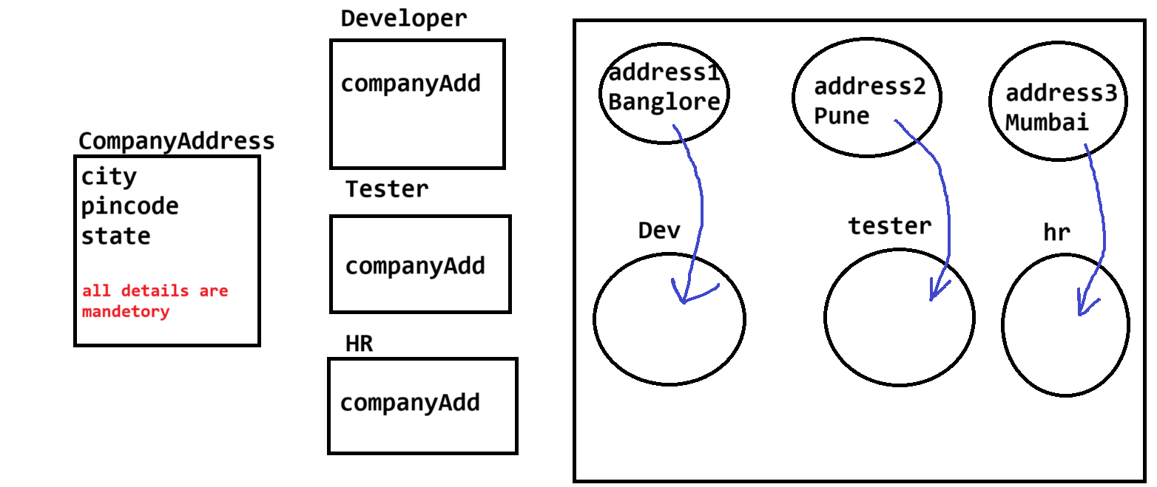

Spring JDBC
- This module is use to connect Spring Application with DB.
- To implement this module you will have to add following jar file
  - Spring-jdbc
  - Spring-tx
  - Db connector jar file
- There are multiple Spring API using which you can efficiently connect to DB
  - DriverManagerDataSource
    - To connect with Db we have to provide DB properties such as driver name, url, username, password
    - This class will accept the DB properties and connect with the Database.
    - This is the spring build-in class
org.springframework.jdbc.datasource.DriverManagerDataSource
  - JdbcTemplate
    - This is a spring build in class.
    - Using this class object you can execute the DB queries.
    - This class required the object of DriverManagerDataSource class.
org.springframework.jdbc.core.JdbcTemplate

Example

Spring ORM
- This module is use to connect Spring Application with DB using ORM (Hibernate) Framework.
- To implement this module you will have to add following jar file
  - Spring-jdbc
  - Spring-tx
  - Spring-orm
  - Db connector jar file
  - All hibernate required jar files
- There are multiple Spring API using which you can efficiently connect to DB
  - DriverManagerDataSource
    - To connect with Db we have to provide DB properties such as driver name, url, username, password
    - This class will accept the DB properties and connect with the Database.
    - This is the spring build-in class
org.springframework.jdbc.datasource.DriverManagerDataSource
  - LocalSessionFactoryBean

org.springframework.orm.hibernate5.LocalSessionFactoryBean
  - HibernateTemplate
org.springframework.orm.hibernate5.HibernateTemplate
  - HibernateTransactionManager
org.springframework.orm.hibernate5.HibernateTransactionManager

Spring MVC

Steps to create Spring MVC
- Set the workspace perspective to Java EE (One time)
- Configure a Server into eclipse. (One time)
- Create a new Dynamic web Project (Select the Check box for Web.xml while creating application)
- Add jar files of the Spring Framework.
- Register Spring Front controller inside web.xml (DispatcherServlet)
<servlet>
<servlet-name>springmvc</servlet-name>
servlet-class>org.springframework.web.servlet.DispatcherServlet</servlet-class>
</servlet>
<servlet-mapping>
<servlet-name>springmvc</servlet-name>
<url-pattern>/</url-pattern>
</servlet-mapping>
- Create a spring configuration file into WEB-INF
  - The name of the file must be a name of front controller as a prefix followed with “<servletName>-servlet.xml”
- Create a JSP pages (inside webapp)

