**JDBC Task**

1. WAP to execute following DB Operations
   1. WAP to create a table product with column as id(int), name(string), price(double), quantity(int).
   2. WAP to accept the product details from the user and insert into table.
   3. WAP to accept the id and quantity of the product from user and update the details in the product table.
   4. WAP to accept the id of the product from user and delete the product of that id from table.
2. Create a table with name “Cart” and has column Id, name, price, quantity

Create a Menu Driven Program

* 1. To Add into Cart

Get the product details for user and insert into table

* 1. To Remove from cart

Get the Product Id from the user and delete the product from the table

* 1. To Update Cart

Get the product id and the quantity from the user and update the product quantity

* 1. To View Bill

Get all the records from that cart and display on console also display the Payable amount

Hints

1. To Create menu driven program use Switch case (get the choice from the user using scanner)
2. Check the use choice into switch case and call the appropriate method

Task – 09-Sept-23

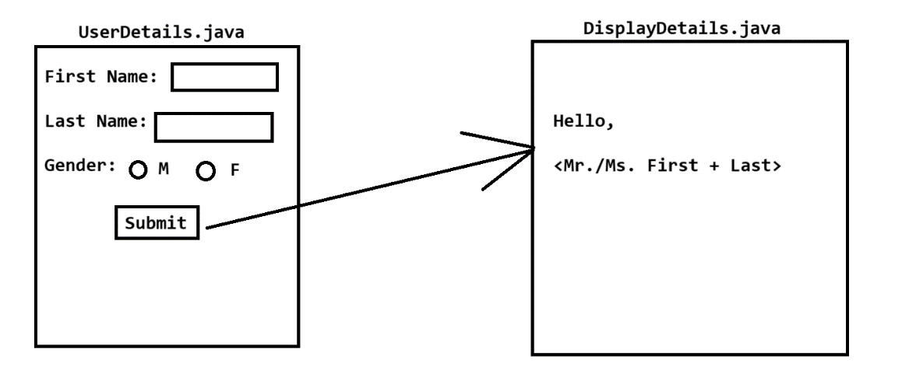

Task – 10-Sept

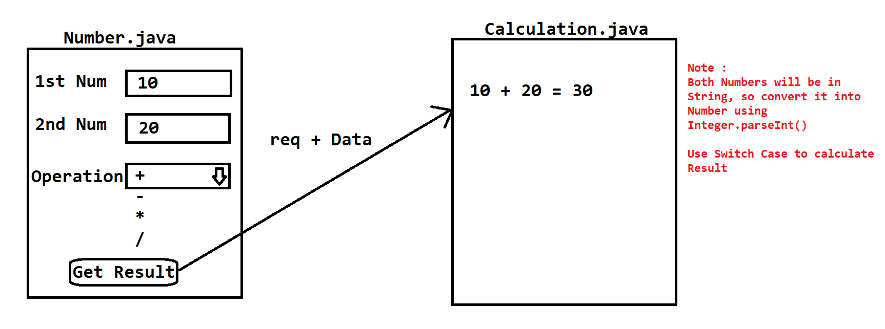



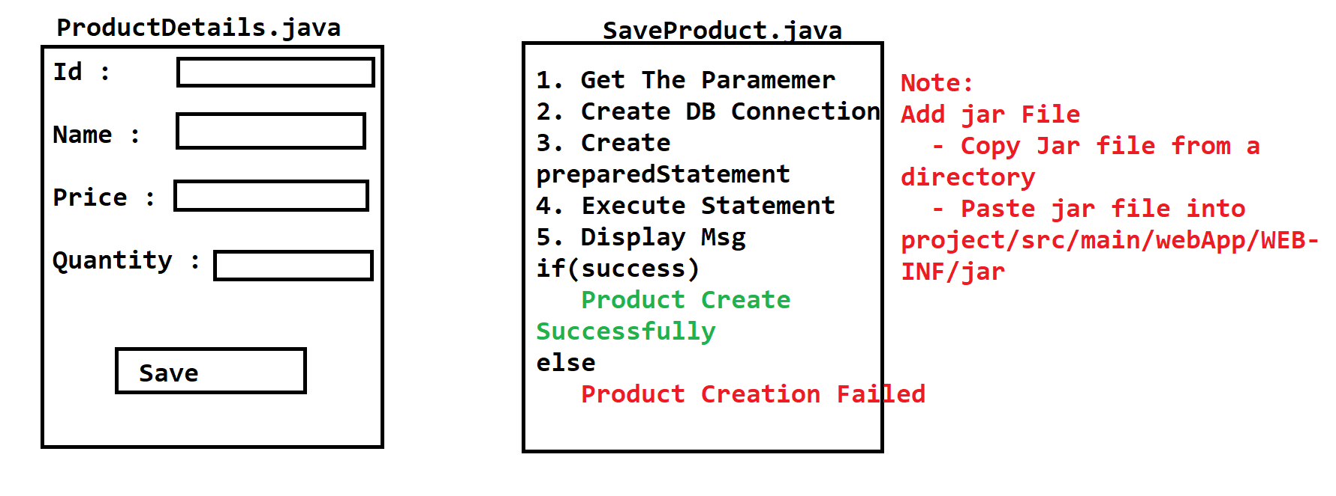



Task – 17-Sept-2022

