**JDBC Task**

Task-1

Create table Employee with empId, name, email, password (Create in SQL)

1. WAP to insert employees into database

2. WAP to Accept email and password from the user by scanner and check whether email and password valid or not

If email id and password valid then print "Valid User" else print "Invalid User" message

**Hint : select * from employee where email=? and password=?**

Task-2

WAP to register and login user

--------------------------------

Select Option

1. Register

2. Login

5. exit

if user select 1

Accept : Name, email, password from user

insert these values into database

Print "User register successfully" message

if user select 2

Accept : email and password from user and check whether user is valid or not

if user is valid the print Welcome "<UserName>" message

else print "Invalid username or password" message

if user select 5

exit from application

other than above options :

print "Invalid choice" message

Hint :

1. use scanner class to accept values from user

2. Use switch statement to check user choice and perform operation

3. Create two method 1st for register user and another for login functionality

4. System.exit(0); to Exit from application

Additional Feature :

Change password

if user select 3

Accept : email, old password, new password from user

update old password with new password only if email address and old password matches

else print "Invalid email or password" message

Hint : use update query and check email and old password by where clause.

**Advance Java Task**

**Task-1 - 9-June-2022**

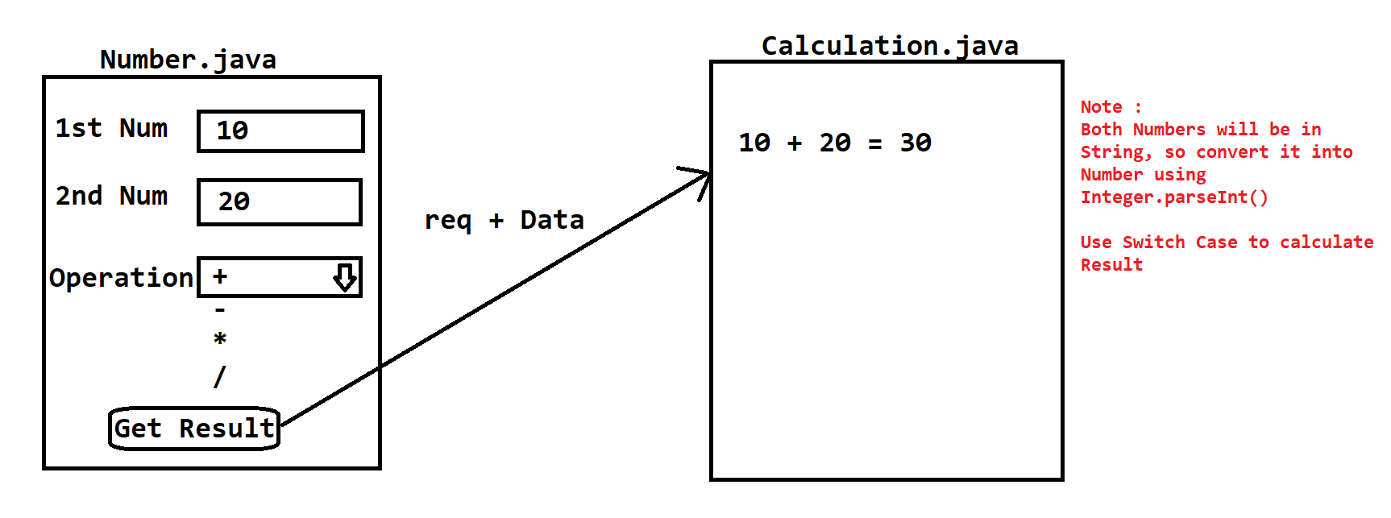

Task-2 - **9-June-2022**

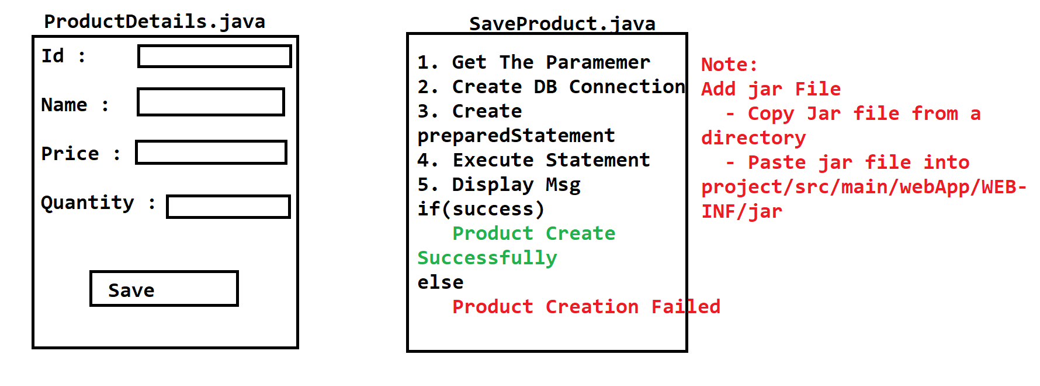

Add Jar file into Project

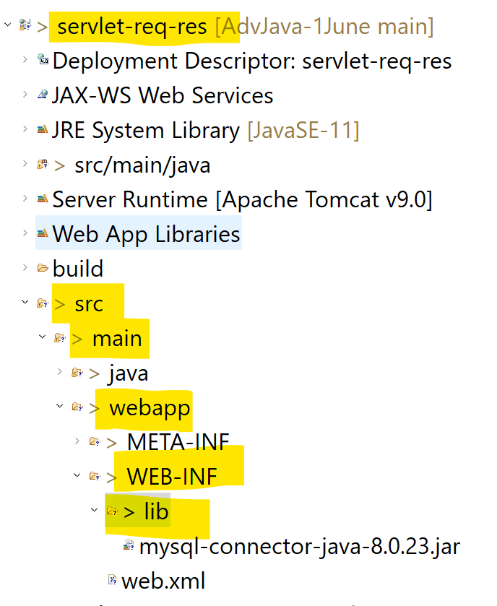

Task 11-June-2022

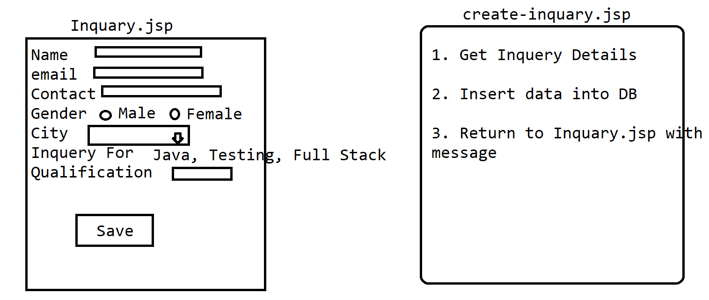

Task – 12-June-2022

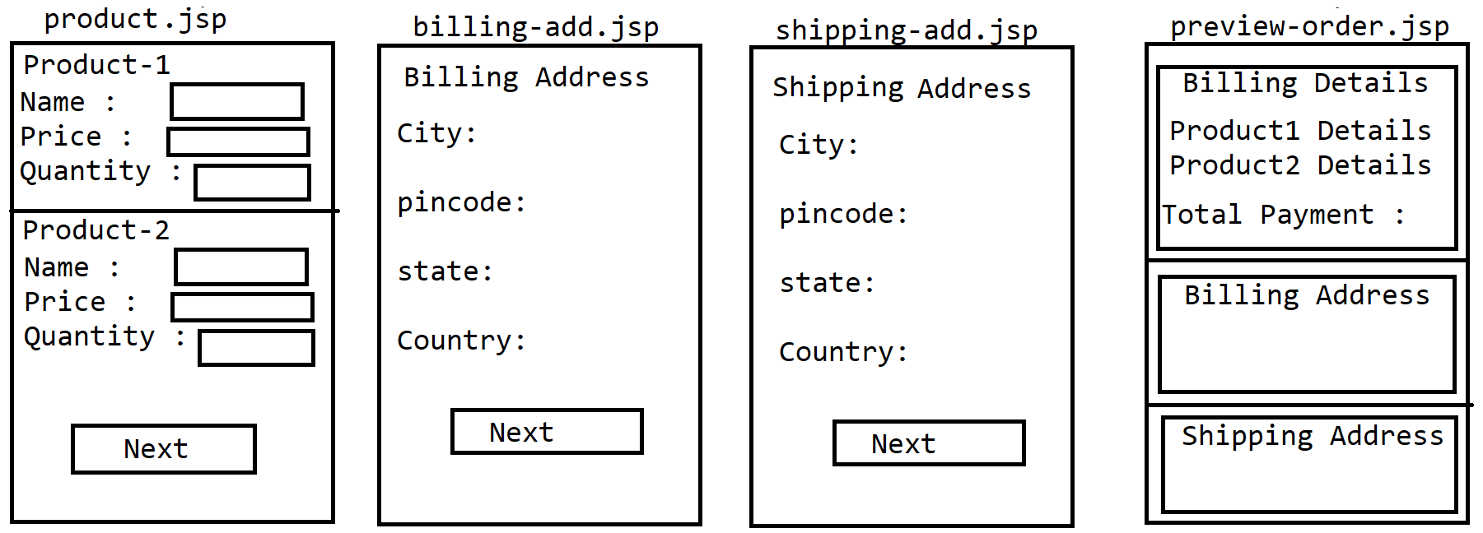

**Task 17-June-22**

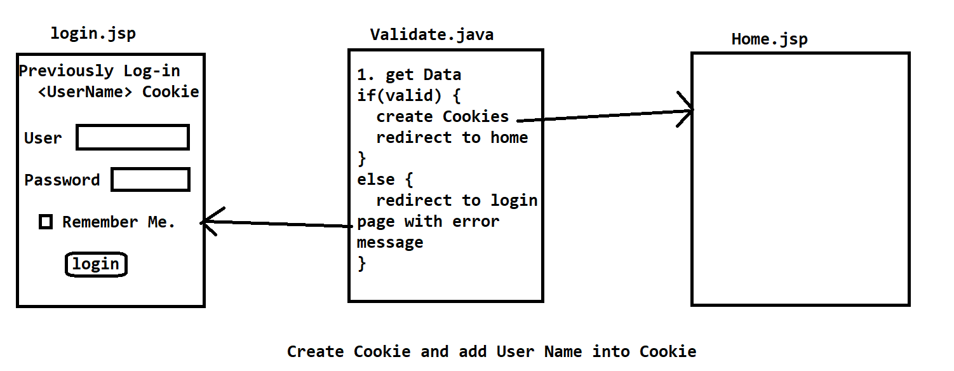

**Task 17-June-2022**

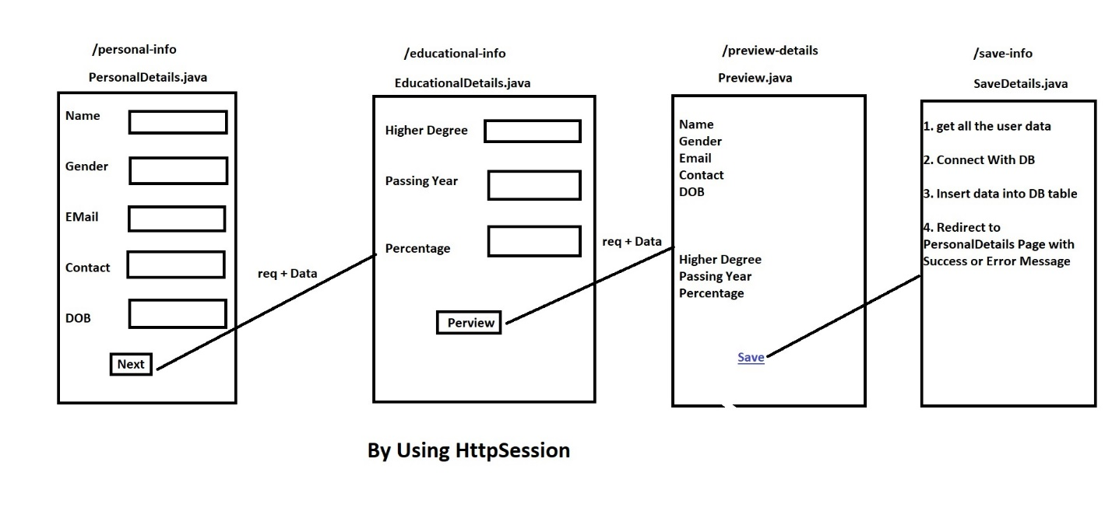

Task-19-June-2022

**Validate Product Details using Filter**

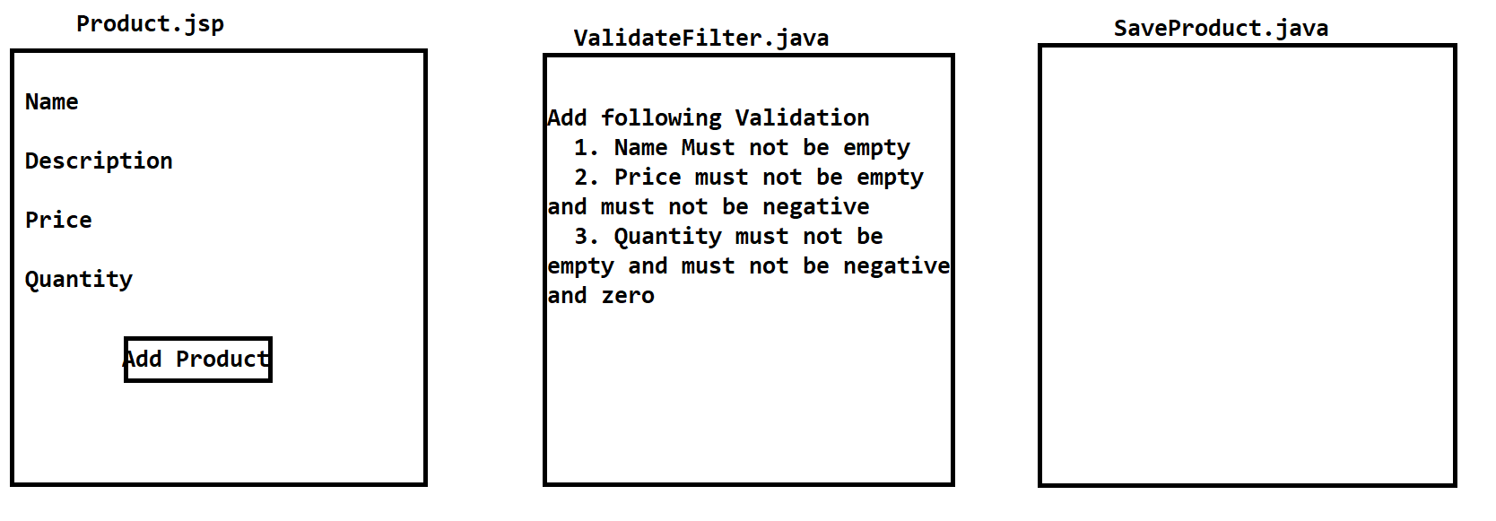

**MVC Application: (Jsp, Servlet, Hibernate, Java, Html, Csss, BootStrap)**

**ToDO Application**

**1. Create New Task**

**2. View All Create Task**

**3. Search Task By Status and Scheduled Date**

**4. Update Task details and Status of the Task**

**5. Delete the task.**

|  |  |
| --- | --- |
| **Column** | **Data Type** |
| **id (PK) auto_increment(sequence)** | **Int** |
| **title** | **Varchar** |
| **Status (Open, Inprogress, Completed)** | **Varchar** |
| **scheduledDate** | **Date** |
| **updatedDate** | **Date** |

mysql> create table task(

-> id int primary key auto_increment,

-> title varchar(100),

-> status varchar(15),

-> scheduledOn Date,

-> updatedOn date);

1. **Create New Task** 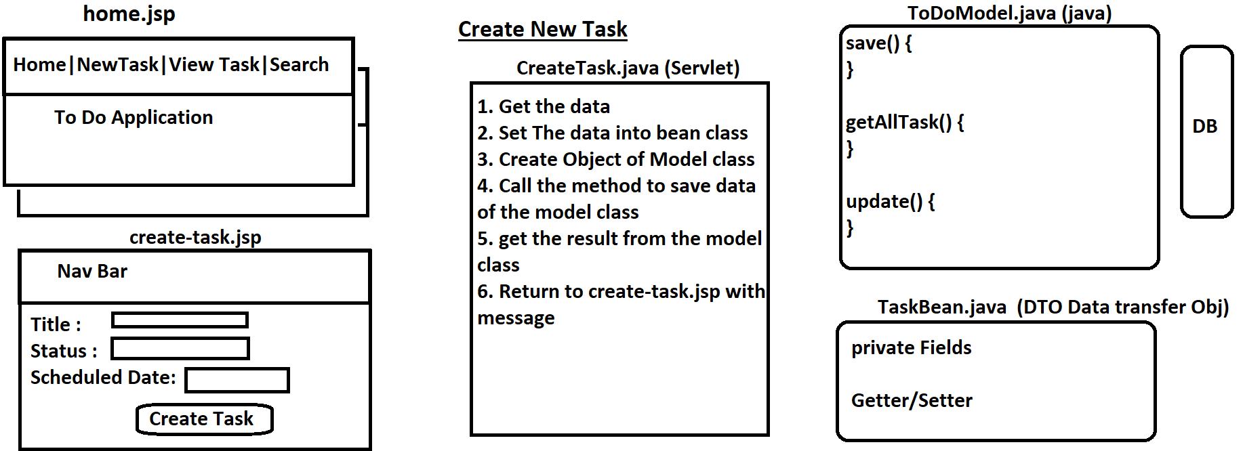
2. **View Task**

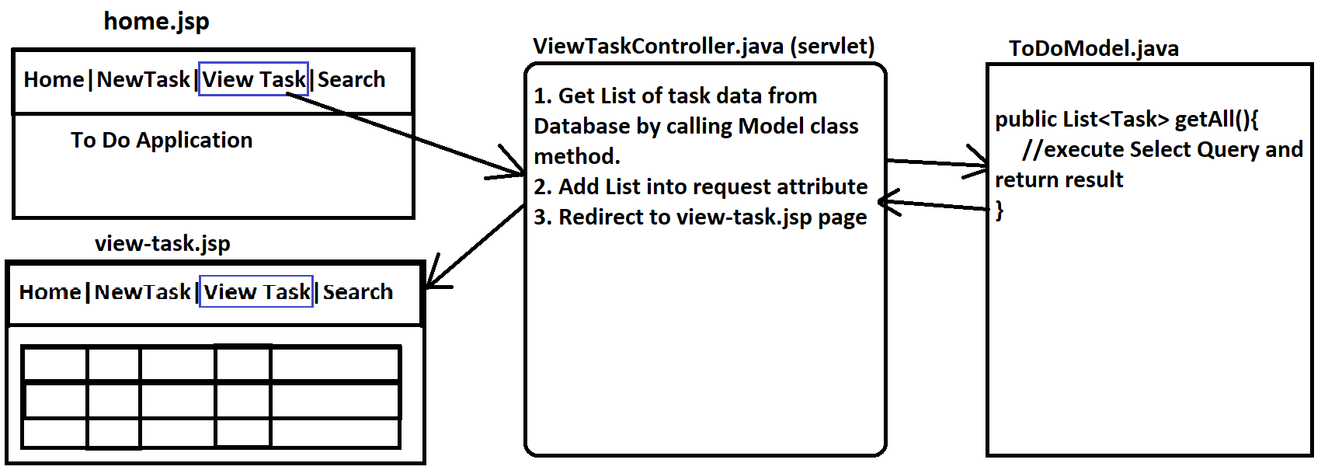

1. **Update Task**

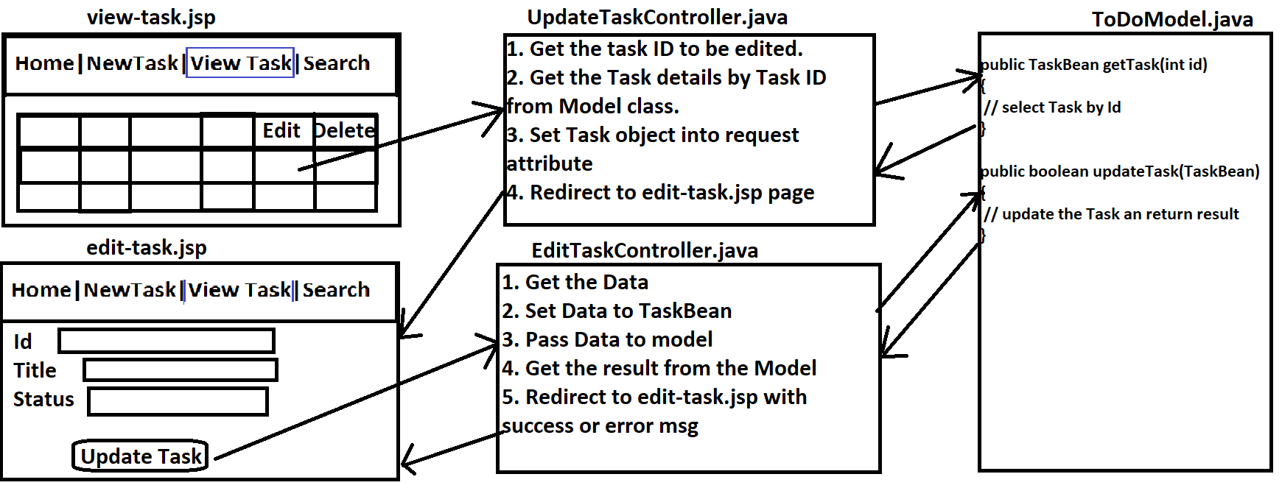



1. **Delete Task**

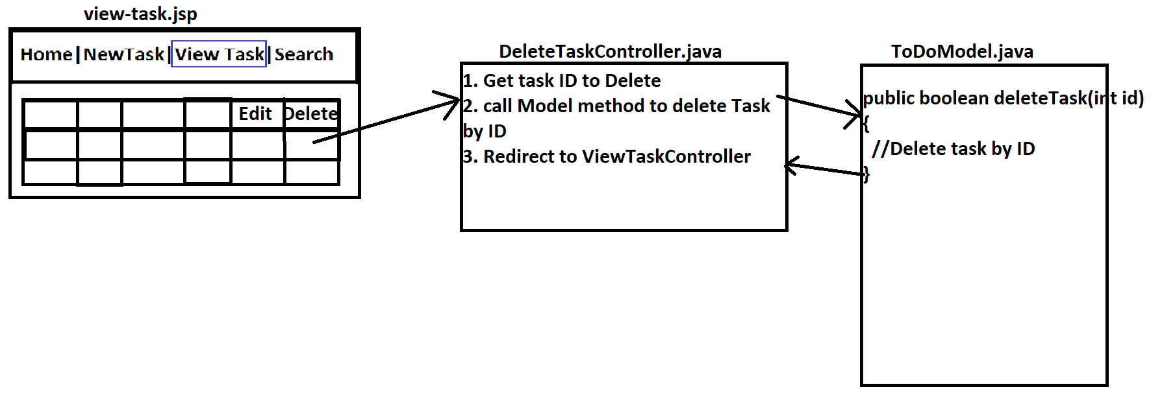

1. **Search Task**

