CREATE TABLE Supplier (
scode INT PRIMARY KEY,
sname VARCHAR(50),
scity VARCHAR(50),
turnover DECIMAL(10, 2)
);

CREATE TABLE Part (
pcode INT PRIMARY KEY,
weight DECIMAL(10, 2),
color VARCHAR(20),
cost DECIMAL(10, 2),
sellingprice DECIMAL(10, 2)
);

CREATE TABLE Supplier_Part (
scode INT,
pcode INT,
qty INT,
PRIMARY KEY (scode, pcode),
FOREIGN KEY (scode) REFERENCES Supplier(scode),
FOREIGN KEY (pcode) REFERENCES Part(pcode)
);

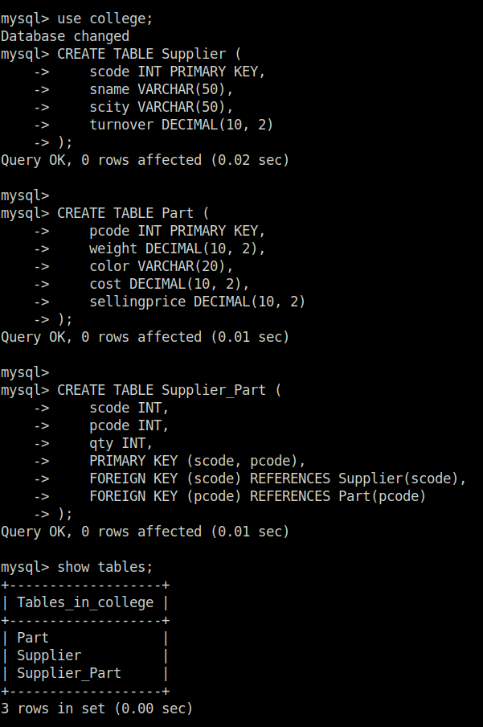

mysql> create database college;
Query OK, 1 row affected (0.01 sec)

mysql> use college;
Database changed
mysql> CREATE TABLE Supplier (
-> scode INT PRIMARY KEY,
-> sname VARCHAR(50),
-> scity VARCHAR(50),
-> turnover DECIMAL(10, 2)
-> );
Query OK, 0 rows affected (0.02 sec)

mysql>
mysql> CREATE TABLE Part (
-> pcode INT PRIMARY KEY,
-> weight DECIMAL(10, 2),
-> color VARCHAR(20),
-> cost DECIMAL(10, 2),
-> sellingprice DECIMAL(10, 2)
-> );
Query OK, 0 rows affected (0.01 sec)

mysql>
mysql> CREATE TABLE Supplier_Part (
-> scode INT,
-> pcode INT,
-> qty INT,
-> PRIMARY KEY (scode, pcode),
-> FOREIGN KEY (scode) REFERENCES Supplier(scode),
-> FOREIGN KEY (pcode) REFERENCES Part(pcode)
-> );
Query OK, 0 rows affected (0.01 sec)

mysql> show tables;
+-------------------+
| Tables_in_college |
+-------------------+
| Part |
| Supplier |
| Supplier_Part |
+-------------------+
3 rows in set (0.00 sec)

mysql> INSERT INTO Supplier (scode, sname, scity, turnover) VALUES
-> (1, 'Supplier A', 'Bombay', 50),
-> (2, 'Supplier B', 'Delhi', 60),
-> (3, 'Supplier C', 'Bombay', 70);
Query OK, 3 rows affected (0.01 sec)
Records: 3 Duplicates: 0 Warnings: 0

mysql> INSERT INTO Part (pcode, weigh, color, cost, sellingprice) VALUES
-> (1, 30, 'Red', 20, 25),
-> (2, 40, 'Blue', 30, 35),
-> (3, 20, 'Green', 40, 45);
ERROR 1054 (42S22): Unknown column 'weigh' in 'field list'
mysql> INSERT INTO Supplier_Part (scode, pcode, qty) VALUES
-> (1, 1, 100),
-> (1, 2, 150),
-> (2, 2, 200),
-> (3, 3, 120);
ERROR 1452 (23000): Cannot add or update a child row: a foreign key constraint fails (`college`.`Supplier_Part`, CONSTRAINT `Supplier_Part_ibfk_2` FOREIGN KEY (`pcode`) REFERENCES `Part` (`pcode`))
mysql> INSERT INTO Supplier (scode, sname, scity, turnover) VALUES
-> (1, 'Supplier1', 'City1', 100000.00),
-> (2, 'Supplier2', 'City2', 150000.00),
-> (3, 'Supplier3', 'City3', 120000.00);
ERROR 1062 (23000): Duplicate entry '1' for key 'Supplier.PRIMARY'
mysql> INSERT INTO Part (pcode, weight, color, cost, sellingprice) VALUES
-> (101, 5.25, 'Red', 10.00, 15.00),
-> (102, 7.50, 'Blue', 15.00, 20.00),
-> (103, 3.00, 'Green', 8.00, 12.00);
Query OK, 3 rows affected (0.01 sec)
Records: 3 Duplicates: 0 Warnings: 0

mysql> INSERT INTO Supplier_Part (scode, pcode, qty) VALUES
-> (1, 101, 50),
-> (1, 102, 30),
-> (2, 101, 20),
-> (3, 102, 40),
-> (3, 103, 50);
Query OK, 5 rows affected (0.01 sec)
Records: 5 Duplicates: 0 Warnings: 0

mysql> SELECT sp.scode, sp.pcode
-> FROM Supplier_Part sp
-> ORDER BY sp.scode ASC;
+-------+-------+
| scode | pcode |
+-------+-------+
| 1 | 101 |
| 1 | 102 |
| 2 | 101 |
| 3 | 102 |
| 3 | 103 |
+-------+-------+
5 rows in set (0.00 sec)

mysql> SELECT *
-> FROM Supplier
-> WHERE scity = 'Bombay' AND turnover = 50;
+-------+------------+--------+----------+
| scode | sname | scity | turnover |
+-------+------------+--------+----------+
| 1 | Supplier A | Bombay | 50.00 |
+-------+------------+--------+----------+
1 row in set (0.00 sec)

mysql> SELECT COUNT(*) AS total_suppliers
-> FROM Supplier;
+-----------------+
| total_suppliers |
+-----------------+
| 3 |
+-----------------+
1 row in set (0.01 sec)

mysql> SELECT pcode
-> FROM Part
-> WHERE weight BETWEEN 25 AND 35;
Empty set (0.00 sec)

mysql> SELECT scode
-> FROM Supplier
-> WHERE turnover IS NULL;
Empty set (0.00 sec)

mysql> SELECT pcode
-> FROM Part
-> WHERE cost IN (20, 30, 40);
Empty set (0.00 sec)

mysql> SELECT scode, pcode FROM Supplier_Part ORDER BY scode;
+-------+-------+
| scode | pcode |
+-------+-------+
| 1 | 101 |
| 1 | 102 |
| 2 | 101 |
| 3 | 102 |
| 3 | 103 |
+-------+-------+
5 rows in set (0.00 sec)

mysql> SELECT * FROM Supplier WHERE scity = 'Bombay' AND turnover = 50;
+-------+------------+--------+----------+
| scode | sname | scity | turnover |
+-------+------------+--------+----------+
| 1 | Supplier A | Bombay | 50.00 |
+-------+------------+--------+----------+
1 row in set (0.00 sec)

mysql> SELECT COUNT(*) AS total_suppliers FROM Supplier;
+-----------------+
| total_suppliers |
+-----------------+
| 3 |
+-----------------+
1 row in set (0.00 sec)

mysql> SELECT pcode FROM Part WHERE weight BETWEEN 25 AND 35;
Empty set (0.00 sec)

mysql> SELECT scode FROM Supplier WHERE turnover IS NULL;
Empty set (0.00 sec)

mysql> SELECT pcode FROM Part WHERE cost IN (20, 30, 40);
Empty set (0.01 sec)

mysql> SELECT SUM(qty) AS total_quantity FROM Supplier_Part WHERE pcode = 2;
+----------------+
| total_quantity |
+----------------+
| NULL |
+----------------+
1 row in set (0.00 sec)

mysql> SELECT s.sname
-> FROM Supplier s
-> JOIN Supplier_Part sp ON s.scode = sp.scode
-> WHERE sp.pcode = 2;
Empty set (0.00 sec)

mysql> SELECT pcode FROM Part WHERE cost > (SELECT AVG(cost) FROM Part);
+-------+
| pcode |
+-------+
| 102 |
+-------+
1 row in set (0.00 sec)

mysql> SELECT scode, turnover FROM Supplier ORDER BY turnover DESC;
+-------+----------+
| scode | turnover |
+-------+----------+
| 3 | 70.00 |
| 2 | 60.00 |
| 1 | 50.00 |
+-------+----------+
3 rows in set (0.00 sec)

mysql>

