1) Write a bash script to add 2 float numbers.

Code:
#!/bin/bash

# Function to add two float numbers
add_float() {
local result=$(echo "$1 + $2" | bc -l)
echo $result
}

# Main script
echo "Enter first float number: "
read num1

echo "Enter second float number: "
read num2

result=$(add_float $num1 $num2)
echo "The sum is: $result"

Output:
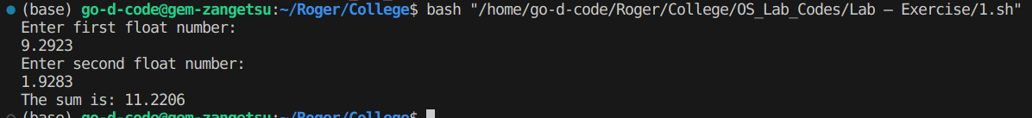

2) Write a bash script that monitors and displays the current CPU and memory usage of the system.

Code:
#!/bin/bash

# Function to display CPU and memory usage
monitor_usage() {
echo "CPU Usage:"
top -bn1 | grep "Cpu(s)" | sed "s/.*, *\([0-9.]*\)%* id.*/\1/" | awk '{print 100 - $1"%"}'
echo "Memory Usage:"
free -m | awk 'NR==2{printf "Total: %s MB\nUsed: %s MB\nFree: %s MB\n", $2,$3,$4}'
}

# Main script
monitor_usage

Output:
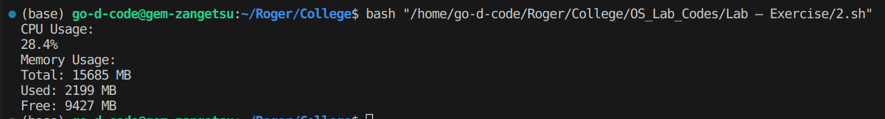
3) Write a bash script that takes a user-input file and destination directory, then creates a backup of the file in the specified destination.

Code:
#!/bin/bash

# Function to create a backup of a file
backup_file() {
cp "$1" "$2"
echo "Backup created successfully."
}

# Main script
echo "Enter the file to backup: "
read file

echo "Enter the destination directory: "
read destination

backup_file $file $destination

Output:
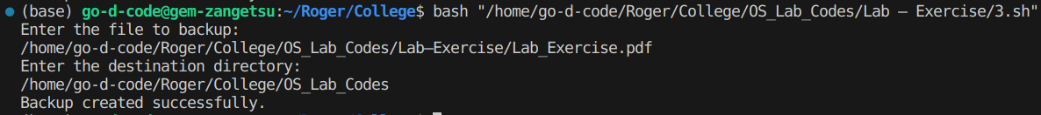
4) Write a user management script with options to add a new user, remove an existing user, and list all users on the system.

Code:
#!/bin/bash

# Function to add a new user
add_user() {
echo "Enter username to add: "
read username
sudo adduser $username
}

# Function to remove an existing user
remove_user() {
echo "Enter username to remove: "
read username
sudo deluser $username
}

# Function to list all users
list_users() {
cut -d: -f1 /etc/passwd
}

# Main script
echo "User Management Script"
echo "1. Add a new user"
echo "2. Remove an existing user"
echo "3. List all users"
read choice

case $choice in
1) add_user ;;
2) remove_user ;;
3) list_users ;;
*) echo "Invalid option" ;;
esac

Output:
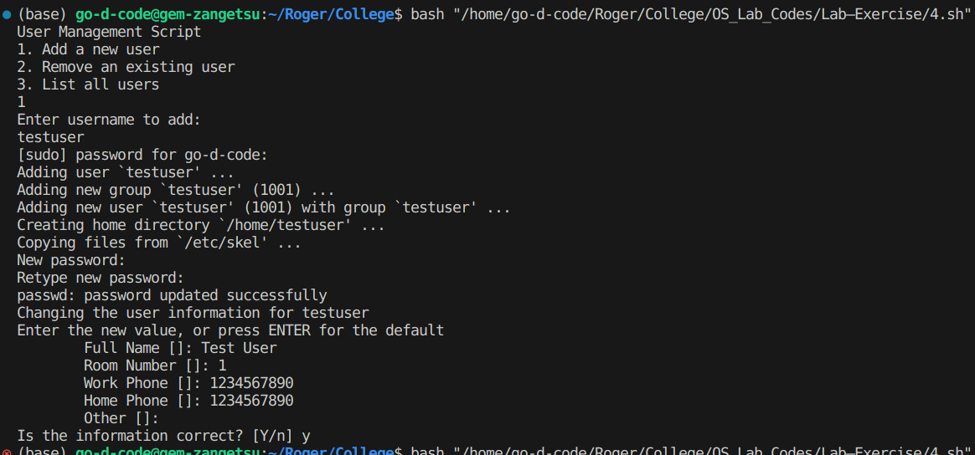
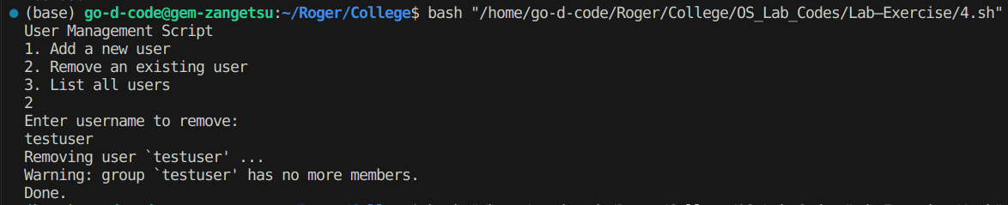
5) Write a script that retrieves and displays information about the network, including the hostname, IP address, and a list of network interfaces.

Code:
#!/bin/bash

# Function to retrieve network information
network_info() {
echo "Hostname:"
hostname
echo "IP Address:"
hostname -I
echo "Network Interfaces:"
ifconfig -a | grep -o '^[a-zA-Z0-9]*'
}

# Main script
network_info

Output:
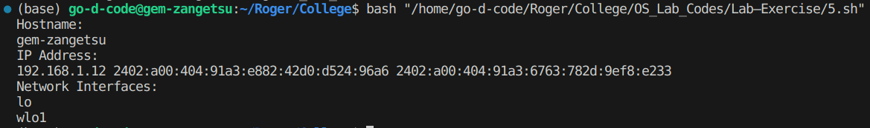
6) Write a bash script that utilizes system calls to create a directory and a file within that directory.

Code:
#!/bin/bash

# Function to create directory and file
create_dir_and_file() {
echo "Enter directory name: "
read directory
mkdir $directory
echo "Enter file name: "
read filename
touch "$directory/$filename"
echo "Directory '$directory' and file '$filename' created successfully."
}

# Main script
create_dir_and_file

Output:
