EXPERIMENT-7,8
TITLE: Nested sql queries or Subquries
Objective: To understand the use SQL Subquery
1.Create the following two tables (EMP and DEPT)
EMP TABLE

Code:
CREATE TABLE EMP (
EMPNO INT PRIMARY KEY,
ENAME VARCHAR(50),
JOB VARCHAR(50),
MGR INT,
HIREDATE DATE,
SAL INT,
COMM INT,
DEPTNO INT
);

CREATE TABLE DEPT (
DEPTNO INT PRIMARY KEY,
DNAME VARCHAR(50),
LOC VARCHAR(50)
);

INSERT INTO EMP (EMPNO, ENAME, JOB, MGR, HIREDATE, SAL, COMM, DEPTNO) VALUES
(7369, 'SMITH', 'CLERK', 7902, '1980-12-17', 500, 800, 20),
(7499, 'ALLEN', 'SALESMAN', 7698, '1981-02-20', 1600, 300, 30),
(7521, 'WARD', 'SALESMAN', 7698, '1981-02-22', 1250, 500, 30),
(7566, 'JONES', 'MANAGER', 7839, '1981-04-02', 2975, NULL, 20),
(7654, 'MARTIN', 'SALESMAN', 7698, '1981-09-28', 1250, 1400, 30),
(7698, 'BLAKE', 'MANAGER', 7839, '1981-05-01', 2850, NULL, 30),
(7782, 'CLARK', 'MANAGER', 7839, '1981-06-09', 2450, NULL, 10),
(7788, 'SCOTT', 'ANALYST', 7566, '1982-12-09', 3000, NULL, 20),
(7839, 'KING', 'PRESIDENT', NULL, '1981-11-17', 5000, NULL, 10),
(7844, 'TURNER', 'SALESMAN', 7698, '1981-09-08', 1500, 0, 30),
(7876, 'ADAMS', 'CLERK', 7788, '1983-01-12', 1100, NULL, 20),
(7900, 'JAMES', 'CLERK', 7698, '1981-12-03', 950, NULL, 30),
(7902, 'FORD', 'ANALYST', 7566, '1981-12-03', 3000, NULL, 20),
(7934, 'MILLER', 'CLERK', 7782, '1982-01-23', 1300, NULL, 10);

INSERT INTO DEPT (DEPTNO, DNAME, LOC) VALUES
(10, 'ACCOUNTING', 'NEW YORK'),
(20, 'RESEARCH', 'DALLAS'),
(30, 'SALES', 'CHICAGO'),
(40, 'OPERATIONS', 'BOSTON');

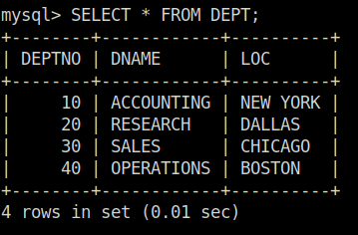

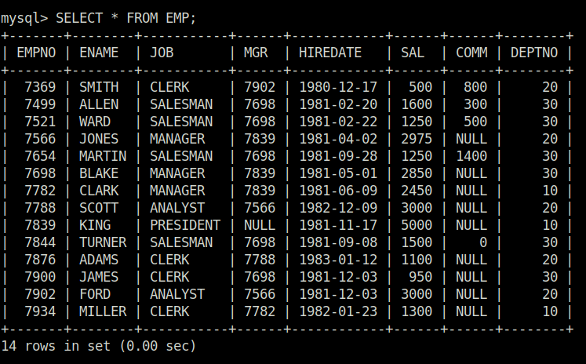
Write the Nested Queries for the following queries.
1. List the details of the emps whose Salaries more than the employee BLAKE.
2. List the emps whose Jobs are same as ALLEN.
3. List the Emps whose Sal is same as FORD or SMITH in desc order of Names.
4. List the emps Whose Jobs are same as MILLER or Sal is more than ALLEN.
5. Find the highest paid employee of sales department.
6. List the employees who are senior to most recently hired employee working under king.
List the employees who are senior to most recently hired employee working
under king.
select * from emp where hiredate < (select max(hiredate) from emp where mgr in
(select empno from emp where ename = 'KING')) ;
7. List the names of the emps who are getting the highest sal dept wise.
select e.ename,e.deptno from emp e where e.sal in
(select max(sal) from emp group by deptno) ;
8. List the emps whose sal is equal to the average of max and minimum
select * from emp where sal =(select (max(sal)+min(sal))/2 from emp);
9. List the emps who joined in the company on the same date.
select * from emp e where hiredate in (select hiredate from emp where e.empno
<> empno);
10. Find out the emps who joined in the company before their Managers.
select * from emp e where hiredate < (select hiredate from emp where
empno = e.mgr)

Code:
SELECT *
FROM EMP
WHERE SAL > (SELECT SAL FROM EMP WHERE ENAME = 'BLAKE');
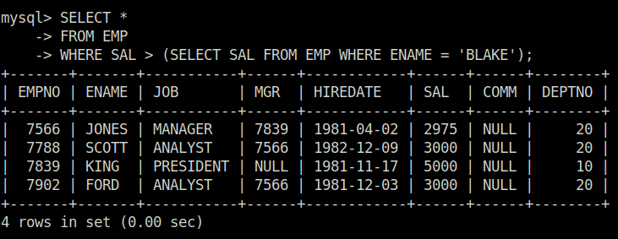
SELECT *
FROM EMP
WHERE JOB = (SELECT JOB FROM EMP WHERE ENAME = 'ALLEN');
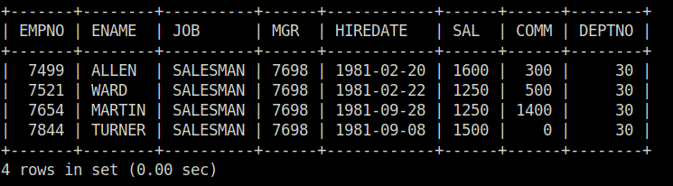
SELECT *
FROM EMP
WHERE SAL IN (SELECT SAL FROM EMP WHERE ENAME IN ('FORD', 'SMITH'))
ORDER BY ENAME DESC;
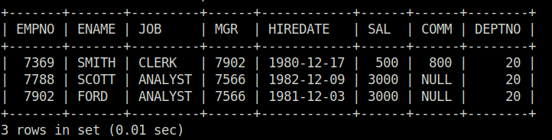
SELECT *
FROM EMP
WHERE JOB IN (SELECT JOB FROM EMP WHERE ENAME = 'MILLER')
OR SAL > (SELECT SAL FROM EMP WHERE ENAME = 'ALLEN');
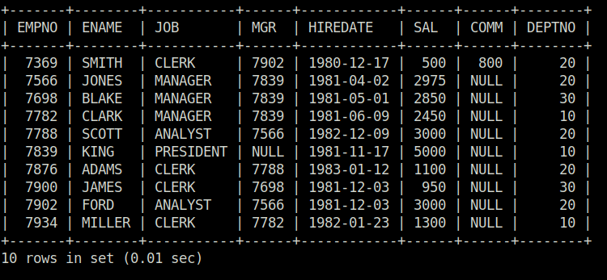
SELECT *
FROM EMP
WHERE SAL = (SELECT MAX(SAL) FROM EMP WHERE DEPTNO = (SELECT DEPTNO FROM DEPT WHERE DNAME = 'SALES'));
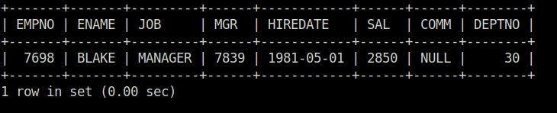
SELECT *
FROM EMP
WHERE HIREDATE < (SELECT MAX(HIREDATE) FROM EMP WHERE MGR = (SELECT EMPNO FROM EMP WHERE ENAME = 'KING'));
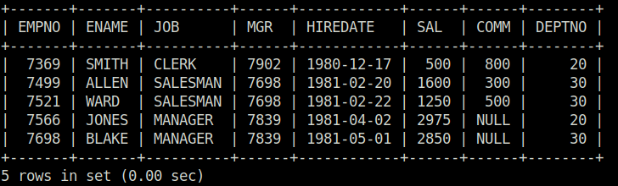
SELECT E.ENAME, E.DEPTNO
FROM EMP E
WHERE E.SAL IN (SELECT MAX(SAL) FROM EMP WHERE DEPTNO = E.DEPTNO GROUP BY DEPTNO);
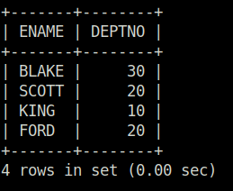

SELECT *
FROM EMP
WHERE SAL = (SELECT (MAX(SAL) + MIN(SAL)) / 2 FROM EMP);
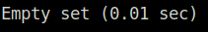

SELECT *
FROM EMP E
WHERE HIREDATE IN (SELECT HIREDATE FROM EMP WHERE EMPNO <> E.EMPNO);
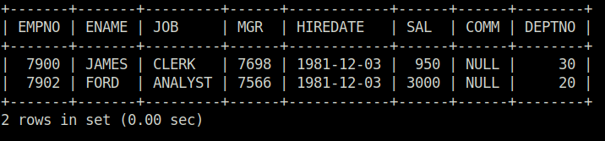
SELECT *
FROM EMP E
WHERE HIREDATE < (SELECT HIREDATE FROM EMP WHERE EMPNO = E.MGR);
