Experiment 1

TITLE: DDL (Data Definition Language) commands
Objective: To understand the concept of designing issue related to the database with creating,
populating the tables.

Create the tables described below:

Table name: CLIENT_MASTER
Description:used to store client information.

Column name | data type | Size
CLIENTNO | Varchar | 6
NAME | Varchar | 20
ADDRESS 1 | Varchar | 30
ADDRESS 2 | Varchar | 30
CITY | Varchar | 15
PINCODE | Integer
STATE | Varchar | 15
BALDUE | decimal | 10,2

Output:
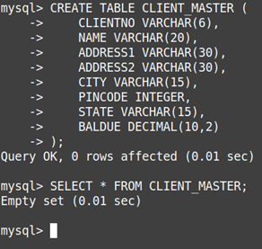

Table Name: PRODUCT_MASTER
Description:used to store product informatio

Column name | data type | Size
PRODUCTNO | Varchar | 6
DESCRIPTION | Varchar | 15
PROFITPERCENT | Decimal | 4,2
UNIT MEASURE | Varchar | 10
QTYONHAND | Integer
REORDERL VL | Integer
SELLPRICE | Decimal | 8,2
COSTPRICE | Decimal | 8,2

Output:
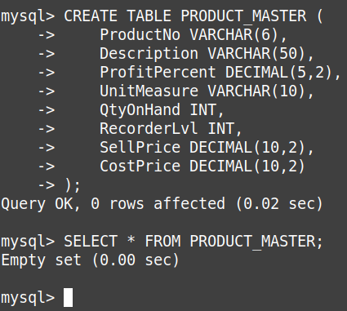

Table Name: SALESMAN_MASTER
Description: Used to store salesman information working for the company.

Column name | data type | Size
SALESMANNO | Varchar | 6
SALESMANNAME | Varchar | 20
ADDRESS 1 | Varchar | 30
ADDRESS 2 | Varchar | 30
CITY | Varchar | 20
PINCODE | Integer
STATE | Varchar | 20
SALAMT | Real
TGTTOGET | Decimal
YTDSALES | Double | 6,2
REMARKS | Varchar | 60

Output:
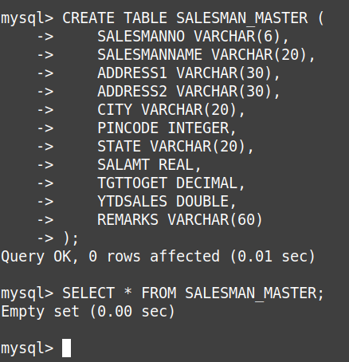

Insert the following data into their respective tables:
- Data for CLIENT_MASTER table:

Client no | Name | city | Pincode | state | BalDue
C00001 | Ivan bayross | Mumbai | 400054 | Maharashtra | 15000
C00002 | Mamta  muzumdar | Madras | 780001 | Tamil nadu | 0
C00003 | Chhaya bankar | Mumbai | 400057 | Maharashtra | 5000
C00004 | Ashwini joshi | Bangalore | 560001 | Karnataka | 0
C00005 | Hansel colaco | Mumbai | 400060 | Maharashtra | 2000
C00006 | Deepak sharma | Mangalore | 560050 | Karnataka | 0

Output:
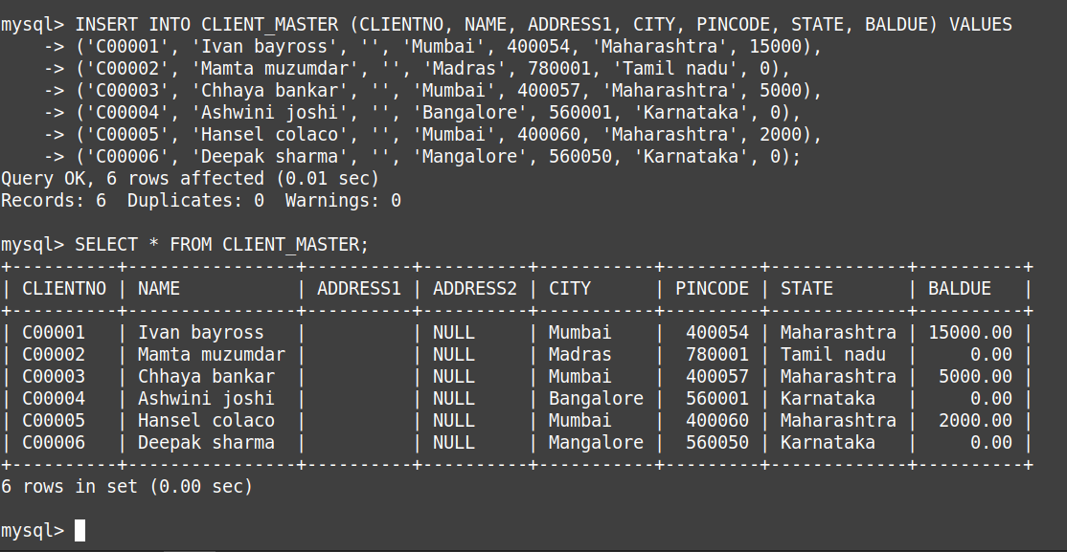
- Data for PRODUCT_MASTER table:

ProductNo | Description | Profit percent | Unit measure | Qtyonhand | RecorderLvl | SellPrice | CostPrice
P00001 | T-Shirt | 5 | Piece | 200 | 50 | 350 | 250
P0345 | Shirts | 6 | Piece | 150 | 50 | 500 | 350
P06734 | Cotton  jeans | 5 | Piece | 100 | 20 | 600 | 450
P07865 | Jeans | 5 | Piece | 100 | 20 | 750 | 500
P07868 | Trousers | 2 | Piece | 150 | 50 | 850 | 550
P07885 | Pull Overs | 2.5 | Piece | 80 | 30 | 700 | 450
P07965 | Denim  jeans | 4 | Piece | 100 | 40 | 350 | 250
P07975 | Lycra tops | 5 | Piece | 70 | 30 | 300 | 175
P08865 | Skirts | 5 | Piece | 75 | 30 | 450 | 300
Output:
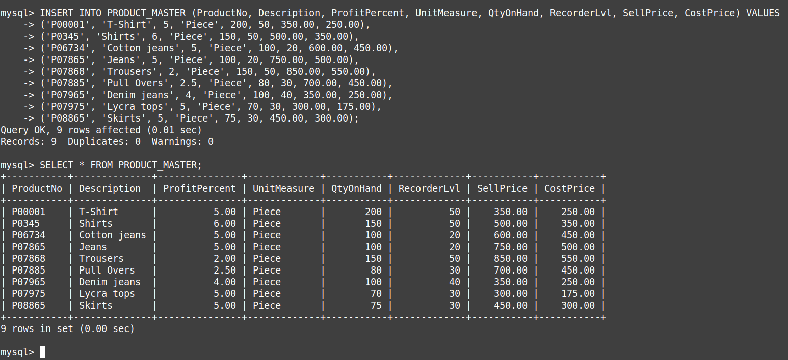
- Data for SALESMAN_MASTER table:

SalesmanNo | Name | Address1 | Address2 | City | PinCode | State
S00001 | Aman | A/14 | Worli | Mumbai | 400002 | Maharashtra
S00002 | Omkar | 65 | Nariman | Mumbai | 400001 | Maharashtra
S00003 | Raj | P-7 | Bandra | Mumbai | 400032 | Maharashtra
S00004 | Ashish | A/5 | Juhu | Mumbai | 400044 | Maharashtra

SalesmanNo | SalAmt | TgtToGet | YtdSales | Remarks
S00001 | 3000 | 100 | 50 | Good
S00002 | 3000 | 200 | 100 | Good
S00003 | 3000 | 200 | 100 | Good
S00004 | 3500 | 200 | 150 | Good

Output:
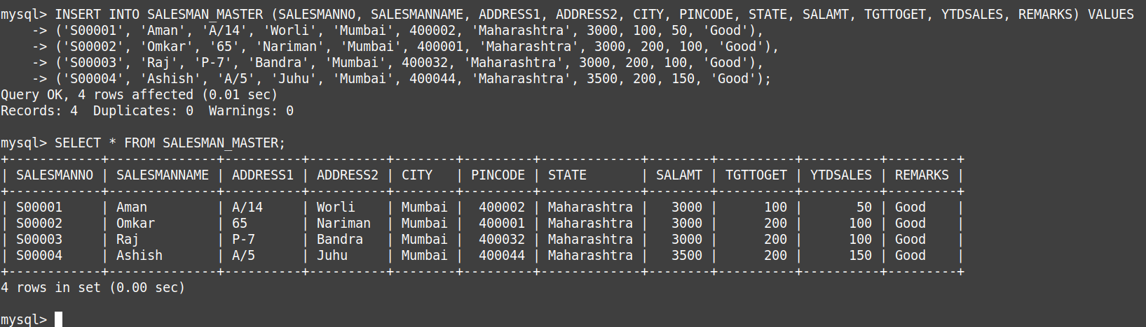

Experiment 2

TITLE: DML commands with constraints
Objective: - To understand the concept of different DML commands.

1. Exercise on retrieving records from a table.
  - Find out the names of all the clients.
Output:
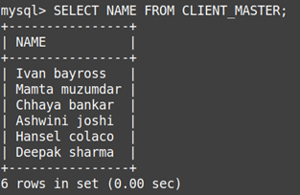

  - Retrieve the entire contents of the Client_Master table.

Output:
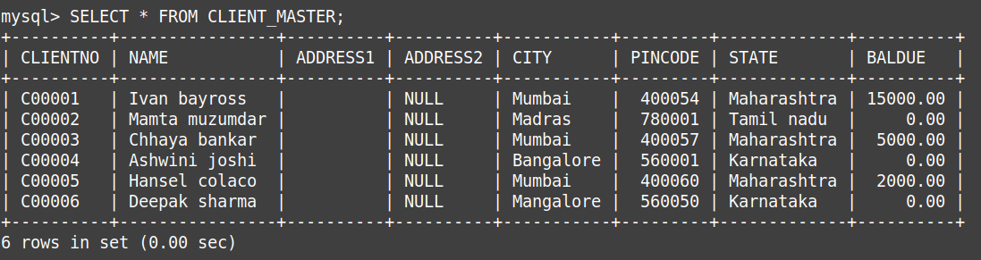

  - Retrieve the list of names,city and the state of all the clients.
Output:

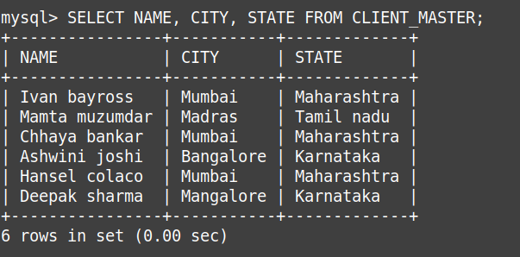

  - List the various products available from the Product_Master table.

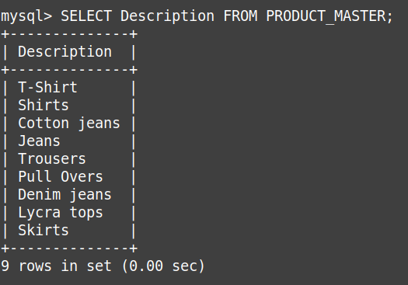
Output:

  - List all the clients who are located in Mumbai.

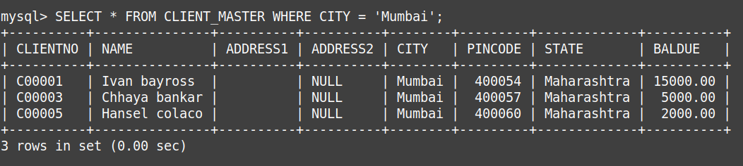
Output:

  - Find the names of salesman who have a salary equal to Rs.3000.

Output:
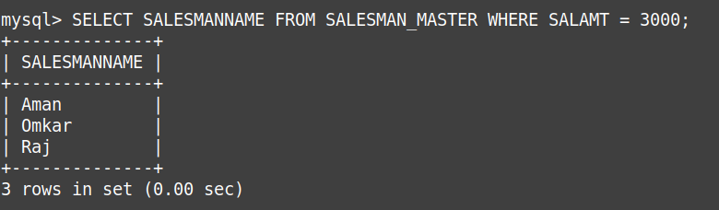

- Exercise on updating records in a table
  - Change the city of ClientNo ‘C00005’ to ‘Bangalore’.

Output:
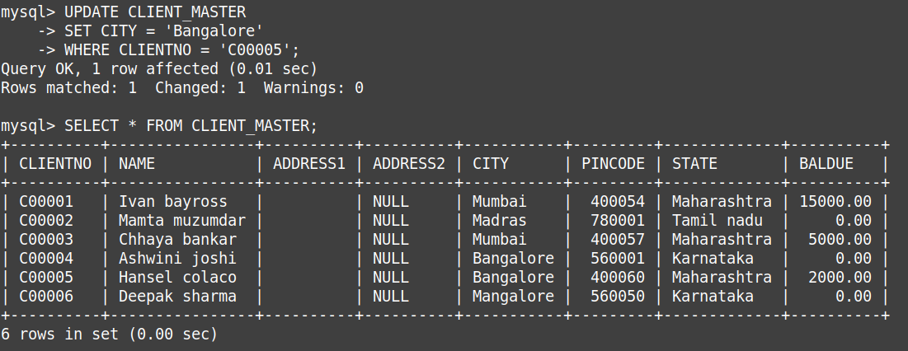
  - Change the BalDue of ClientNo ‘C00001’ to Rs.1000.

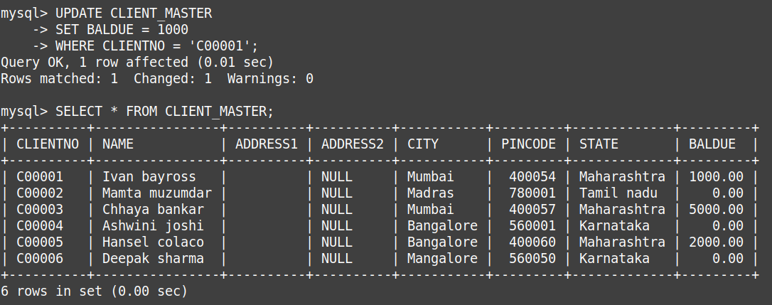
Output:

  - Change the cost price of ‘Trousers’ to rs.950.00.

Output:
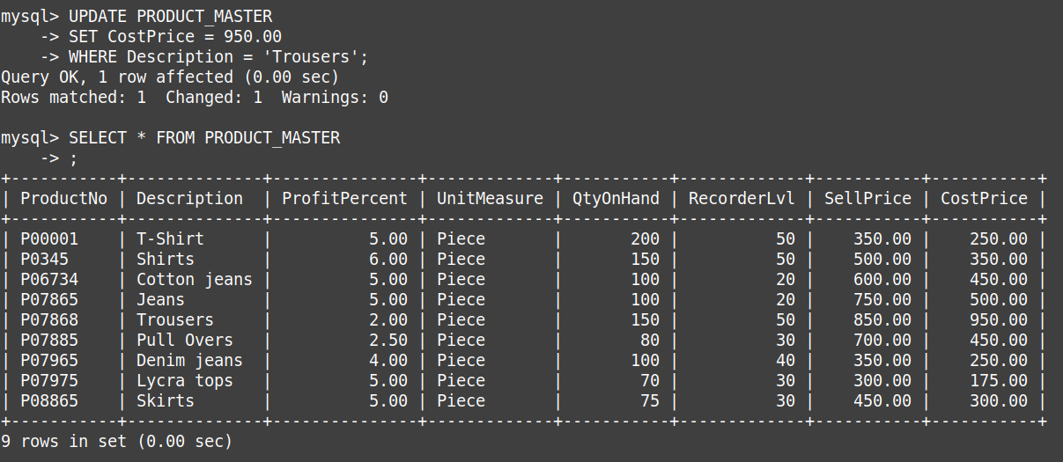
  - Change the city of the salesman to Pune.

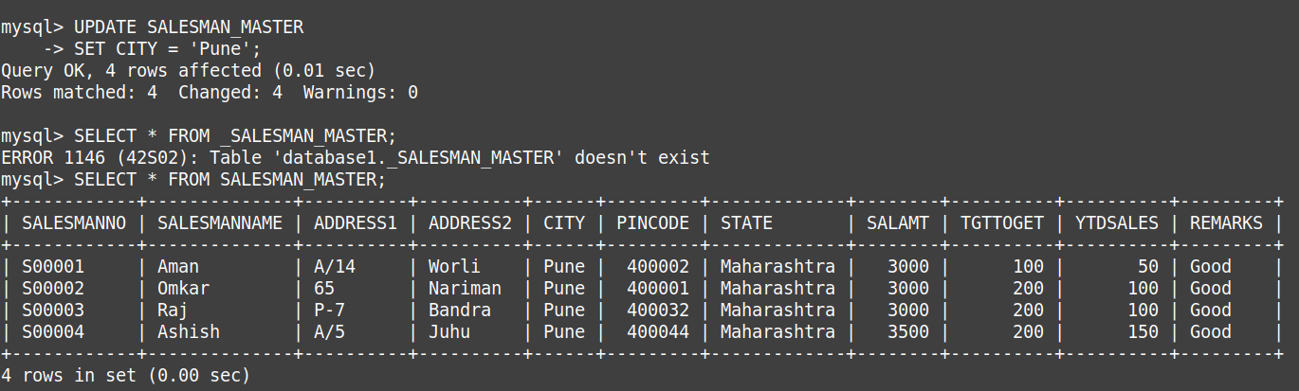
Output:

- Exercise on deleting records in a table
a. Delete all salesman from the Salesman_Master whose salaries are equal to Rs.3500.

Output:
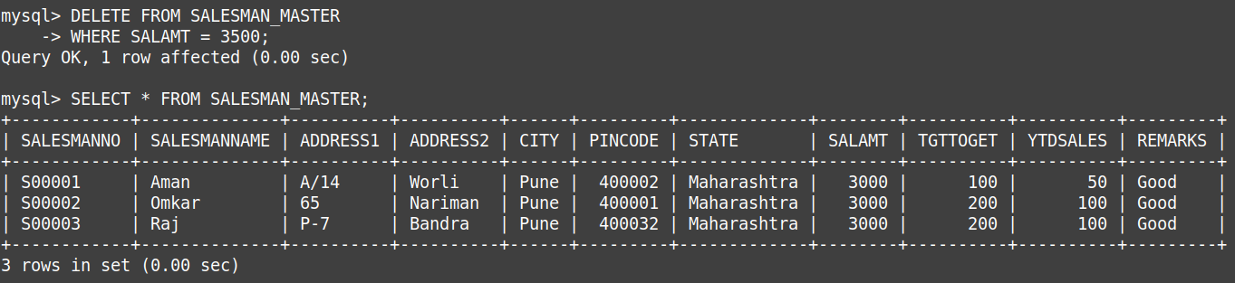
b. Delete all products from Product_Master where the quantity on hand is equal to 100.
Output:

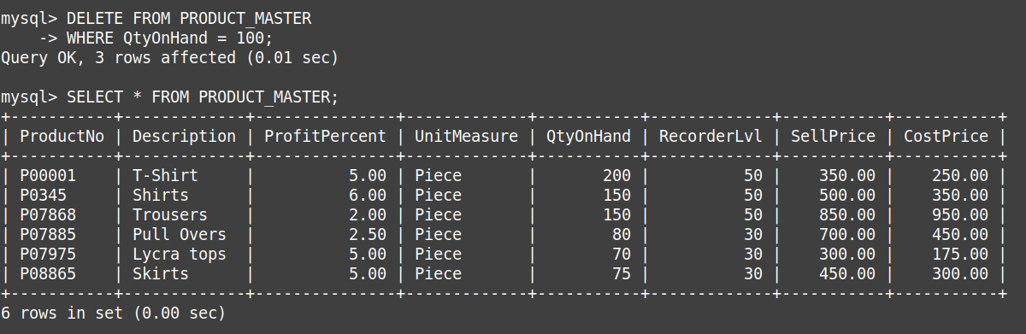
c. Delete from Client_Master where the column state holds the value ‘Tamil Nadu’.

Output:

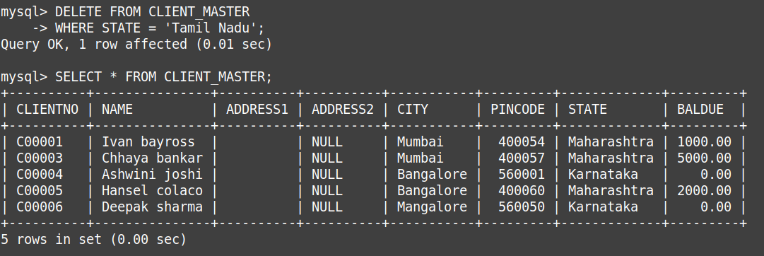
- Exercise on altering the table structure
a. Add a column called ‘Telephone’ of data type integer to the Client_Master table.

Output:

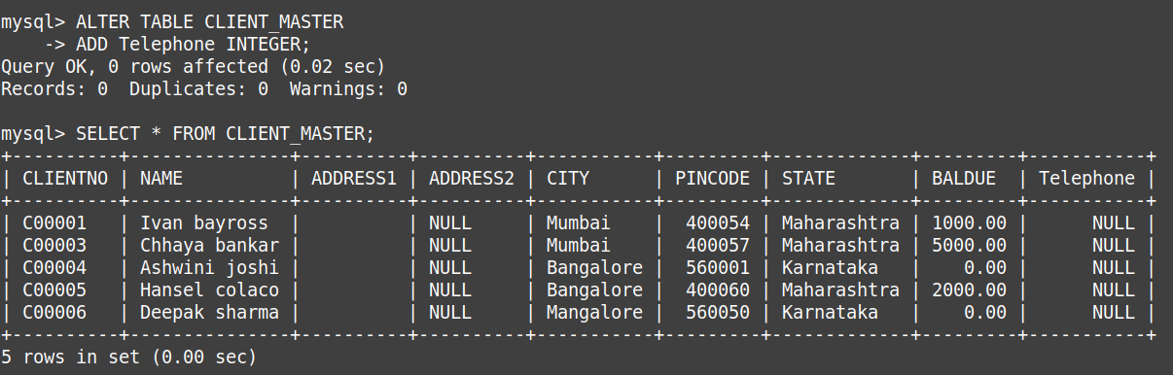
b. Change the size off SellPrice column in Product _Master to 10, 2.

Output:
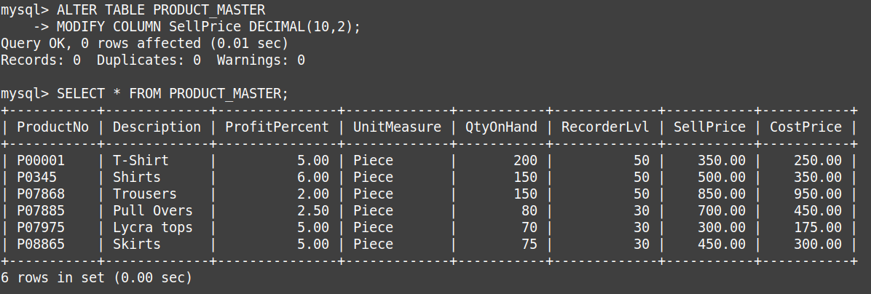

5. Exercise on deleting the table structure along with the data
- Destroy the table Client_Master along with its data.
Output:
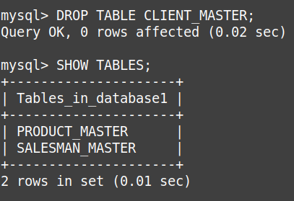

6. Exercise on renaming the table
- Change the name of the Salesman_Master to sman_mast.

Output:
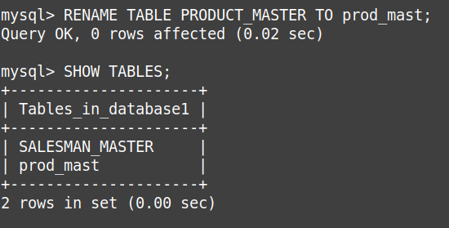

EXPERIMENT-3
TITLE: DDL (Data Definition Language) commands with Data Constraints
Objective: To understand the concept of data constraints that is enforced on data being stored in the table. Focus on Primary Key and the Foreign Key

Create the tables described below:

Table name: CLIENT_MASTER_1

Description: used to store client information.

Column name | data type | Size | Constraints
CLIENTNO | Varchar | 6 | Primary key / first letter must start with ‘C’
NAME | Varchar | 20 | Not Null
ADDRESS 1 | Varchar | 30
ADDRESS 2 | Varchar | 30
CITY | Varchar | 15
PINCODE | Integer | 8
STATE | Varchar | 15
BALDUE | Decimal | 10,2

Output:

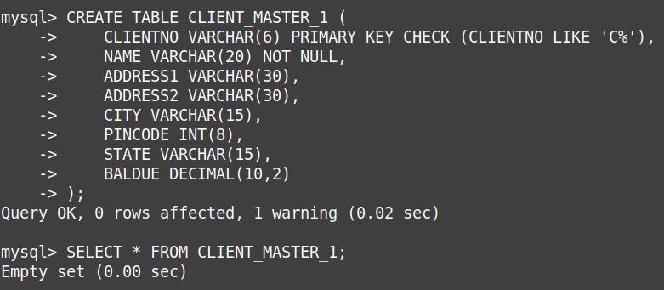

Table Name: PRODUCT_MASTER_1 Description: used to store product information
Column name | data type | Size | Attributes
PRODUCTNO | Varchar | 6 | Primary Key/ first letter must start with ‘P’
DESCRIPTION | Varchar | 15 | Not Null
PROFITPERCENT | Decimal | 4,2 | Not Null
UNIT MEASURE | Varchar | 10 | Not Null
QTYONHAND | Integer | 8 | Not Null
REORDERL VL | Integer | 8 | Not Null
SELLPRICE | Decimal | 8,2 | Not Null
COSTPRICE | Decimal | 8,2 | Not Null

Output:
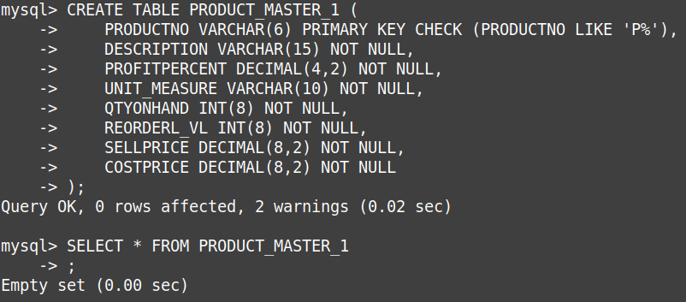

Name: SALESMAN_MASTER _1
Description: used to shoe salesman information working for the company.

Column name | data type | Size | Attributes
SALESMANNO | Varchar | 6 | Primary Key/ first letter must start with ‘S’
SALESMANNAME | Varchar | 20 | Not Null
ADDRESS 1 | Varchar | 30 | Not Null
ADDRESS 2 | Varchar | 30
CITY | Varchar | 20
PINCODE | Integer | 8
STATE | Varchar | 20
SALAMT | Real | 8,2 | Not Null , Cannot be 0
TGTTOGET | Decimal | 6,2 | Not Null , Cannot be 0
YTDSALES | Double | 6,2 | Not Null
REMARKS | Varchar | 60

Output:
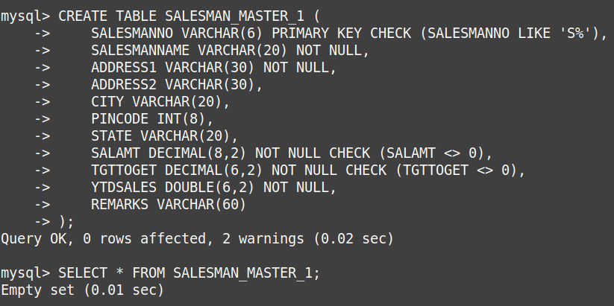

Reinsert the data in these two tables based upon Lab 2.

Output:
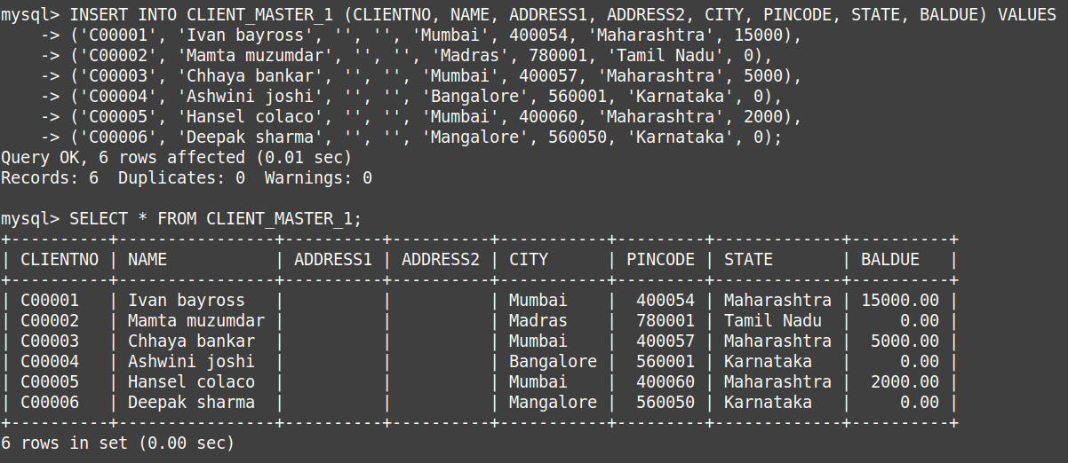
- Display the contents of each table.
Output:

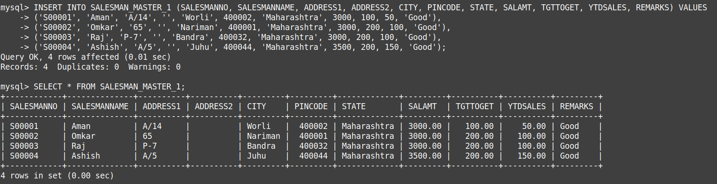
EXPERIMENT-4

TITLE: DDL (Data Definition Language) commands with Data Constraints
Objective: To understand the concept of data constraints that is enforced on data being stored in the table. Focus on Primary Key, The Foreign Key and constraints.
Review this diagram
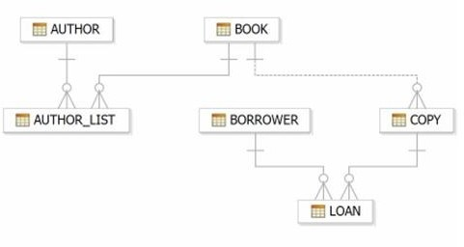

1. Create table AUTHOR = {Author_ID , Lastname, Firstname, Email, City, Country}
Where:
Author_ID – text data type, 5 characters, primary key
Lastname – text data type, 15 characters, not null
Firstname – text data type, 15 characters, not null
Email – text data type, 40 characters,
City – text data type, 15 characters,
Country – text data type, 15 characters,
Output:
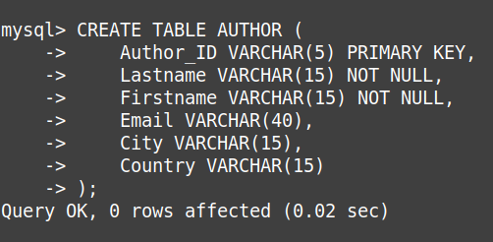

2. Create Table BOOK={ Book_ID, Book_Title, Copies)
Where :
Book_ID – text data type, 5 characters Primary Key Start With Character B
Book_Title - Text data Type Not Null
Copies- No.of copies Data Type int always greater the 2

Output:
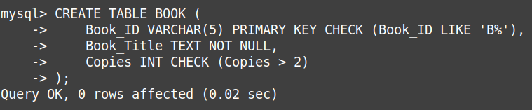

3. Create table AUTHOR_LIST = {Author_ID , Book_ID , Role}
Where:
Author_ID – text data type, 5 characters, referenced by Author_ID from AUTHOR
table
Book_ID – text data type, 5 characters
Role – text data type, 15 characters
and primary key is: Author_ID, Book_ID
Output:
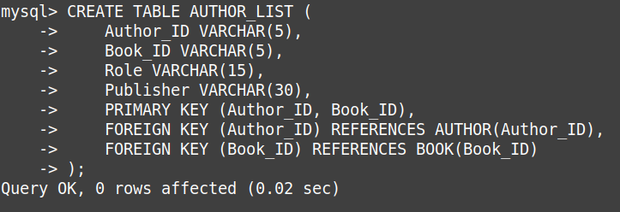

4. Add four records in each tables AUTHOR, BOOK, BOOK_LIST.
Output:
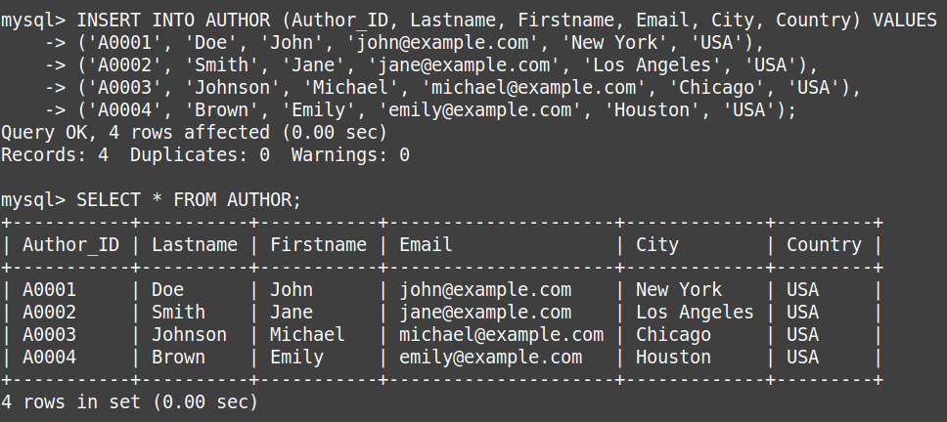
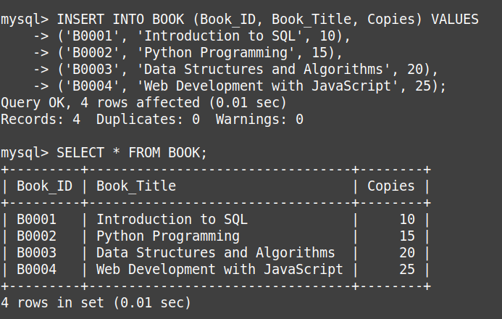

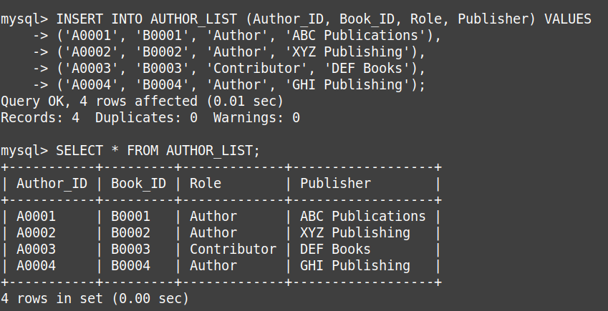

5. Alter structure of table AUTHOR_LIST add the field Publisher data type of 30 Character.
Output:

