Creational Design Pattern

Singleton Design

Aim:
The aim is to ensure that a class has only one instance globally accessible, facilitating efficient resource management and providing a centralized point for accessing and controlling shared state within the application.

Description:
The provided Java code implements the Singleton design pattern, ensuring that only one instance of the `Singleton` class exists. The class contains a private static instance and a private constructor to prevent external instantiation. Access to the singleton instance is provided through a static method `getInstance()`. The `TestClass` demonstrates obtaining and modifying singleton instances, showcasing the pattern's ability to maintain a single global point of access to shared resources. This design enhances resource management and facilitates centralized control of global state within the application. Through thread-safe instantiation and efficient memory usage, the Singleton pattern promotes efficient and organized software design.

Code:

1. Singleton.java

package design;

public class Singleton {
private static Singleton soleInst=new Singleton();
public int i;
private Singleton() {
System.out.println("Created");
}

public static Singleton getInstance() {
return soleInst;
}

public int getI() {
return i;
}

public static void getSoleInstance(Singleton soleInst) {
Singleton.soleInst = soleInst;
}
public void setI(int i) {
this.i = i;
}

}

2. TestClass.java

package design;

public class TestClass {
public static void main(String[] args) {
Singleton s1 = Singleton.getInstance();
Singleton s2 = Singleton.getInstance();
s1.setI(5);
s2.setI(10);
System.out.println(s1.getI());
s2.i = s1.i + s2.i;
System.out.println(s2.getI());
print("S1",s1);
print("S2",s2);
}
static void print(String name, Singleton obj) {
System.out.println(String.format("Object: %s, Hashcode: %d", name, obj.hashCode()));
}
}

Output:
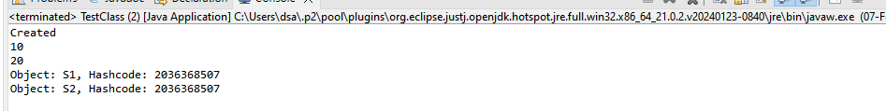

Class Diagram:
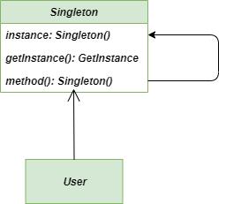

Aim:
The aim is to ensure that a class has only one instance globally accessible, facilitating efficient resource management and providing a centralized point for accessing and controlling shared state within the application.

Description:
This Java code implements the Singleton design pattern with a `MailBox` class, ensuring there's only one instance of the mailbox throughout the program. The `MailBox` class has a private constructor and a static method `getInstance()` to retrieve the singleton instance, creating it if it doesn't exist. It also includes a method `receiveMail()` to handle incoming messages. The `Main` class demonstrates the usage by prompting the user to enter a mail message, obtaining the singleton instance of `MailBox`, and then receiving the mail message through the `receiveMail()` method. This pattern ensures centralized access to the mailbox instance, promoting efficient resource management and organized handling of mail messages.

Code:

1. Main.java
import java.util.Scanner;

// Singleton MailBox class
class MailBox {
// Private static instance variable
private static MailBox instance;

// Private constructor to prevent instantiation from outside
private MailBox() {
}

// Public static method to get the instance
public static MailBox getInstance() {
if (instance == null) {
instance = new MailBox();
}
return instance;
}

// Method to handle incoming mail
public void receiveMail(String message) {
System.out.println("Received mail: " + message);
}
}

// Main class to demonstrate usage
public class Main {
public static void main(String[] args) {
Scanner scanner = new Scanner(System.in);

// Prompt user to enter mail message
System.out.println("Enter your mail message:");
String message = scanner.nextLine();

// Get the instance of the Singleton MailBox
MailBox mailBox = MailBox.getInstance();

// Use the mailBox instance to receive mail
mailBox.receiveMail(message);

scanner.close();
}
}

Output:

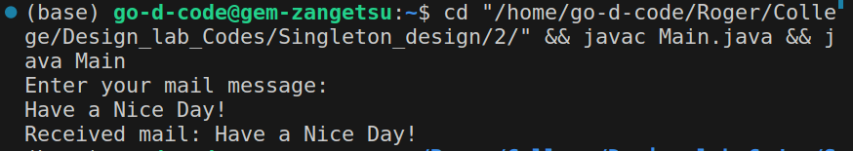
Class Diagram:
