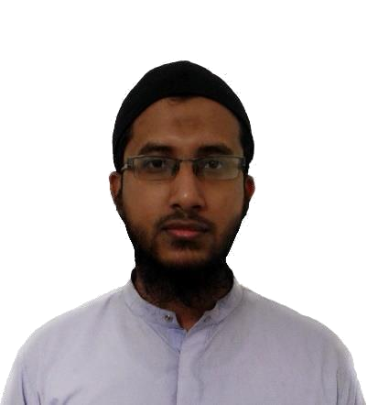
Md. Ashfaqur Rahman

Email: ashfaqdev.php@gmail.com

Contact no: 01813727901

Address: C/O, khizirur Rahman

Shopno kutir, Noju Munshi lane
Thana: Bandar, Chittagong

Profile Summary

I am a problem solver, a real one. Good at programming and my analytical capability is strong. To describe myself i would like to say i am dedicated, hard worker and innovative.

Experience

- I worked as a Junior Web Developer in LII Lab from October 2016 to January 2017

- I am working as a Software Engineer in LionCoders from February 2018 - Present

Professional Skill

Web Development:

- Skilled in PHP - Laravel framework, HTML-CSS, Bootstrap
- Good at JQUERY

- Good at MySQL query, can design relational database

Programming Skill:

- Good at programming, solved almost 150 online problems in various online judge like UvaOJ and LightOJ

- Have solved 143 problems in UvaOJ. My ID is: back devil

- Mainly solved algorithm related problem. I solved problem of Graph Theory (BFS, DFS, MST, Dijkstra, Floyd Warshall etc.)

- Also solved DP related problem like LIS (Longest Increasing Subsequence), LCS (Longest Common Subsequence) etc.
Important Projects

- I had worked in an image service project with PHP-Laravel. Please visit below link at your convenient time: https://ashfaq2016@bitbucket.org/ashfaq2016/image_server.git

- Create a Meal Management System by using PHP, HTML / CSS

- I made a game named “Catch The Ball” with Java
- Made a chat messenger with Java

Research

My Thesis Topic was Latent Semantic Analysis. I worked on Text Summarization with Latent Semantic Analysis. Have studied five Machine Learning algorithm of Latent Semantic Analysis and implement them on Bangla Text

Academic Qualification

S.S.C Result:

Chittagong Collegiate School

GPA 5.0 (2009)

H.S.C Result:

Govt City College Chittagong

GPA 4.8 (2011)

B.S.C Result:

Appeared

Department: Computer Science & Engineering

Shahjalal University of Science & Technology

Session: 2011-12

References

Md. Mushfiqur Rahman Sheikh Nabil Mohammad

Co-founder of LII Lab Assistant professor, SUST
Contact No: 01711829496 Contact No: 01678137313

