CprE 3810: Computer Organization and Assembly-Level Programming

Project Part 1 Report

Team Members: ______________________________________________

______________________________________________

______________________________________________

Project Teams Group #:_________________________

Refer to the highlighted language in the project 1 instruction for the context of the following questions.

[Part 2 (d)] Include your final RISC-V processor schematic in your lab report.
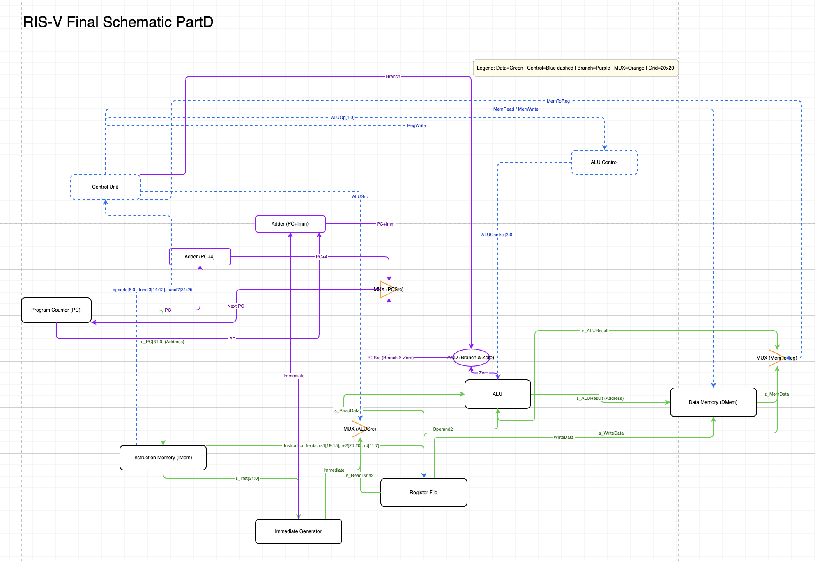

[Part 3.1.a.] Create a spreadsheet detailing the list of M instructions to be supported in your project alongside their binary opcodes and funct fields, if applicable. Create a separate column for each binary bit. Inside this spreadsheet, create a new column for the N control signals needed by your datapath implementation. The end result should be an N*M table where each row corresponds to the output of the control logic module for a given instruction.
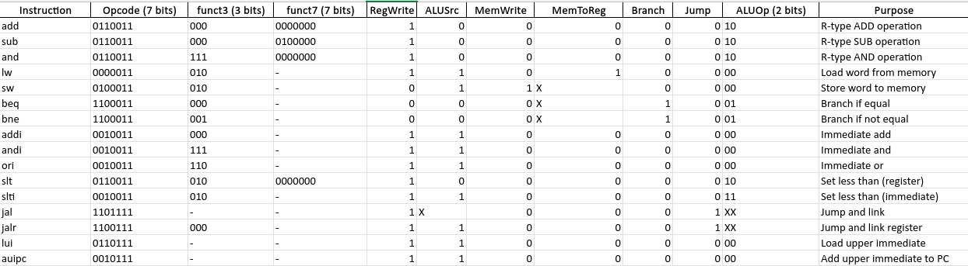
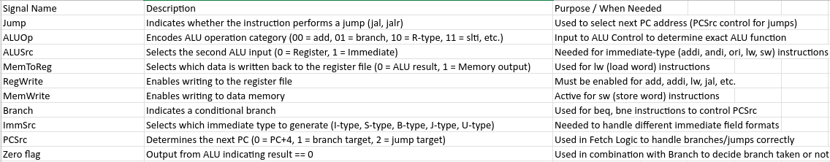

[Part 3.1.(b)] Implement the control logic module using whatever method and coding style you prefer. Create a testbench to test this module individually and show that your output matches the expected control signals from problem 1(a).
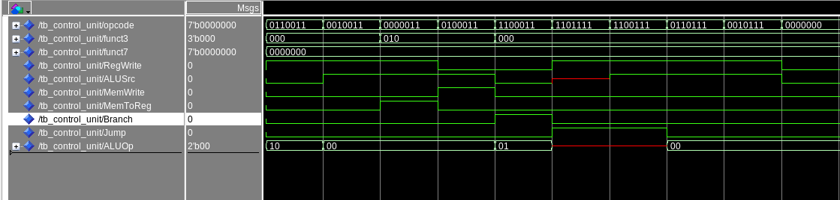
The simulation of the Control Unit verifies that all control signals are correctly generated according to the RISC-V instruction types. Each opcode triggers the expected combination of control signals such as RegWrite, ALUSrc, MemWrite, MemToReg, Branch, and Jump.
The waveform clearly shows that:
- RegWrite is asserted for R-type, I-type, Load, and Jump Instruction.
- ALUSrc is set for immediate-based operations(I-type, Load, Store, etc..)
- MemWrite and MemToReg are only active for memory access instructions.
- Branch and Jump behave correctly for control-flow instruction.

These results confirm that Control Unit successfully decodes instruction opcodes and generates the proper control signals required for data path operation.

[Part 3.2. (a)] What are the control flow possibilities that your instruction fetch logic must support? Describe these possibilities as a function of the different control flow-related instructions you are required to implement.
The instruction fetch logic must support several control flow possibilities to determine the correct next program counter (PC) value for each instruction type.
In a single-cycle RISC-V processor, the possible control flow cases are as follows:
- Sequential Execution (PC + 4):
For most instructions, the PC is simply incremented by 4 to fetch the next sequential instruction.
- Branch Instructions (PC + Immediate):
For conditional branch instructions (e.g., BEQ, BNE, BLT, BGE, etc.), the next PC is determined by adding the sign-extended immediate value to the current PC, but only if the branch condition is satisfied (Branch = 1 and Zero = 1 from ALU).
- JAL (Jump and Link):
The JAL instruction causes an unconditional jump by adding the immediate offset to the current PC.
Additionally, PC + 4 must be written to the destination register (rd) as the return address.
- JALR (Jump and Link Register):
The JALR instruction computes the next PC as the sum of the base register (rs1) and the sign-extended immediate value.
The least significant bit of the result is forced to zero to ensure alignment.
Like JAL, it also stores PC + 4 into rd.
- Other Instructions:
For non-control-flow instructions (e.g., arithmetic, load, store), the next PC always follows the sequential path (PC + 4).

[Part 3.2. (b)] Draw a schematic for the instruction fetch logic and any other datapath modifications needed for control flow instructions. What additional control signals are needed?
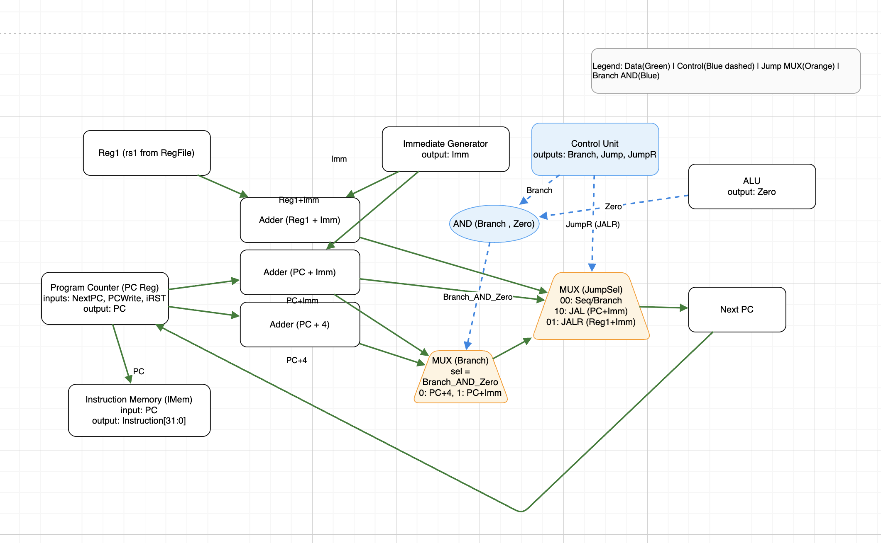
In the updated datapath, additional components were introduced to support control flow instructions (branch, JAL, and JALR). Specifically, new adders (PC+Imm, Reg1+Imm), two multiplexers (Branch MUX, JumpSel MUX), and an AND gate (Branch & Zero) were added. These allow the processor to correctly calculate the next program counter (PC) for sequential, branch, and jump instructions. Additional control signals (Jump, JumpR, and Branch) were also included to drive these new components.

[Part 3.2.(c)] Implement your new instruction fetch logic using VHDL. Use QuestaSim to test your design thoroughly to make sure it is working as expected. Describe how the execution of the control flow possibilities corresponds to the QuestaSim waveforms in your writeup.
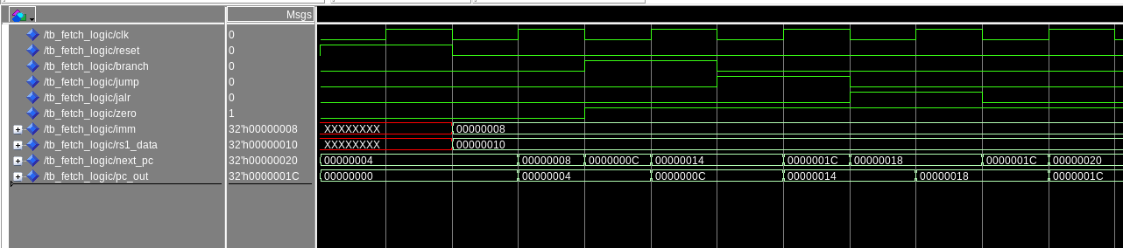
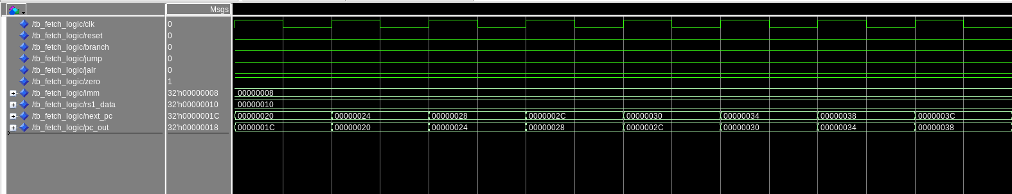
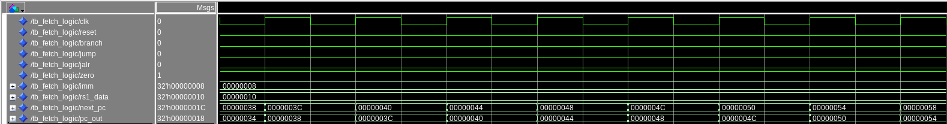
The simulation waveforms clearly demonstrate the correct operation of the instruction fetch logic according to the control flow possibilities.
Initially, after reset is deasserted, the Program Counter (PC) starts from address 0x00000000 and increments by 4 for every clock cycle, as shown by the transition of next_pc and pc_out from 0x00000000 → 0x00000004 → 0x00000008. This confirms the normal sequential instruction fetch behavior (PC + 4).
When the Branch and Zero signals are asserted simultaneously, the waveform shows that next_pc changes to 0x0000000C, which corresponds to PC + Immediate. On the next clock cycle, pc_out updates to the same value, indicating that the branch target address has been correctly computed and applied.
Next, when the Jump (JAL) signal is asserted, the next_pc value changes again by the immediate offset (PC + Immediate), confirming that the fetch logic correctly performs unconditional jumps.
Following that, when the JALR signal is asserted, next_pc updates to rs1_data + Immediate (e.g., 0x00000010 + 0x00000008 = 0x00000018), and the subsequent pc_out reflects this new address. This verifies correct JALR (jump and link register) behavior.
Finally, once all control signals are deasserted (branch = jump = jalr = 0), the waveform shows pc_out resuming its normal sequential pattern (PC + 4).
Throughout the simulation, next_pc always updates one cycle before pc_out, which matches the expected synchronous behavior of the PC register.
Hence, the QuestaSim results confirm that the fetch logic correctly implements all control flow cases: normal increment, branch, JAL, and JALR, each producing the appropriate next PC values in sequence.

[Part 3.3.1.(a)] Describe the difference between logical (srl) and arithmetic (sra) shifts. Why does RISC-V not have a sla instruction?

[Part 3.3.1.(b)] In your writeup, briefly describe how your VHDL code implements both the arithmetic and logical shifting operations.

[Part 3.3.1.(c)] In your writeup, explain how the right barrel shifter above can be enhanced to also support left shifting operations.

[Part 3.3.1.(d)] Describe how the execution of the different shifting operations corresponds to the QuestaSim waveforms in your writeup.

[Part 3.3.2.(a)] In your writeup, briefly describe your design approach, including any resources you used to choose or implement the design. Include at least one design decision you had to make.

[Part 3.3.2.(b)] Describe how the execution of the different operations corresponds to the QuestaSim waveforms in your writeup.

[Part 3.3.3] Draw a simplified, high-level schematic for the 32-bit ALU. Consider the following questions: How is Zero calculated? How is slt implemented?

[Part 3.3.5] Describe how the execution of the different operations corresponds to the QuestaSim waveforms in your writeup.

[Part 3.3.8] justify why your test plan is comprehensive. Include waveforms that demonstrate your test programs functioning.

[Part 4] In your writeup, show the QuestaSim output for each of the following tests, and provide a discussion of result correctness. It may be helpful to also annotate the waveforms directly.

[Part 4.a] Create a test application that makes use of every required arithmetic/logical instruction at least once. The application need not perform any particularly useful task, but it should demonstrate the full functionality of the processor (e.g., sequences of many instructions executed sequentially, 1 per cycle while data written into registers can be effectively retrieved and used by later instructions). Name this file Proj1_base_test.s.

[Part 4.b] Create and test an application which uses each of the required control-flow instructions and has a call depth of at least 5 (i.e., the number of activation records on the stack is at least 4). Name this file Proj1_cf_test.s.

[Part 4.c] Create and test an application that sorts an array with N elements using the MergeSort algorithm (link). Name this file Proj1_mergesort.s.

[Part 5] Report the maximum frequency your processor can run at and determine what your critical path is. Draw this critical path on top of your top-level schematic from part 1. What components would you focus on to improve the frequency?

