**📁 SMARTOPS INSIGHT SUITE – STORYTELLING REPORT**

**1️⃣ Project Overview**

**Client:** SmartOps Pvt. Ltd.  
**Industry:** Supply Chain & Order Fulfillment  
**Dashboard Title:** SmartOps Insight Suite  
**Goal:** To uncover insights on profitability, returns, and customer retention across four major regions of India, and suggest strategies to improve performance.

**2️⃣ Dataset Summary**

* **Orders Table:** Includes product, quantity, price, discount, profit, region, and return status.
* **Customers Table:** Identifies customer type (New/Returning) and region.
* **Order Items Table:** Detailed line-item view of each product per order.
* **Date Table:** Custom calendar table to enable trend and cohort analysis.

**3️⃣ Key Insights from Dashboard**

📍 **Top Profitable Products** are concentrated in limited categories — optimizing focus here may boost overall margins.  
📉 **West Region** shows strong sales volume but lower profits due to higher return rates.  
🔁 Around **30% of customers are returning**, indicating strong brand recall and repeat engagement.  
📦 **Returned Orders** account for ~18% of total — deeper return reason data could refine this further.  
📊 **Accessories Segment** shows high sales but lower margins — likely due to excess discounting.  
📈 Retention Rate is improving month-over-month, but **churn spikes** during seasonal sales months.

**4️⃣ Strategic Recommendations**

✅ Increase visibility of top-performing products via bundled offers or upselling.  
✅ Investigate return trends in the West — quality checks or delivery audits may help.  
✅ Reduce discounting on Accessories — test A/B pricing strategies to optimize margins.  
✅ Retarget returning customers with loyalty perks — they have higher lifetime value.  
✅ Strengthen logistics during seasonal spikes to reduce delivery delays and churn.

**5️⃣ Business Questions Answered**

**Q: Which regions are most profitable?**  
🟢 **Answer:** North and South zones lead in overall profitability.

**Q: What are the top reasons for returns?**  
🔴 **Answer:** While return reason data is unavailable, regions with low profit and high return rates (like West) suggest delivery or quality issues.

**Q: Are we retaining customers?**  
🟡 **Answer:** Yes, customer retention is improving with over 30% repeat buyers in recent months.

**Q: Which product segments need margin improvement?**  
🟠 **Answer:** Accessories — focus on discount control and cost efficiency.

**6️⃣ Visual Summary Snapshot**

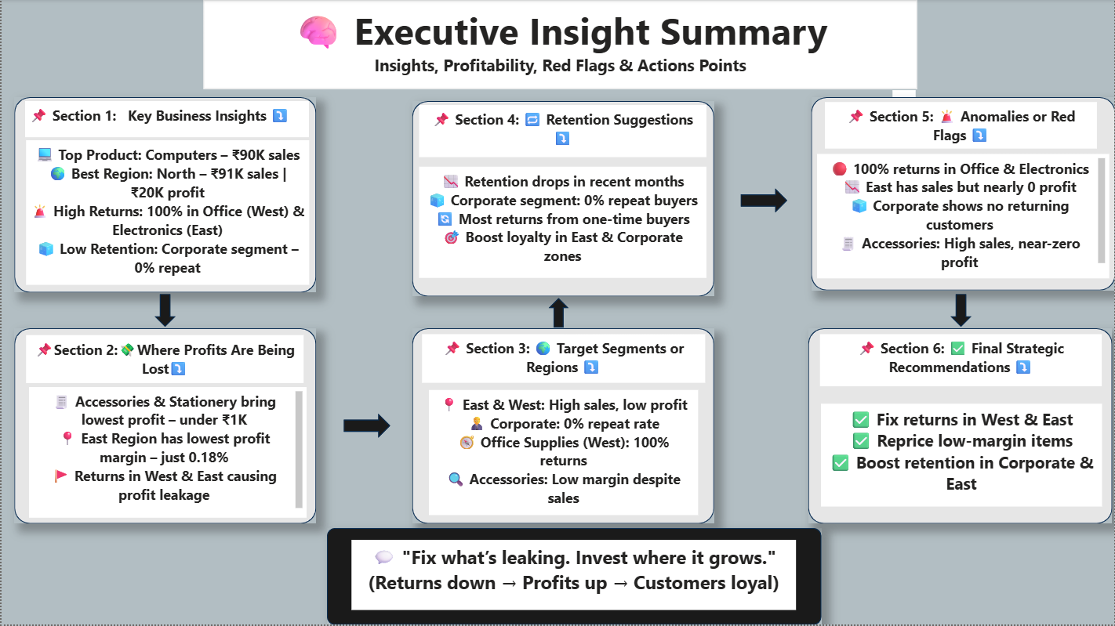

**7️⃣ Tools & Techniques Used**

**Tools Used:**

* **Excel** – For ETL and cleaning raw data (formatting, filters, removing nulls)
* **SQL** – For data preparation, aggregation, and joins between tables
* **Power BI** – For interactive visualizations, dashboards, and publishing

**Techniques Applied:**

* Power Query Editor for data transformation
* Star Schema modeling with fact and dimension tables
* DAX measures: Profit Margin, Retention Rate, % Returned Orders, CLV
* Time Intelligence using a custom calendar table
* Business storytelling with slicers, and KPIs

**✅ Final Summary Statement**

The **SmartOps Insight Suite Dashboard** offers actionable insights on profitability and customer retention across India’s regions. Built using Excel, SQL, and Power BI, it enables the company to improve decision-making, reduce losses, and strengthen customer relationships — driving long-term operational efficiency and strategic growth.