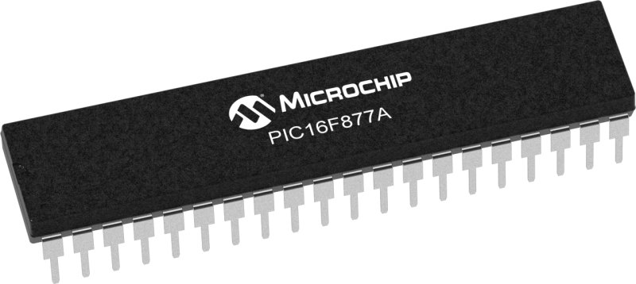

**Embedded Systems Course**

**Solution of Task 1**

**الطالب:** كريم وائل محمد محمد

**الفرقة:** تانية اتصالات

1. **Pins of PIC16f877A**

The PIC16F877A is a popular 8-bit microcontroller from Microchip Technology, widely used in various embedded systems and projects. It has a total of 40 pins, each with its unique functionality. Here's a brief description of each pin:

RA0 - Pin 2: Analog Input/Output pin 0. It can be used as an analog input for ADC or as a digital input/output.

RA1 - Pin 3: Analog Input/Output pin 1. Similar to RA0, it can be used for analog or digital purposes.

RA2 - Pin 4: Analog Input/Output pin 2. It can be used for analog input or digital input/output.

RA3 - Pin 5: Analog Input/Output pin 3.

RA4 - Pin 6: Digital Input/Output pin.

RA5 - Pin 7: Digital Input/Output pin.

VSS - Pin 8: Ground (0V) reference.

VDD - Pin 9: Supply Voltage pin (+5V).

RB0/INT - Pin 10: Digital Input/Output pin. It can be used as an external interrupt input.

RB1 - Pin 11: Digital Input/Output pin.

RB2 - Pin 12: Digital Input/Output pin.

RB3 - Pin 13: Digital Input/Output pin.

RB4 - Pin 14: Digital Input/Output pin.

RB5 - Pin 15: Digital Input/Output pin.

RB6/PGC - Pin 16: Digital Input/Output pin.

RB7/PGD - Pin 17: Digital Input/Output pin.

RB6/PGC - Pin 18: Digital Input/Output pin.

RB7/PGD - Pin 19: Digital Input/Output pin.

VSS - Pin 20: Ground (0V) reference.

VDD - Pin 21: Supply Voltage pin (+5V).

RC0 - Pin 22: Digital Input/Output pin.

RC1 - Pin 23: Digital Input/Output pin.

RC2 - Pin 24: Digital Input/Output pin.

RC3 - Pin 25: Digital Input/Output pin.

RC4 - Pin 26: Digital Input/Output pin.

RC5 - Pin 27: Digital Input/Output pin.

RE0/AN5 - Pin 28: Analog Input/Output pin 5.

RE1/AN6 - Pin 29: Analog Input/Output pin 6.

RE2/AN7 - Pin 30: Analog Input/Output pin 7.

VSS - Pin 31: Ground (0V) reference.

VDD - Pin 32: Supply Voltage pin (+5V).

RD0 - Pin 33: Digital Input/Output pin.

RD1 - Pin 34: Digital Input/Output pin.

RD2 - Pin 35: Digital Input/Output pin.

RD3 - Pin 36: Digital Input/Output pin.

RD4 - Pin 37: Digital Input/Output pin.

RD5 - Pin 38: Digital Input/Output pin.

RD6 - Pin 39: Digital Input/Output pin.

RD7 - Pin 40: Digital Input/Output pin.

VSS - Pin 1: Ground (0V) reference.

1. **Main blocks in PIC16f877A**

**ALU (Arithmetic Logic Unit):**

The ALU is the core computational unit of the microcontroller responsible for performing arithmetic and logic operations. It can perform various operations, including addition, subtraction, AND, OR, XOR, shifting, and more. The ALU takes input from the working registers, performs the specified operation, and stores the result in the destination register or memory location. It plays a crucial role in executing arithmetic and logical instructions of the microcontroller.

**Status and Control:**

The Status and Control register (sometimes referred to as the "Status Register") is a special register that contains important flags and control bits. These flags indicate the outcome of previous instructions and provide status information to the CPU. For example, the Zero (Z) flag is set if the result of an operation is zero, the Carry (C) flag is used for carry or borrow in arithmetic operations, the Overflow (OV) flag is used for signed arithmetic operations, and so on. Additionally, control bits in this register are used to enable or disable specific features of the microcontroller and to control interrupt handling.

**Program Counter (PC):**

The Program Counter is a register that keeps track of the address of the next instruction to be fetched from memory and executed. It automatically increments after each instruction fetch. The PC plays a crucial role in the instruction execution cycle, ensuring that the microcontroller sequentially fetches instructions from program memory and executes them one by one.

**Flash Program Memory:**

The Flash Program Memory is the non-volatile memory used to store the program code that the microcontroller executes. In the case of the PIC16F877A, the program memory is based on flash technology, which allows the contents to be electrically erased and reprogrammed. The program memory holds the machine code instructions that make up the user's program and any constants or data stored in the program memory space.

**Instruction Register (IR):**

The Instruction Register is a temporary storage unit that holds the current instruction fetched from the program memory. After fetching an instruction from program memory, it is loaded into the Instruction Register, and then the instruction decoder interprets the opcode and operands to execute the corresponding microcontroller operation.

**Instruction Decoder:**

The Instruction Decoder is responsible for analyzing the opcode portion of the instruction stored in the Instruction Register. It decodes the opcode to determine which instruction needs to be executed and what operands are involved. Based on the decoded opcode, the instruction decoder generates control signals to enable the necessary components of the microcontroller, such as the ALU, registers, and data buses, to execute the instruction accurately.

1. **Why a led connected to RA4 for flashing prepose not working probably?**

According to PIC16F877A data sheet, pins are usually connected to PMOS and NMOS transistors. If both transistors are given 1, resulting I/O pin is 1 (+5V). If both transistors are given 0, the resulting I/O pin is 0 (GND).

RA4 is a special pin where it is connected to NMOS transistor only. If the transistor is given 0, resulting I/O pin is 0 (GND) while if it is given 1, resulting I/O pin is undefined meaning it is neither 0 nor 1 as it’s open circuit.

Connecting the led as source will not work in this case:

While connecting led as sink will work:

We can also connect led as source, but the circuit will have minor adjustments as follows:

**Note:** PIC16F877A cannot withstand current more than 25mA so a resistor of 330 ohm is used (5V / 330ohm = 15mA < 25mA).

1. **ATMega328P vs PIC16f877A**

**Memory Size:**

ATMega328P: The ATMega328P is an 8-bit microcontroller. It has 32KB of flash program memory and 2KB of SRAM (static RAM).

PIC16F877A: The PIC16F877A is also an 8-bit microcontroller. It has 14KB of flash program memory and 368 bytes of SRAM.

The ATMega328P has more flash program memory, which is beneficial for larger and more complex applications.

**Power Consumption:**

ATMega328P: The ATMega328P is known for its low power consumption, making it suitable for battery-powered and energy-efficient applications.

PIC16F877A: The PIC16F877A has moderate power consumption characteristics but may not be as power-efficient as the ATMega328P.

The ATMega328P's low power consumption makes it a better choice for projects that require extended battery life.

**Pin Count:**

ATMega328P: The ATMega328P has 28 pins.

PIC16F877A: The PIC16F877A has 40 pins.

In summary, the ATMega328P excels in low power consumption, has more flash program memory, and offers smaller package options compared to the PIC16F877A. It is a better fit for battery-powered and energy-efficient applications, as well as projects with space constraints like wearable devices (smartwatches, fitness trackers, etc.), DIY Robotics, and Home Automation Systems.