|  |  |  |  |
| --- | --- | --- | --- |
| **Sr. No.** | **Company** | **Year** | **Package**  **LPA** |
| 1 | Byjus | 2017-18 | 7.0 |
| 2 | Meccademia | 2017-18 | 5.76 |
| 3 | LG | 2017-18 | 3.6 |
| 4 | Farmerp | 2017-18 | 3.6 |
| 5 | Rieco | 2017-18 | 3.6 |
| 6 | Intellectyx | 2018-19 | 12.4 |
| 7 | Veda | 2018-19 | 12.0 |
| 8 | Algo | 2018-19 | 8.0 |
| 9 | Wayfair | 2018-19 | 7.5 |
| 10 | Khimji | 2018-19 | 6.07 |
| 11 | Softcore | 2018-19 | 5.59 |
| 12 | Qperior | 2018-19 | 5.3 |
| 13 | Vodafone | 2018-19 | 4.5 |
| 14 | UBI | 2018-19 | 4.25 |
| 15 | Siemens | 2018-19 | 4.2 |
| 16 | Flextronics | 2018-19 | 4.0 |
| 17 | Samsonite | 2018-19 | 3.75 |
| 18 | Fig | 2018-19 | 3.75 |
| 19 | Indicus | 2018-19 | 3.7 |
| 20 | GUNN | 2018-19 | 3.7 |
| 21 | Laish | 2018-19 | 3.6 |
| 22 | 3i | 2019-20 | 6.16 |
| 23 | Cloud | 2019-20 | 5.5 |
| 24 | Stellium | 2020-21 | 4.5 |
| 25 | Ovvio | 2020-21 | 3.78 |
| 26 | Magna | 2020-21 | 3.75 |
| 27 | Aligned | 2020-21 | 3.60 |
| 28 | Mentor | 2020-21 | 3.57 |
| 29 | Mindtree | 2021-22 | 4.0 |
| 30 | Accenture | 2021-22 | 4.5 |
| 31 | Amazon | 2021-22 | 4.5 |

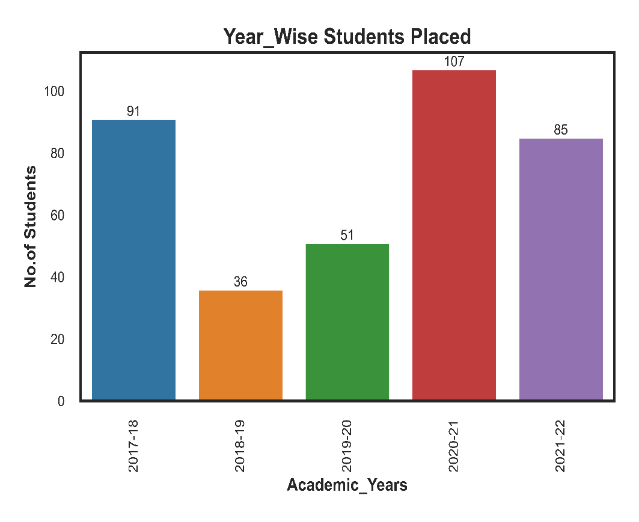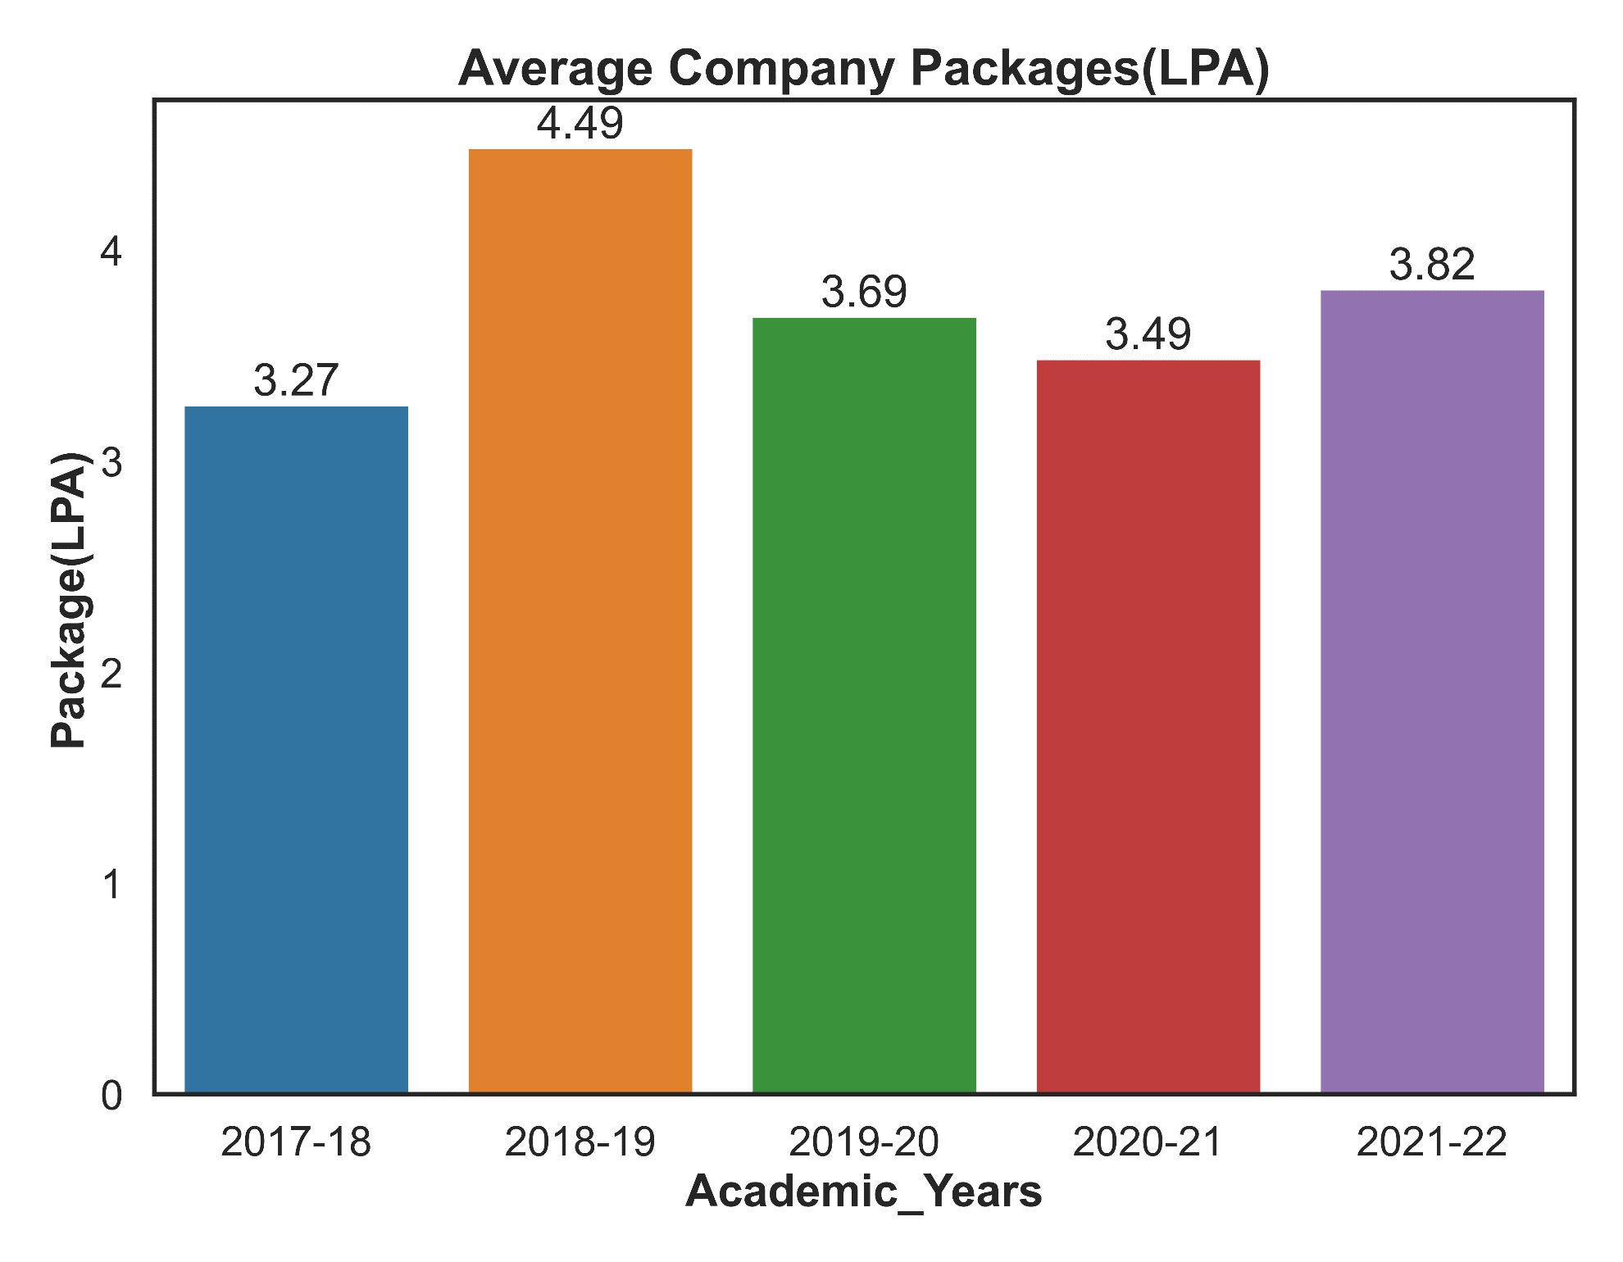

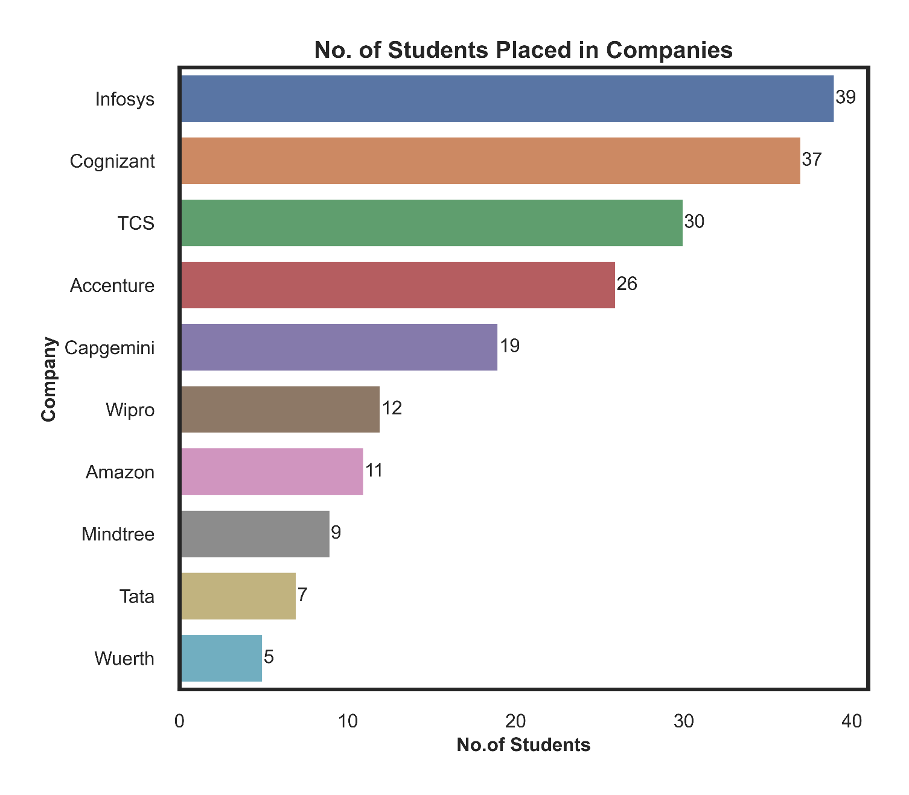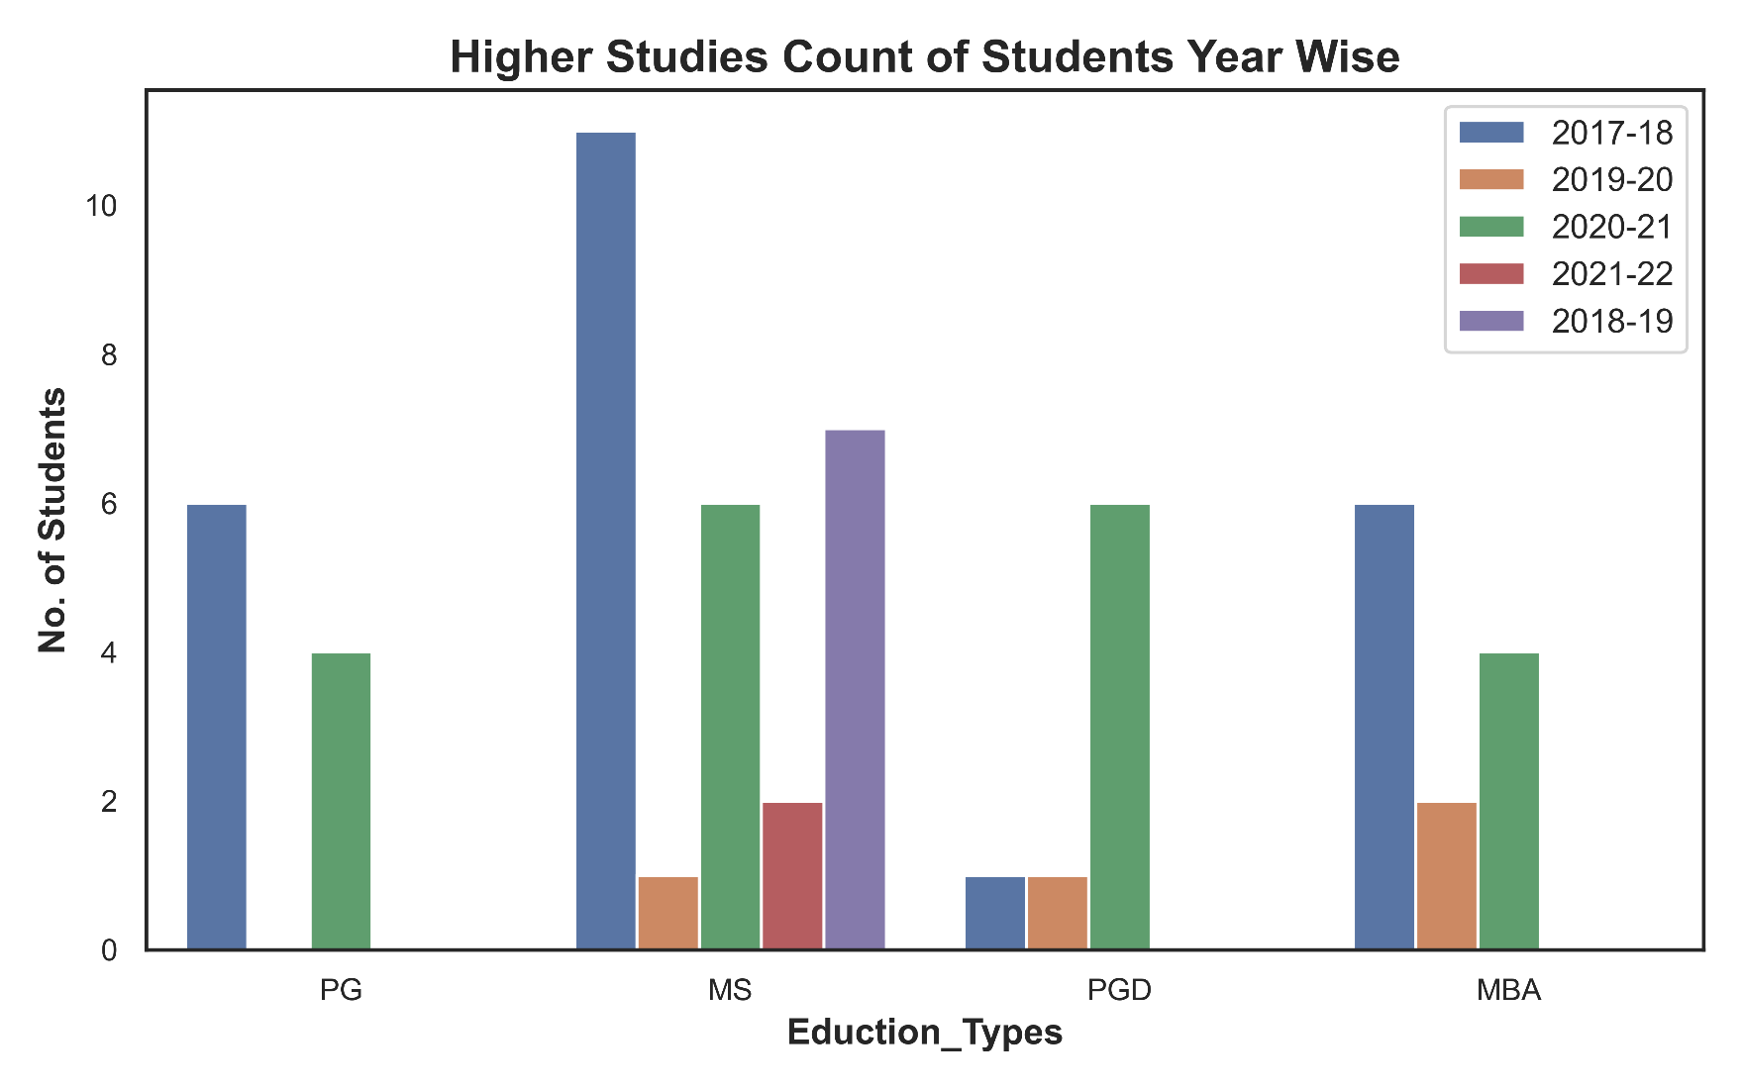

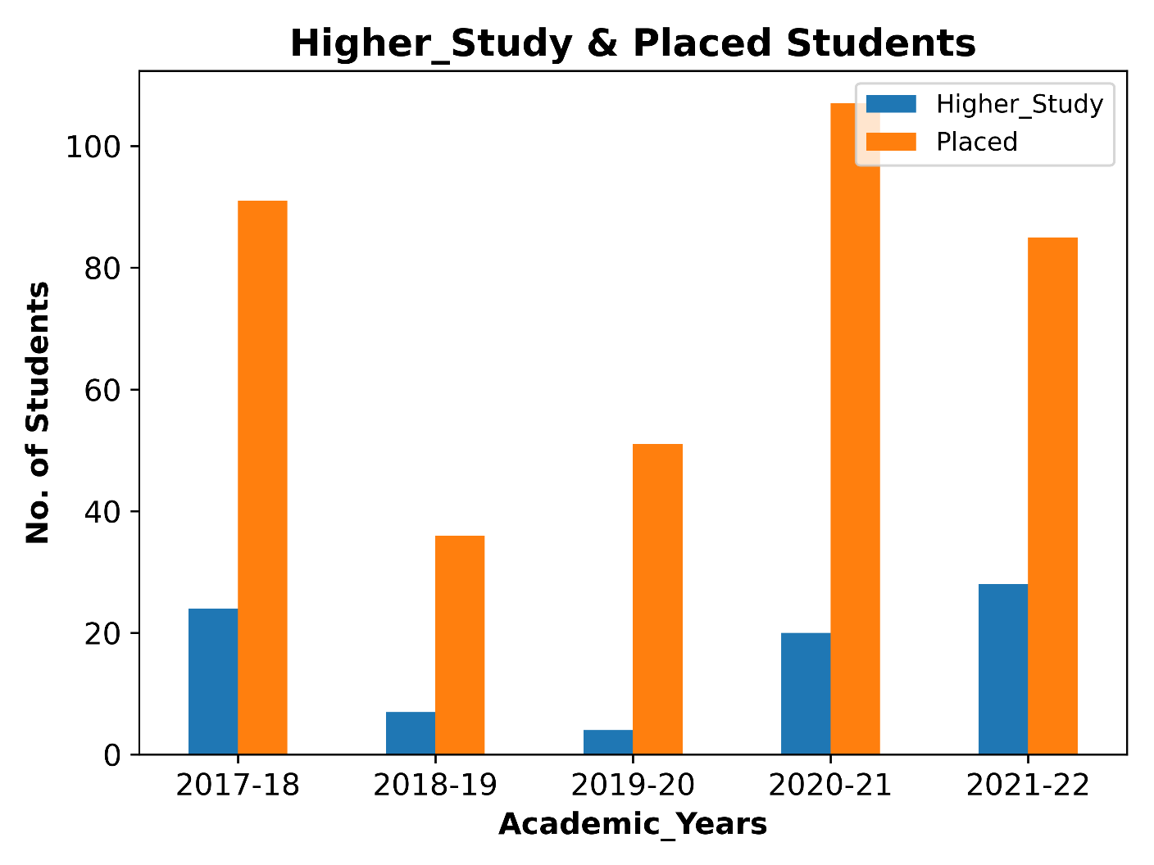

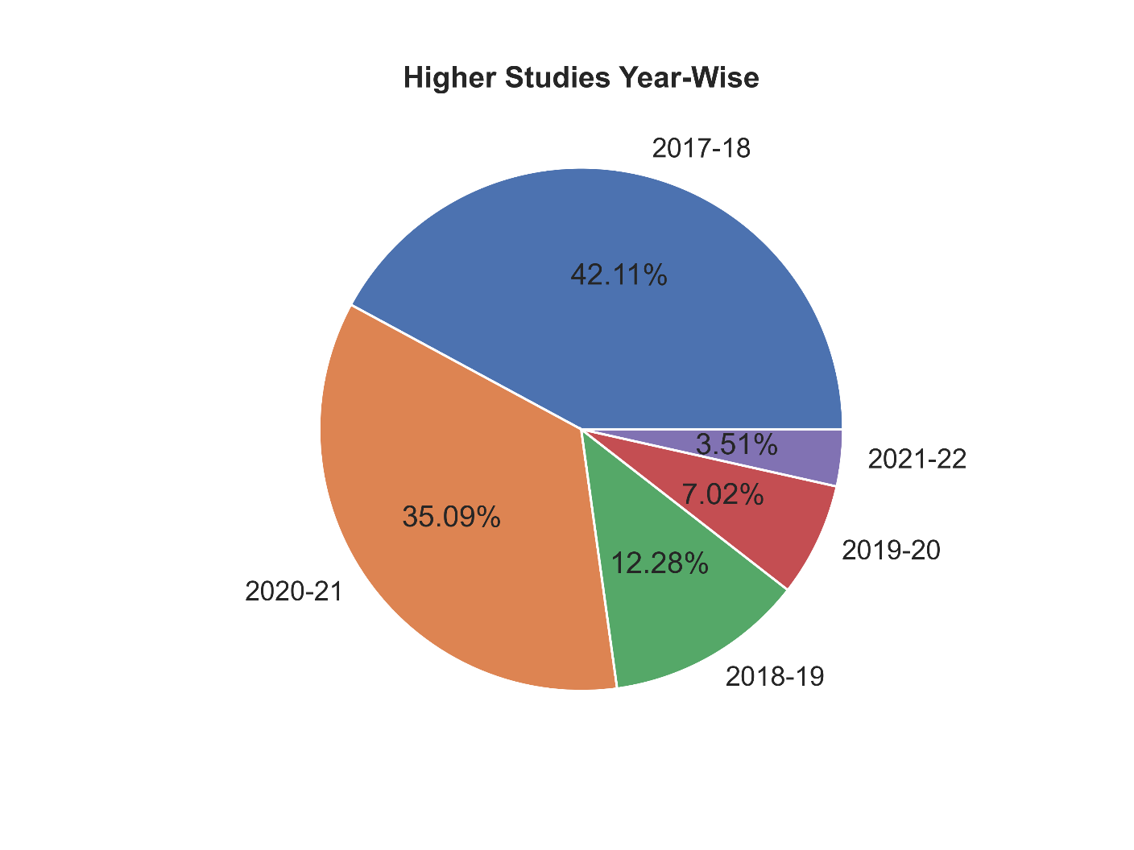

|  |  |  |
| --- | --- | --- |
|  |  |  |
|  |  |  |
|  |  |  |
|  |  |  |

|  |  |  |  |  |  |  |  |
| --- | --- | --- | --- | --- | --- | --- | --- |
|  |  |  | 4,042 Amazon Logo Stock Photos - Free & Royalty-Free Stock Photos from  Dreamstime |  |  |  |  |
|  |  |  |  |  |  |  |  |
|  |  |  | Mercedes Logo Wallpapers - Wallpaper Cave |  |  |  |  |
|  |  |  |  |  |  |  |  |