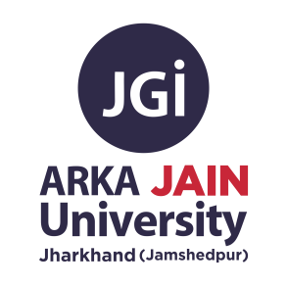

| **Date of Event** | 08/10/23 |
| --- | --- |
| **Name and Type of Event** | DevFest Ranchi 2023 |
| **Conducted by** | GDG Ranchi in collaboration with GDSC BIT Mesra , GDSC  Arka Jain University, GDSC IIIT Ranchi and other GDSCs from the state |
| **No. of Participants** | 43 Participant From Arka Jain University |
| **Objectives** | To get the insigth of Computer Science by Industry Experts |
| **Outcome** | Networking with Industry Experts |



DevFest 2023 Ranchi, a flagship event organized by the Google Developer Groups (GDG) in collaboration with Google Developer Student Clubs (GDSCs) across the state, evolved into a remarkable celebration of technology and innovation. On October 8, 2023, this event was organized at the BIT Mesra campus in Ranchi, where it brought together a diverse congregation of technology enthusiasts, seasoned developers, and eager students. The day unfolded as a tapestry of profound discussions, hands-on workshops, and invaluable networking opportunities, all made possible by the generous support of our sponsor, Orkes.

The journey leading up to this grand occasion commenced a month prior to the event. It began with GDG Ranchi rolling out the registration forms, inviting attendees to embark on this enlightening expedition. Collaborative efforts with GDSCs paved the way for the dissemination of posters across social media platforms, amplifying the event's reach and anticipation.

After all the collaboration, GDG initiated the process of reaching out to distinguished speakers hailing from various corners of the country. After receiving confirmations from these experts, nine speakers were honoured with speaking slots at the event, promising an enriching experience for all attendees. The indispensable support of our event sponsor, Orkes, provided the crucial underpinning for this exceptional occasion.

The culmination of weeks of preparation and dedication materialized with the distribution of event tickets to the eager attendees. Finally, as the sun dawned on the much-anticipated day, all the hard work, planning and commitment bore fruit, as DevFest 2023 Ranchi unfolded into a day of profound learning and exchange of ideas.

**Poster of the Event:**

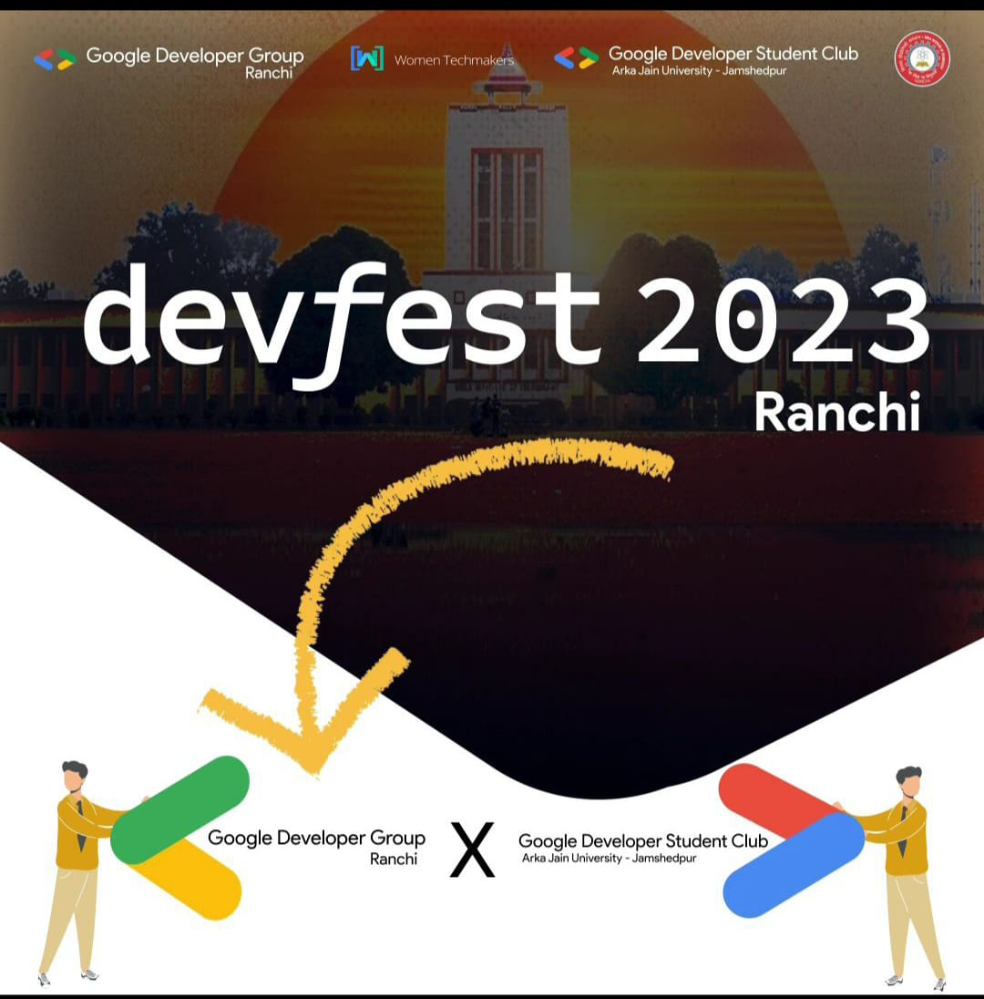

**Photos of the Event:**

|  |
| --- |
|  |
|  |

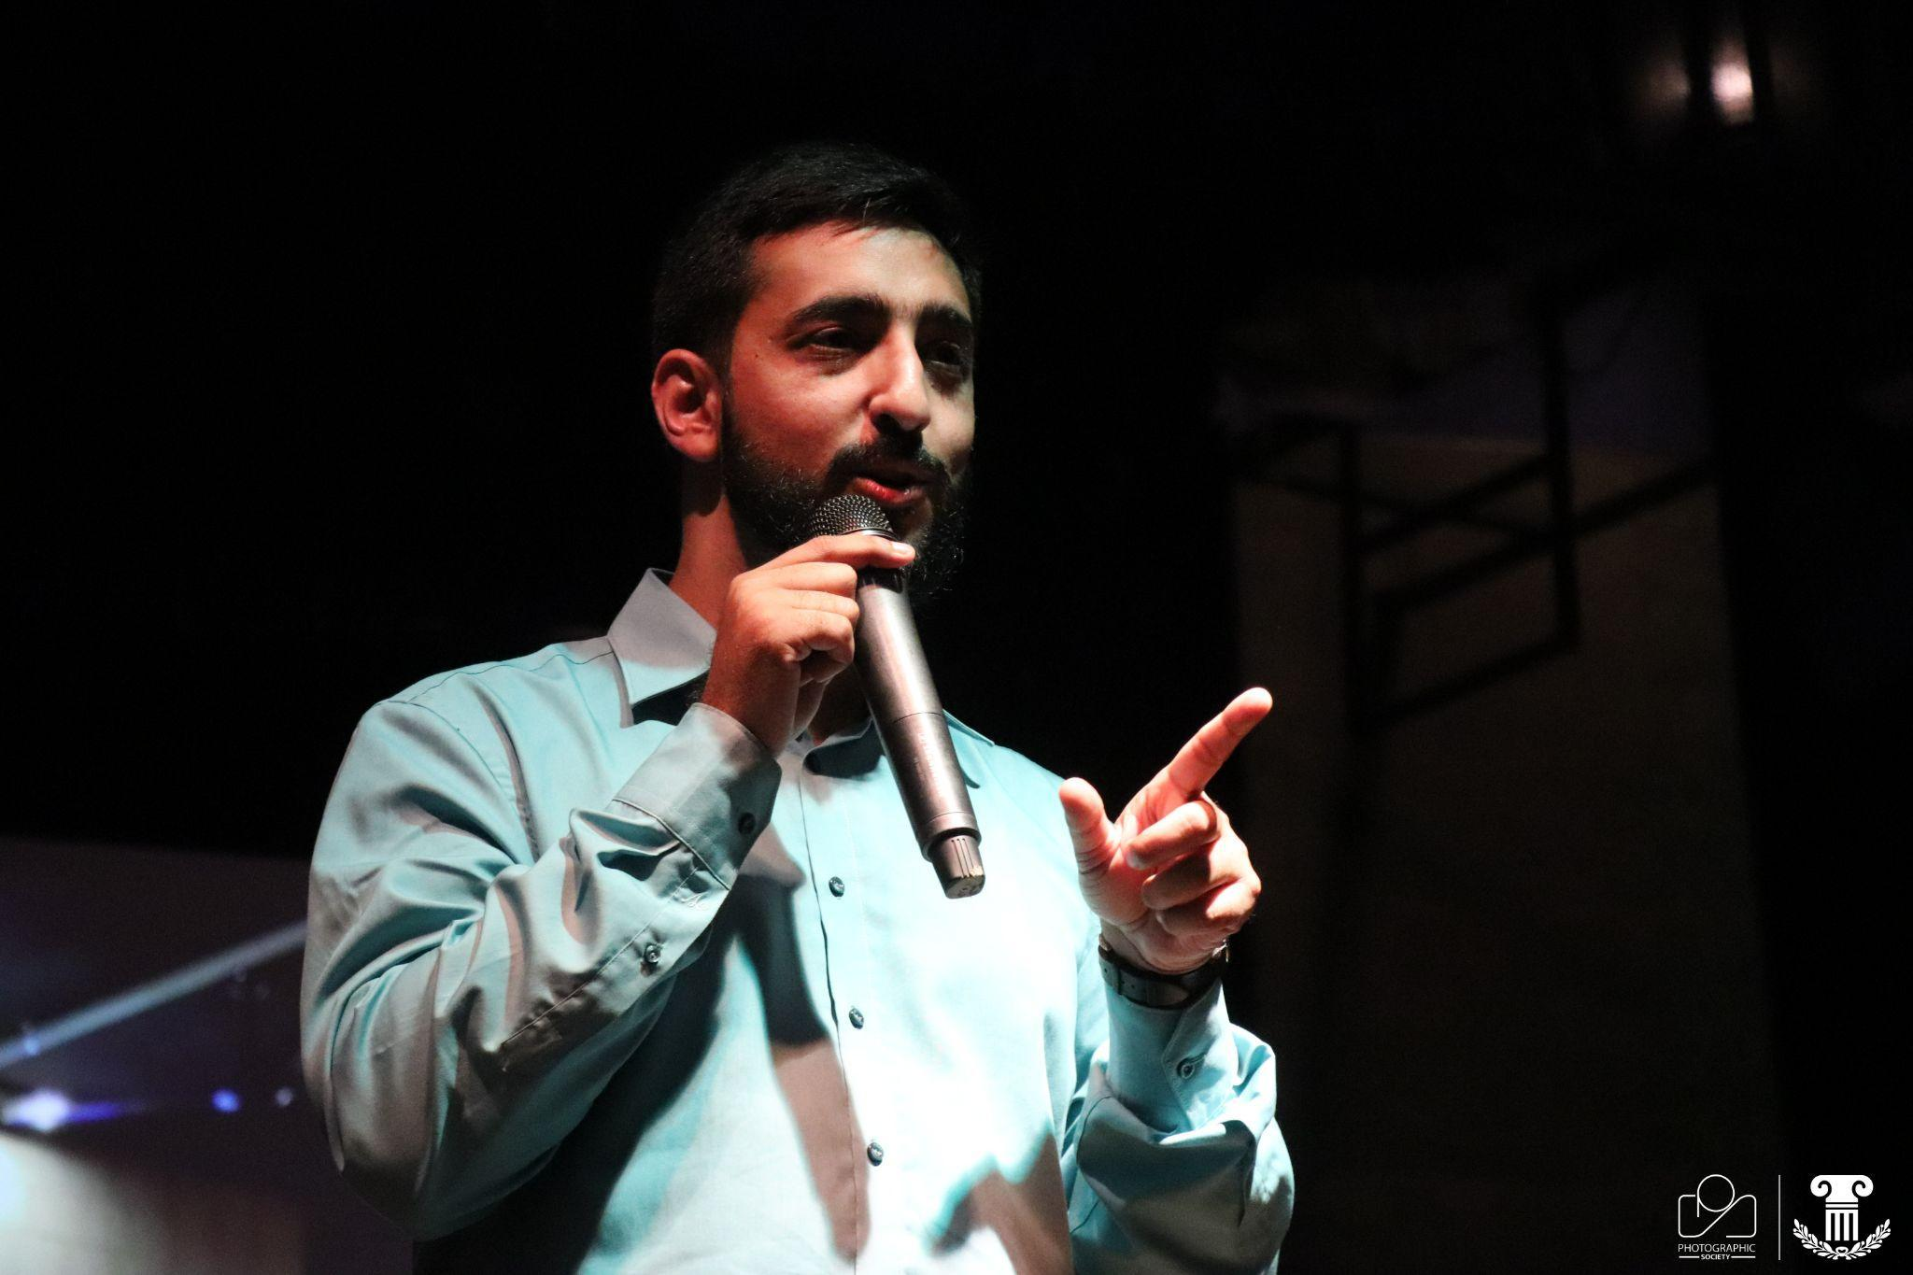

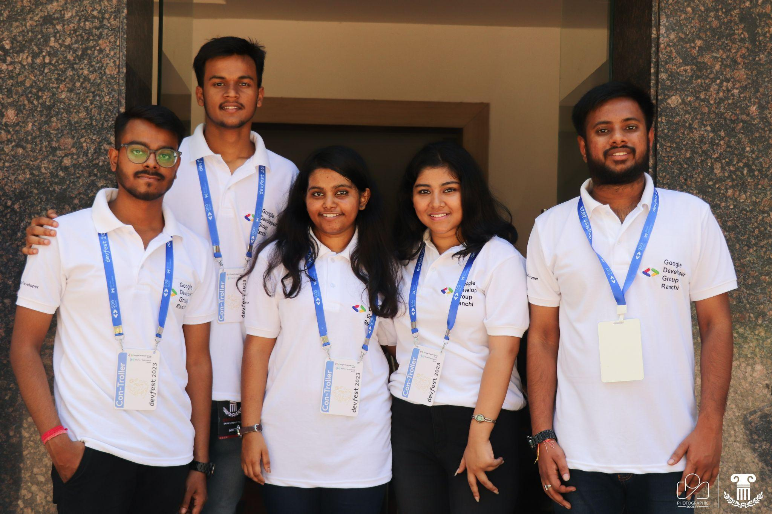

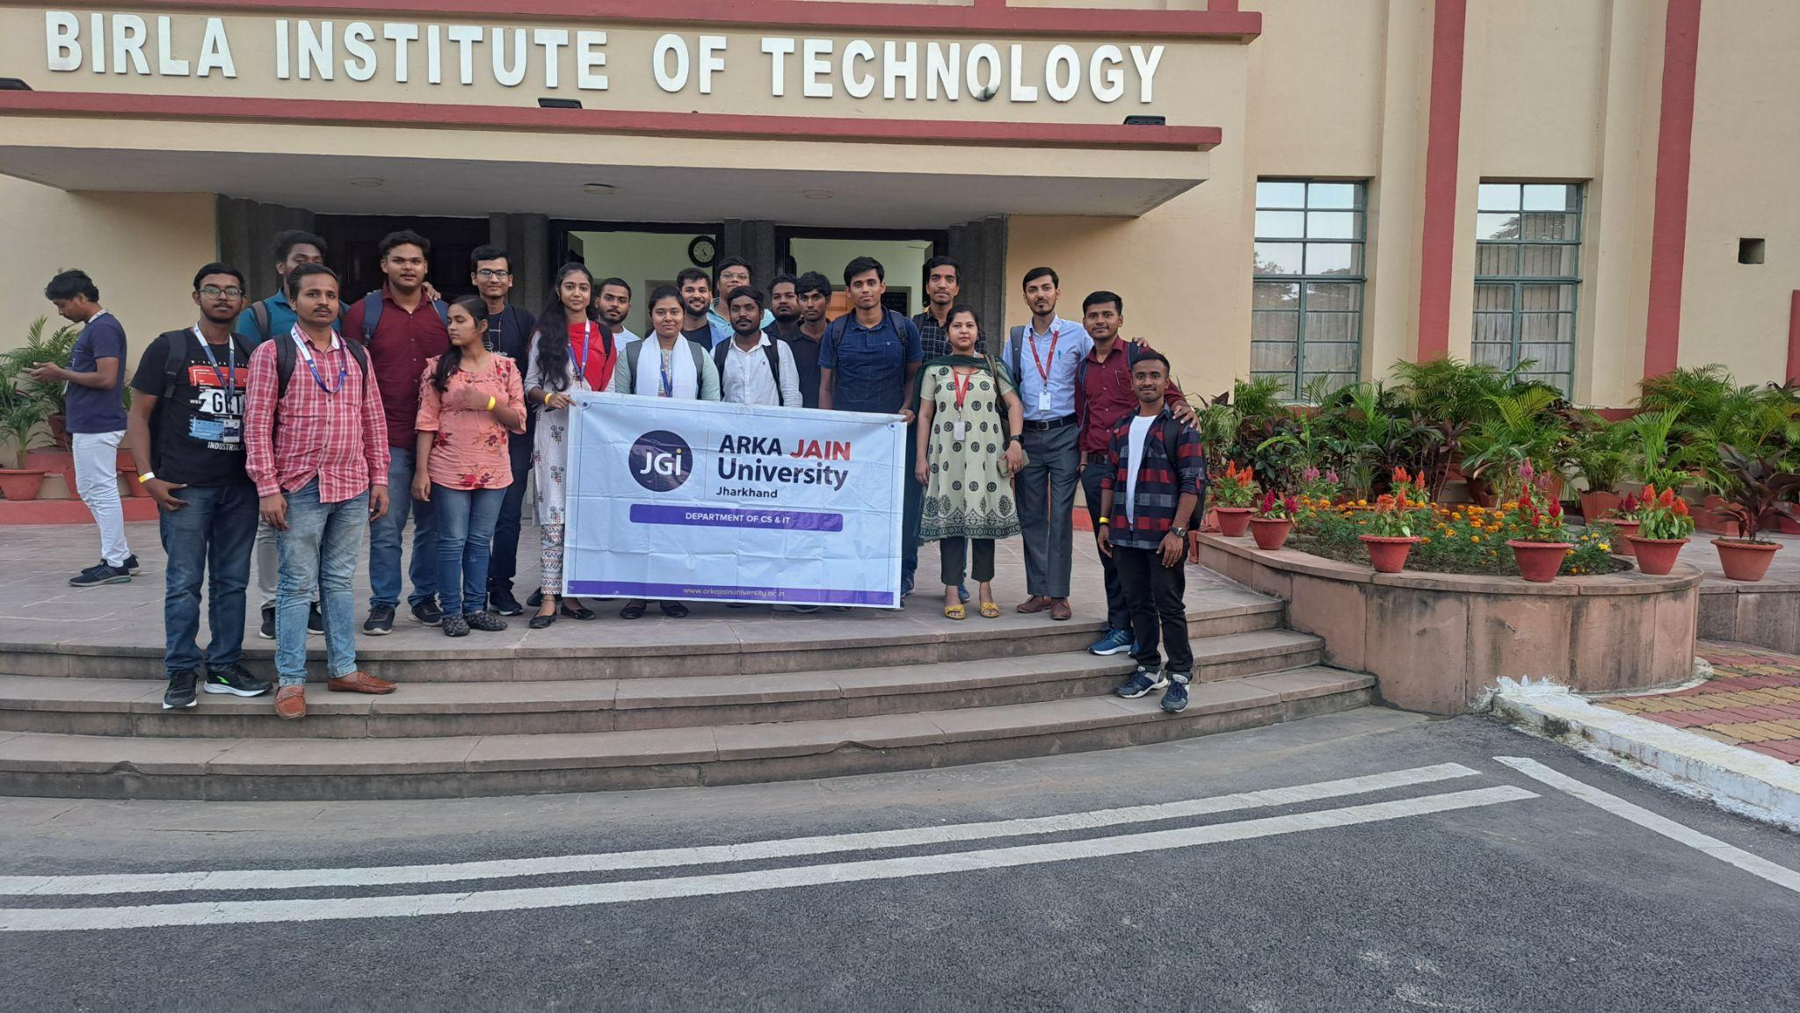

**Participants list:-**

|  |
| --- |

**Speaker Sessions:**

The event featured nine distinguished speakers who delivered insightful talks on various technology and development topics. Which goes in the following order.

1. **Shrutirupa Banerjee:**

She is the Google Developer Expert (GDE) on web technologies and Senior Security Researcher at Quick Heal.

**Topic of the session - Malicious JavaScript: Code that Conceals**

2. **Pranay Nanda:**

He is the Customer Engineer at Google

**Topic of the session- Where's my Cloud? - Cloud in the Era of GenAI**

3. **Saurabh Rajpal:**

He is the APAC Tech Lead and Staff Partner solution Engineer at Google

**Topic of the session- Web Beyond Browsers**

4. **Pooja Gera:**

She is an SWE at PaloAlto Networks, Ex – SWE intern at Microsoft.

She has won some nation Hackathon and Runner-up at Flipkart Grid 3.0.

**Topic of the session: Unravelling the Web's Web: A Primer on Web**

5. **Namrata More:**

Technical program manager at Razorpay and GDG Organizer at Pune

**Topic of the session- BTS: What Influences Payment Success Rates!**

6. **Sangeeta Gupta:**

Community Programs manager at Orkes

**&**

**Nitta Mathew Chacko:**

DevOps Engineer at Orkes

**Topic of the Session- Modernizing Applications: Unleashing the Power of Microservices with Conductor**

7. **Rumanu Bhardwaj:**

She is the Natural Language Processing Scientist at Indian School of Business and Technical Speaker.

**Topic of the session- How Differential Privacy Changed the World, and What the Math Really Means**

8. **Antriksh Gupta:**

He is the Sr. Manager Data & AI Practice at Genzeon

**Topic of the session - The Future of Secure AI: An In- Depth look at GenAI**

**Conclusion:**



DevFest 2023 Ranchi, organized by GDG Ranchi in collaboration with GDSC Arka Jain University and other GDSCs across the state, was a resounding success. The event showcased the spirit of innovation, knowledge sharing, and community collaboration that drives the tech ecosystem in Ranchi and the surrounding regions.

We extend our heartfelt thanks to all the speakers, sponsors, attendees, and volunteers for making this event possible. DevFest 2023 Ranchi was a testament to the power of community-driven tech initiatives and will continue to inspire and empower future generations of developers.

I would also like to thank Dr. Ashwini Kumar Dean of Department of Engineering & IT of Arka Jain University for providing the Transport facility to university students to attend the devfest at BIT Mesra Ranchi.

Thank you for being a part of this incredible journey!