Model1::UseCaseDiagram1

**USE CASE DIAGRAM FOR EXAM REGISTRATION SYSTEM**

**LOGIN**

**VIEW EXAM DETAILS**

**VIEW FEE DETAILS**

**PAY FEE**

**REGISTER**

**DISPLAY DETAILS**

**MAINTAIN EXAM DETAILS**

**LOGOUT**

SHALINI KUMARI

AJU/221596

BTCS-AIML/026

**STUDENT**

**EXAM CONTROLLER**

Activity1::ActivityDiagram1

ACTIVITY DIAGRAM FOR EXAM REGISTRATION SYSTEM

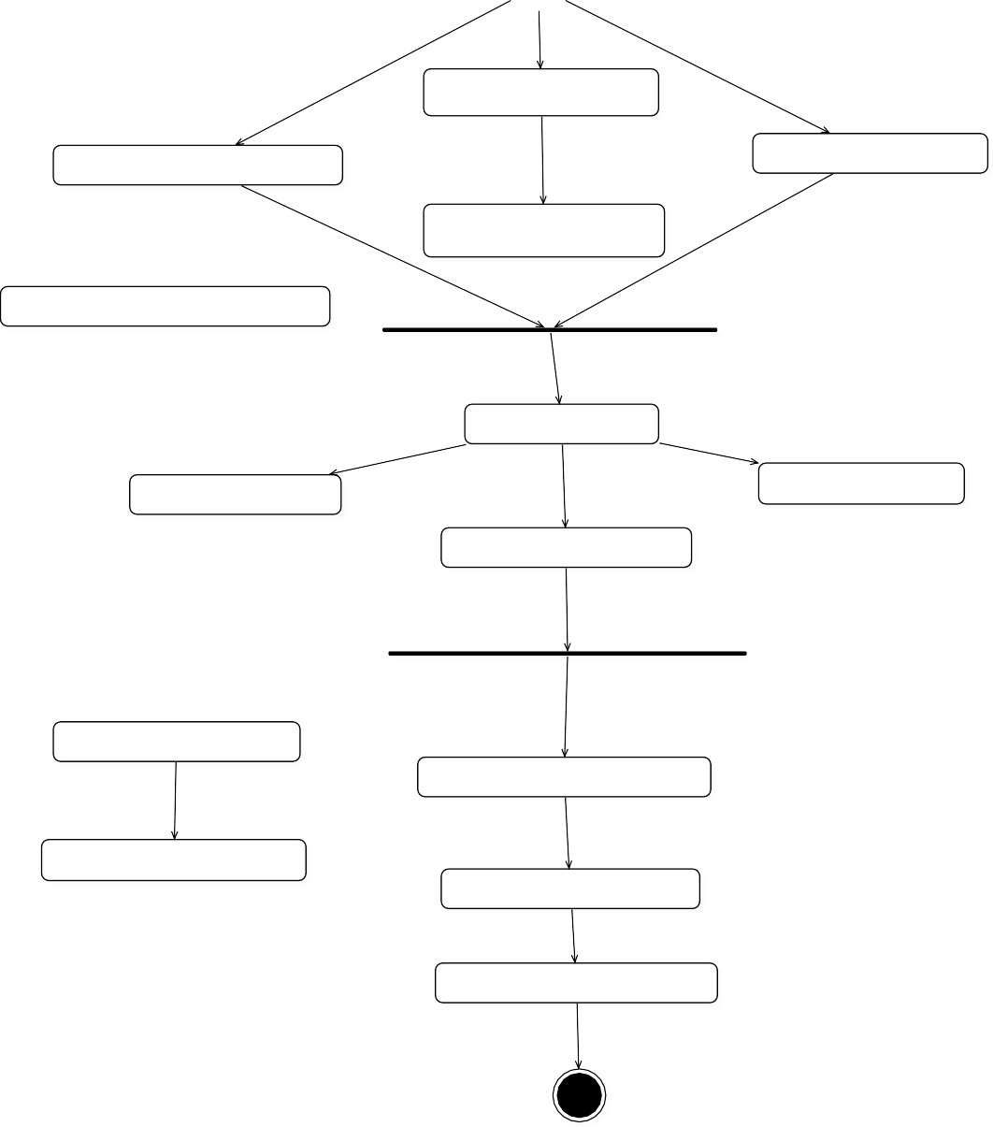

**REGISTRATION**

**GET REGISTRATION RECEIPT**

**STUDENT DETAILS**

**NEW REGISTRATION**

**DOWNLOAD APPLICATION FORM**

**EXAM**

**OBTAIN EXAM DATES**

**GET EXAM RESULTS**

**GET EXAM INSTRUCTION**

**ENROLL A STUDENT**

**UPLOAD REPOSITORY FEES**

**GET PREVIOUS MARKS**

**UPDATE NEWS**

**GET UEGES NEWS**

SHALINI KUMARI

AJU/221596

BTCS-AIML/026

Model2::ClassDiagram1

SHALINI KUMARI

AJU/221596

BTCS-AIML/026

CLASS DIAGRAM FOR EXAM REGISTRATION SYSTEM

+theExamController

+login()

+logout()

+fee_details()

+display_Fees()

+confirmation()

+Exam_Controller()

+user_id: string

+password: string

+exam_fees: integer

+fee_due: integer

**EXAM CONTROLLER**

+login()

+logout()

+confirmation()

+register()

+newFeesDetails()

+Student()

+id: string

+password: string

+name: string

+age: integer

+sex: string

+course: string

**STUDENT**

Collaboration1::Interaction1::SequenceDiagram1

**STUDENT**

**DATABASE**

**EXAM CONTROLLER**

**sd** SequenceDiagram1

1. : LOGIN
2. : CONFIRMATION
3. : PAY
4. : REGISTER
5. : CONFIRMATION
6. : VIEW EXAM DETAILS
7. : LOGOUT

SEQUENCE DIAGRAM FOR EXAM REGISTRATION SYSTEM

SHALINI KUMARI

AJU/221596

BTCS-AIML/026

Model3::DeploymentDiagram1

DEPLOYMENT DIAGRAM FOR EXAM REGISTRATION SYSTEM

SHALINI KUMARI

AJU/221596

BTCS-AIML/026

**SERVER**

<<server>> :To mcat6

**DATABASE**

<<database>>

:MySQL

**WORKSTATION**

<client workstation>>: GenericPC

Model4::ComponentDiagram1

COMPONENT DIAGRAM FOR EXAM REGISTRATION SYSTEM



**DATABASE SERVER**

**WEB SERVER**

**CLIENT MACHINE**

TCP/IP

**IIS SERVER**

LAN

**DB**

**WEB BROWSER**

SHALINI KUMARI

AJU/221596

BTCS-AIML/026

Model5::PackageDiagram1

COMPONENT DIAGRAM FOR EXAM REGISTRATION SYSTEM

SHALINI KUMARI

AJU/221596

BTCS-AIML/026

**UI**

**SWING**

**TEXT**

EXAMREG CONSOLE

EXAMREG SYSTEM

**DOMAIN**

**STUDENT**

**EXAM CONTROLLER**

**AUTHENTICATION**

LOGIN

LOGOUT

DISPLAY FEE

CONFIRMATION

VIEW FEE DEATILS

REGISTER

**TECHNICAL SERVICES**

**PERSISTANCE**

**SOAP**

**Log4J**

DBFacade

StateMachine1::StatechartDiagram1

STATECHART DIAGRAM FOR EXAM REGISTRATION SYSTEM

SHALINI KUMARI

AJU/221596

BTCS-AIML/026



**Subject Choice**

**Date Choice**

**Enrolled**

**In Progress**

**Completed**

**Cancelled**