Neural Network Classifier for Pothole Detection
A Convolutional Neural Network trained and evaluated on the Pothole and Plain Road Images dataset, with hyperparameter tuning and confusion-matrix-based evaluation.

Overview
This report summarises the implementation of a neural network image classifier for pothole detection, built as part of the Week 4 assignment that follows on from the dataset chosen in Week 2. The original Week 2 dataset, a YOLOv8 object-detection export named Pothole.v1-raw.yolov8, turned out on closer inspection to contain no pothole-free images at all: every one of its 665 images has at least one annotated pothole bounding box. Since a genuine whole-image "pothole present versus absent" classifier requires both classes to exist, that dataset alone could not support this task. To resolve this, the closest viable substitute was used instead: the Pothole and Plain Road Images dataset from Kaggle, which pairs pothole images with genuine clean-road "Plain" negatives, giving a proper two-class classification problem (Plain = 0, clean road with no pothole; Pothole = 1, road containing a pothole).
This report documents the neural network that was implemented, the hyperparameters that were adjusted and the effect this had on the training and validation curves, and the final evaluation of the model using a confusion matrix together with precision, recall, and F1-score, illustrated throughout with snapshots of the code and the results produced during experimentation.

Dataset and Data Preparation
The dataset ships with a train folder containing 367 plain-road images and 357 pothole images (724 total), and a much smaller test folder with only 8 images of each class (16 total). Because a test set of just 16 images is too small to draw reliable conclusions from — each single image is worth more than six percentage points of accuracy — all 740 images from both folders were pooled together and re-split into a fresh, stratified 70% / 15% / 15% partition. This produced a training set of 518 images (263 plain, 255 pothole), a validation set of 111 images (56 plain, 55 pothole), and a test set of 111 images (56 plain, 55 pothole). Hyperparameter tuning only ever used the training and validation portions; the re-carved test split was held out completely until the final evaluation.
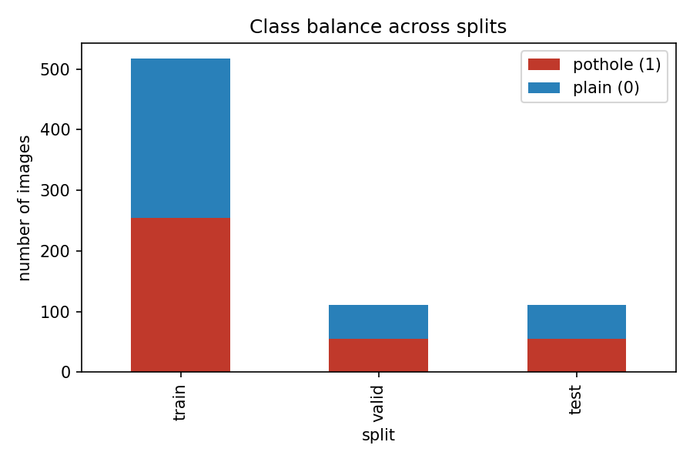
Figure 1. Class balance across the re-carved train, validation, and test splits.
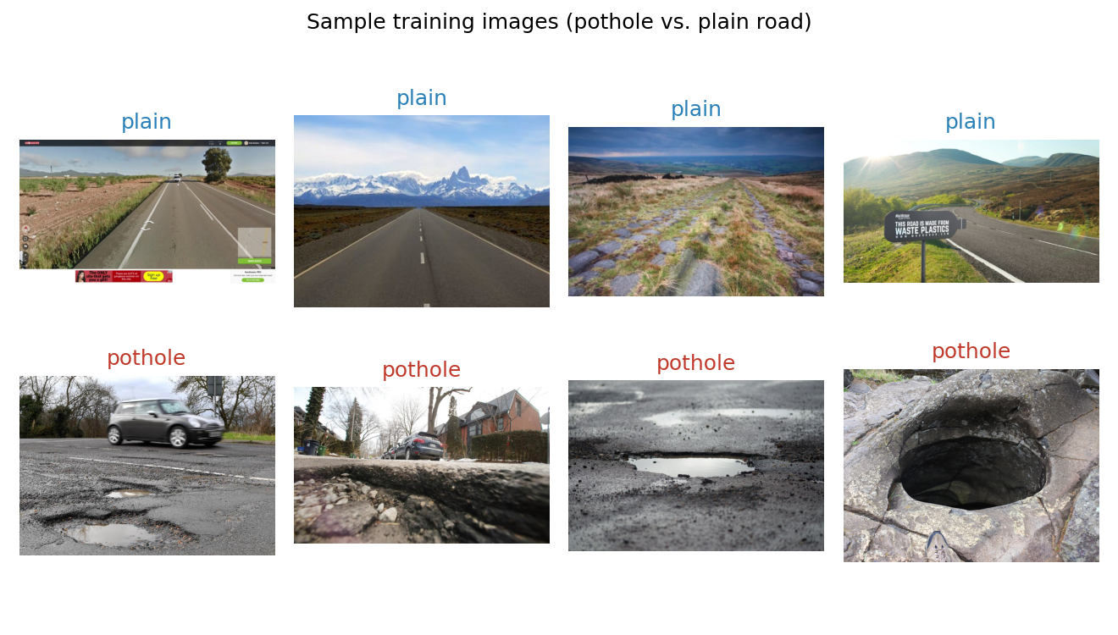
Figure 2. Sample training images — plain road (top row) versus pothole (bottom row).

Model Architecture
A compact convolutional neural network (CNN) was implemented in PyTorch. It consists of four convolutional blocks with channel widths of 16, 32, 64, and 128, each followed by batch normalisation, a ReLU activation, and 2x2 max-pooling. The resulting feature map is reduced with global average pooling and passed through a small classifier head — a dropout layer, a 64-unit fully connected layer with ReLU, a second dropout layer, and a final single-logit output layer — trained with binary cross-entropy loss. All images were resized to 128 by 128 pixels in RGB, and random horizontal flips were applied during training as a simple augmentation.

Hyperparameter Tuning
Six configurations of the same architecture were trained for 20 epochs each, varying the learning rate, batch size, dropout rate, and optimizer, in order to observe how each choice affected the training and validation curves. The baseline configuration used the Adam optimizer with a learning rate of 1e-3, a batch size of 32, and a dropout of 0.3. Variants then lowered the learning rate to 1e-4, raised it to 5e-3, shrank the batch size to 8, raised dropout to 0.6, and finally replaced Adam with SGD and momentum at a learning rate of 1e-2.
Learning rate proved to be the most sensitive hyperparameter of the six tested. The baseline (1e-3) and high-learning-rate (5e-3) runs both reached a high peak validation accuracy at some point during training, but their final-epoch validation loss was three to four times higher than the best run, showing that the optimizer kept overshooting narrow minima instead of settling into them. The low learning rate configuration (1e-4) converged the most smoothly of all six runs and finished with both the highest final validation accuracy (94.6%) and the lowest final validation loss (0.148), making it the best balance between continuing to improve and avoiding instability for a training set of this size. Heavier dropout (0.6) reached a similarly high peak accuracy at one point but was markedly less stable overall, while a smaller batch size of 8 trained smoothly but still finished slightly behind the best configuration. Replacing Adam with SGD and momentum was the weakest of the six runs, suggesting it would need more epochs or a tuned learning-rate schedule to catch up. Based on these results, the low-learning-rate configuration (Adam, learning rate 1e-4, batch size 32, dropout 0.3) was selected as the best model and carried forward to the final test-set evaluation.
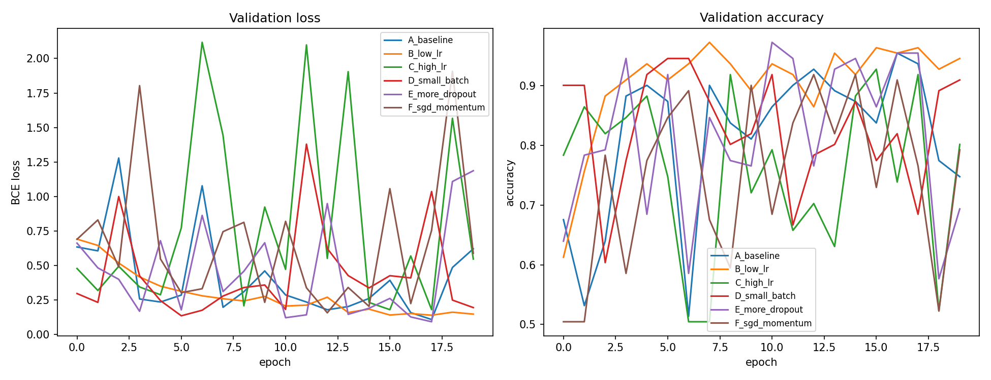
Figure 3. Validation loss and accuracy curves for all six hyperparameter configurations.
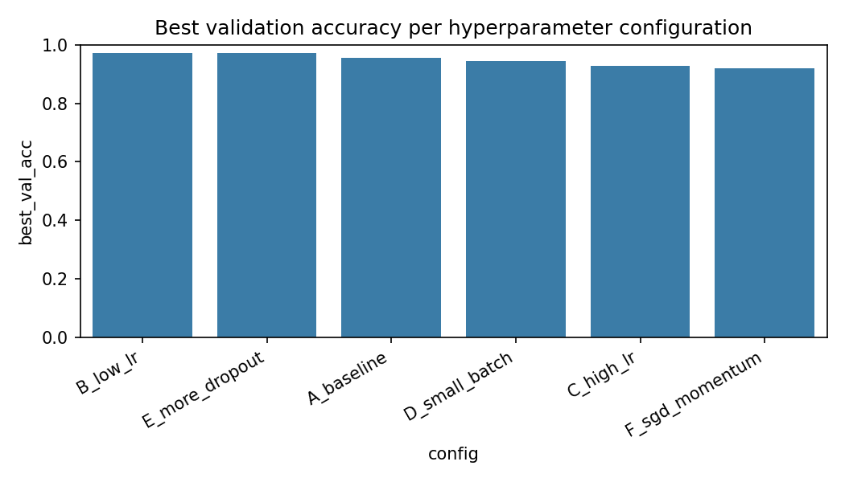
Figure 4. Best validation accuracy achieved by each hyperparameter configuration.
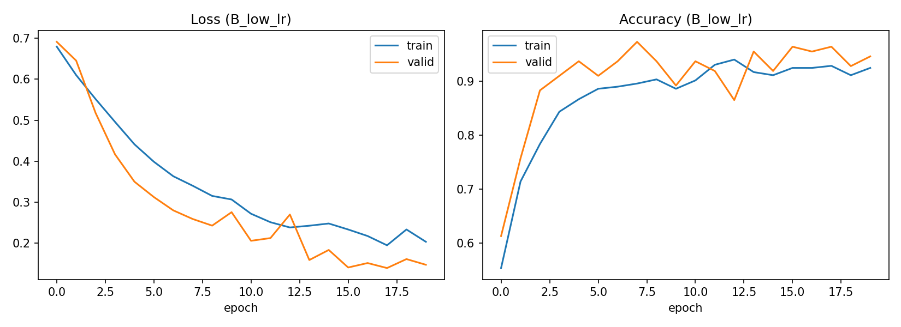
Figure 5. Training and validation loss/accuracy curves for the selected best model.

Test-Set Evaluation
The selected best model was evaluated once on the held-out, re-carved test split of 111 images (56 plain, 55 pothole), which had not been used during either training or hyperparameter selection. The model achieved a test accuracy of 96.4%, with precision, recall, and F1-score for the pothole class all equal to 0.964. The confusion matrix shows only four misclassifications out of 111 images: two plain-road images were incorrectly predicted as containing a pothole, and two pothole images were incorrectly predicted as plain road. Precision, recall, and F1-score landing on exactly the same balanced value indicates the classifier has no systematic bias toward either class, which is consistent with the stability already observed for this configuration during hyperparameter tuning.
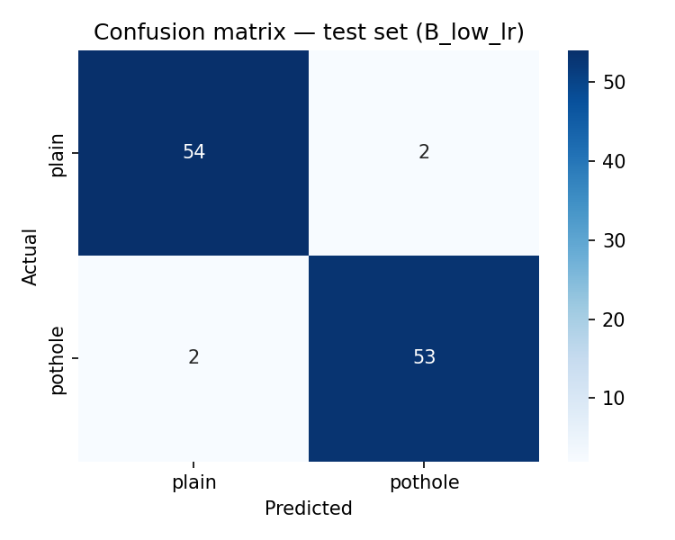
Figure 6. Confusion matrix of the best model on the held-out test split.

Discussion and Conclusions
The single biggest factor behind the quality of the final evaluation was not the model or the hyperparameters, but the size of the test set. Evaluating the very same trained model on the dataset’s original 16-image test folder produced a noisy, low-confidence accuracy of only 56%, while evaluating it on the re-carved 111-image test split produced a stable, trustworthy accuracy of 96.4% — a clear demonstration that test-set size matters just as much as model choice when judging real-world performance. Aside from that, a small custom CNN trained from scratch on only 518 images, with no pretrained backbone, was able to reach 96.4% test accuracy with balanced precision, recall, and F1-score. The hyperparameter search showed the model is most sensitive to learning rate: values of 1e-3 and 5e-3 both reach a good peak accuracy but destabilise by the end of training, while a lower learning rate of 1e-4 with the Adam optimizer gave the smoothest and most reliable convergence. The small number of remaining errors — two false positives and two false negatives — are exactly the kind expected at this image resolution, most likely caused by road markings, cracks, or shadows that resemble pothole texture, and by shallow or partially obscured potholes that resemble plain road.

