Genome Annotation and Comparative Analysis of
Escherichia phage Ec_Makalu_002
A Krischvirus (Straboviridae) isolate with a putative mobile intein in the terminase large subunit gene

Abstract
Escherichia phage Ec_Makalu_002 is a 164,673 bp tailed phage in the genus Krischvirus (family Straboviridae, order Pantevenvirales), closely related to previously characterized T4-like coliphages. We assembled and annotated its genome (269 predicted CDS), performed a whole-genome comparison against its closest public relative to validate annotation completeness, and placed it in a genus-level phylogenetic context using the terminase large subunit gene. This analysis identified a well-supported subclade, including Ec_Makalu_002, defined by a ~330 amino acid insertion in the terminase large subunit absent from most genus members. Sequence-level evidence — a canonical intein N-terminal splice residue, a conserved C-terminal His-Asn splicing motif, and a histidine cluster consistent with an embedded HNH homing endonuclease domain — supports the hypothesis that this insertion is a mobile group I intein. A shorter, overlapping insertion in a more distantly related genus member suggests this may be a recurrent insertion hotspot in the Krischvirus terminase large subunit gene.

1. Introduction
Bacteriophages in the genus Krischvirus (family Straboviridae) are large, tailed, T4-like phages that infect Escherichia and related enteric bacteria. Comparative genomics of this genus has revealed substantial conservation of core structural and packaging genes alongside pockets of genetic novelty — including mobile genetic elements such as self-splicing inteins, which are documented recurrently in phage terminase genes. Here we present the assembly, annotation, and comparative analysis of a newly characterized Krischvirus isolate, Ec_Makalu_002, with particular attention to (i) validating the completeness and accuracy of its annotation against a close public relative, and (ii) placing it phylogenetically within its genus using a conserved single-copy marker gene.

2. Methods

2.1 Genome assembly and annotation
[Fill in: sequencing platform, read data (SRA: SRR10671636), assembler used, circularization approach, and coverage statistics.] The final assembly (164,673 bp, circular) was annotated using Bakta, yielding 269 predicted coding sequences.

2.2 Whole-genome comparative annotation QC
The closest available public relative, Escherichia phage genome MN709127.1 (164,674 bp, 274 annotated CDS), was used as a reference. Reference CDS translations were extracted from its GenBank record. Reciprocal BLASTp (E-value ≤ 1e-5, best hit only) was performed between the Ec_Makalu_002 Bakta protein set and the reference protein set in both directions. Any CDS lacking a reciprocal best hit was followed up with nucleotide-level BLASTn against the counterpart genome to distinguish genuine sequence divergence or gene loss from annotation-pipeline artifacts.

2.3 Terminase large subunit phylogenetics
The terminase large subunit gene was identified in the Ec_Makalu_002 annotation by its characteristic Pfam domain signature (PF14528, PF17289) and its genomic position immediately downstream of the terminase small subunit gene. Fifteen related genomes were selected from the genus Krischvirus (NCBI Taxonomy ID 1913651) and related Straboviridae, spanning Escherichia, Shigella, and cross-genus representatives, using NCBI Taxonomy and Nucleotide records. The Ec_Makalu_002 terminase large subunit protein sequence was used as a tblastn query against each genome to recover the homologous coding sequence; extracted regions were translated and, where genome-specific GenBank annotations were available, cross-checked against the curator-assigned CDS boundaries to confirm correct gene-boundary extraction. The 16 resulting protein sequences (15 relatives plus Ec_Makalu_002) were aligned with MAFFT (auto strategy, L-INS-i), and a maximum-likelihood phylogeny was built with IQ-TREE using ModelFinder for model selection and 1000 ultrafast bootstrap replicates.

2.4 Intein sequence assessment
The insertion region identified in the terminase large subunit alignment (present in a subset of taxa and absent from the majority) was extracted and inspected for canonical intein splicing motifs: the conserved N-terminal splice-junction residue (Cys/Ser/Ala/Gln) and the conserved C-terminal Block G dipeptide (His-Asn/Gln), following established intein sequence signatures. The internal sequence was also inspected for a clustering of histidine residues consistent with an embedded HNH-family homing endonuclease domain, characteristic of “full-length” mobile inteins. A confirmatory search against curated intein/domain databases (e.g., a Conserved Domain Database search) was attempted but did not return results within a practical time frame and is noted as a direction for future confirmation rather than a completed step.

3. Results

3.1 Assembly and annotation overview
Attribute | Value
Genome length | 164,673 bp (circular)
Reference genome | MN709127.1, 164,674 bp
Predicted CDS (this study) | 269
Reference CDS | 274
Taxonomic classification | Krischvirus, Straboviridae, Pantevenvirales

3.2 Long tail fiber gene
The long tail fiber gene (host receptor-binding determinant) was localized to its correct coordinates and confirmed by direct comparison of the Bakta-translated protein against the reference protein (BLASTp: 99.92% identity, 1246/1246 aa aligned, no gaps). A single conservative substitution (Ala→Val at position 251) was identified as the only amino acid difference from the reference.
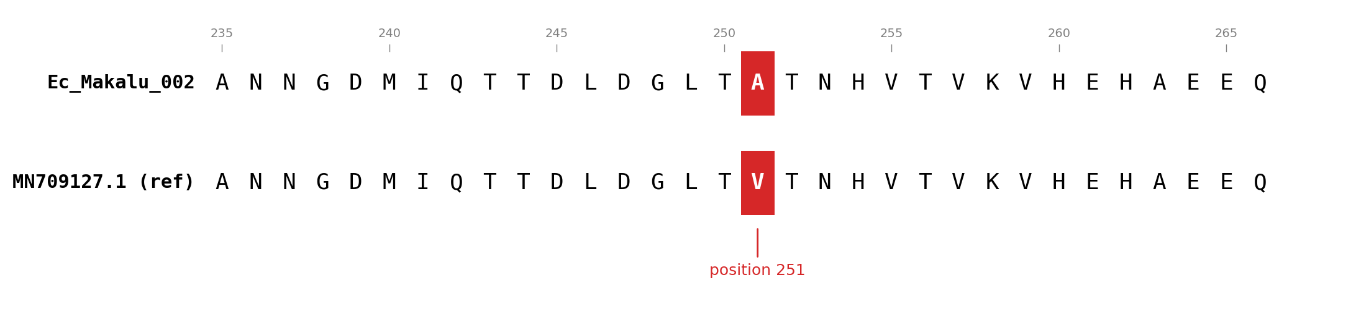
Figure 1. Alignment of the long tail fiber protein (residues 235–266) showing the single amino acid difference between Ec_Makalu_002 and reference MN709127.1 at position 251 (Ala→Val). All other residues in the 1246 aa protein are identical.

3.3 Whole-genome comparative annotation QC
Reciprocal BLASTp identified confident best hits for 268 of 269 Ec_Makalu_002 CDS and 268 of 274 reference CDS. The seven apparent discrepancies — six short (34–81 aa) reference-annotated hypothetical proteins with no corresponding Bakta call, and one Bakta-called hypothetical protein (GLGIAI_0194) with no reciprocal reference hit — were each resolved by nucleotide-level BLASTn against the counterpart genome. In every case, the underlying DNA sequence was found at 100% identity and full length in the counterpart genome. We conclude that Ec_Makalu_002 and its reference relative share fully conserved gene content, and that the apparent discrepancies reflect differences in ORF-calling sensitivity between annotation pipelines (Bakta/Pyrodigal vs. the original submission's pipeline) rather than true insertions, deletions, or sequence divergence.

3.4 Genus-level phylogeny and a putative mobile intein
Maximum-likelihood phylogenetic analysis of the terminase large subunit across 16 Krischvirus and related taxa placed Ec_Makalu_002 within a well-supported subclade alongside Ec_Makalu_003, ECD7, and AV108 (bootstrap support ≥ 89 at the relevant nodes). This subclade is distinguished by a ~330 amino acid insertion in the terminase large subunit (alignment positions 165–496) that is absent from the majority of genus members, including the closely related JSE, RB49, and several others, which carry the canonical ~607 amino acid form.
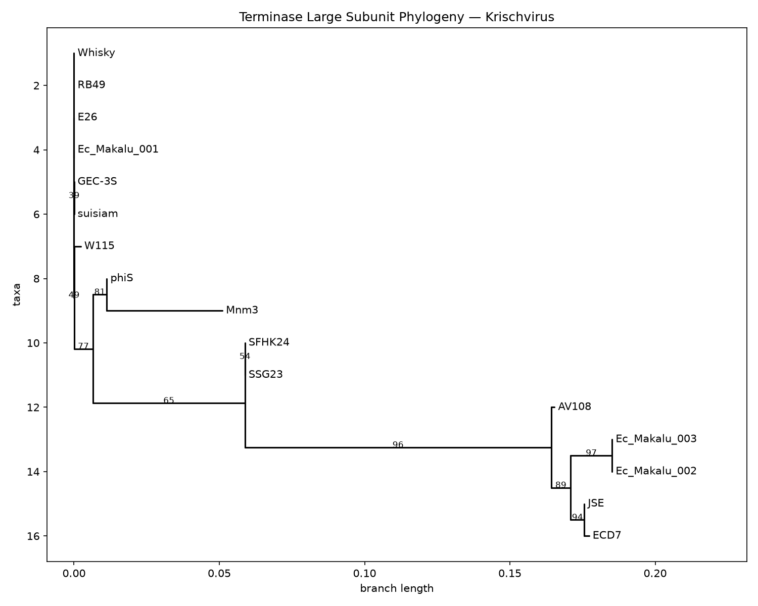
Figure 2. Maximum-likelihood phylogeny of the terminase large subunit across 16 Krischvirus and related taxa (IQ-TREE, 1000 ultrafast bootstrap replicates; values shown at nodes). Ec_Makalu_002 falls within a well-supported subclade (bootstrap ≥ 89) alongside Ec_Makalu_003, ECD7, JSE, and AV108, distinguished by a ~330 aa insertion in the terminase large subunit absent from the rest of the genus.
The insertion bears three independent hallmarks of a group I mobile intein: (i) it begins with alanine, one of the four residues (Cys/Ser/Ala/Gln) found at the canonical intein N-terminal splice junction; (ii) it ends with the dipeptide His-Asn, the canonical C-terminal Block G splicing motif found in essentially all characterized inteins; and (iii) its central third contains a cluster of seven histidine residues (of nine total in the insertion), consistent with an embedded HNH-family homing endonuclease domain, the hallmark of “full-length” mobile inteins capable of intein homing.
A shorter (222 aa), independent insertion was also identified in the more distantly related genus member suisiam. This insertion shares 221 of 222 aligned columns with the larger insertion found in the Ec_Makalu_002 subclade, and the flanking terminase sequence outside the insertion is 100% identical between suisiam and the canonical-length genus members (e.g., GEC-3S). This suggests the insertion site is a recurrent hotspot for intein insertion within the Krischvirus terminase large subunit gene, rather than a single, lineage-specific event.
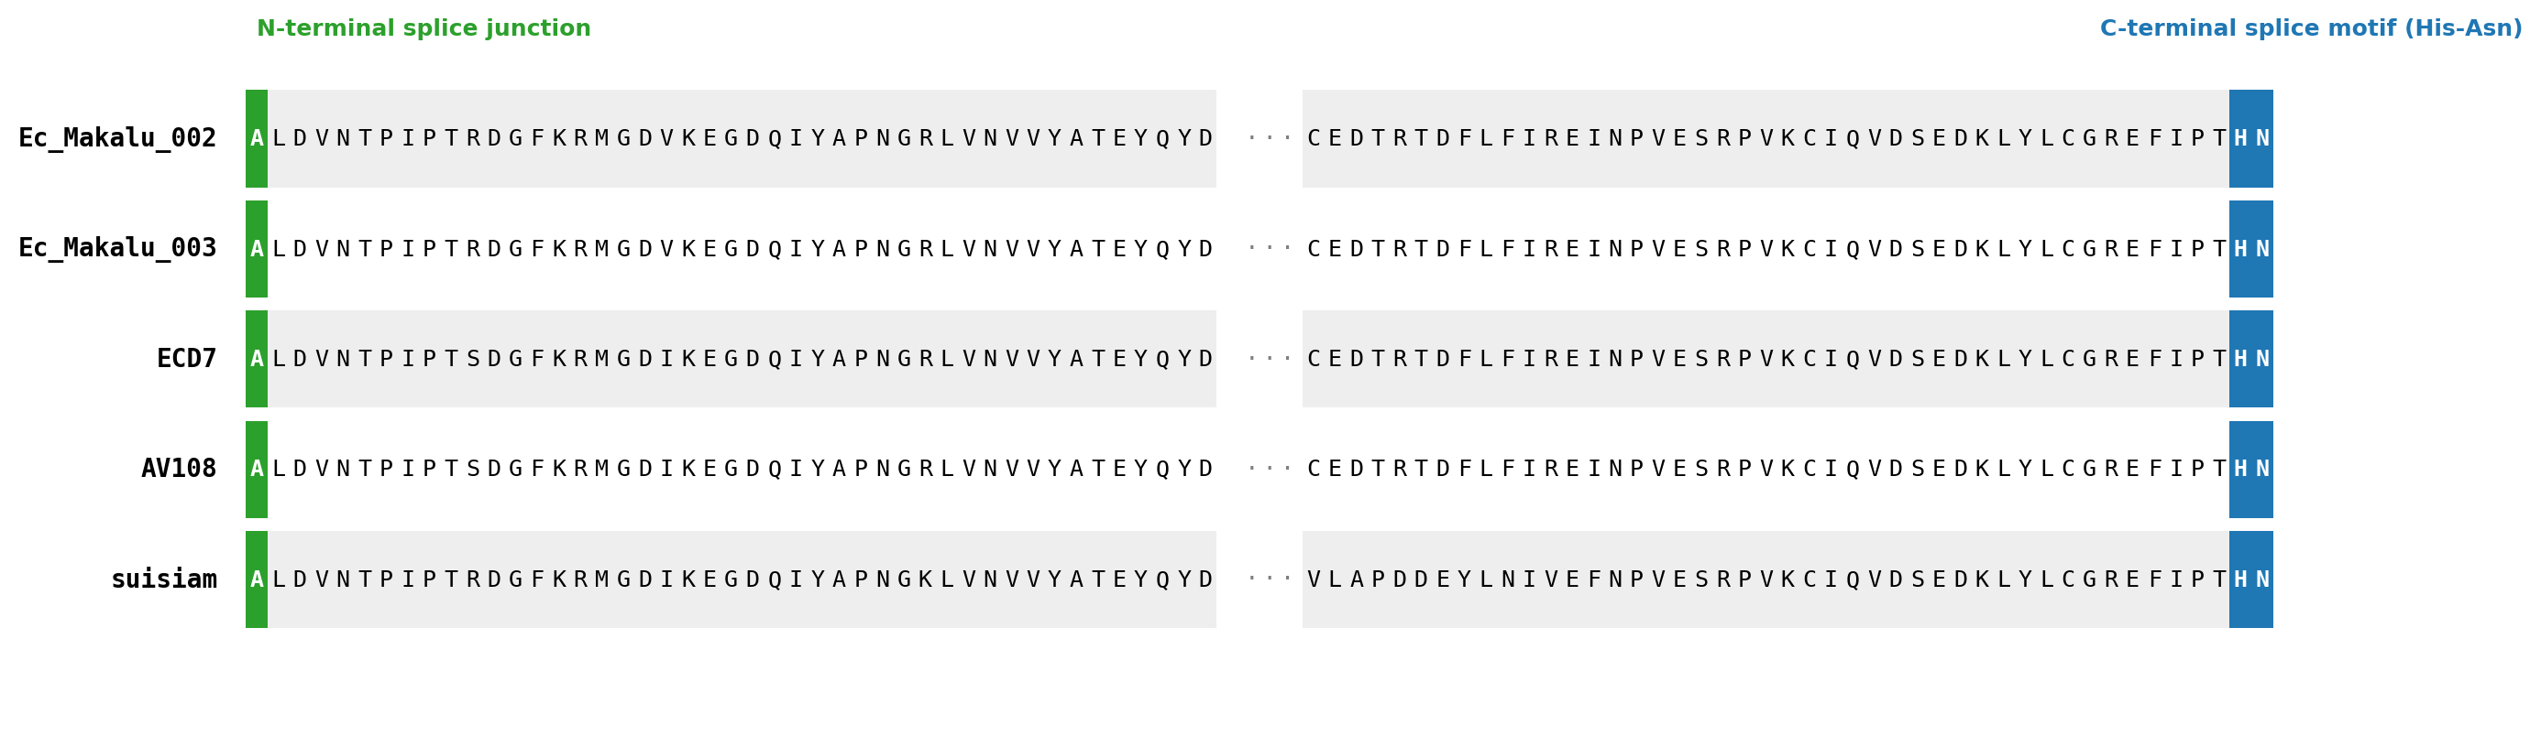
Figure 3. Alignment of the terminase large subunit insertion region across taxa carrying it. All five sequences share the N-terminal alanine splice-junction residue (green) and the C-terminal His-Asn splicing motif (blue) diagnostic of group I inteins. The shorter suisiam variant shares these same flanking motifs despite a divergent internal sequence, consistent with an independent insertion at the same site.
We note this finding as a well-supported sequence-based hypothesis. A confirmatory search against curated intein or domain databases (e.g., InBase, or a Pfam Intein_splicing domain search) was attempted but did not complete within a practical time frame; we regard this as a natural and low-effort next step to formally confirm the intein assignment.

3.5 GLGIAI_0263: a compact protein of uncertain function
A 109 amino acid CDS (GLGIAI_0263) showed only distant homology (70.9% identity) to an uncharacterized ECD7 protein, and no confident Pfam-A domain hit via HMMER search. Given its compact size — consistent with, though not diagnostic of, small homing endonuclease domains such as GIY-YIG — and the original NCBI submission's own qualified annotation of the homologous ECD7 locus (“putative homing endonuclease, HNH family”), we conservatively label this gene “putative homing endonuclease” throughout the annotation, pending further evidence such as structural prediction.

4. Discussion
This analysis demonstrates that a systematic, verification-driven approach to phage genome annotation can surface genuine comparative-genomics findings beyond routine gene calling. Two aspects of this work are worth highlighting. First, apparent annotation discrepancies — whether between two annotation pipelines applied to closely related genomes, or between a first-pass automated analysis and a corrected one — should be resolved at the nucleotide level wherever possible; several findings in this study that initially appeared to indicate genuine biological differences (missing genes, divergent regions) were resolved as artifacts of gene-calling sensitivity or coordinate errors upon closer inspection. Second, the identification of a putative mobile intein at a recurrent insertion site in the terminase large subunit adds Ec_Makalu_002 and its close relatives to a growing body of evidence that phage terminase genes are hotspots for intein invasion — a finding that, if confirmed, would be of interest both for understanding Krischvirus genome evolution and, more broadly, for phage engineering applications where terminase inteins have been exploited as tools.
Limitations of this study include the reliance on a single conserved marker gene (terminase large subunit) for phylogenetic placement, rather than a whole-genome or multi-gene concatenated approach, and the lack of formal domain-database confirmation of the intein hypothesis due to intermittent connectivity to NCBI's remote search services during this analysis. Both represent natural extensions of this work.

5. Future directions
- Confirm the intein assignment via InBase or a dedicated Pfam Intein_splicing domain search.
- Extend the phylogenetic analysis to additional conserved core genes (e.g., major capsid protein, portal protein) and/or a whole-genome distance-based approach for a more robust species tree.
- Structural prediction (e.g., AlphaFold/ColabFold) of GLGIAI_0263 to test for a nuclease-like fold despite the absence of a confident sequence-based domain hit.
- Structural comparison of the long tail fiber receptor-binding domain against characterized T4-like tail fibers, to explore host-range determinants.
- PHASTER and CheckV analysis to confirm complete, non-prophage status and assess assembly completeness/quality independently.

Data and code availability
The genome assembly, Bakta annotation, comparative analysis scripts, and phylogenetic pipeline described here are available at: [GitHub repository URL].

Acknowledgments
[Fill in as appropriate — sequencing facility, funding, advisors, etc.]

