**RECIPE WEBSITE**

**Kyle Abrahams**

**SPMP**

**Individual Project**

1. **Introduction**

1.1 Project Overview

1.1.1 Project Description

* The recipe website will consist of a curated list of homemade recipes with inexpensive ingredients and organized into sections based on restaurant .Chipotle, KFC, Friday’s and more will all be featured on the website.
* Because of covid 19, many individuals cannot go to their favorite restaurants like Chipotle and KFC. This website will be tailored to people who are inexperienced at cooking or baking and want to eat similar foods of their favorite restaurants without the need of utilizing doordash or visiting their restaurant.

1.2 Project Deliverables

* The recipe web application will be delivered to PaaS providers such as netlify and heroku so clients can access
* Clients can expect to access the recipe web application by early may

1.3 Evolution of the SPMP

1.3.1 Managing Change

Currently the main feature of the recipe web application will be searching through recipes making use of an existing recipe api. There are several other key features such as having a comment section where recipes can be discussed in review within a residing restaurant category like Chipotle, or Friday’s. Another main feature would be to have users be able to add custom recipes to these categories. After these main features are accomplished within a few weeks, the goal would be to test user flow of the recipe web app and make sure no use case is missing from the user flow that would prevent a user from having the best experience.

1. **Managerial Process**

2.1 Management Objectives and Priorities

* The Philosophy is that the team should be responsible and commit to daily tasks as each feature is built for the recipe app
* No money will be spent asides from purchasing a domain name
* Will utilize free hosting through PaaS Cloud providers to develop a stable product

2.2 Assumptions, Dependencies and Constraints

* Dependent on acquiring Recipe API
* Dependent on acquiring Free PaaS cloud providers
* Assuming Recipe API satisfies all of the product needs
* Constraint is time limit since the product must be delivered in a little over a month

2.3 Risk Management

* Size of the Project
  + As deadline, gets closer focus on perfecting main features of recipe web app instead of adding more features to recipe web app so it can be easily deployed to production with high satisfaction from our clients
* Complexity of the Project
  + As requirements multiply, organize them in hierarchical manner and separate into non-functional and functional requirements and make sure that requirements at the top of the hierarchy are accomplished first
* Client Acceptance
  + If Client does not like the developed prototype we will ask for a deeper review from the client and request desired use cases that the client may desire. Then on the next release to production, we will accomplish what clients request provided it is feasible for our budget and time.

1. **Technical Process**

3.1 Methods & Tools

3.1.1 Methods

* The client will be able to send requests
* The server will be able to receive and handle those requests
* Will Organize the backend through an architectural design pattern
* Will provide version control to keep development stable

3.1.2 Tools

* JavaScript
* React
* mongodb
* Express
* Git & Github
* Heroku & Netlify

3.2 Justification of Software Process

The developer has experience with react, express, and javascript already and is comfortable using these technologies. MongoDB, even though less scalable than SQL databases, is still scalable enough for the project needs. And lastly, git and github is what the developer finds most easy to use for version control.

The software process that the developer will be using will be agile and not waterfall. The reason for this is because we are on a tight schedule and have limited time to release a good product. We need to make sure that features are being built through continuous integration and continuous employment on a weekly basis so that features being added to our application are stable and have good user flow for our consumers. Consumers would also be able to see small features being added slowly and test the recipe app’s user flow - another benefit.

1. **Description of Work Packages**

4.1 Work Breakdown Structures (WBS)

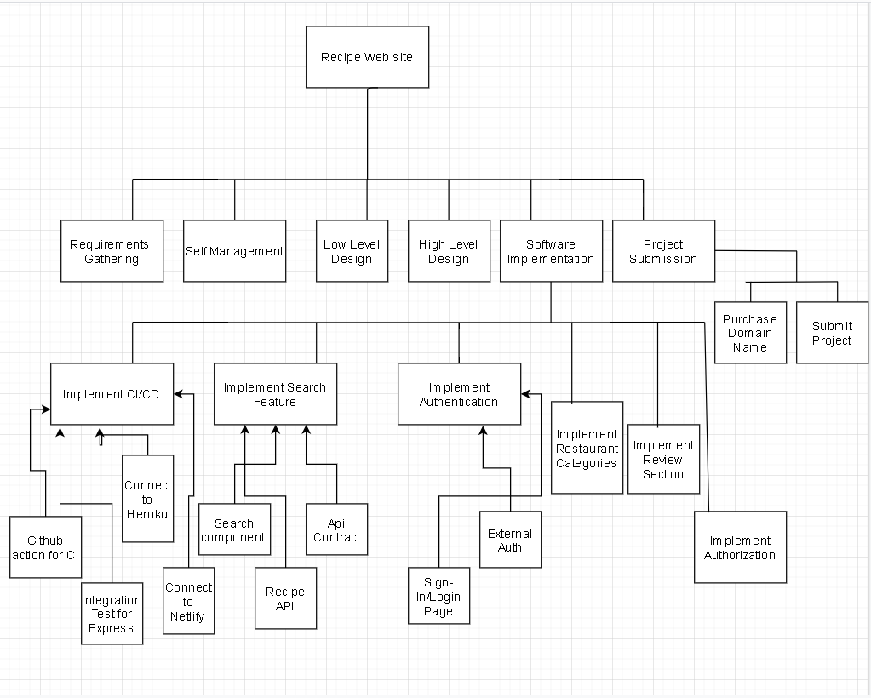

4.2 Gantt Schedule (Timeline)

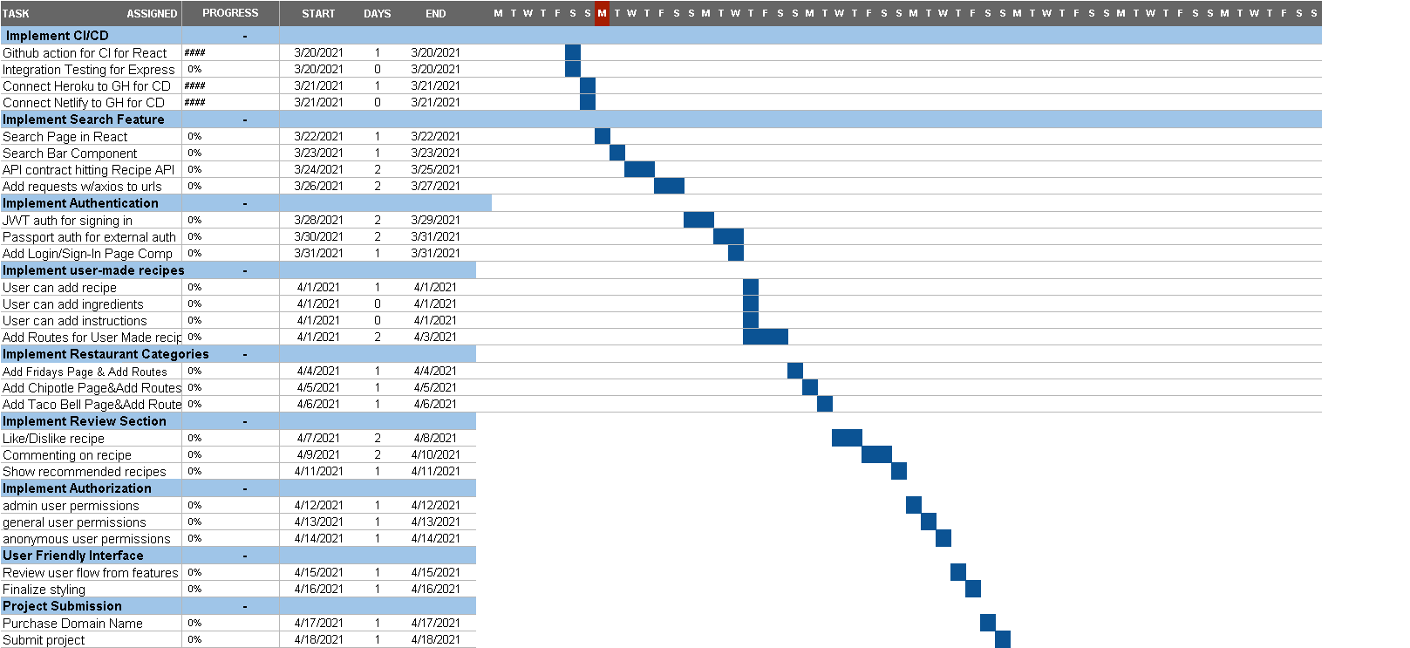

Key:

# = 25% completion

## = 50% completion

### = 75% completion

#### = 100% completion