Міністерство освіти і науки України
Національний технічний університет України
«Київський політехнічний інститут імені Ігоря Сікорського»
Факультет інформатики та обчислювальної техніки
Кафедра обчислювальної техніки

Лабораторна робота №2
з дисципліни
«Об’єктно-орієнтоване програмування»
на тему
«Розробка модульного проєкту програми у середовищі Microsoft Visual Studio»

Виконав: Перевірив:
студент групи ІМ-54 Рекечинський Д. О.
Дяденчук Ілля Сергійович
Номер в списку - 12
Київ 2026
Завдання:
- Створити у середовищі розробки новий проект з ім’ям Lab2.
- Скомпілювати проект і отримати виконуваний файл програми.
- Перевірити роботу програми. За потреби налагодити програму.
- Проаналізувати та прокоментувати результати та вихідний текст програми.
- Оформити звіт.
Завдання згідно варіанту:
- Динамічний масив для Shape обсягом 112 об’єктів
- "Гумовий" слід – суцільна лінія чорного кольору
- Прямокутник: по двом протилежним кутам охопл. прямокутника, чорний контур з кольоровим заповненням, колір заповнення: жовтий
- Еліпс: ввід від центру до одного з кутів, чорний контур без заповнення
- Позначка поточного типу об’єкту: в меню

#include "models/shapes/dot.hpp"
#include "models/shapes/line.hpp"
#include "models/shapes/oval.hpp"
#include "models/shapes/rectangle.hpp"
#include "utils/logger.hpp"
#include "ui/windows/mainWindow.hpp"
#include <QApplication>

int main(int argc, char** argv) {
QApplication app(argc, argv);

MainWindow window;

window.registerShape<DotShape>();
window.registerShape<LineShape>();
window.registerShape<OvalShape>();
window.registerShape<RectangleShape>();

window.show();

Logger::info("window initiation");
return app.exec();
}
#include "shapesCanvas.hpp"
#include <QPaintEvent>

void ShapesCanvas::paintEvent(QPaintEvent* event) {
Q_UNUSED(event);

QPainter painter(this);

painter.setRenderHint(QPainter::Antialiasing);
painter.fillRect(rect(), QColor(255, 255, 255));

for (const auto& shape : canvasShapes) {
shape->renderShape(painter);
}

if (drawingShape) {
drawingShape->renderPhantomShape(painter);
}
}

void ShapesCanvas::mousePressEvent(QMouseEvent* event) {
if (event->button() == Qt::MouseButton::LeftButton) {
const auto position = event->pos();

mouseState.isDragging = true;
mouseState.dragStartX = position.x();
mouseState.dragStartY = position.y();
mouseState.dragEndX = position.x();
mouseState.dragEndY = position.y();

if (currentShapeType) {
drawingShape = currentShapeType->createInstance();
drawingShape->updateShapeConfig({ mouseState.dragStartX, mouseState.dragStartY }, { mouseState.dragEndX, mouseState.dragEndY });
}
}
}

void ShapesCanvas::mouseMoveEvent(QMouseEvent* event) {
const auto position = event->pos();

mouseState.dragEndX = position.x();
mouseState.dragEndY = position.y();

if (drawingShape) {
drawingShape->updateShapeConfig({ mouseState.dragStartX, mouseState.dragStartY }, { mouseState.dragEndX, mouseState.dragEndY });
update();
}
}

void ShapesCanvas::mouseReleaseEvent(QMouseEvent* event) {
if (event->button() == Qt::MouseButton::LeftButton && mouseState.isDragging) {
mouseState.isDragging = false;

if (drawingShape) {
canvasShapes.push_back(std::move(drawingShape));
}

update();
}
}
#include "mainWindow.hpp"
#include "../../utils/logger.hpp"
#include "../../config.hpp"
#include <QtWidgets/QMenuBar>

MainWindow::MainWindow(QWidget* parent) noexcept :
QMainWindow(parent) {

initUI();
}

MainWindow::~MainWindow() noexcept {
Logger::info("window closed");
}

// UI

void MainWindow::initUI() noexcept {
setWindowTitle(tr(WINDOW_TITLE));

canvas = new ShapesCanvas(this);
setCentralWidget(canvas);

menuBar()->addMenu(tr("&Файл"));
shapesMenu = menuBar()->addMenu(tr("&Об'єкти"));
menuBar()->addMenu(tr("&Довідка"));

connect(shapesMenu, &QMenu::triggered, this, &MainWindow::shapeSelected);
}

void MainWindow::updateShapesMenu() noexcept {
shapesMenu->clear();

for (const auto& shape : registeredShapes) {
auto action = shapesMenu->addAction(tr(shape->getShapeName()));
action->setChecked(selectedShapeID == shape->getShapeID());
action->setCheckable(true);
action->setData(shape->getShapeID());
}
}

// Slots

void MainWindow::shapeSelected(QAction* action) {
const int64_t data = action->data().toLongLong();
selectedShapeID = data;

for (const auto& shape : registeredShapes) {
if (shape->getShapeID() == data) {
canvas->setDrawingShape(std::move(shape->createInstance()));
}
}

updateShapesMenu();
}
#ifndef INCLUDE_CONFIG_HPP_
#define INCLUDE_CONFIG_HPP_

static constexpr char WINDOW_TITLE[] {"Lab No.2"};

#endif
#ifndef INCLUDE_MODEL_SHAPES_DOT_HPP_
#define INCLUDE_MODEL_SHAPES_DOT_HPP_

#include "./shape.hpp"

class DotShape : public Shape {
public:
DotShape() = default;
DotShape(Position position) : position(position) {};
~DotShape() = default;
DotShape(const DotShape& dot_shape) noexcept : position(dot_shape.position) {}
DotShape& operator=(DotShape other) {
this->position = other.position;
return *this;
}

[[nodiscard]] Position getPosition() const {
return position;
}

void setPosition(Position position) {
this->position = position;
}

char* getShapeName() const noexcept override {
static char shape_name[] { "Точка" };
return shape_name;
}

uint8_t getShapeID() const noexcept override {
return 1;
}

std::unique_ptr<Shape> createInstance() const noexcept override {
return std::make_unique<DotShape>();
}

void renderShape(QPainter& painter) const override {
painter.setBrush(QBrush(QColor(0, 0, 0)));
painter.setPen(Qt::NoPen);
painter.drawEllipse(position.x - 4, position.y - 4, 8, 8);
}

void renderPhantomShape(QPainter& painter) const override {
painter.setBrush(QBrush(QColor(0, 0, 0, 100)));
painter.setPen(Qt::NoPen);
painter.drawEllipse(position.x - 4, position.y - 4, 8, 8);
}

void updateShapeConfig(const Position& drag_start, const Position& drag_end) noexcept override {
this->position = drag_end;
}

private:
Position position { 0, 0 };
};

#endif
#ifndef INCLUDE_MODEL_SHAPES_LINE_HPP_
#define INCLUDE_MODEL_SHAPES_LINE_HPP_

#include "./shape.hpp"

class LineShape : public Shape {
public:
LineShape() = default;
LineShape(Position a_pos, Position b_pos) : start_position(a_pos), end_position(b_pos) {};
~LineShape() = default;
LineShape(const LineShape& line_shape) noexcept : start_position(line_shape.start_position), end_position(line_shape.end_position) {}
LineShape& operator=(LineShape other) {
this->start_position = other.start_position;
this->end_position = other.end_position;
return *this;
}

[[nodiscard]] Position getStartPosition() const {
return start_position;
}

void setStartPosition(Position position) {
this->start_position = position;
}

[[nodiscard]] Position getEndPosition() const {
return start_position;
}

void setEndPosition(Position position) {
this->end_position = position;
}

char* getShapeName() const noexcept override {
static char shape_name[] { "Лінія" };
return shape_name;
}

uint8_t getShapeID() const noexcept override {
return 2;
}

std::unique_ptr<Shape> createInstance() const noexcept override {
return std::make_unique<LineShape>();
}

void renderShape(QPainter& painter) const override {
painter.setBrush(Qt::NoBrush);
QPen pen;
pen.setColor(QColor(0, 0, 0));
pen.setWidth(2);
painter.setPen(pen);
painter.drawLine(start_position.x, start_position.y, end_position.x, end_position.y);
}

void renderPhantomShape(QPainter& painter) const override {
painter.setBrush(Qt::NoBrush);
QPen pen;
pen.setColor(QColor(0, 0, 0, 100));
pen.setWidth(2);
painter.setPen(pen);
painter.drawLine(start_position.x, start_position.y, end_position.x, end_position.y);
}

void updateShapeConfig(const Position& drag_start, const Position& drag_end) noexcept override {
this->start_position = drag_start;
this->end_position = drag_end;
}

private:
Position start_position { 0, 0 };
Position end_position { 0, 0 };
};

#endif
#ifndef INCLUDE_MODEL_SHAPES_OVAL_HPP_
#define INCLUDE_MODEL_SHAPES_OVAL_HPP_

#include "./shape.hpp"

class OvalShape : public Shape {
public:
OvalShape() = default;
OvalShape(Position center_pos, Position corner_pos) : center_position(center_pos), corner_position(corner_pos) {};
~OvalShape() = default;
OvalShape(const OvalShape& oval_shape) noexcept : center_position(oval_shape.center_position), corner_position(oval_shape.corner_position) {}
OvalShape& operator=(OvalShape other) {
this->center_position = other.center_position;
this->corner_position = other.corner_position;
return *this;
}

[[nodiscard]] Position getCenterPosition() const {
return center_position;
}

void setCenterPosition(Position position) {
this->center_position = position;
}

[[nodiscard]] Position getCornerPosition() const {
return corner_position;
}

void setCornerPosition(Position position) {
this->corner_position = position;
}

char* getShapeName() const noexcept override {
static char shape_name[] { "Овал" };
return shape_name;
}

uint8_t getShapeID() const noexcept override {
return 4;
}

std::unique_ptr<Shape> createInstance() const noexcept override {
return std::make_unique<OvalShape>();
}

void renderShape(QPainter& painter) const override {
painter.setBrush(Qt::NoBrush);
QPen pen;
pen.setColor(QColor(0, 0, 0));
pen.setWidth(2);
painter.setPen(pen);

Position half_size {
std::abs(center_position.x - corner_position.x),
std::abs(center_position.y - corner_position.y)
};

painter.drawEllipse(
center_position.x - half_size.x,
center_position.y - half_size.y,
half_size.x * 2,
half_size.y * 2
);
}

void renderPhantomShape(QPainter& painter) const override {
painter.setBrush(Qt::NoBrush);
QPen pen;
pen.setColor(QColor(0, 0, 0, 100));
pen.setWidth(2);
painter.setPen(pen);

Position half_size {
std::abs(center_position.x - corner_position.x),
std::abs(center_position.y - corner_position.y)
};

painter.drawEllipse(
center_position.x - half_size.x,
center_position.y - half_size.y,
half_size.x * 2,
half_size.y * 2
);
}

void updateShapeConfig(const Position& drag_start, const Position& drag_end) noexcept override {
this->center_position = drag_start;
this->corner_position = drag_end;
}

private:
Position center_position { 0, 0 };
Position corner_position { 0, 0 };
};

#endif
#ifndef INCLUDE_MODEL_SHAPES_RECTANGLE_HPP_
#define INCLUDE_MODEL_SHAPES_RECTANGLE_HPP_

#include "./shape.hpp"

class RectangleShape : public Shape {
public:
RectangleShape() = default;
RectangleShape(Position a_pos, Position b_pos) : start_position(a_pos), end_position(b_pos) {};
~RectangleShape() = default;
RectangleShape(const RectangleShape& rect_shape) noexcept : start_position(rect_shape.start_position), end_position(rect_shape.end_position) {}
RectangleShape& operator=(RectangleShape other) {
this->start_position = other.start_position;
this->end_position = other.end_position;
return *this;
}

[[nodiscard]] Position getStartPosition() const {
return start_position;
}

void setStartPosition(Position position) {
this->start_position = position;
}

[[nodiscard]] Position getEndPosition() const {
return start_position;
}

void setEndPosition(Position position) {
this->end_position = position;
}

char* getShapeName() const noexcept override {
static char shape_name[] { "Прямокутник" };
return shape_name;
}

uint8_t getShapeID() const noexcept override {
return 3;
}

std::unique_ptr<Shape> createInstance() const noexcept override {
return std::make_unique<RectangleShape>();
}

void renderShape(QPainter& painter) const override {
painter.setBrush(QBrush(QColor(255, 255, 0)));
QPen pen;
pen.setColor(QColor(0, 0, 0));
pen.setWidth(2);
painter.setPen(pen);
painter.drawRect(start_position.x, start_position.y, end_position.x - start_position.x, end_position.y - start_position.y);
}

void renderPhantomShape(QPainter& painter) const override {
painter.setBrush(Qt::NoBrush);
QPen pen;
pen.setColor(QColor(0, 0, 0, 100));
pen.setWidth(2);
painter.setPen(pen);
painter.drawRect(start_position.x, start_position.y, end_position.x - start_position.x, end_position.y - start_position.y);
}

void updateShapeConfig(const Position& drag_start, const Position& drag_end) noexcept override {
this->start_position = drag_start;
this->end_position = drag_end;
}

private:
Position start_position { 0, 0 };
Position end_position { 0, 0 };
};

#endif
#ifndef INCLUDE_MODEL_SHAPES_SHAPE_HPP_
#define INCLUDE_MODEL_SHAPES_SHAPE_HPP_

#include <QPainter>

struct Position {
int64_t x { 0 };
int64_t y { 0 };
};

class Shape {
public:
virtual ~Shape() noexcept = default;

[[nodiscard]] virtual char* getShapeName() const noexcept = 0;
[[nodiscard]] virtual uint8_t getShapeID() const noexcept = 0;
[[nodiscard]] virtual std::unique_ptr<Shape> createInstance() const noexcept = 0;

virtual void renderShape(QPainter& painter) const = 0;
virtual void renderPhantomShape(QPainter& painter) const = 0;
virtual void updateShapeConfig(const Position& drag_start, const Position& drag_end) noexcept = 0;
};

#endif
#ifndef INCLUDE_UI_COMPONENTS_SHAPES_CANVAS_HPP_
#define INCLUDE_UI_COMPONENTS_SHAPES_CANVAS_HPP_

#include "../../models/shapes/shape.hpp"
#include <QWidget>

struct MouseState {
bool isDragging { false };
int64_t dragStartX { -1 };
int64_t dragStartY { -1 };
int64_t dragEndX { -1 };
int64_t dragEndY { -1 };
};

class ShapesCanvas : public QWidget {
Q_OBJECT

public:
explicit ShapesCanvas(QWidget* parent = nullptr) noexcept : QWidget(parent) {};
~ShapesCanvas() noexcept = default;
ShapesCanvas(const ShapesCanvas& other) = delete;
ShapesCanvas& operator=(ShapesCanvas other) = delete;

void setDrawingShape(std::unique_ptr<Shape> shape) {
currentShapeType = std::move(shape);
}

protected:
void paintEvent(QPaintEvent* event) override;
void mousePressEvent(QMouseEvent* event) override;
void mouseMoveEvent(QMouseEvent* event) override;
void mouseReleaseEvent(QMouseEvent* event) override;

private:
std::unique_ptr<Shape> currentShapeType { nullptr };
MouseState mouseState {};
std::unique_ptr<Shape> drawingShape { nullptr };
std::vector<std::unique_ptr<Shape>> canvasShapes;
};

#endif
#ifndef INCLUDE_UI_WINDOWS_MAIN_WINDOW_HPP_
#define INCLUDE_UI_WINDOWS_MAIN_WINDOW_HPP_

#include <QMainWindow>
#include "../components/shapesCanvas.hpp"

class MainWindow : public QMainWindow {
Q_OBJECT

public:
explicit MainWindow(QWidget* parent = nullptr) noexcept;
~MainWindow() noexcept;

template<std::derived_from<Shape> T>
void registerShape() {
registeredShapes.push_back(std::make_unique<T>());
updateShapesMenu();
}

private:
QMenu* shapesMenu;
ShapesCanvas* canvas;
uint64_t selectedShapeID { 0 };
std::vector<std::unique_ptr<Shape>> registeredShapes;

void initUI() noexcept;
void updateShapesMenu() noexcept;

signals:
private slots:
void shapeSelected(QAction* action);
};

#endif
#ifndef INCLUDE_UTILS_LOGGER_HPP_
#define INCLUDE_UTILS_LOGGER_HPP_

#include <iostream>
#include <string_view>

namespace Logger {
inline void info(std::string_view message) {
std::cout << "\033[34mINFO |\033[0m " << message << std::endl;
}

inline void err(std::string_view message) {
std::cerr << "\033[0;31mERROR |\033[0m " << message << std::endl;
}

inline void debug(std::string_view message) {
#ifndef NDEBUG
std::cout << "\033[38;2;255;165;0mDEBUG |\033[0m " << message << std::endl;
#endif
}
}

#endif
Скріншоти
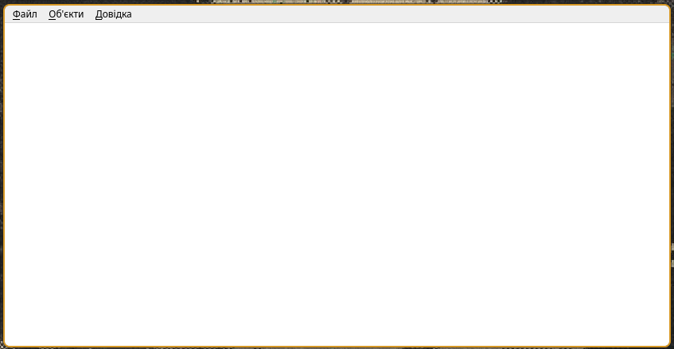
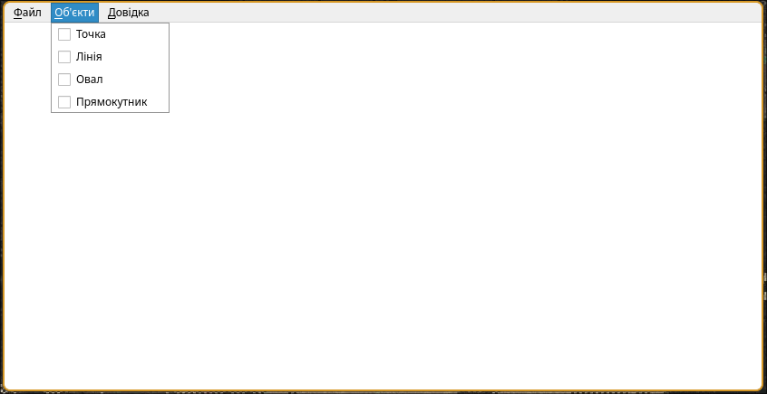
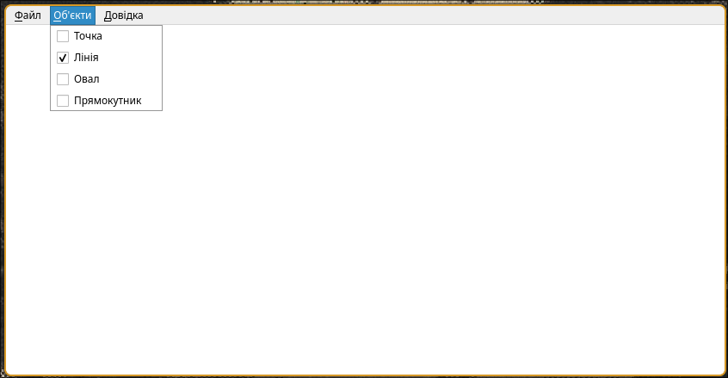
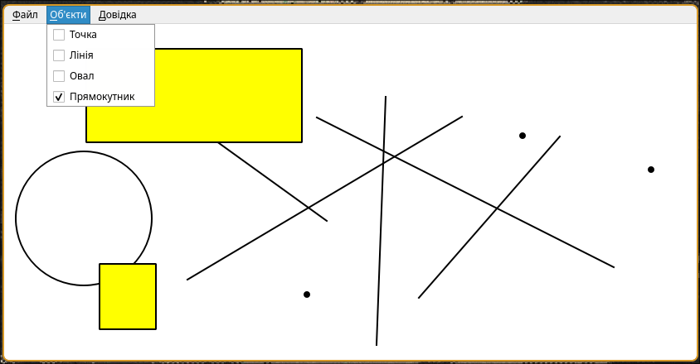
Діаграма класів
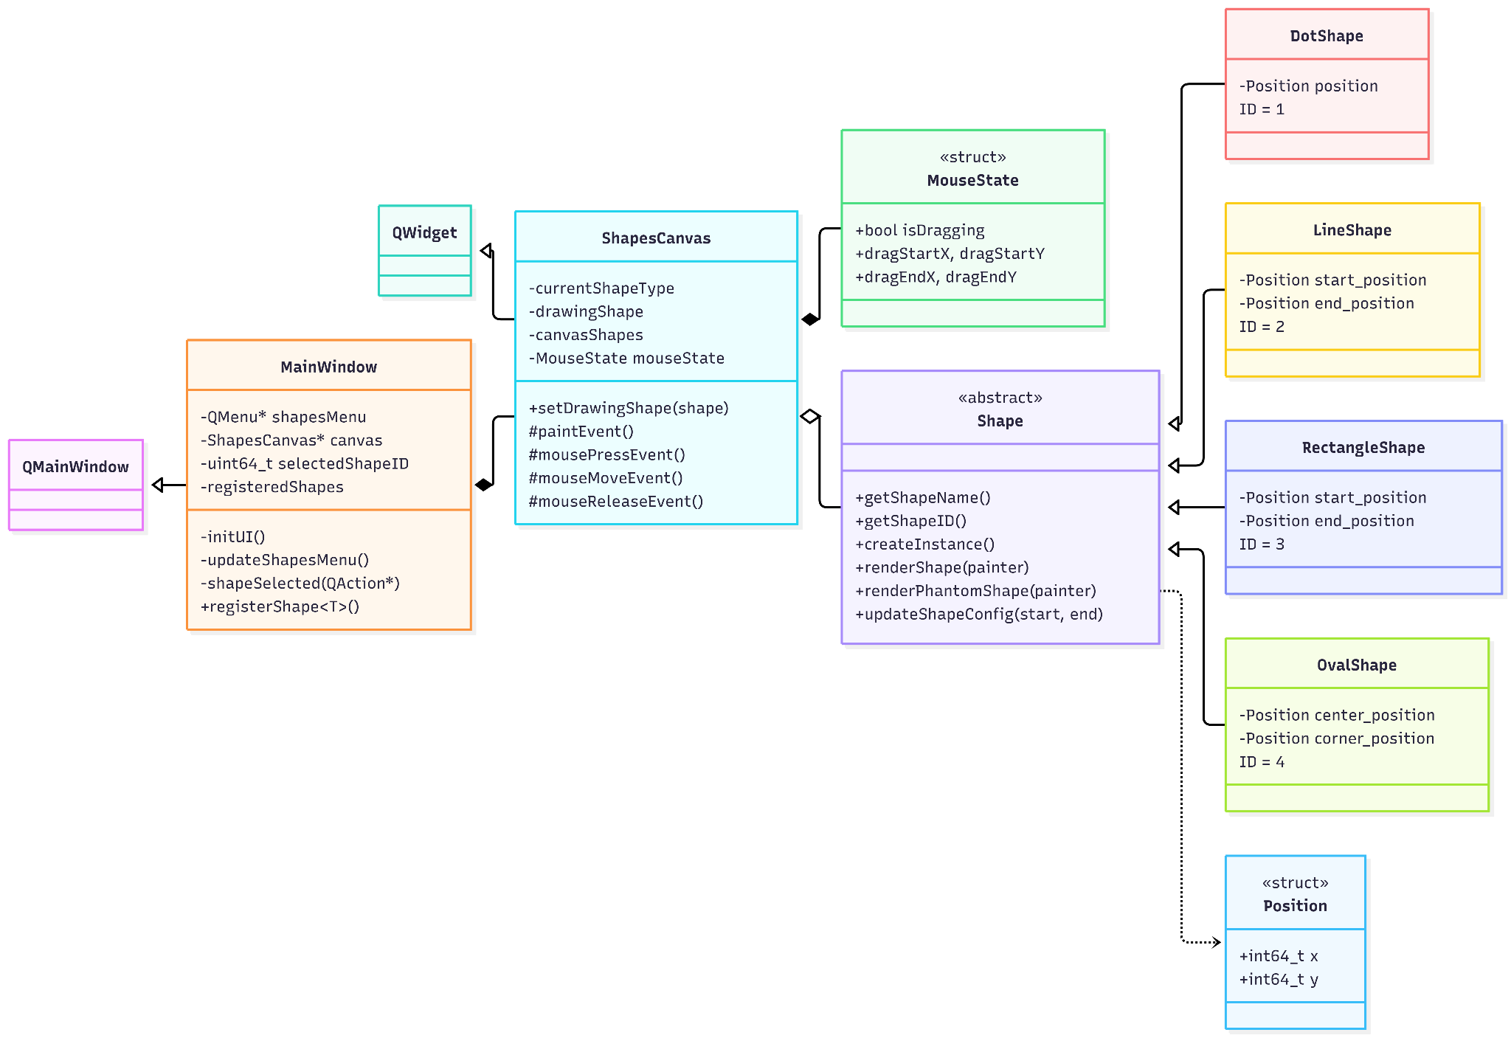

Висновки:
У лабораторній работі я виконав завдання згідно свого варіанту.
Було створено вікно з пунктами меню у вигляді фігур та робочим полотном для їх відтворення.

