Міністерство освіти і науки України
Національний технічний університет України
«Київський політехнічний інститут імені Ігоря Сікорського»
Факультет інформатики та обчислювальної техніки
Кафедра обчислювальної техніки

Лабораторна робота №3
з дисципліни
«Об’єктно-орієнтоване програмування»
на тему
«Розробка модульного проєкту програми у середовищі Microsoft Visual Studio»

Виконав: Перевірив:
студент групи ІМ-54 Рекечинський Д. О.
Дяденчук Ілля Сергійович
Номер в списку - 12
Київ 2026
Завдання:
- Створити у середовищі розробки проект з ім’ям Lab3.
- Написати вихідний текст програми згідно варіанту завдання.
- Скомпілювати вихідний текст і отримати виконуваний файл програми.
- Перевірити роботу програми. За потреби налагодити програму.
- Проаналізувати та прокоментувати результати та вихідний текст програми.
- Оформити звіт.
Завдання згідно варіанту:
- Статичний масив для Shape обсягом 113 об’єктів
- "Гумовий" слід – суцільна лінія червоного кольору
- Прямокутник: ввід від центру до одного з кутів, чорний контур без заповнення
- Еліпс: по двом протилежним кутам охопл. прямокутника, чорний контур з кольоровим заповненням, колір заповнення: жовтий
- Позначка поточного типу об’єкту: в заголовку вікна

#include "models/shapes/dot.hpp"
#include "models/shapes/line.hpp"
#include "models/shapes/oval.hpp"
#include "models/shapes/rectangle.hpp"
#include "utils/logger.hpp"
#include "ui/windows/mainWindow.hpp"
#include <QApplication>

int main(int argc, char** argv) {
QApplication app(argc, argv);

MainWindow window;

window.registerShape<DotShape>();
window.registerShape<LineShape>();
window.registerShape<OvalShape>();
window.registerShape<RectangleShape>();

window.show();

Logger::info("window initiation");
return app.exec();
}
#include "shapesCanvas.hpp"
#include <QPaintEvent>
#include <algorithm>
#include <cstdint>

void ShapesCanvas::paintEvent(QPaintEvent* event) {
Q_UNUSED(event);

QPainter painter(this);

painter.setRenderHint(QPainter::Antialiasing);
painter.fillRect(rect(), QColor(255, 255, 255));

for (uint64_t shapeIndex = 0; shapeIndex < shapesCount; ++shapeIndex) {
canvasShapes[shapeIndex]->renderShape(painter);
}

if (drawingShape) {
drawingShape->renderPhantomShape(painter);
}
}

void ShapesCanvas::mousePressEvent(QMouseEvent* event) {
if (event->button() == Qt::MouseButton::LeftButton) {
const auto position = event->pos();

mouseState.isDragging = true;
mouseState.dragStartX = position.x();
mouseState.dragStartY = position.y();
mouseState.dragEndX = position.x();
mouseState.dragEndY = position.y();

if (currentShapeType) {
drawingShape = currentShapeType->createInstance();
drawingShape->updateShapeConfig({ mouseState.dragStartX, mouseState.dragStartY }, { mouseState.dragEndX, mouseState.dragEndY });
}
}
}

void ShapesCanvas::mouseMoveEvent(QMouseEvent* event) {
const auto position = event->pos();

mouseState.dragEndX = position.x();
mouseState.dragEndY = position.y();

if (drawingShape) {
drawingShape->updateShapeConfig({ mouseState.dragStartX, mouseState.dragStartY }, { mouseState.dragEndX, mouseState.dragEndY });
update();
}
}

void ShapesCanvas::mouseReleaseEvent(QMouseEvent* event) {
if (event->button() == Qt::MouseButton::LeftButton && mouseState.isDragging) {
mouseState.isDragging = false;

if (drawingShape) {
const uint64_t newShapesCount = std::min(shapesCount + 1, MAX_CANVAS_SHAPES);
canvasShapes[newShapesCount - 1] = std::move(drawingShape);
shapesCount = newShapesCount;
}

update();
}
}
#include "mainWindow.hpp"
#include "../../utils/logger.hpp"
#include "../../config.hpp"
#include <QtWidgets/QMenuBar>
#include <string>

MainWindow::MainWindow(QWidget* parent) noexcept :
QMainWindow(parent) {

initUI();
}

MainWindow::~MainWindow() noexcept {
Logger::info("window closed");
}

// UI

void MainWindow::initUI() noexcept {
setWindowTitle(tr(WINDOW_TITLE));

canvas = new ShapesCanvas(this);
setCentralWidget(canvas);

menuBar()->addMenu(tr("&Файл"));
shapesMenu = menuBar()->addMenu(tr("&Об'єкти"));
menuBar()->addMenu(tr("&Довідка"));

shapesToolbar = new QToolBar("Об'єкти", this);
addToolBar(shapesToolbar);

connect(shapesMenu, &QMenu::triggered, this, &MainWindow::shapeSelected);
connect(shapesToolbar, &QToolBar::actionTriggered, this, &MainWindow::shapeSelected);
}

void MainWindow::updateShapesMenu() noexcept {
shapesMenu->clear();

for (const auto& shape : registeredShapes) {
auto action = shapesMenu->addAction(tr(shape->getShapeName()));
action->setData(shape->getShapeID());
}
}

void MainWindow::changeShape(uint8_t shapeID) {
for (const auto& shape : registeredShapes) {
if (shape->getShapeID() == shapeID) {
selectedShapeID = shapeID;
canvas->setDrawingShape(shape->createInstance());
const auto newTitle = std::string("Обрано: ") + shape->getShapeName();
setWindowTitle(tr(newTitle.c_str()));
}
}

for (const auto& action : toolbarShapesButtons) {
action.second->setChecked(false);
}

toolbarShapesButtons.at(shapeID)->setChecked(true);
}

// Slots

void MainWindow::shapeSelected(QAction* action) {
const uint32_t data = action->data().toUInt();
changeShape(data);
}
#ifndef INCLUDE_CONFIG_HPP_
#define INCLUDE_CONFIG_HPP_

#include <cstdint>

static constexpr char WINDOW_TITLE[] { "Lab No.3" };
static constexpr uint64_t MAX_CANVAS_SHAPES { 113 };

#endif
#ifndef INCLUDE_MODEL_SHAPES_DOT_HPP_
#define INCLUDE_MODEL_SHAPES_DOT_HPP_

#include "./shape.hpp"
#include <qicon.h>

class DotShape : public Shape {
public:
DotShape() = default;
DotShape(Position position) : position(position) {};
~DotShape() = default;
DotShape(const DotShape& other) noexcept : position(other.position) {}
DotShape& operator=(DotShape other) {
this->position = other.position;
return *this;
}

[[nodiscard]] Position getPosition() const {
return position;
}

void setPosition(Position position) {
this->position = position;
}

char* getShapeName() const noexcept override {
static char shapeName[] { "Точка" };
return shapeName;
}

uint8_t getShapeID() const noexcept override {
return 1;
}

std::unique_ptr<Shape> createInstance() const noexcept override {
return std::make_unique<DotShape>();
}

void renderShape(QPainter& painter) const override {
painter.setBrush(QBrush(QColor(0, 0, 0)));
painter.setPen(Qt::NoPen);
painter.drawEllipse(position.x - 4, position.y - 4, 8, 8);
}

void renderPhantomShape(QPainter& painter) const override {
painter.setBrush(QBrush(QColor(255, 0, 0, 100)));
painter.setPen(Qt::NoPen);
painter.drawEllipse(position.x - 4, position.y - 4, 8, 8);
}

void updateShapeConfig(const Position& drag_start, const Position& drag_end) noexcept override {
this->position = drag_end;
}

QIcon getToolbarIcon() noexcept override {
return QIcon(":/icons/dot.png");
}

private:
Position position { 0, 0 };
};

#endif
#ifndef INCLUDE_MODEL_SHAPES_LINE_HPP_
#define INCLUDE_MODEL_SHAPES_LINE_HPP_

#include "./shape.hpp"
#include <qicon.h>

class LineShape : public Shape {
public:
LineShape() = default;
LineShape(Position aPos, Position bPos) : startPosition(aPos), endPosition(bPos) {};
~LineShape() = default;
LineShape(const LineShape& other) noexcept : startPosition(other.startPosition), endPosition(other.endPosition) {}
LineShape& operator=(LineShape other) {
this->startPosition = other.startPosition;
this->endPosition = other.endPosition;
return *this;
}

[[nodiscard]] Position getStartPosition() const {
return startPosition;
}

void setStartPosition(Position position) {
this->startPosition = position;
}

[[nodiscard]] Position getEndPosition() const {
return endPosition;
}

void setEndPosition(Position position) {
this->endPosition = position;
}

char* getShapeName() const noexcept override {
static char shapeName[] { "Лінія" };
return shapeName;
}

uint8_t getShapeID() const noexcept override {
return 2;
}

std::unique_ptr<Shape> createInstance() const noexcept override {
return std::make_unique<LineShape>();
}

void renderShape(QPainter& painter) const override {
painter.setBrush(Qt::NoBrush);
QPen pen;
pen.setColor(QColor(0, 0, 0));
pen.setWidth(2);
painter.setPen(pen);
painter.drawLine(startPosition.x, startPosition.y, endPosition.x, endPosition.y);
}

void renderPhantomShape(QPainter& painter) const override {
painter.setBrush(Qt::NoBrush);
QPen pen;
pen.setColor(QColor(255, 0, 0, 100));
pen.setWidth(2);
painter.setPen(pen);
painter.drawLine(startPosition.x, startPosition.y, endPosition.x, endPosition.y);
}

void updateShapeConfig(const Position& dragStart, const Position& dragEnd) noexcept override {
this->startPosition = dragStart;
this->endPosition = dragEnd;
}

QIcon getToolbarIcon() noexcept override {
return QIcon(":/icons/line.png");
}

private:
Position startPosition { 0, 0 };
Position endPosition { 0, 0 };
};

#endif
#ifndef INCLUDE_MODEL_SHAPES_OVAL_HPP_
#define INCLUDE_MODEL_SHAPES_OVAL_HPP_

#include "./shape.hpp"
#include <qicon.h>

class OvalShape : public Shape {
public:
OvalShape() = default;
OvalShape(Position aPos, Position bPos) : startPosition(aPos), endPosition(bPos) {};
~OvalShape() = default;
OvalShape(const OvalShape& other) noexcept : startPosition(other.startPosition), endPosition(other.endPosition) {}
OvalShape& operator=(OvalShape other) {
this->startPosition = other.startPosition;
this->endPosition = other.endPosition;
return *this;
}

[[nodiscard]] Position getStartPosition() const {
return startPosition;
}

void setStartPosition(Position position) {
this->startPosition = position;
}

[[nodiscard]] Position getEndPosition() const {
return endPosition;
}

void setEndPosition(Position position) {
this->endPosition = position;
}

char* getShapeName() const noexcept override {
static char shapeName[] { "Овал" };
return shapeName;
}

uint8_t getShapeID() const noexcept override {
return 4;
}

std::unique_ptr<Shape> createInstance() const noexcept override {
return std::make_unique<OvalShape>();
}

void renderShape(QPainter& painter) const override {
painter.setBrush(QColor(255, 255, 0));
QPen pen;
pen.setColor(QColor(0, 0, 0));
pen.setWidth(2);
painter.setPen(pen);

painter.drawEllipse(
startPosition.x,
startPosition.y,
endPosition.x - startPosition.x,
endPosition.y - startPosition.y
);
}

void renderPhantomShape(QPainter& painter) const override {
painter.setBrush(Qt::NoBrush);
QPen pen;
pen.setColor(QColor(255, 0, 0, 100));
pen.setWidth(2);
painter.setPen(pen);

painter.drawEllipse(
startPosition.x,
startPosition.y,
endPosition.x - startPosition.x,
endPosition.y - startPosition.y
);
}

void updateShapeConfig(const Position& dragStart, const Position& dragEnd) noexcept override {
this->startPosition = dragStart;
this->endPosition = dragEnd;
}

QIcon getToolbarIcon() noexcept override {
return QIcon(":/icons/oval.png");
}

private:
Position startPosition { 0, 0 };
Position endPosition { 0, 0 };
};

#endif
#ifndef INCLUDE_MODEL_SHAPES_RECTANGLE_HPP_
#define INCLUDE_MODEL_SHAPES_RECTANGLE_HPP_

#include "./shape.hpp"
#include <qicon.h>
#include <qnamespace.h>

class RectangleShape : public Shape {
public:
RectangleShape() = default;
RectangleShape(Position centerPos, Position cornerPos) : centerPosition(centerPos), cornerPosition(cornerPos) {};
~RectangleShape() = default;
RectangleShape(const RectangleShape& other) noexcept : centerPosition(other.centerPosition), cornerPosition(other.cornerPosition) {}
RectangleShape& operator=(RectangleShape other) {
this->centerPosition = other.centerPosition;
this->cornerPosition = other.cornerPosition;
return *this;
}

[[nodiscard]] Position getCenterPosition() const {
return centerPosition;
}

void setCenterPosition(Position position) {
this->centerPosition = position;
}

[[nodiscard]] Position getCornerPosition() const {
return cornerPosition;
}

void setCornerPosition(Position position) {
this->cornerPosition = position;
}

char* getShapeName() const noexcept override {
static char shapeName[] { "Прямокутник" };
return shapeName;
}

uint8_t getShapeID() const noexcept override {
return 3;
}

std::unique_ptr<Shape> createInstance() const noexcept override {
return std::make_unique<RectangleShape>();
}

void renderShape(QPainter& painter) const override {
painter.setBrush(Qt::NoBrush);
QPen pen;
pen.setColor(QColor(0, 0, 0));
pen.setWidth(2);
painter.setPen(pen);

Position half_size {
std::abs(centerPosition.x - cornerPosition.x),
std::abs(centerPosition.y - cornerPosition.y)
};

painter.drawRect(
centerPosition.x - half_size.x,
centerPosition.y - half_size.y,
half_size.x * 2,
half_size.y * 2
);
}

void renderPhantomShape(QPainter& painter) const override {
painter.setBrush(Qt::NoBrush);
QPen pen;
pen.setColor(QColor(255, 0, 0, 100));
pen.setWidth(2);
painter.setPen(pen);

Position half_size {
std::abs(centerPosition.x - cornerPosition.x),
std::abs(centerPosition.y - cornerPosition.y)
};

painter.drawRect(
centerPosition.x - half_size.x,
centerPosition.y - half_size.y,
half_size.x * 2,
half_size.y * 2
);
}

void updateShapeConfig(const Position& dragStart, const Position& dragEnd) noexcept override {
this->centerPosition = dragStart;
this->cornerPosition = dragEnd;
}

QIcon getToolbarIcon() noexcept override {
return QIcon(":/icons/rectangle.png");
}

private:
Position centerPosition { 0, 0 };
Position cornerPosition { 0, 0 };
};

#endif
#ifndef INCLUDE_MODEL_SHAPES_SHAPE_HPP_
#define INCLUDE_MODEL_SHAPES_SHAPE_HPP_

#include <QPainter>

struct Position {
int64_t x { 0 };
int64_t y { 0 };
};

class Shape {
public:
virtual ~Shape() noexcept = default;

[[nodiscard]] virtual char* getShapeName() const noexcept = 0;
[[nodiscard]] virtual uint8_t getShapeID() const noexcept = 0;
[[nodiscard]] virtual std::unique_ptr<Shape> createInstance() const noexcept = 0;

virtual void renderShape(QPainter& painter) const = 0;
virtual void renderPhantomShape(QPainter& painter) const = 0;
virtual void updateShapeConfig(const Position& dragStart, const Position& dragEnd) noexcept = 0;
virtual QIcon getToolbarIcon() noexcept = 0;
};

#endif
#ifndef INCLUDE_UI_COMPONENTS_SHAPES_CANVAS_HPP_
#define INCLUDE_UI_COMPONENTS_SHAPES_CANVAS_HPP_

#include "../../config.hpp"
#include "../../models/shapes/shape.hpp"
#include <QWidget>
#include <cstdint>

struct MouseState {
bool isDragging { false };
int64_t dragStartX { -1 };
int64_t dragStartY { -1 };
int64_t dragEndX { -1 };
int64_t dragEndY { -1 };
};

class ShapesCanvas : public QWidget {
Q_OBJECT

public:
explicit ShapesCanvas(QWidget* parent = nullptr) noexcept : QWidget(parent) {};
~ShapesCanvas() noexcept = default;
ShapesCanvas(const ShapesCanvas& other) = delete;
ShapesCanvas& operator=(ShapesCanvas other) = delete;

void setDrawingShape(std::unique_ptr<Shape> shape) {
currentShapeType = std::move(shape);
}

protected:
void paintEvent(QPaintEvent* event) override;
void mousePressEvent(QMouseEvent* event) override;
void mouseMoveEvent(QMouseEvent* event) override;
void mouseReleaseEvent(QMouseEvent* event) override;

private:
std::unique_ptr<Shape> currentShapeType { nullptr };
MouseState mouseState {};
std::unique_ptr<Shape> drawingShape { nullptr };
std::unique_ptr<Shape> canvasShapes[MAX_CANVAS_SHAPES];
uint64_t shapesCount { 0 };
};

#endif
#ifndef INCLUDE_UI_WINDOWS_MAIN_WINDOW_HPP_
#define INCLUDE_UI_WINDOWS_MAIN_WINDOW_HPP_

#include <QMainWindow>
#include <QtWidgets/QToolBar>
#include <cstdint>
#include <utility>
#include "../components/shapesCanvas.hpp"

class MainWindow : public QMainWindow {
Q_OBJECT

public:
explicit MainWindow(QWidget* parent = nullptr) noexcept;
~MainWindow() noexcept;

template<std::derived_from<Shape> T>
void registerShape() {
std::unique_ptr<Shape> object = std::make_unique<T>();

QAction* action = new QAction(this);
action->setIcon(object->getToolbarIcon());
action->setToolTip(tr(object->getShapeName()));
action->setCheckable(true);
action->setData(object->getShapeID());
toolbarShapesButtons.emplace(object->getShapeID(), action);
shapesToolbar->addAction(action);

registeredShapes.push_back(std::move(object));
updateShapesMenu();
}

private:
QMenu* shapesMenu;
QToolBar* shapesToolbar;
ShapesCanvas* canvas;
uint64_t selectedShapeID { 0 };
std::vector<std::unique_ptr<Shape>> registeredShapes;
std::map<uint8_t, QAction*> toolbarShapesButtons;

void initUI() noexcept;
void updateShapesMenu() noexcept;
void changeShape(uint8_t shapeID);

signals:
private slots:
void shapeSelected(QAction* action);
};

#endif
#ifndef INCLUDE_UTILS_LOGGER_HPP_
#define INCLUDE_UTILS_LOGGER_HPP_

#include <iostream>
#include <string_view>

namespace Logger {
inline void info(std::string_view message) {
std::cout << "\033[34mINFO |\033[0m " << message << std::endl;
}

inline void err(std::string_view message) {
std::cerr << "\033[0;31mERROR |\033[0m " << message << std::endl;
}

inline void debug(std::string_view message) {
#ifndef NDEBUG
std::cout << "\033[38;2;255;165;0mDEBUG |\033[0m " << message << std::endl;
#endif
}
}

#endif
Скріншоти
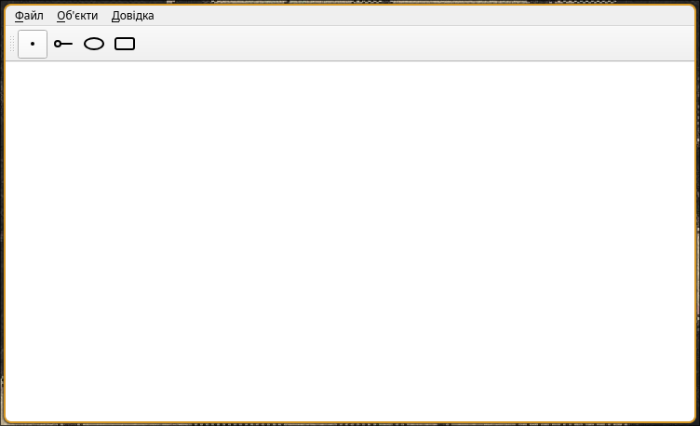
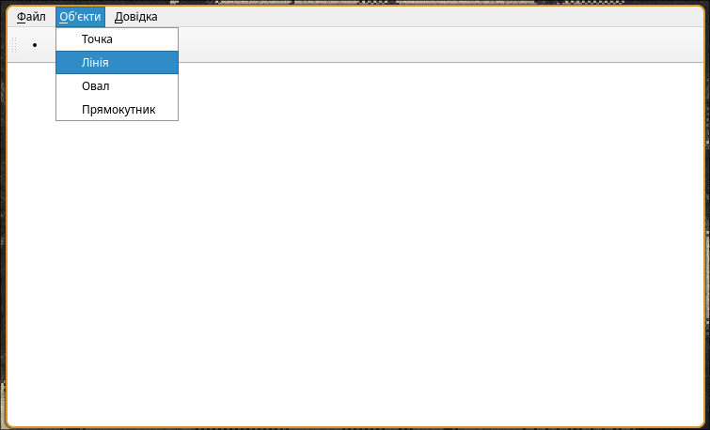
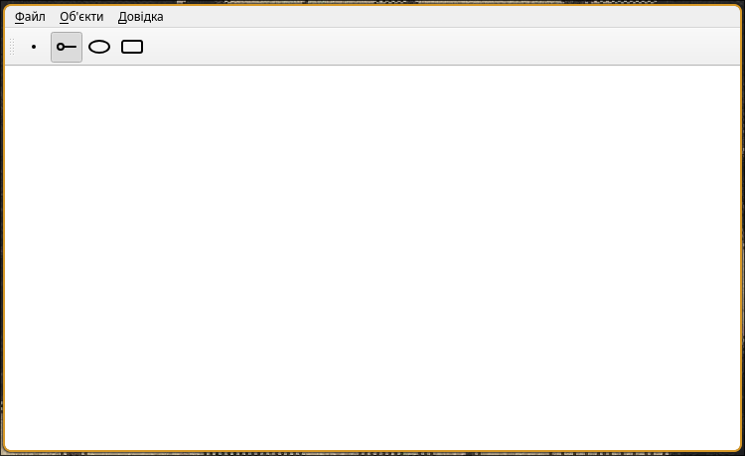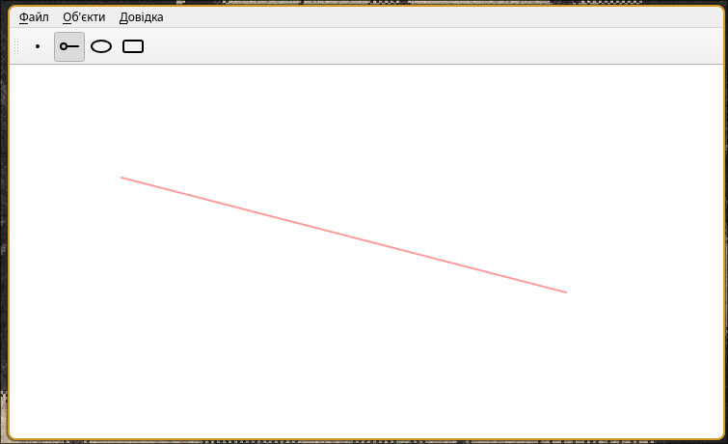
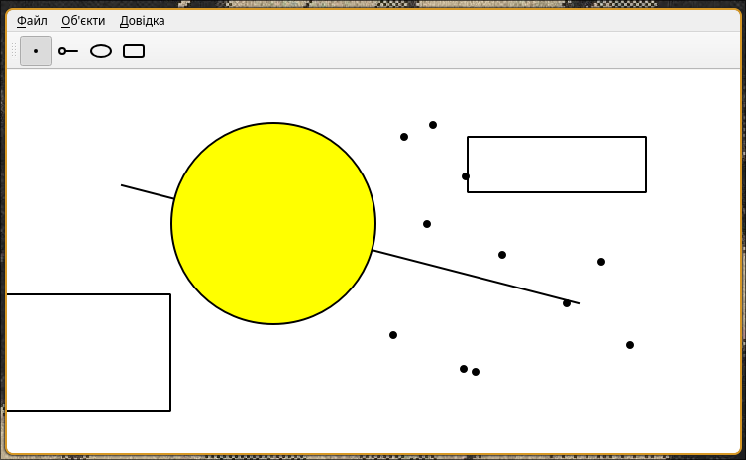

Діаграма класів
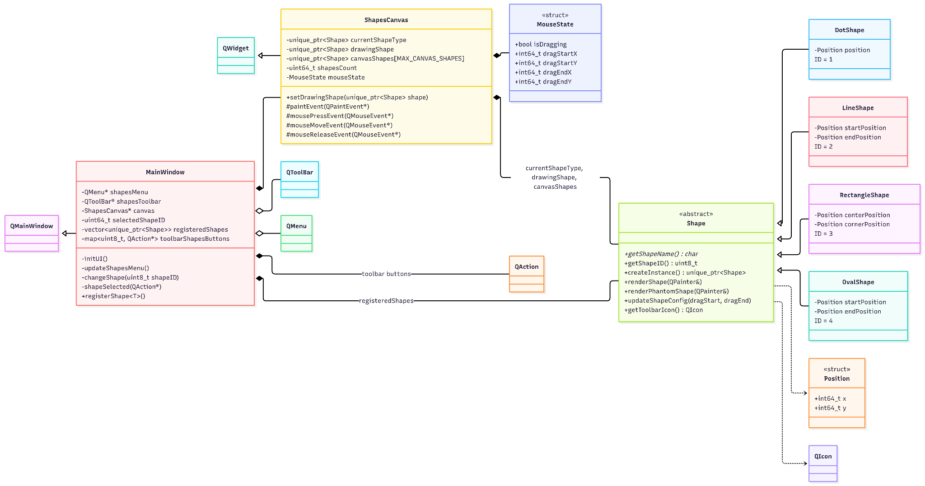

Висновки:
У лабораторній работі я виконав завдання згідно свого варіанту.
Було створено вікно з пунктами меню у вигляді фігур, також красивий тулбар та робоче полотно для відтворення фігур.

