HR MODULE
Tab wise snaps with description
- General
  - View Employee: This displays all on floor employees with two operations accessible only to HR department.
    - Edit Profile: This enabled HR to edit profile details except Salary and Joining Date.
    - View Documents: This option redirects to page where HR can generate employee documents.
(Snap: View Employee)
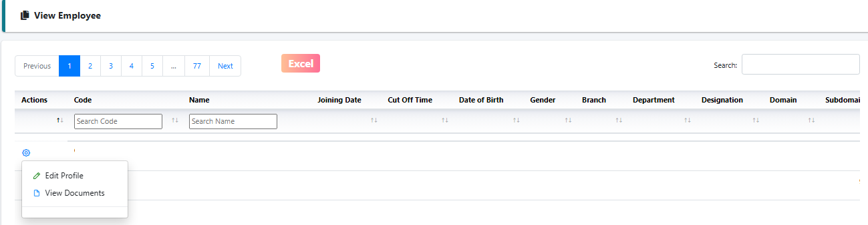
(Snap: View Documents)
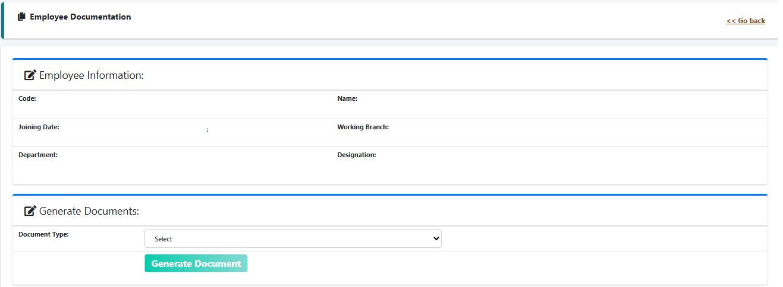

(Snap: Edit Profile)
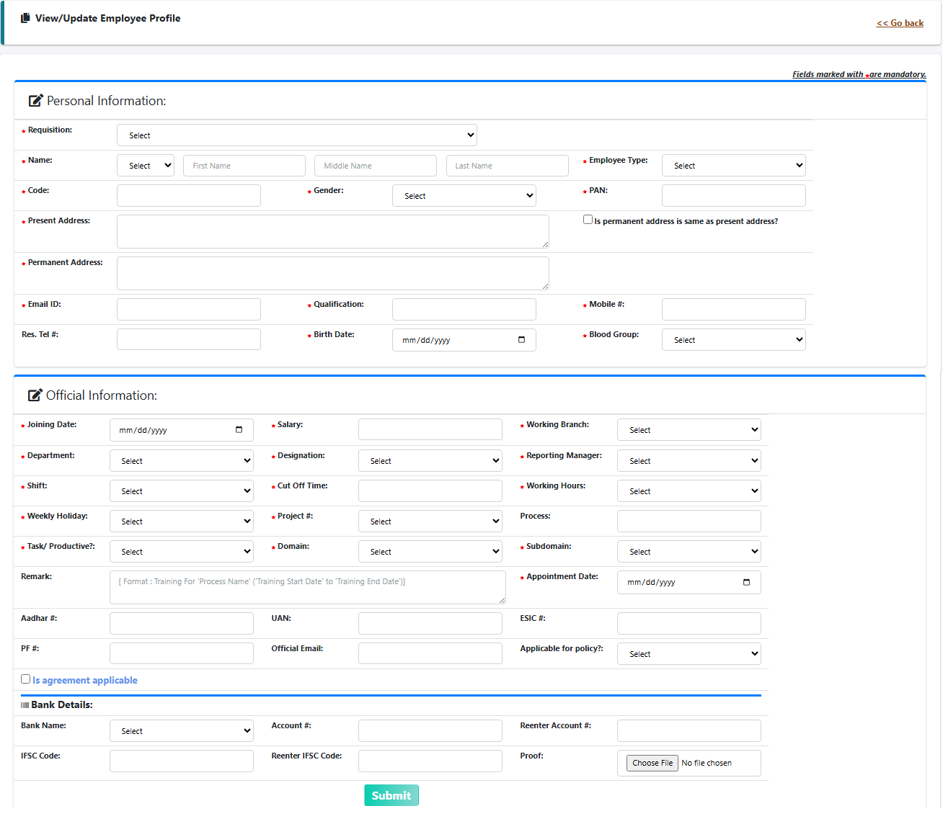
  - Log Details:
(Snap: Log Details)
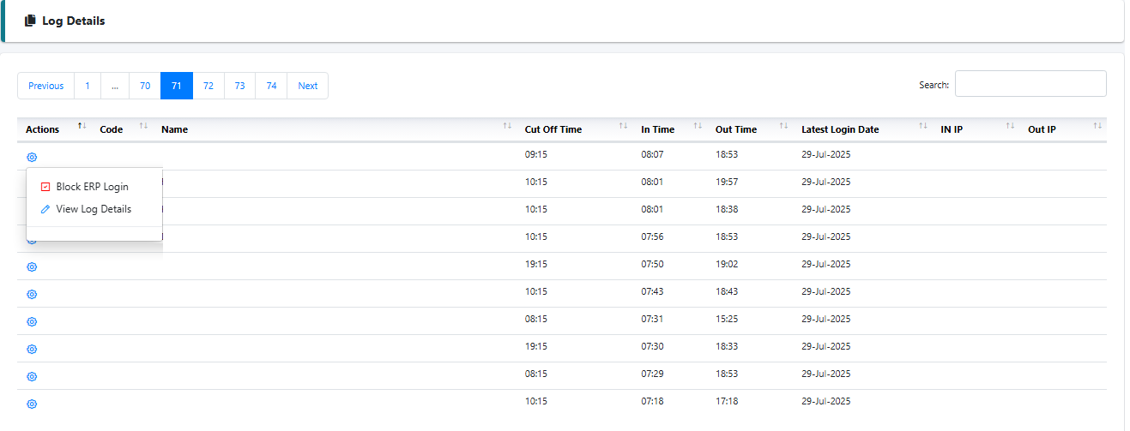
(Snap: Block/Activate ERP Login)
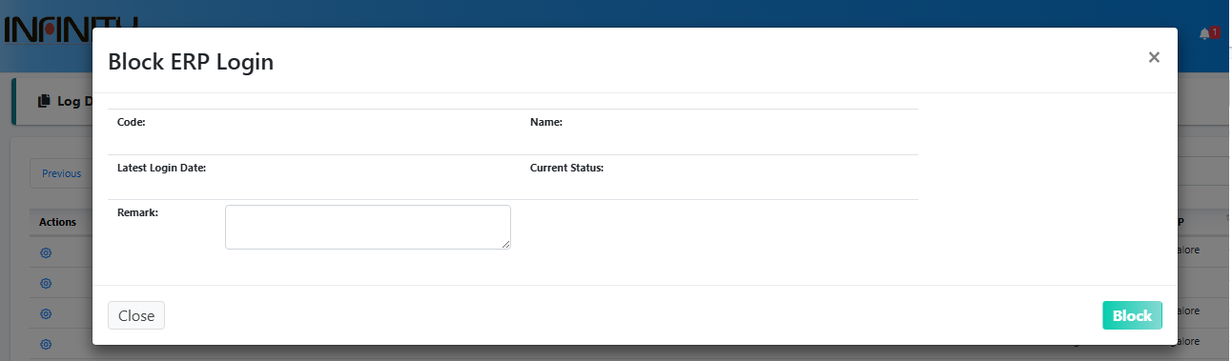
(Snap: Log Details)
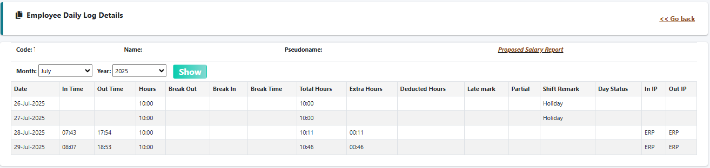
  - Employee Resignation: There are total 5 tabs present on page. Tabs are visible to user as per their role and designation.
Reporting Manager and Above: Step 1 - Initiate Resignation
Domain Head: Step 2 - Finalize Resignation and Edit Finalized Resignation
HR: Step 3 – Dropout Employee and Direct Dropout
HR Manager: All tabs
(Snap: Employee Resignation Step 1: Initiate Resignation)
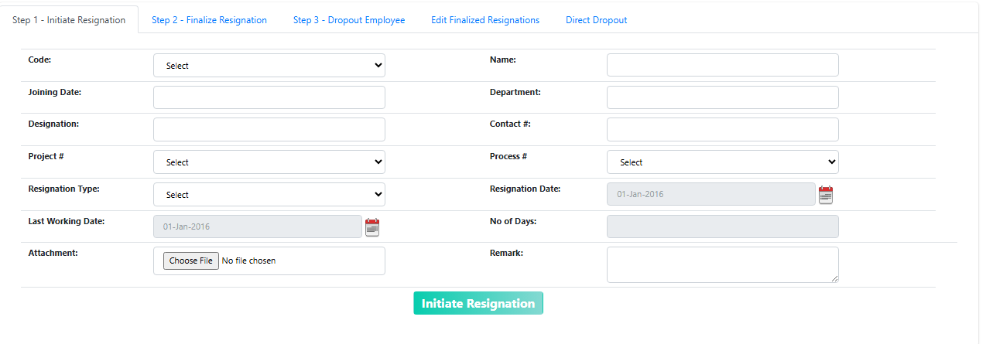

(Snap: Employee Resignation Step 2: Finalize Resignation) :Option to Approve/Reject Resignation
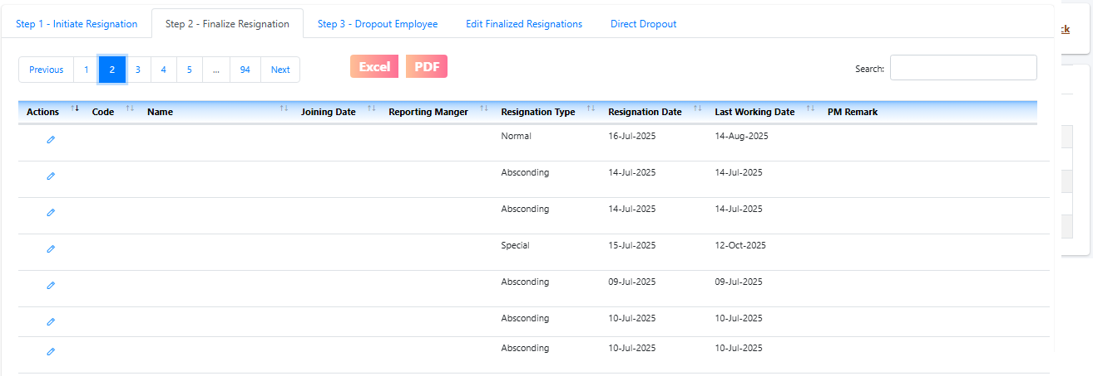
(Snap: Employee Resignation Step 3: Dropout Employee)
Send Exit Formality Email: To inform Accounts team through email that exit formality is completed.
Delete User: Final Dropout from System (Soft Delete)
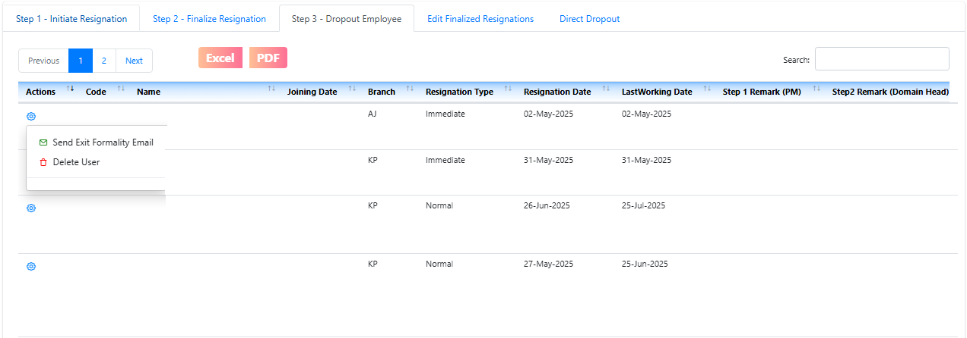
(Snap: Employee Resignation Edit Finalized Resignations)
Change Resignation Type
Extend/ Shorten Notice period
Cancel Resignation
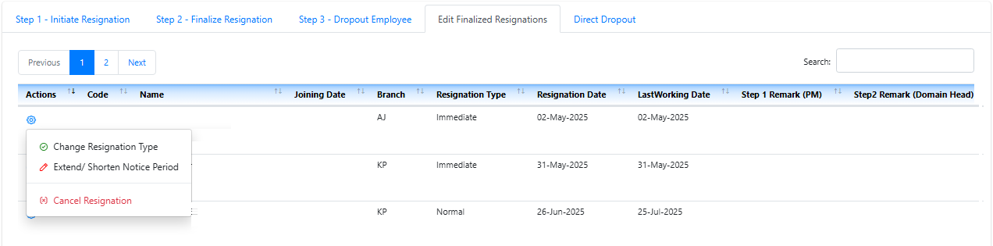
(Snap: Employee Resignation Direct Dropout)
Option to Skip Step 2 and direct dropout user from ERP.
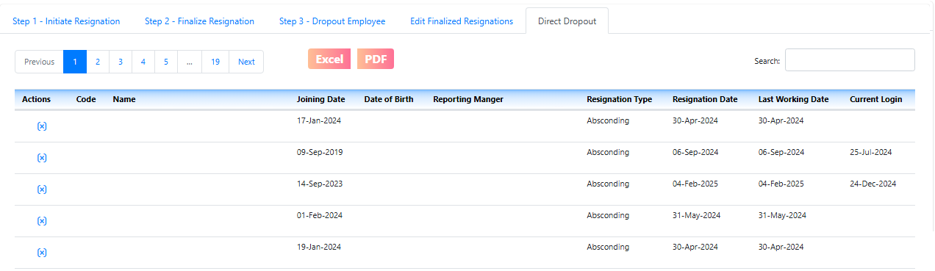
  - Skip Level Meeting
(Snap: Skip Level Entry)
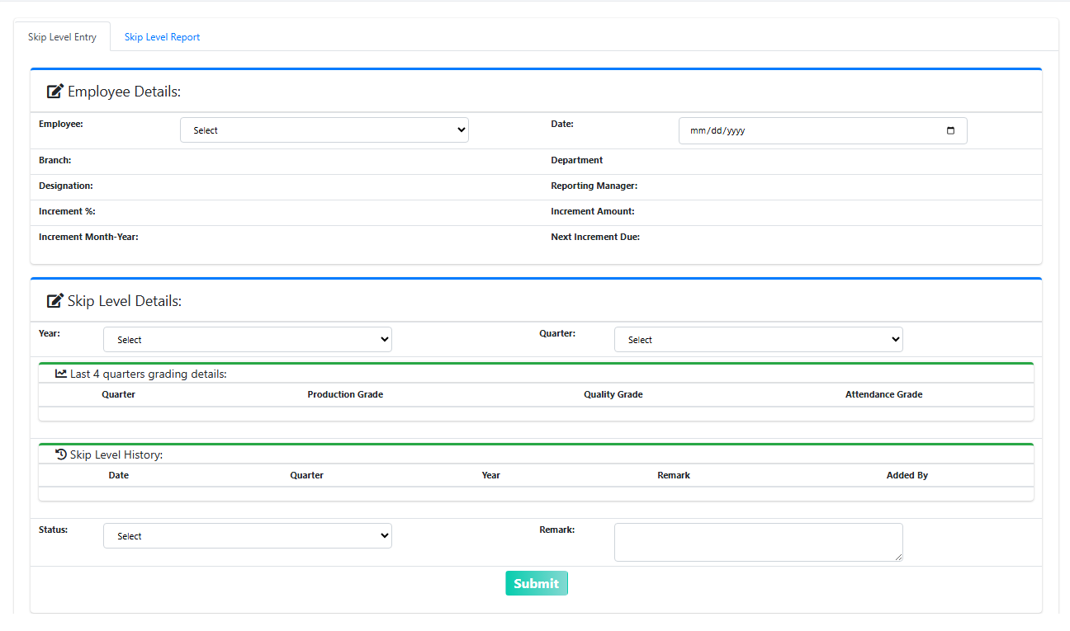
(Snap: Skip Level Report)
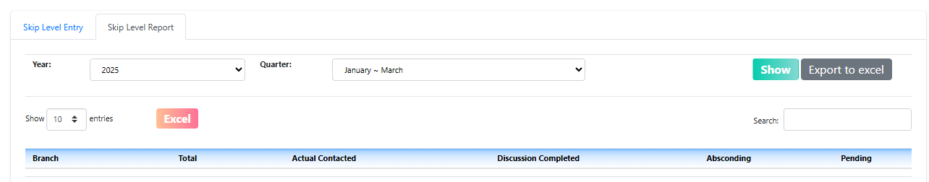
  - Employee Verification Details
  - Pending Bank Account
- Recruitment
  - Application Form:

(Snap: Application Form)
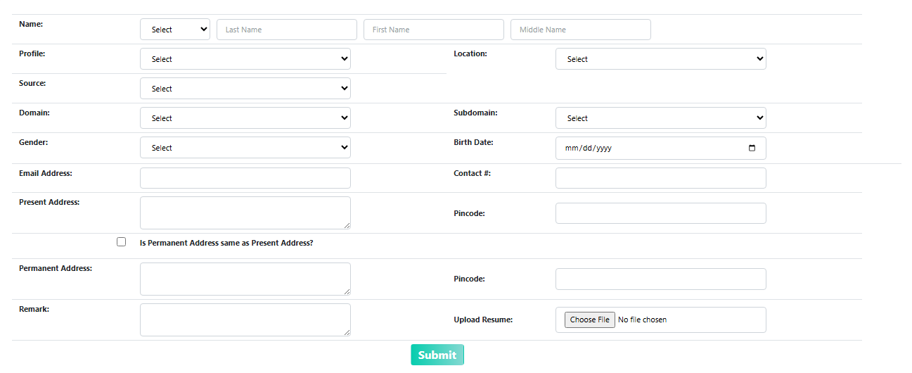
  - Manpower Requisition:
(Snap: Manpower Requisition)
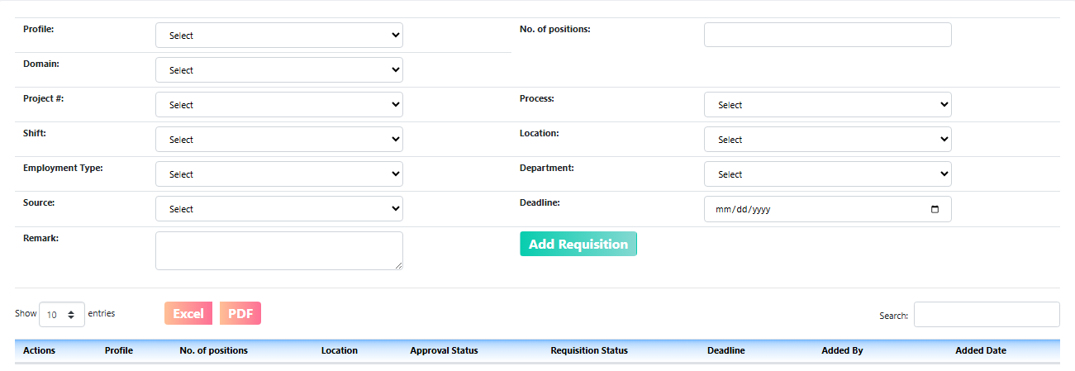
  - View All Applicants:

(Snap: View All Applicants)
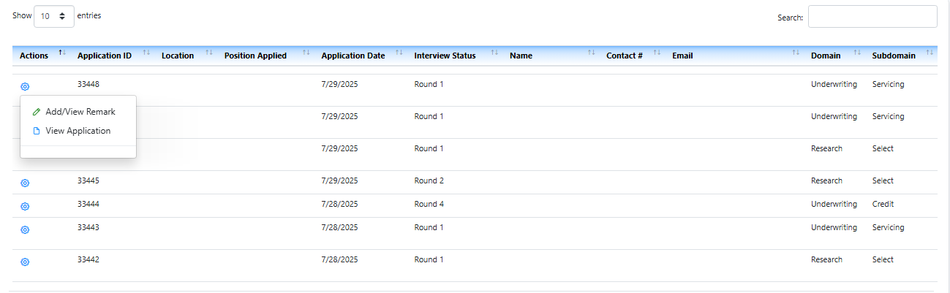
  - View Selected Applicants:

(snap: View Selected Applicants)
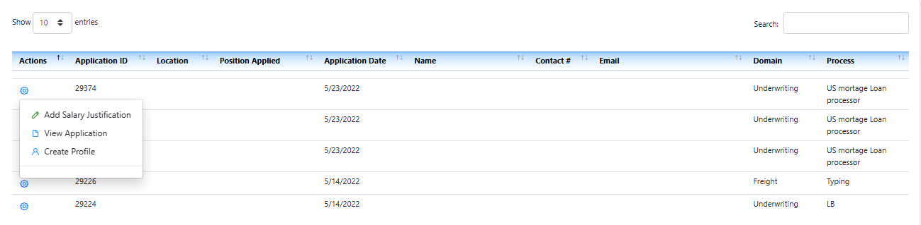
  - Underwriting Test Module
(Snap: Underwriting Test Module Question Set (Credit))
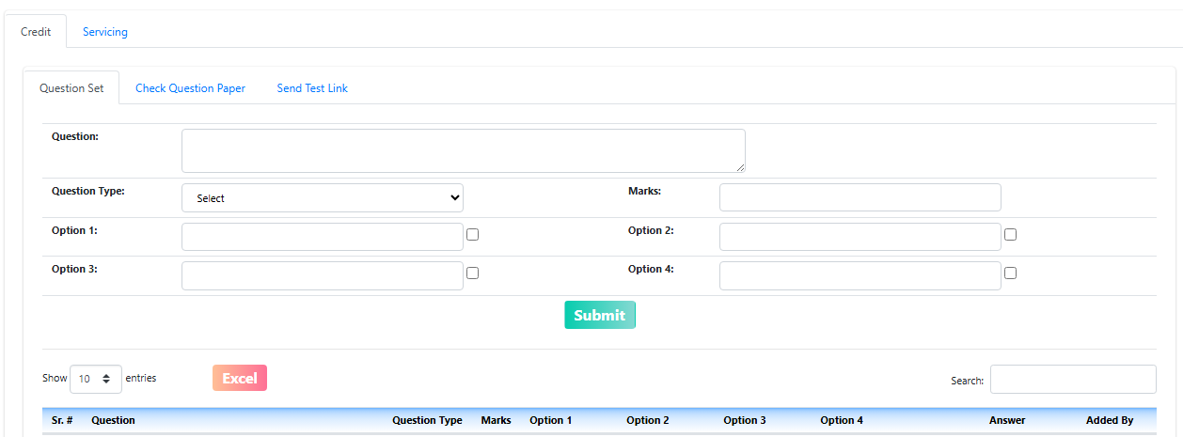
(Snap: Underwriting Test Module Check Question Paper (Credit))
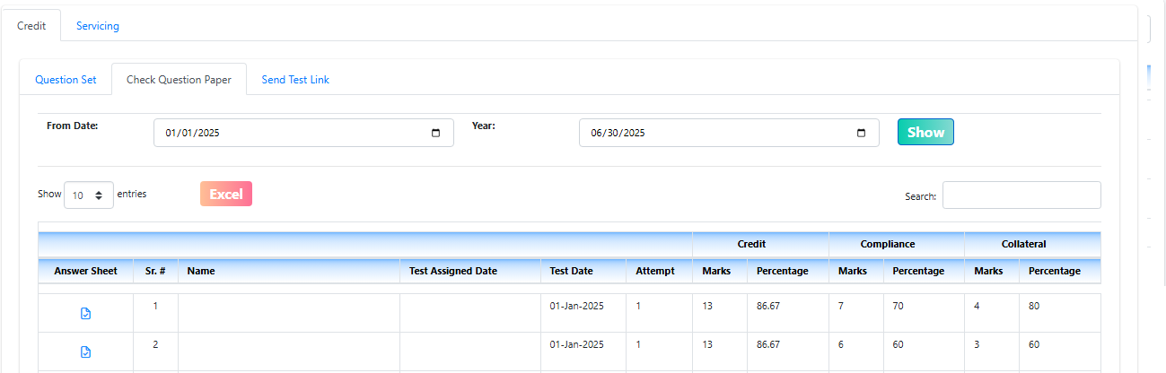

(Snap: Underwriting Test Module Send Test Link (Credit))
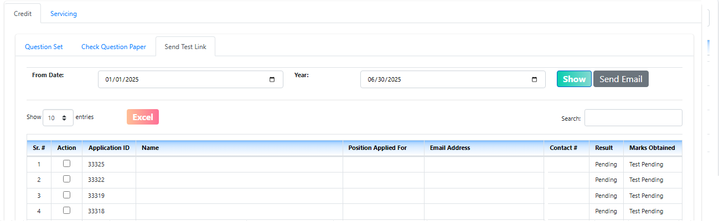
- Stamp Paper:
  - Stamp Paper Information:
(Snap: Stamp Paper Information)
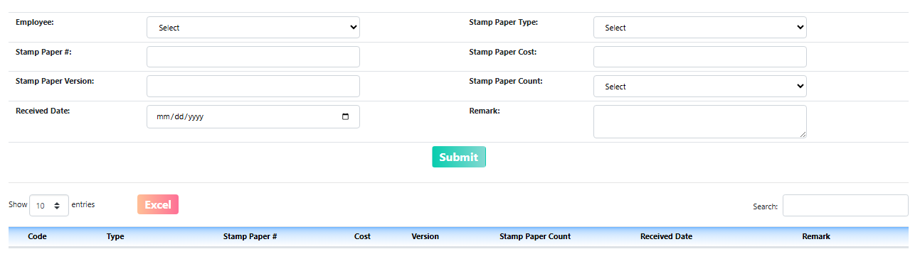
  - Stamp Paper Invoice:
(Snap: Stamp Paper Invoice)
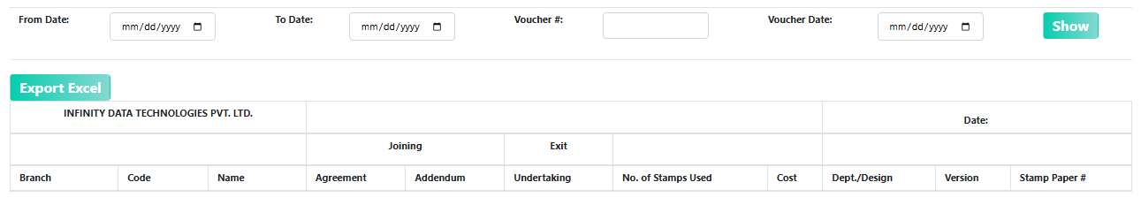
- Verification:
  - Address Verification
(Snap: Address Verification)
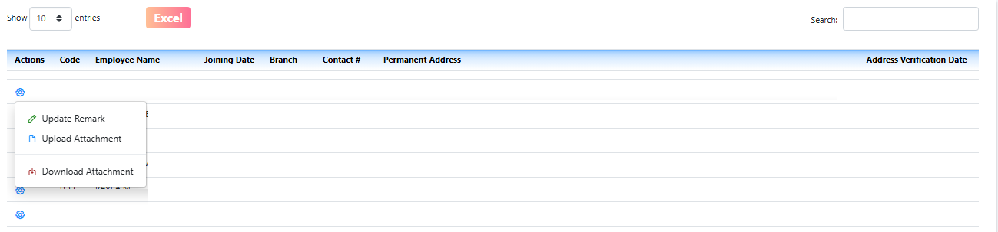
  - Ex Employer Verification:

(Snap: Ex Employer Verification)
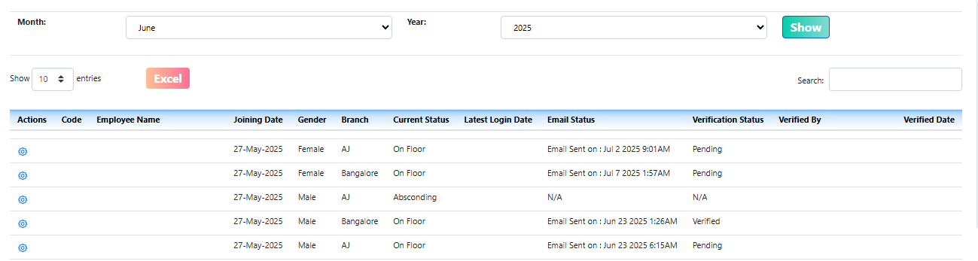
- Other:
  - New Joinee HR Follow up
(Snap: New Joinee HR Follow up)
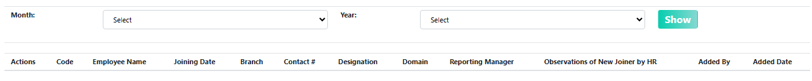
  - Absconding Employee Follow up)
(Snap: Absconding Employees Follow up)
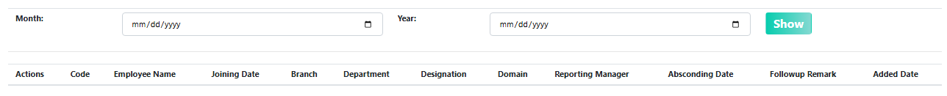
  - Letter Head Management
(Snap: Letter Head Management)
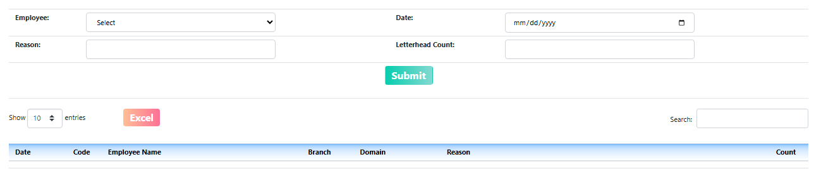
  - Fun Friday
(Snap: Fun Friday)
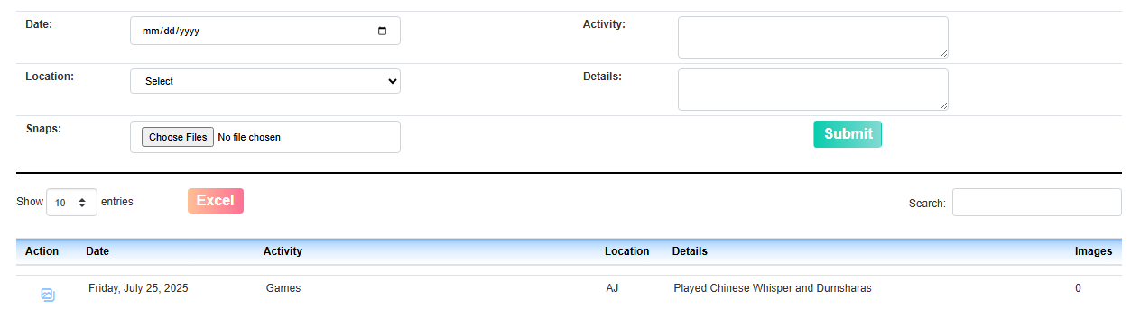

  - Reward and Recognition
(Snap: Reward and Recognition Add Employee)
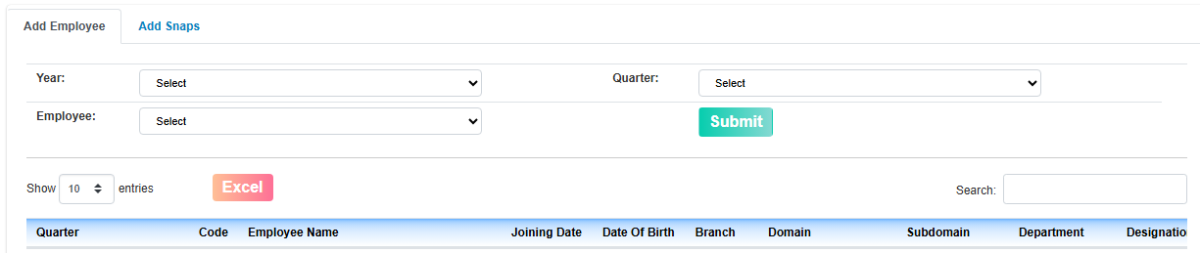
(Snap: Reward and Recognition Add Snaps)
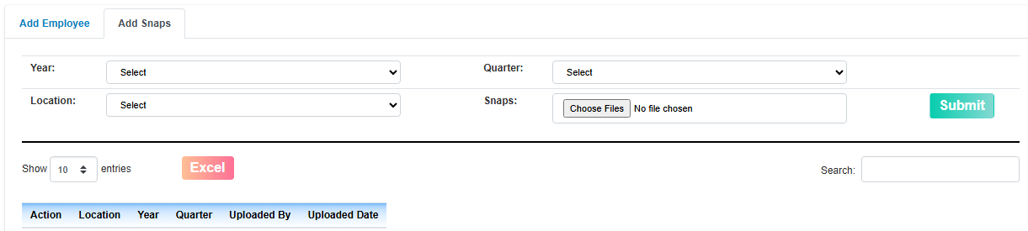
- Miscellaneous
  - HR Induction:
(Snap: HR Induction Question Set)
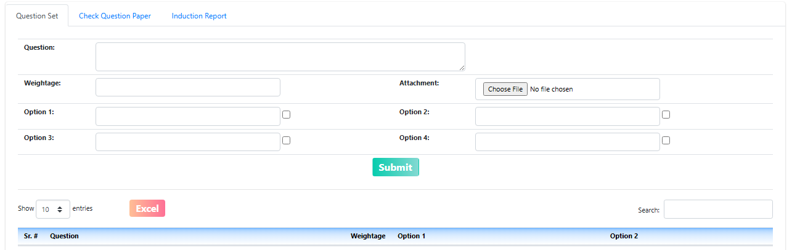
(Snap: HR Induction Check Question paper)
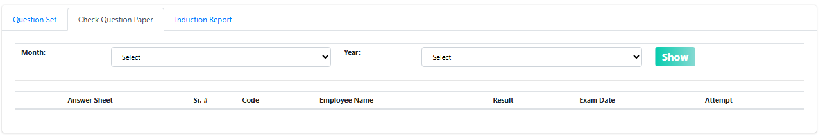

(Snap: HR Induction Induction Report)
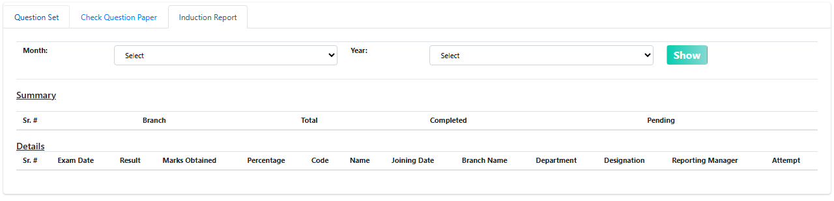
  - POSH Induction Test Result:
(Snap: POSH Induction Test Result)
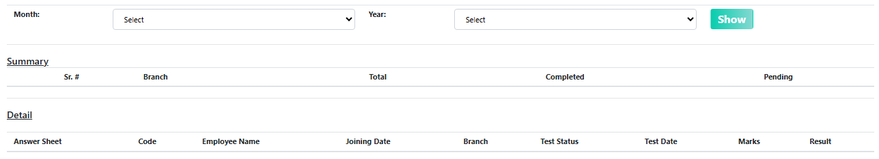

Reports
- New Joined Employees
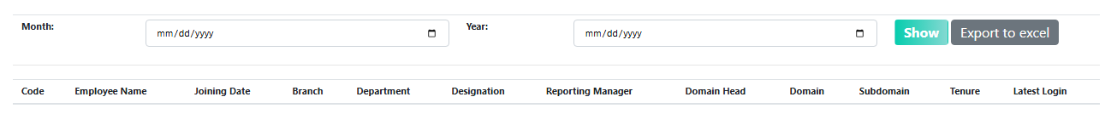
- All Resigned Employees
(Snap: All Resigned Employees Summary)
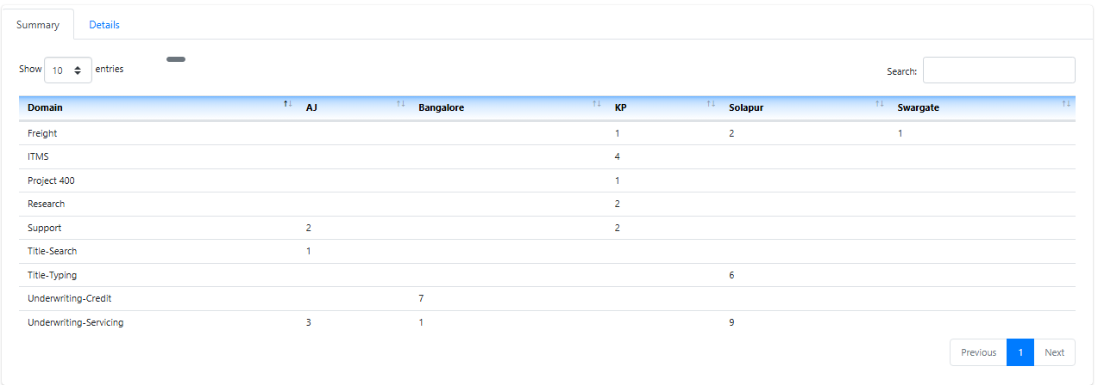
(Snap: All Resigned Employees Details)
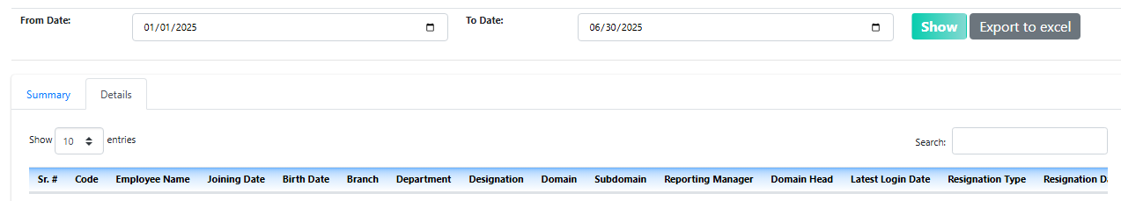
- Dropout Employees
- Monthly Absconding and Leaves Report
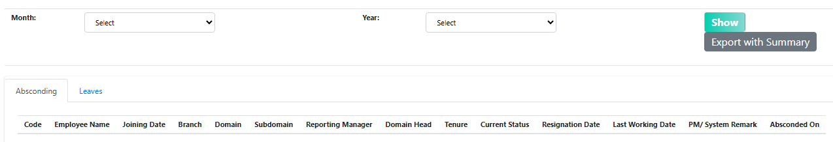
- Attrition Report
