Vaibhav V. Mahajan

Designation: **Senior Software Engineer**

E-mail: [vaibhav.mahajan@coforge.com](mailto:vaibhav.mahajan@coforge.com)

Mob. No: +918459923606

Experience: 3+ years

Location: Pune

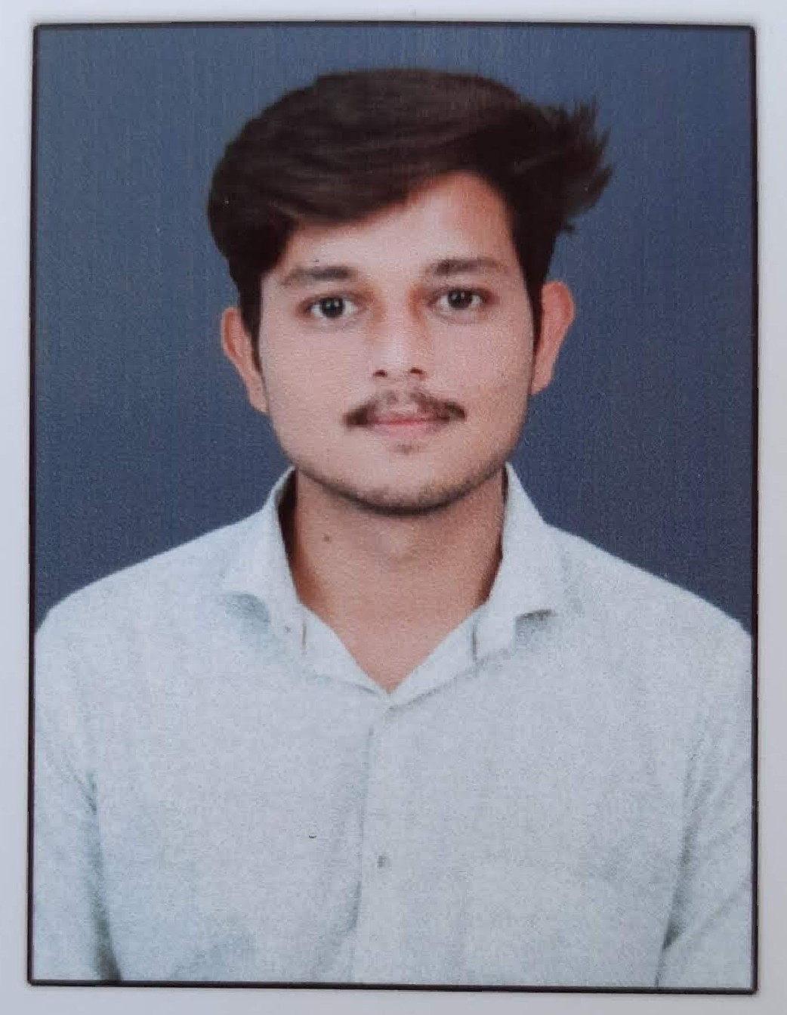Please add Passport size photograph here

|  |
| --- |
| **Professional Summary:** |

* **3 years** of IT experience in Software Design, Development of various client/server and web based Enterprise Applications using different tools and technologies.
* Experience in **Marketplaces**, **Service** and **Education** domains.
* Expertise in using **Core Java** and Web technologies like **Java EE, Spring-boot, JPA.**
* Experience in working with **Angular 7+, HTML, JavaScript, jQuery** and **Ajax**.
* Experience in working with **Mat design, CSS, Bootstrap.**
* Experience in **AGILE** Methodology.
* Good Knowledge of **Microservices Architecture**.
* Strong Experience with **Object Oriented Programming Concepts (OOPS**).
* **Experience in Spring Boot and java 1.8**
* Experience in RDBMS databases like **SQLServer, MySQL.**
* Experience with IDE tools **Eclipse, STS** and also with **version controls like SVN and Git hub.**

|  |
| --- |
| **Technical Summary:** |

|  |  |
| --- | --- |
| **Technologies/ Frameworks** | JAVA, Spring-boot, Angular |
| **Domain/Industry** | Service and market places |
| **Build Tools** | Maven |
| **Web/Enterprise Servers** | Tomcat |
| **Databases** | MySQL, SqlServer |
| **Version Control** | Git, SVN |
| **Loggers** | Log4j |
| **IDE** | Eclipse, Vs-code, Intellij |
| **Operating Systems** | Linux, Windows |
| **Software Methodologies** | Agile, Waterfall |

|  |
| --- |
| **Project Details :** |

|  |  |  |
| --- | --- | --- |
| **Client : Cogbooks** | | **Duration: 07-2021 to 05-2022** |
| **Team Size** | 3 | |
| **Technologies** | JAVA, Spring boot MVC, PostgreSQL | |
| **Role** | Full stack Developer | |
| **Project Overview:** | Cog books is the online learning platform handle by Cambridge university. | |
| **Roles**  **& Responsibilities** | * Provide the maintenance to project by solving bug based on tickets. * Test, maintain and recommend application improvements to ensure strong functionality and optimization * Added new module, C/R requests. | |

|  |  |  |
| --- | --- | --- |
| **Client : Proxy Paradise** | | **Duration: 08- 2020 to 09-2021** |
| **Team Size** | 4 | |
| **Technologies** | JAVA, Spring boot, Angular 8, MySQL | |
| **Role** | Full Stack Developer | |
| **Project Overview:** | It is the marketplace, here user can buy and maintain the mobile generated proxies. | |
| **Roles**  **& Responsibilities** | * Develop, test and implement new web app programs on basis of project requirement * Design front end UI and backend Rest API * Mentoring junior members in the team. * Coordinating with other teams working on the same project. | |

|  |  |  |
| --- | --- | --- |
| **Client : BuildThePro** | | **Duration : 10-2019 to 07-2021** |
| **Team Size** | 4 | |
| **Technologies** | JAVA, Angular 7, MySQL. | |
| **Role** | Full stack Developer | |
| **Project Overview:** | Build the pro is the Social Group, here user can ask career and job related questions to the professionals. Also professionals can share and sell career story to users. | |
| **Roles**  **& Responsibilities** | * Interacting with the client to understand the project and finalize its scope. * Estimation, design and development of various modules. * Bug fixing and maintenance of the product. * Ensuring smooth delivery of the project | |

|  |
| --- |
| **Work Experience:** |

* Currently Working with **Coforge** as **Senior Software Engineer from May 2022**.
* Worked for **Dakshabhi IT Solutions** as **Software Developer** from July 2019 to April 2022.

|  |
| --- |
| **Educational Qualifications / Certifications:** |

* **MCA** from North Maharashtra University, Jalgaon, Maharashtra - 2019
* **BSC** from Smt. G. G. Khadse College- 2016