WEEKLY LINKEDIN SHOWCASE REPORT
WEEK 1 | CYBERSECURITY INTERNSHIP
BIG BRAINS LEARNING
Intern Name | Prabin Tamang
Organization | Big Brains Learning
Publication Date | 2026-10-30

1. LinkedIn Post Details
Published LinkedIn post URL: https://lnkd.in/p/gUdTD_cf
Visibility and tagging: Make the post publicly accessible and mention Big Brains Learning or Founder Shoaib Hamza where appropriate.

2. Summary of Work Showcased
During Week 1 of my cybersecurity internship at Big Brains Learning, I focused on three foundational areas: cybersecurity awareness, basic computer networking, and Linux fundamentals. I learned why cybersecurity is important, explored common threats and the real-world impact of cyberattacks, and developed basic security awareness. I also studied how computers communicate through networks, including IP addresses, routers, clients, servers, DNS, and website communication. Finally, I was introduced to Linux and practiced using the terminal, navigating folders, creating and reading files, and following safe command-line practices.

3. Key Learning Points

A. Cybersecurity Fundamentals
- Meaning and importance of cybersecurity: Understood how cybersecurity helps protect devices, networks, systems, and information from digital threats.
- Common cybersecurity threats: Learned about common threats such as viruses, worms, malware, phishing, and unauthorized access.
- Real-world impact of cyberattacks: Explored how cyberattacks can cause data loss, financial damage, service disruption, and privacy risks.
- Basic security awareness: Learned the importance of strong passwords, careful handling of links and attachments, software updates, and protecting sensitive information.

B. Basic Computer Networking
- Basic computer networking: Learned how connected devices communicate and share information.
- IP addresses and routers: Understood that IP addresses identify devices on a network and routers help direct traffic between networks.
- Clients and servers: Learned how clients request resources or services and servers respond to those requests.
- DNS and website communication: Understood how DNS translates domain names into IP addresses and how a browser communicates with a website server.
- Networking and cybersecurity: Recognized that networking knowledge helps identify, understand, and protect against network-based security risks.

C. Linux Fundamentals
- Introduction to Linux: Learned about Linux as an operating system commonly used in technical and cybersecurity environments.
- Using the terminal: Practiced interacting with the system through command-line instructions.
- Navigating folders: Learned to move between directories and understand the file-system structure.
- Creating and reading files: Practiced basic file operations, including creating files and viewing their contents.
- Safe command-line practice: Learned to use commands carefully, understand their purpose, and avoid running unfamiliar or potentially destructive commands.

4. Skills and Knowledge Developed
Cybersecurity awareness • Threat identification basics • Networking fundamentals • IP addressing and routing concepts • Client-server communication • DNS and website communication • Linux terminal basics • File and directory management • Safe command-line habits

5. Reflection and Conclusion
Week 1 helped me build a foundation for further learning in cybersecurity. I now have a clearer understanding of why security matters, how devices and websites communicate over networks, and how to perform basic tasks in a Linux terminal. These fundamentals will support my progress into more advanced topics and practical cybersecurity exercises in the coming weeks.

6. Supporting Evidence
Screenshot of the published LinkedIn post:
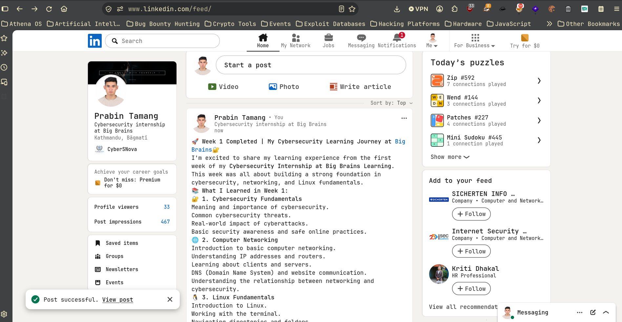
Submission reminder: Add the real public LinkedIn post URL, publication date, and screenshot before submitting. Do not include passwords, API keys, private credentials, or confidential information.

