Name: Shreyash Patil
PRN: 22510039
Batch: T3
Assignment 7 ADS
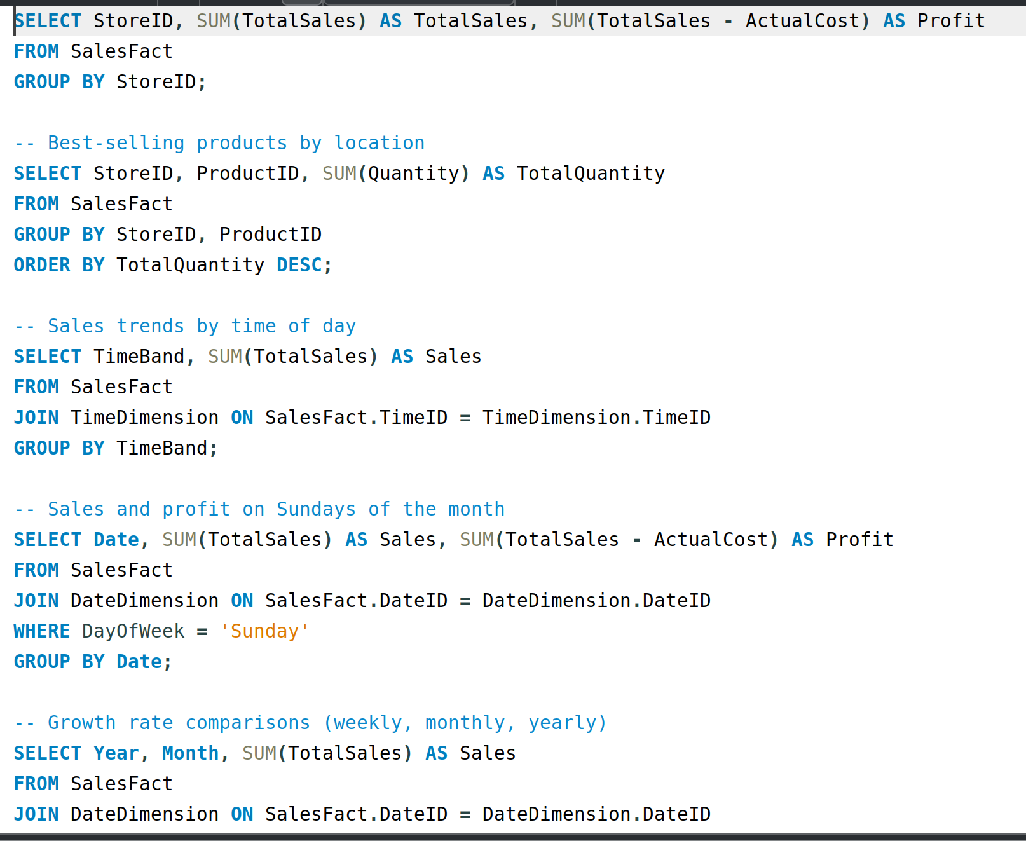
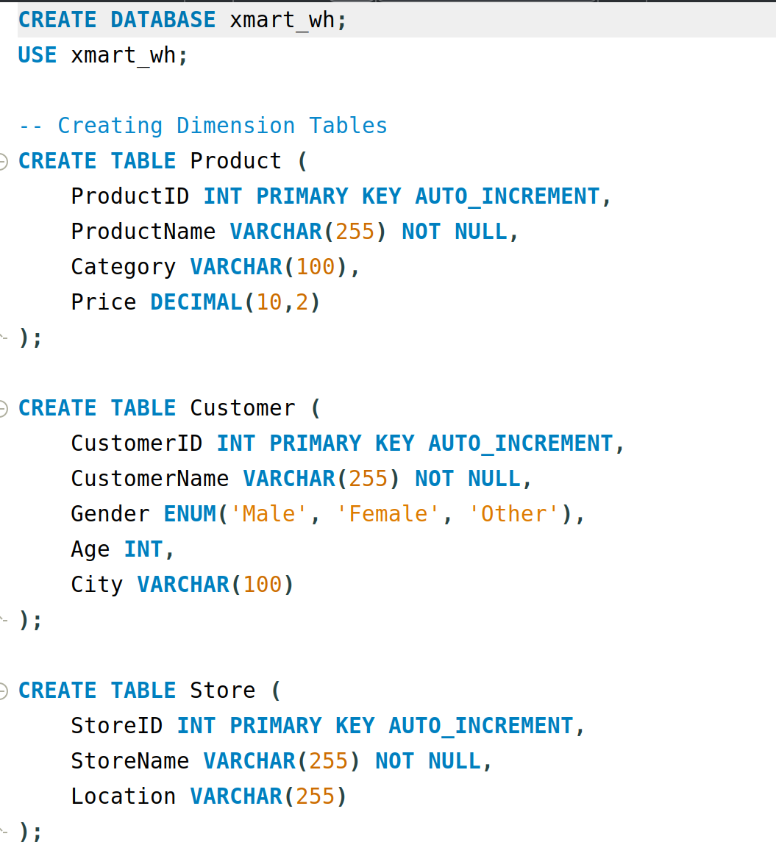
This has the star schema

