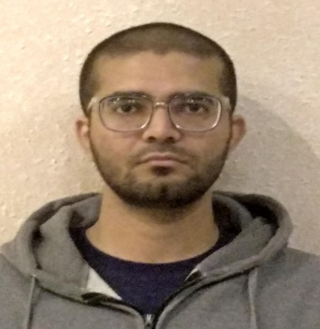

*Contact:*

📞**phone/WHATSAPP:**

**:** 0309-2740879

✉ **email:**  [devlover717@gmail.com](mailto:Devlover717@gmail.com)

🏠 **address:** C/35 Block B North Nazimabad, Karachi.

GitHub - Apps on Google Play **github:** devlover717

*Skills:*

* Html
* Css
* JavaScript
* Git
* Responsive Design

*Soft Skills:*

* Adaptability
* Communication

***MUHAMMAD OSAMA***

*WEB DEVELOPER*

*Career Objective:*

Seeking to obtain a Web Developer Intern position within an organization that will provide additional learning opportunities, utilizing education and strong interpersonal and organization skills.

*Projects:*

* Counter app
* Calculator app
* Color Palette Generator app
* Tell me a Joke app

Visit my Website https://www.devlover717.github.io/portfolio for viewing the projects

*Education:*

Jinnah Govt. College

* Intermediate

Al-Huda School

* Matriculation