To install docker:

sudo yum install docker
sudo systemctl start docker
sudo systemctl status docker
sudo systemctl enable docker
sudo systemctl status docker
sudo docker run hello-world

sudo docker run hello-world ( To check if docker installed and running)

echo $USER ('centos')
sudo groupadd docker
sudo usermod -aG docker $USER (to change the acsess)
docker login --username=devmabh --password=Srcm@2018
sudo systemctl restart docker
(Open duplicate session)
docker run hello-world
(to see list of images )
docker images
sudo docker logs -f <container id> (To check the logs)

sudo docker build -t mamta12/sprintboot . (to build the docker)
sudo docker run -p 8081:8080 -d mamta12/sprintboot (to run the docker)
or
docker container run -d -p 8081:8080 -v /var/run/docker.sock:/var/run/docker.sock devmabh/jenkins

sudo docker ps
docker ps -a
docker exec -it 73f1291c2fe5 bash (To go into the container)
sudo docker ps
docker stop <docker id> (to stop the docker container)

To Uninstall docker

sudo yum remove docker \
docker-client \
docker-client-latest \
docker-common \
docker-latest \
docker-latest-logrotate \
docker-logrotate \
docker-selinux \
docker-engine-selinux \
docker-engine

Again install latesr version

sudo yum update
sudo yum install yum-utils device-mapper-persistent-data lvm2

Objective 1 : Creating docker image of any application.

Sudo yum install docker
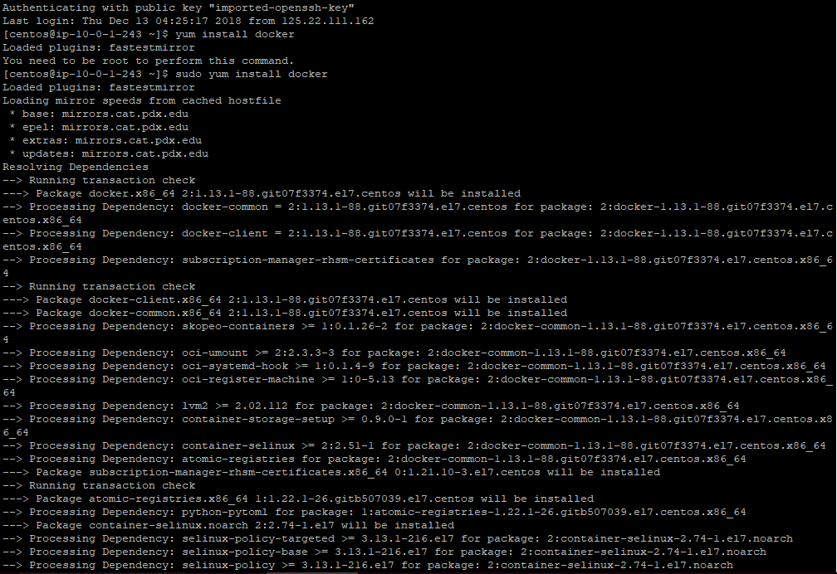

sudo systemctl status docker (to check if docker enabled or not)
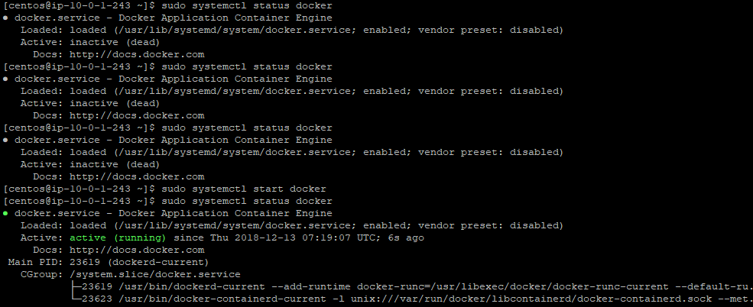

sudo docker run hello-world ( To check if docker installed and running)
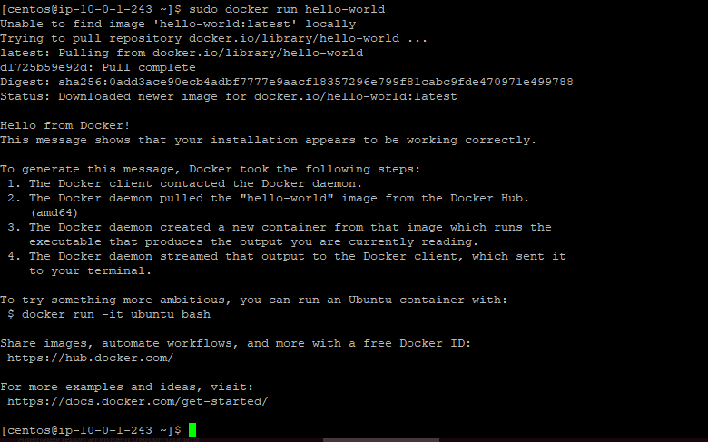
Go to git hub in project and Create a dockerfile
Check Dockerfile in your github account: devmabh/cicd-pipeline-gradle

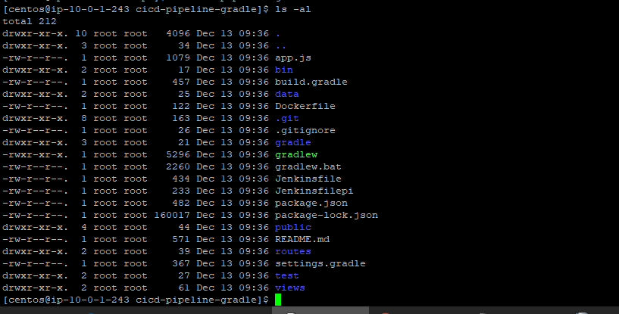
We can see the dockerfile over here
Create your docker hub: https://hub.docker.com/

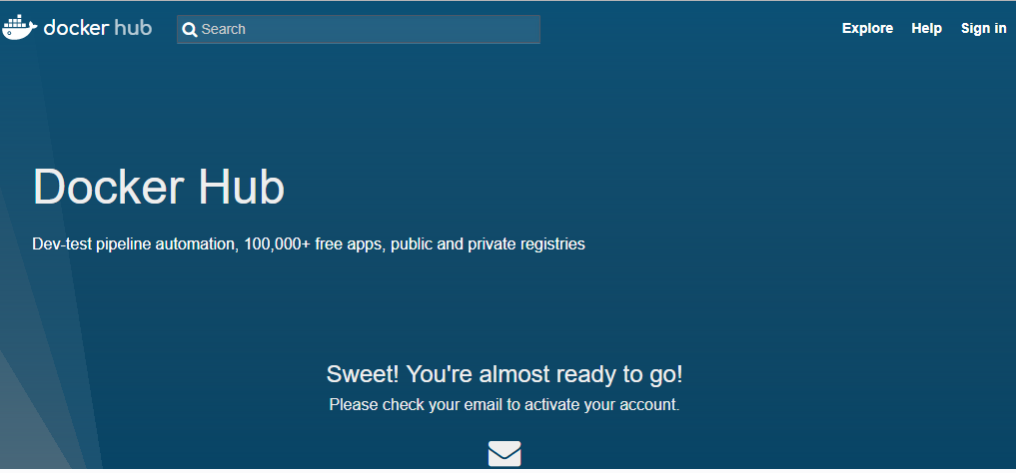

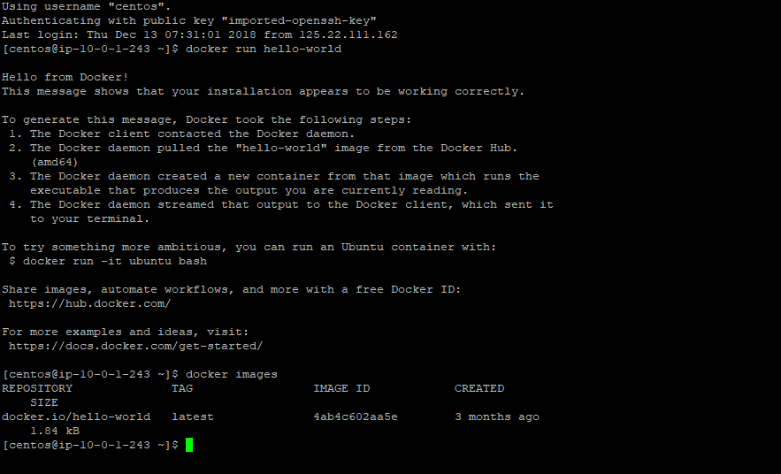
Latest means which tag is latest and it will be pulled.(for that Docker image)

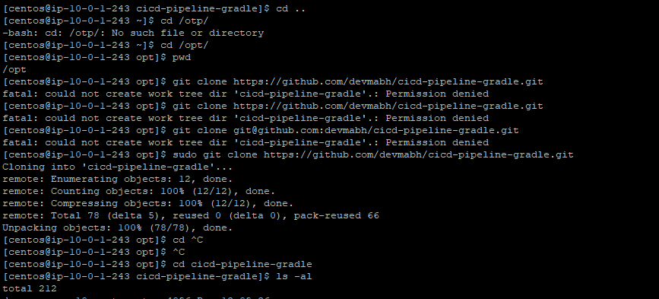

sudo docker build -t mamta12/sampleapp .
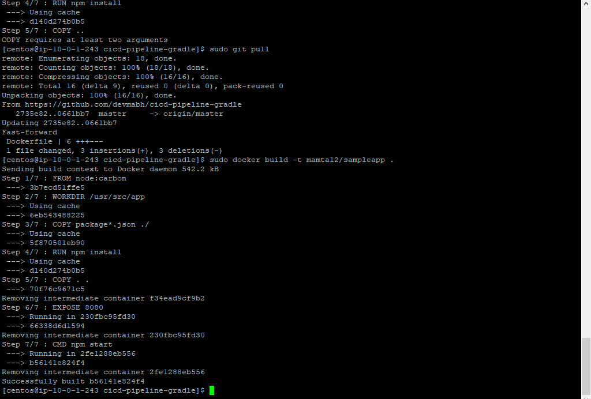

sudo docker run -p 8081:3000 -d mamta12/sampleapp

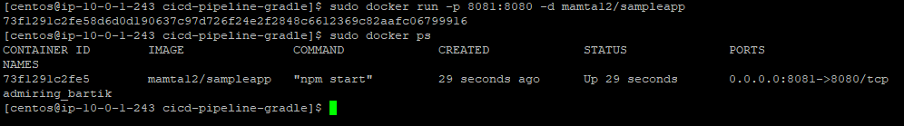
sudo docker ps
docker ps -a
docker exec -it 73f1291c2fe5 bash
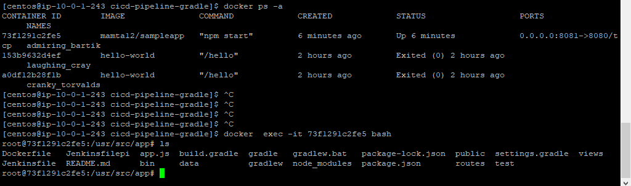
sudo docker ps
docker stop <docker id>
sudo docker run -p 8081:3000 -d mamta12/sampleapp

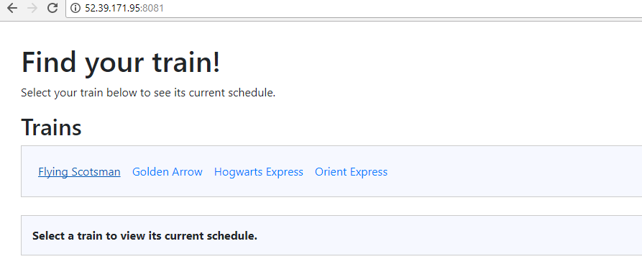

Objective 2: Creating dockerised image of jenkins.
To create docker with jenkins image

mkdir jenkins
create file Dockerfile inside the jenkins directory and paste the below code
(link https://medium.com/@manav503/how-to-build-docker-images-inside-a-jenkins-container-d59944102f30)

from jenkinsci/jenkins:lts

USER root
RUN apt-get update -qq \
&& apt-get install -qqy apt-transport-https ca-certificates curl gnupg2 software-properties-common
RUN curl -fsSL https://download.docker.com/linux/debian/gpg | apt-key add -
RUN add-apt-repository \
"deb [arch=amd64] https://download.docker.com/linux/debian \
$(lsb_release -cs) \
stable"
RUN apt-get update -qq \
&& apt-get install docker-ce=17.12.1~ce-0~debian -y
RUN usermod -aG docker jenkins

docker build -t mamta12/jenkin .
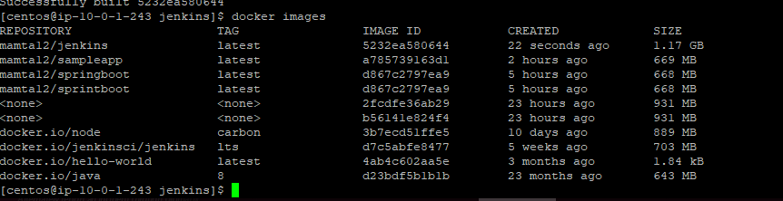
sudo docker run -p 8080:3000 -d mamta12/jenkins ( run using this command will show erroer daemon)
or
docker container run -d -p 8081:8080 -v /var/run/docker.sock:/var/run/docker.sock devmabh/jenkins

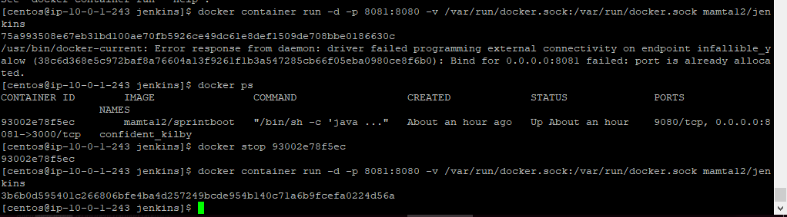

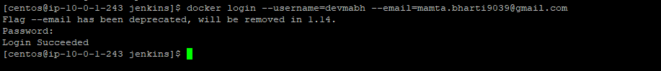
docker login --username=devmabh --email=mamta.bharti9039@gmail.com
docker login -u=devmabh -p=<password>
docker push devmabh/jenkins
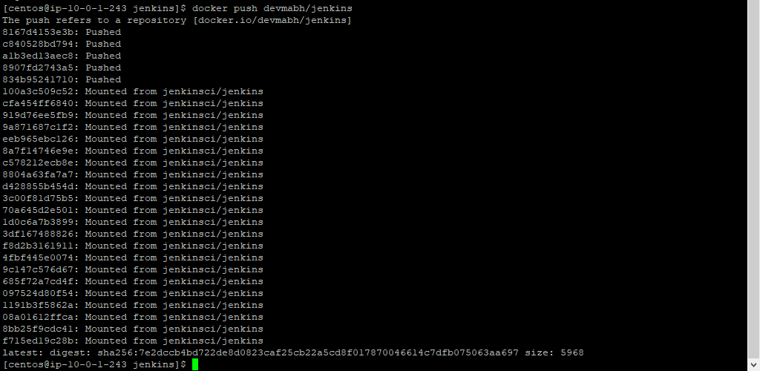
Now you check in your docker hub account that image has been pushed
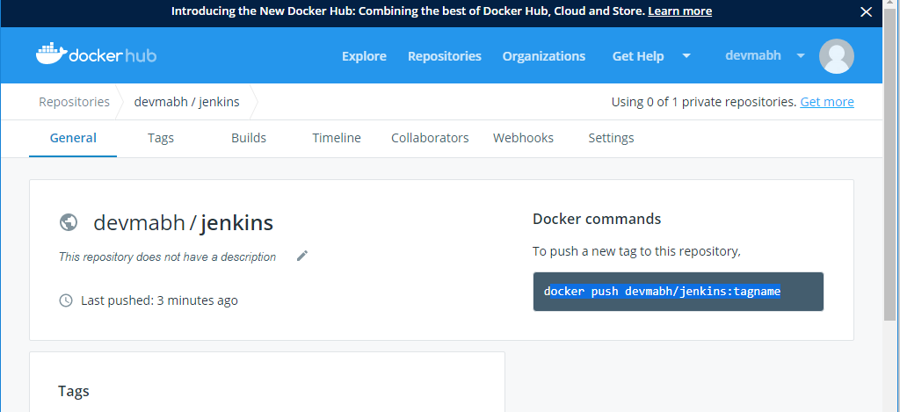

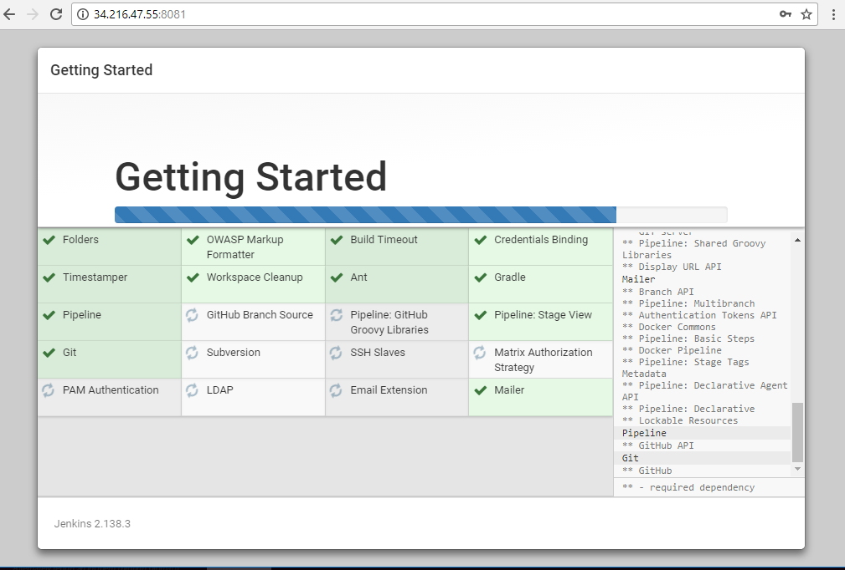

Objective 3 : Installing jenkins with dokerised image of jenkins which is there in docker hub

Now in new server: We have docker with jenkins image, now will pull it and run the docker. So in this way we will be able to login jenkins without installing jenkins in our host machine.

we have just installed docker and pulled the images from docker
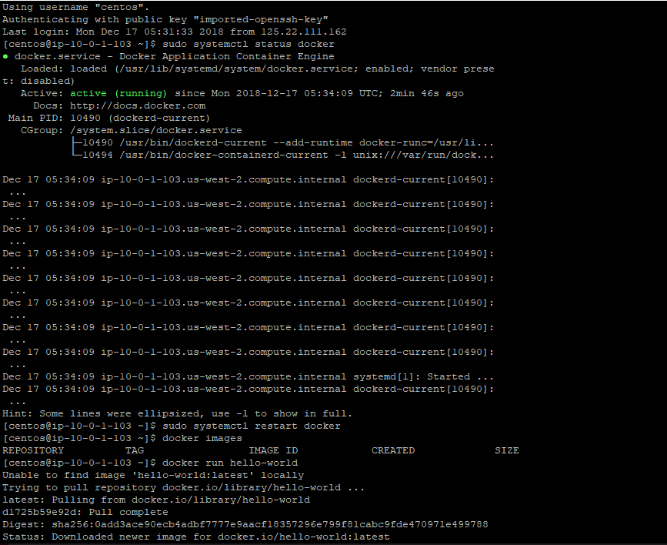

docker pull devmabh/jenkins
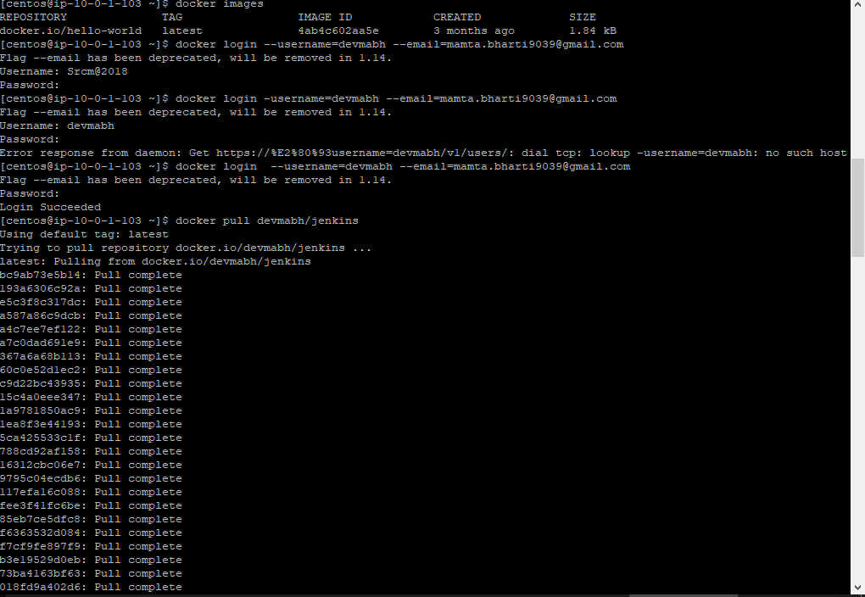

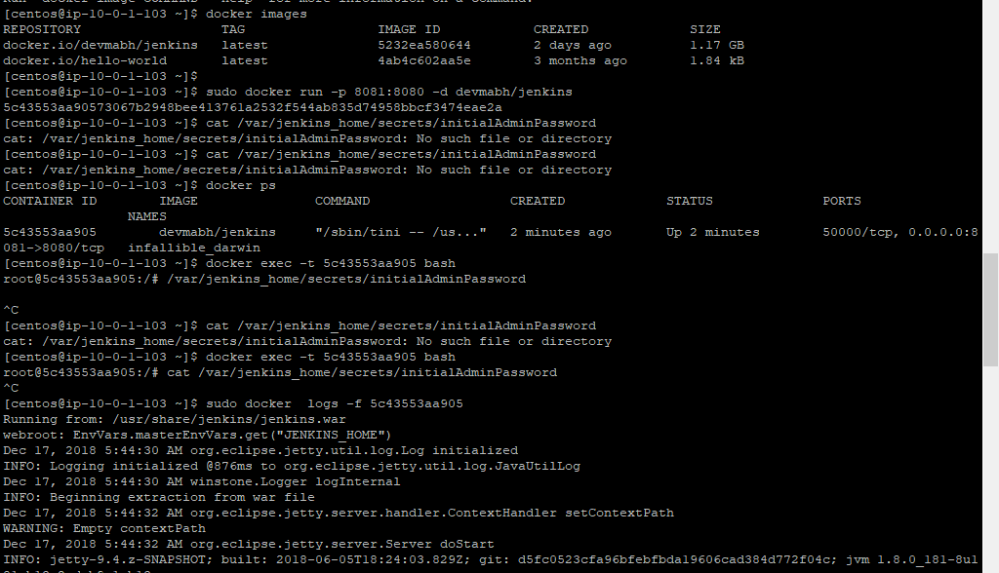

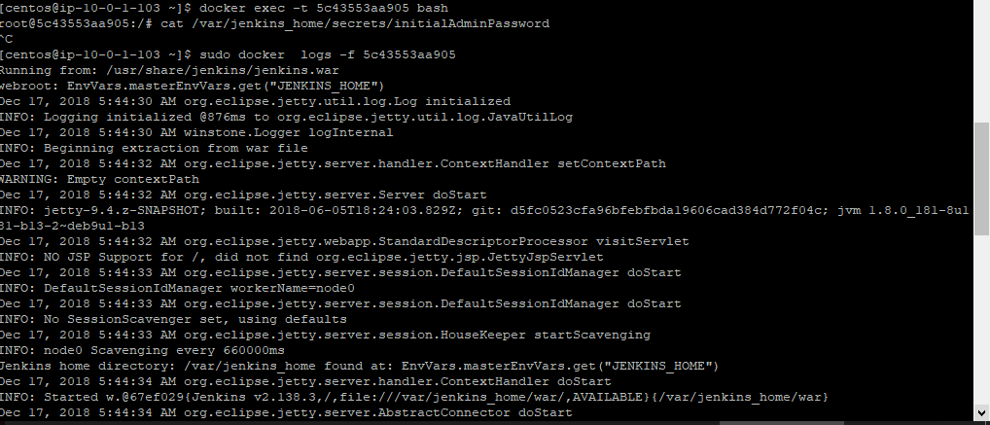

Objective 4 : Installing jenkins with dokerised image of jenkins which is there in docker hub and then create an image of your application and push it in docker hub

Till jenkins follow the steps which is there in Ojective3

Jenkins - > manage jenkins -> configure system

Part of code which is there in Dockerfile:

stage ('docker build') {
steps {
sh "sudo docker build -t devmabh/springboot . "
sh "sudo docker login -u=$env.dockerlogin -p=$env.password"
sh "sudo docker push devmabh/springboot"
sh "sudo docker run -p 3000:9080 -d devmabh/springboot"
}
}

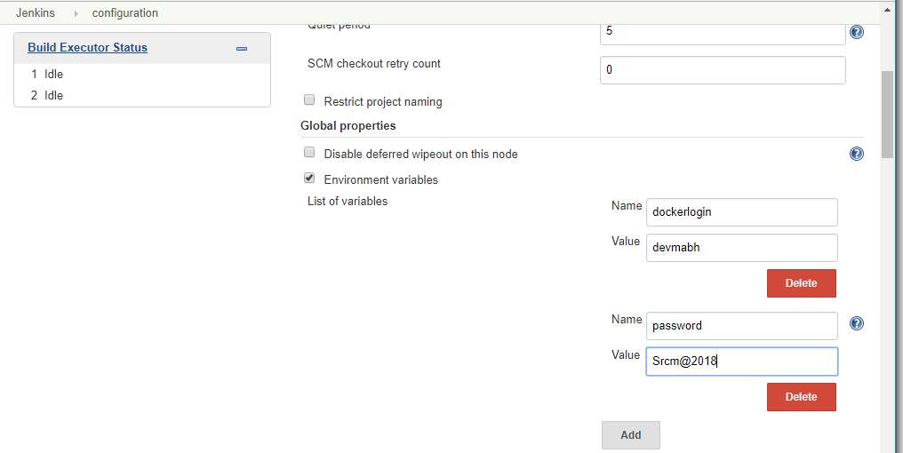
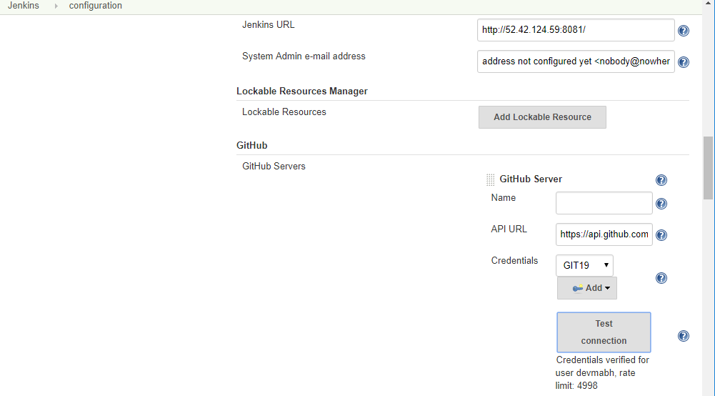
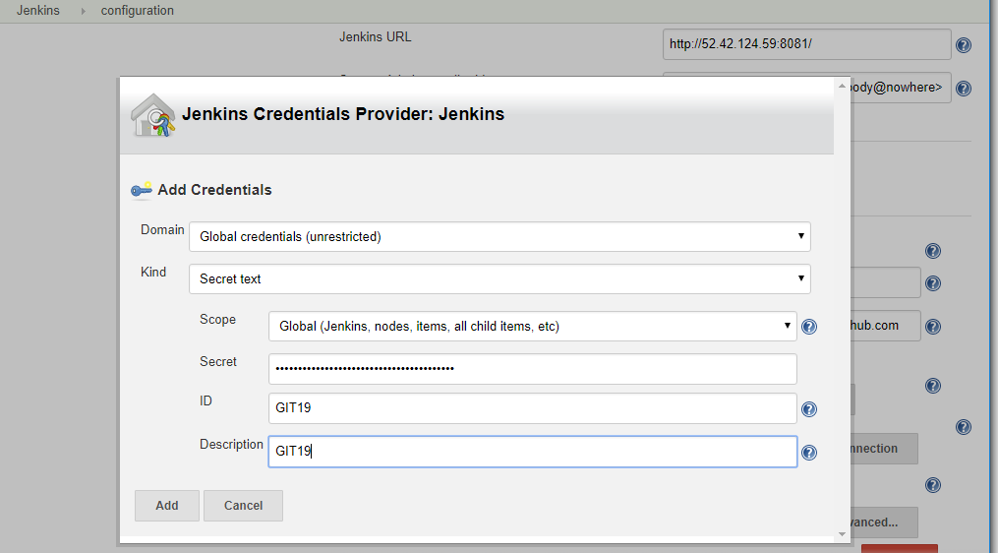
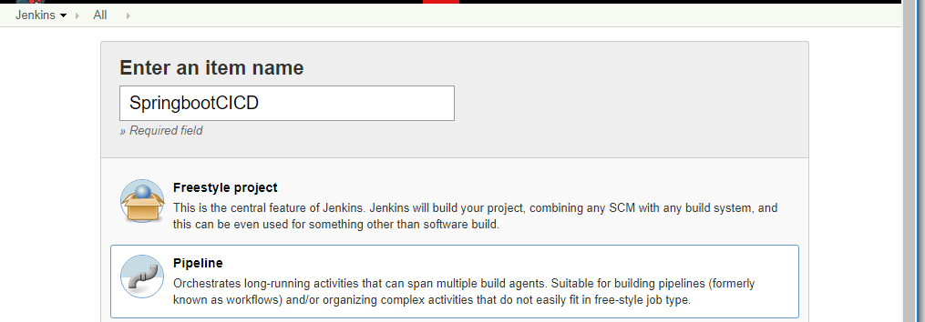

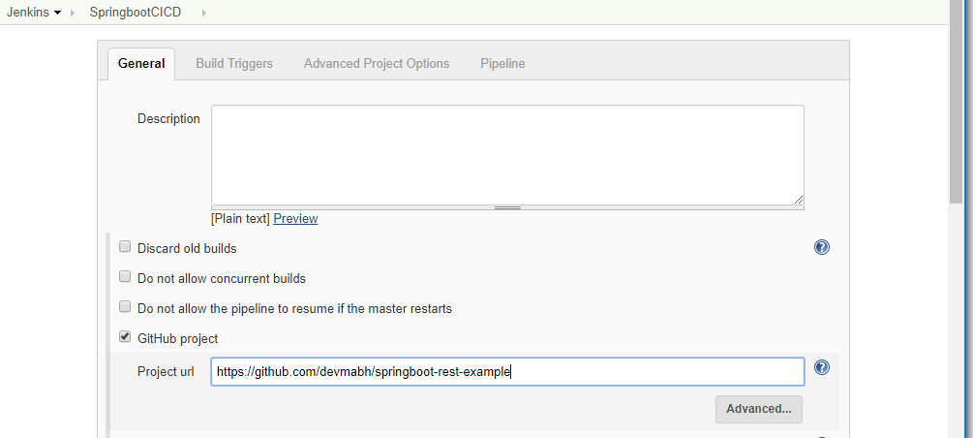

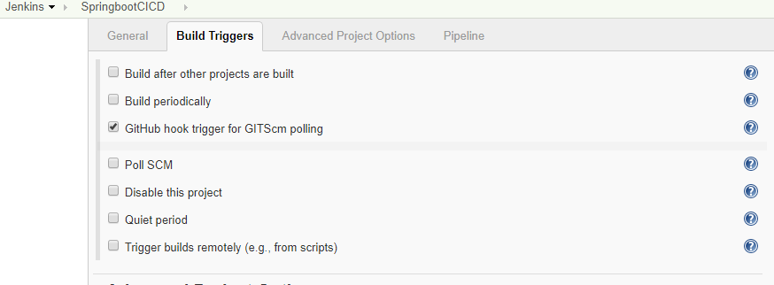

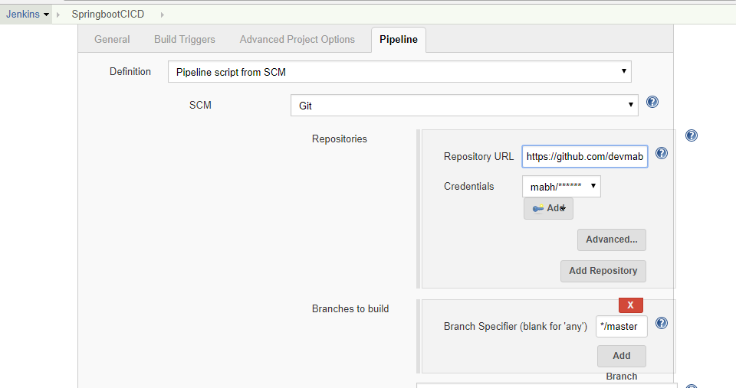

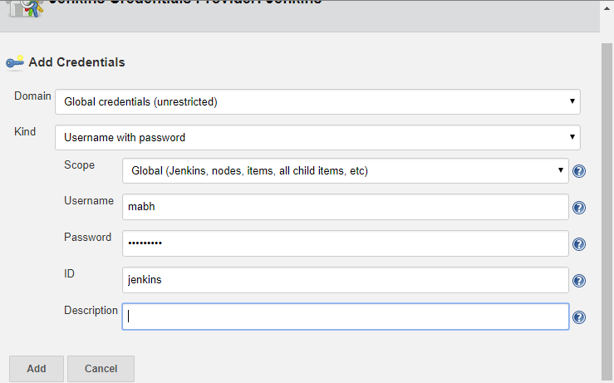

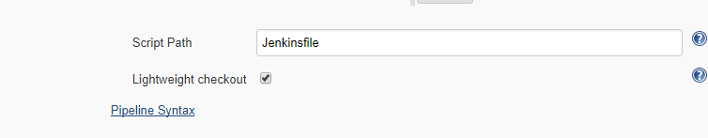

To check our app

http://34.215.174.203:3000/api/books/

Note:

- The docker build command builds Docker images from a Dockerfile and a “context”. A build's context is the set of files located in the specified PATH or URL . The build process can refer to any of the files in the context. For example, your build can use a COPY instruction to reference a file in the context.

- The docker run command is the command used to launch Docker containers.
The docker run command first creates a writeable container layer over the specified image.
and then starts it using the specified command.

