Steps to be follow:

Step1. Putty setup

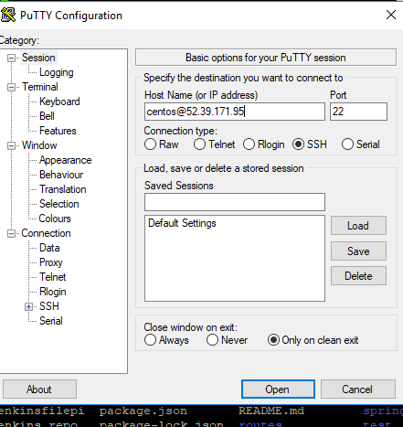

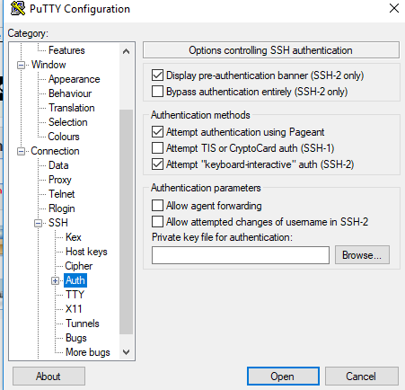
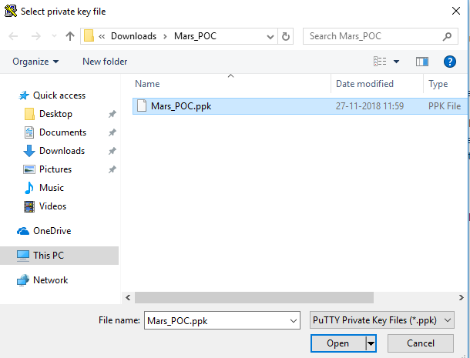
Step2: check git version and if not then install git

[centos@ip-10-0-1-83 ~]$ git --version
-bash: git: command not found
[centos@ip-10-0-1-83 ~]$ sudo yum install -y git

check git version again

[centos@ip-10-0-1-83 ~]$ git --version
git version 1.8.3.1

Step3. Add user and git email id as global variable. Then generate SSH key

[centos@ip-10-0-1-83 ~]$ git config --global user.name "mamta"
[centos@ip-10-0-1-83 ~]$ git config --global user.email mamta.bharti9039@gmail.com
[centos@ip-10-0-1-83 ~]$ ssh-keygen -t rsa -b 4096

enter 3 times

Step4: take the key from following location: Copy that key and save it to use further in github
cat /home/centos/.ssh/id_rsa.pub

Step5: Go to github and login

setting -> select SSH and GPG keys -> add in New SSH key

Step6: take any sample project from git.

Fork
Clone the project :

Step7: go to putty session execute the below command

git clone <URL>

Step8: Create git branch

git checkout -b mybranch

Step9: Perform git add , commit

git add
git commit -b <branch name>
git push

Step10: Install gradle

./gradlew build

sudo yum -y install unzip java-1.8.0-openjdk
java -version
echo $PATH

Inside the project execute below command
ls
cd
./gradlew build
./gradlew init

vi build.gradle
plugins { id "com.moowork.node" version "1.2.0"
}

node {
download=true
version="9.11.1"
npmVersion="5.6.0"
}
task build

task zip(type: Zip) {
from ('.') {
include "*"
include "bin/**"
include "data/**"
include "node_modules/**"
include "public/**"
include "routes/**"
include "views/**"
}

destinationDir(file("dist"))
baseName "sampleapp"
}

build.dependsOn zip
zip.dependsOn npm_build
npm_build.dependsOn npmInstall

./gradlew build

ls -al

make an entry in .gitignore while commiting the dist

Step10: git add .
git commit -b added build file
git push

Step11. Install jenkins with following commands:

sudo yum -y install epel-release
sudo yum install -y wget
sudo wget -O /etc/yum.repos.d/jenkins.repo http://pkg.jenkins-ci.org/redhat-stable/jenkins.repo
sudo rpm --import https://jenkins-ci.org/redhat/jenkins-ci.org.key
sudo yum install -y jenkins-2.121.1
sudo vi /etc/sysconfig/jenkins
jenkins user = "root"
sudo chown -R root:root /var/lib/jenkins
sudo chown -R root:root /var/cache/jenkins
sudo chown -R root:root /var/log/jenkins
ps -ef | grep jenkins
sudo systemctl enable jenkins
sudo systemctl start jenkins
sudo service jenkins restart (If jenkins is not responding)

Note: To install Jenkins, Java needs to be installed.

Step12. Open jenkins in browser

http://34.222.110.173:8080/

execute below command in putty
sudo cat /var/lib/jenkins/secrets/initialAdminPassword

(This command will generate a password, that will be use to authenticate jenkins)

now enter password and continue

Step13. Inside jenkins -> manage jenkins - > configure System

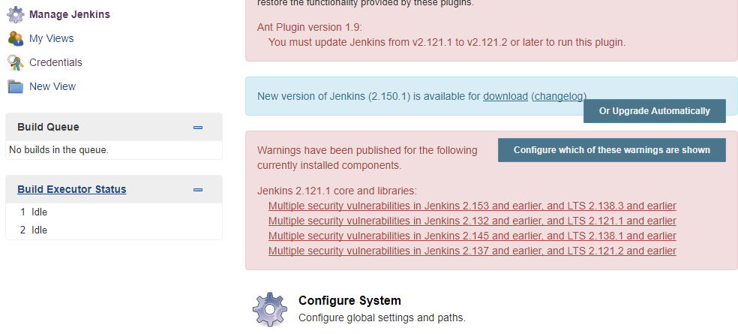

Step13. configure System

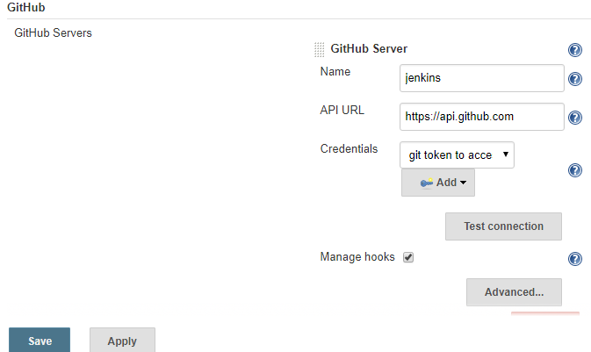
Add
Credential - > Jenkins secret

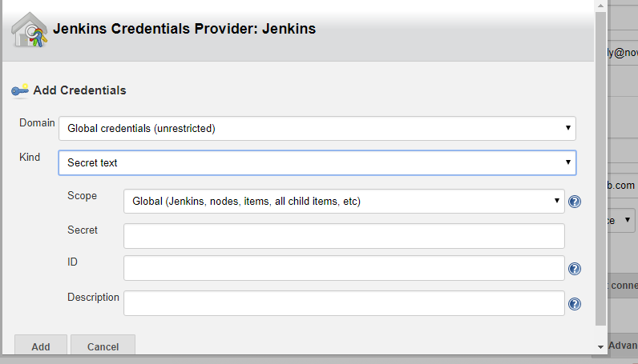

take access token from git hub add it secret in above screen shot

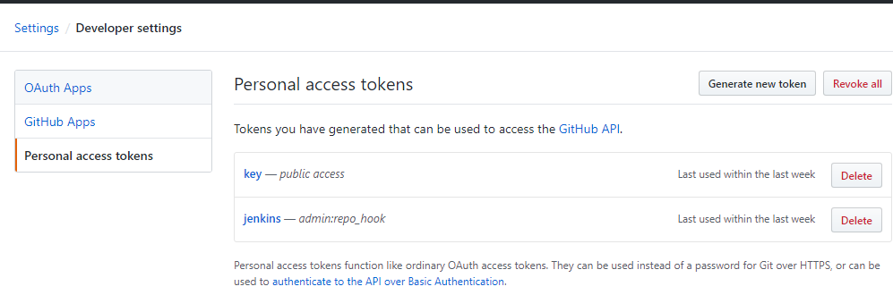
Generate new token and add it to jenkins credential provider(as in last screen)

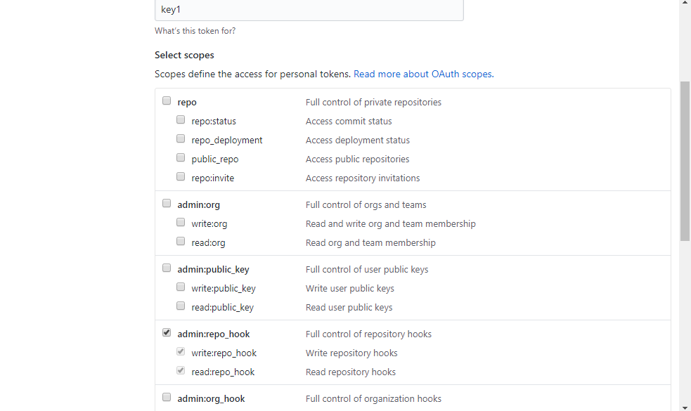

Generate the token

03ca4d9adc00d0b7344204ec7db4dbe5d63a07e1

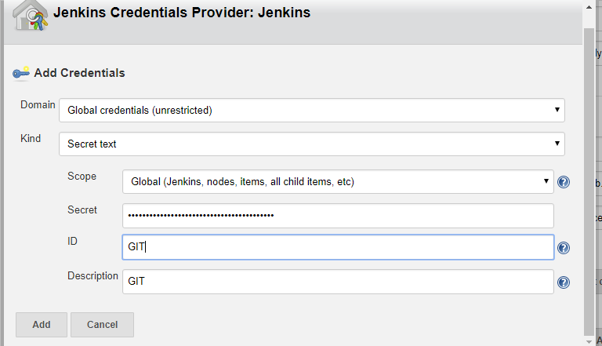

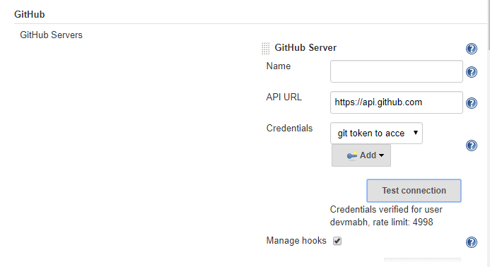
Save and Apply

Create free style projects:

