CI with pipeline project

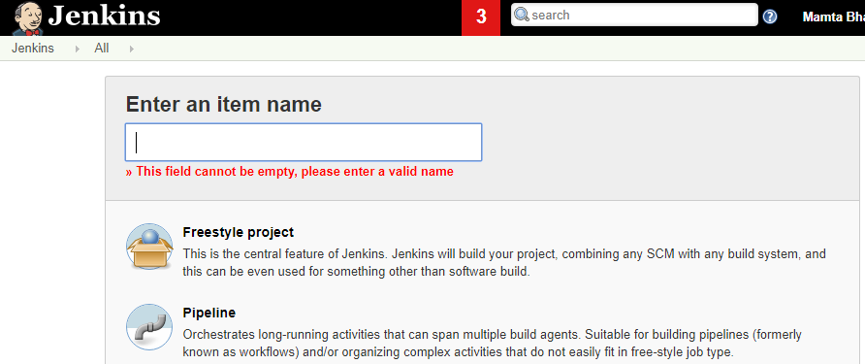

Jenkinsfile

pipeline {
agent any
stages {
stage ('checkout') {
steps
{
git credentialsId: 'GITHUB', url: 'https://github.com/devmabh/cicd-pipeline-gradle.git'
}
}
stage ('Build') {
steps {
echo 'Running Build Automation'
sh './gradlew build --no-daemon'
archiveArtifacts artifacts: 'dist/sampleapp.zip'
}
}
}
}

