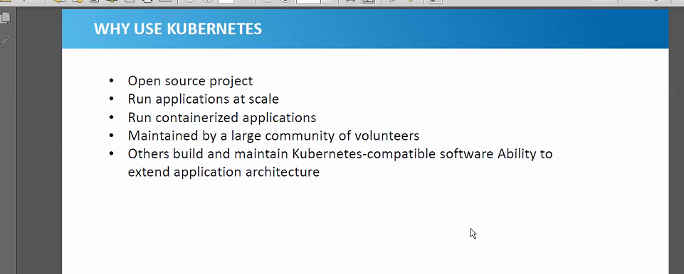

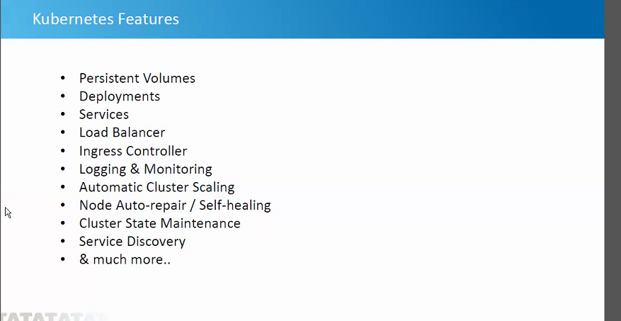

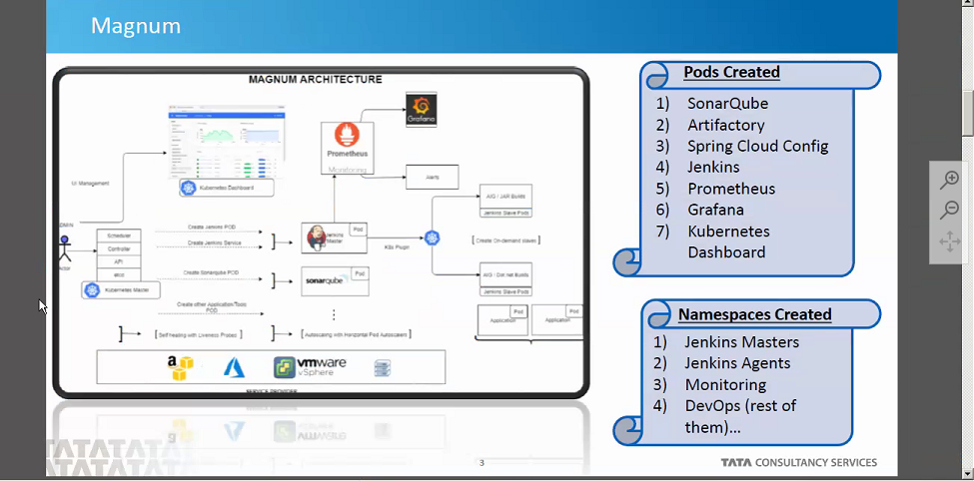

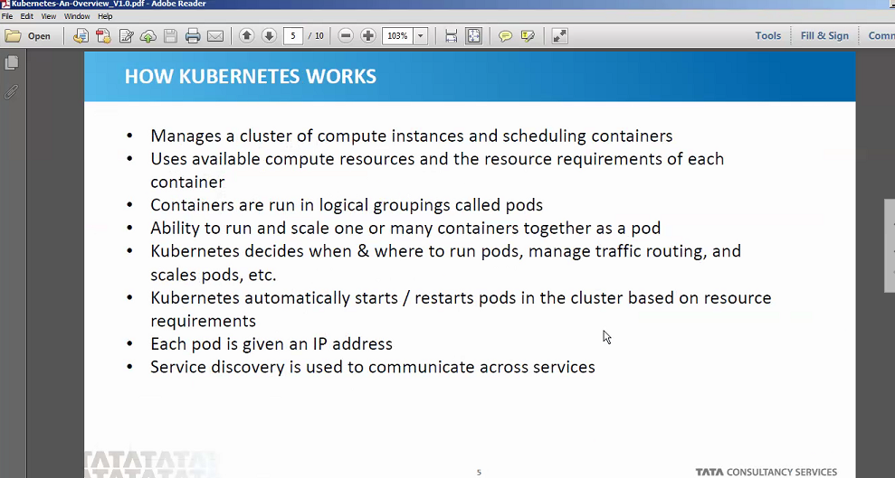

A Kubernetes pod is a group of containers that are deployed together on the same host. If you frequently deploy single containers, you can generally replace the word "pod" with "container" and accurately understand the concept.

The kubelet is responsible for maintaining a set of pods, which are composed of one or more containers, on a local system. Within a Kubernetes cluster, thekubelet functions as a local agent that watches for pod specs via the KubernetesAPI server.

A Node is a worker machine in Kubernetes and may be either a virtual or a physical machine, depending on the cluster. ... Kubelet, a process responsible for communication between the Kubernetes Master and the Node; it manages the Pods and the containers running on a machine
