Reimagining Material Exchange: Co-Creating Digital Solutions with Households and Bhangari Workers
Group name: Doctor Strange
Section: B

1. Research Questions
- How do households and bhangari collectors currently manage, exchange, and process recyclable or reusable household materials?
- What social, logistical, motivational, and technological barriers prevent smooth material exchange through existing informal systems?
- What challenges do bhangari collectors face in their daily work and income generation?
- How ready are households and bhangari collectors to adopt a digital platform, and what features would best support their needs?

2. Target Population and Sample description:
- Urban household members who make decisions about storing, selling, or donating reusable or recyclable items. Multiple household members living in urban residential buildings (apartments and houses), interviewed through semi-structured interviews
- Bhangari / informal waste collectors who collect, purchase, and resell recyclable household materials. 10 Informal waste collectors working within specific neighborhoods or blocks were interviewed in person.
- Online Survey: 50 respondents from urban households, collected through an online questionnaire to gather broader behavioral and attitudinal data.
This sample size aligns with formative research expectations in HCI and is sufficient to surface recurring themes and early design directions.

3.1 Methods Used:
- Semi-Structured Interviews with households and bhangari collectors
- Online Survey with household participants

3.2 Why These Methods Were Selected:
Interviews were chosen to gain rich, contextual insights into everyday practices, challenges, emotions, and power dynamics that are difficult to capture through quantitative methods alone. Semi-structured interviews allowed flexibility to probe sensitive topics such as trust, pricing conflicts, harassment, and social treatment, while still aligning with the research questions.
Surveys were used to complement interview findings with broader trends and patterns. The survey helped validate whether issues identified in interviews were widespread, and to assess digital readiness, smartphone usage, and willingness to adopt a digital platform at scale.

4. Key Findings and Design Implications
Formative Takeaway | Evidence / Insight | Design Implication
1. Communication breakdown is the core problem | Households rely on shouting from upper floors or waiting unpredictably for collectors. Bhangari collectors walk through lanes without knowing where materials are available. Communication is ad-hoc and unreliable for both sides. | The platform should prioritize low-effort, clear communication through request-based pickups, notifications, and precise location sharing.
2. Timing mismatch and uncertainty waste time and income | Households miss collectors due to schedule conflicts, while collectors often walk long distances without finding materials, leading to frustration and income insecurity. | Features such as scheduled pickups, availability indicators, and advance requests can better align expectations and reduce wasted effort for both households and collectors.
3. Trust, safety, and pricing transparency are major concerns | Households feel unsafe or uncomfortable during face-to-face bargaining. Collectors face suspicion, disrespect, and frequent disputes over pricing, often leading to failed exchanges. | The system should support transparent or estimated pricing, reduce direct bargaining pressure, and clearly identify collectors to build mutual trust and safety.
4. High digital readiness and strong willingness to adopt | Survey results show widespread smartphone ownership and familiarity with apps, social media, and mobile financial services. Both groups expressed strong interest in a simple digital solution. | A mobile-first design using simple language, minimal steps, and optional Bangla voice support would ensure accessibility and inclusive adoption.

5. Impact on Design Direction
- Supporting predictable and respectful interactions between households and collectors
- Reducing income uncertainty and wasted labor for bhangari workers
- Enhancing transparency, safety, and trust through digital mediation

6. Team Roles and Responsibilities (Formative Phase)
- Household Interviews: Anisa, Lubna
- Bhangari Collector Interviews: Mashrafe, Prince , Mahbe
- Survey Design, Distribution, Data Analysis, and Synthesis: Jarin, Mahbe
All team members contributed to discussion, interpretation of findings, and consolidation of insights.

Appendix:
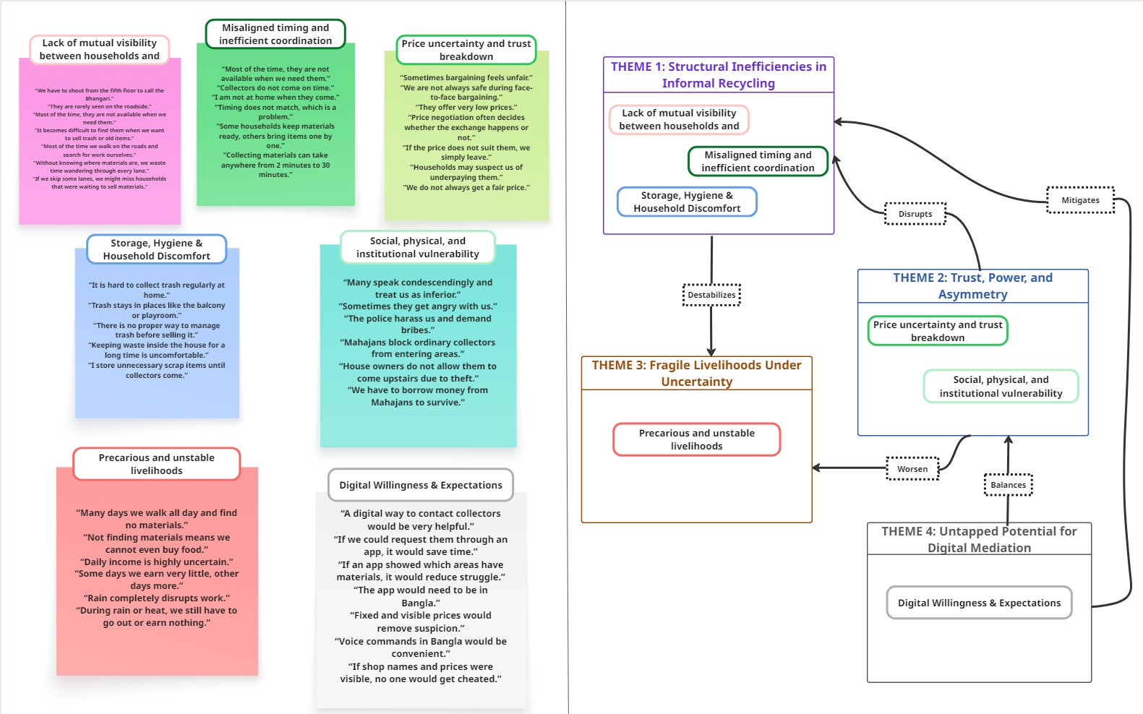
- Affinity Diagram: Insights from Household and Bhangari Stakeholders

B. Interview Materials
- Recordings of semi-structured interview guides for bhangari collectors: https://drive.google.com/drive/folders/1QJihXCXh4oaGEIPnNCrMoXyqKplfmZGT?usp=drive_link

- Quotes of Bhangari collectors:
https://docs.google.com/document/d/1H5lqxXC0GgEdKebRFxafRKx9LRM85tPj/edit?usp=sharing&ouid=112183278470494905675&rtpof=true&sd=true

- Recordings of semi-structured interview guides for household members:
https://drive.google.com/drive/folders/1K11j6t6M-79VNNKw0KDdgn2uhlSJdlc8?usp=drive_link
https://drive.google.com/drive/folders/1H41ihfS91FSF8mb8RHQw7agS3ykTIB2i
- Quotes of Household:
https://docs.google.com/document/d/1uLfTeh5IyRbguKcCPSSQ6RZ-w8GiqxFmK66uuA_k67M/edit?usp=sharing

C. Survey Materials
- Online questionnaire (50 responses)
https://docs.google.com/spreadsheets/d/1Ef8fVN51uZFph1_rXXnoJ5SO_UE16nQ8rWbpRzqDxzA/edit?usp=sharing

